Rich Rigby

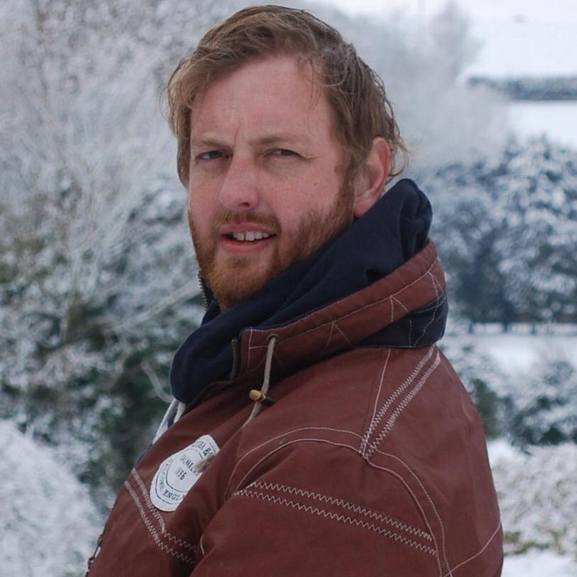A1806EA Image may contain: 1 person 

23 Anglesey Arms Road

Alverstoke

Hampshire

PO12 2DG

12th May 2018

Mr. Steven Knight

C/O

United Agents

12-26 Lexington Street

London

[W1F 0LE](http://www.unitedagents.co.uk/contact)

Dear Mr. Knight:

Awfully difficult to know who to start a letter to someone who’s work you greatly respect and admire, without sounding embarrassingly effusive and sycophantic. Instead, I will remain utterly “British”, without flappery (made up word!), and start by offering my sincere congratulations on your most recent BAFTA win for the paradigm breaking “Peaky Blinders”; the inspiration behind my letter to your good self. I can only echo your sentiment that the cast who bring your very personal story to life will one day also be recognized. Messrs. Hardy and Murphy especially, whom have shared such a brooding interaction together. I especially love how Toms character provides an enzymic quality to the drama; catalysing all that is terrifying when dealing with a character of such destabilising bipolarity.

Indeed, it is the role of Alfie Solomons that got me thinking. First and foremost, however, I feel I should explain myself a little. My name is Richard and I have been travelling all over the world in various roles for the past 14 years. In fact, my passport will tell you I have visited 56 countries in the past ten years! Ostensibly I have been working for Al Jazeera Human Rights department as a security adviser, specifically with regards to protecting journalists’ communications in hostile environments and war zones. However, due to the rise of the 4th generation asymmetric warfare conditions of the Syrian conflict, and the lack of desire from major networks to put journalists in harms way (thankfully!), I found myself out of a job and as a result began writing and acting in Theatre productions and period productions. All good, wholesome fun! I was starting to get a modicum of success when, out of the blue early December 2016, I was arrested on suspicion of Fraud and Money Laundering! This was a complete shock to both myself and my family, but after attending Portsmouth Police station, the situation became clear.

I had, prior to working with Al Jazeera, been working in the UK as an independent risk advisor for individuals and companies looking to make multimillion pound investments in a variety of assets. Very long story short, I took salary for a job back in 2012 and was then accused of stealing both my salary AND a further £150,000. This was completely absurd, but despite actually repaying the salary for the job, the case still went to court, and in a further incredulous twist, the judge deemed that the fact that the money had been repaid was irrelevant and sentenced me to 2 years in prison. Naturally my whole life fell apart on that day on the 3rd August 2017. Within 4 hours, I went from a free man, assured that the case would be dropped by the CPS as funds had been repaid, to being on B Wing, HMP Winchester; prisoner no. A1806EA.

Some specific accomplishments include:

* Expanded client base by 40 percent through persistent effort and excellent service.
* Ninety percent of my clients renewed annual contracts.
* Traveled throughout large territory, managing time well.

Does this sound like the person you need? If it does, I am eager to speak with you. I’ve enclosed my resume for your review. I look forward to hearing from you.

Sincerely, Image may contain: 1 person

Rich Rigby