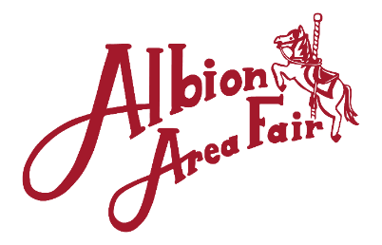
2020 Premium Book Ad & Sponsorship Form
Company Name:_________________ Contact Person:______________________
Street Address / State / ZIP:_________________________________________________
Phone:__________________ eMail:___________________________________
Business Website Address:__________________________________________________
DIGITAL IMAGE REQUIREMENTS for Ads: MINIMUM 300 dpi in a common format such as JPEG, PNG, PDF. VECTOR artwork required for a banner or $40 set up fee will apply. All artwork email to: albionfairbook@gmail.com
Website Ad
[ ] Logo with Link to business $25
Placemat Ad
5000 copies distributed to local restaurants.
Size: 2”x2”
[ ] Ad placed on printed placemat $25
Fair Book Ad
Vast distribution & Available Online
1/8 Page: [ ] B/W $75 [ ] Color $80
1/4 Page: [ ] B/W $125 [ ] Color $140
1/2 Page: [ ] B/W $200 [ ] Color $250
Full Page: [ ] B/W $325 [ ] Color $350
Based on an 8”x10.5” Page.

Vinyl Banner
Color 4’x6’
$250 (new) / $100 (yearly renewal)
Desired Location(s):
[ ] Main Entrance [ ] Pull Track
[ ] Knapp Arena [ ] Midway
[ ] Practice Arena
Event Sponsor ($500 minimum per event)
[ ] Horse Show $____ [ ] Tractor Pull $____ [ ] Queen/Junior Miss Pageant $____
[ ] Truck Pull $____ [ ] Parade $____ [ ] Concert/Music $____
Other Donations
[ ] Barn:_______ $____ [ ] Shuttle Carts $____ [ ] Your Choice: _________________ $____
VIP Parking Space ($100 each)
VIP package includes two Booster Buttons for weeklong fair entry. VIP parking spaces are limited. Please contact: Angie at 814-218-7766 or albionfairtreasurer@gmail.com to reserve your spot today and send payment to address below.
Parking Areas include Main Gate (Tennis Court), Log Cabin/Big Tent, Information Stand (Lower Fair Office).
Total Amount Enclosed: _____________________
PLEASE RETURN FORM WITH PAYMENT BY MAY 15th, 2020.

