The Highly Sensitive Empath… Who Am I?

Please NOTE: HSP’s and Empaths will be referred to as Sensitives in this document.

Before we start it’s important to understand how many Sensitives there are in the world so you won’t feel so alone.

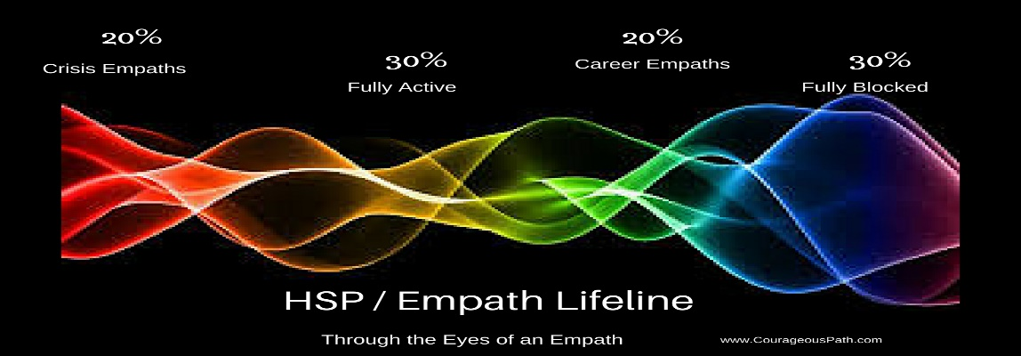

At birth all people are born Sensitive.

By age 21:
- 30% of all people are still hyper-sensitive to other’s feelings. These are the HSPs and Empaths of the world.
- 20% are what I call Crisis Sensitives who use their gifts only in times of crisis
- 20% are what I call Career Sensitives using their gifts in their chosen careers but turning it off or down when they leave work.

Career Sensitives are the nurses, doctors, alternative healers, caregivers, teachers, moms and dads, social workers, counsellors… anyone who touches other’s lives or bodies as part of their work.

- 30% are the ‘normals’ who have unconsciously blocked their HSP gifts

Who Am I?
This is the cry of every Sensitive who doesn’t know how to use their gifts.
This is the cry of every Sensitive who doesn’t remember how to use the quantum energy protection encoded into your DNA.

We have been born into incredible times of quantum energy discovery that validates who we are and how we do what we do. Learning who YOU are begins with understanding how every human being is connected energetically and how we all have the ability to filter, block, and return unwanted energy without physical or verbal confrontation. Sensitives have always been at the forefront of using this communicative energy.

Scientists are proving that we are not mentally impaired, and our abilities are measurable, and they are real. It’s our work to learn how to use what we have, to live empowered, out- loud, productive lives. So, let’s begin to understand what we need to know so we can get those empowered lives working our magic for our best lives.

The Beginning
Every one of us who begins life as the gentle child, hearing the flowers, talking with the animals, and feeling every feeling of every person who is in your life knows what I’m talking about. As this child, you felt everything your mother felt before you were born and still hold all those feelings as cellular memories which are triggered by sounds and vibrational frequencies that tickle, tease, and at times terrify you into fight, flight, or freeze reactions. This instinctual survival is held deep in the center of our brains… called the limbic or ancient brain. This ancient brain is the computer app that reads electric vibrations from all other living things and alerts your body using physical sensation to get your attention.

Physical sensation is the limbic brain’s language and vocabulary. You’ll notice that the fear vibration whether your own, or someone else’s is always felt in the same body location and with the same sensation, while anxiety is a different sensation felt in a different location.

Who are you? The Sensitive is a person whose limbic responses are more excitable and hyper-sensitive than others. To know who you are is to embrace the sensations your survival partner – the limbic response - sends to alert you in advance of danger.

Your homework is to document survival sensations and learn to read them. Prove to yourself that your ‘intuition’ is mostly right, and that you are energetically reading your environment.

Who are you? You are an energy reading machine!

Next Level Understanding
Every person in this world broadcasts energetic vibration silently letting everyone else know what they need and what they feel about themselves and their lives. Sensitives act as lightening rods or cell phone towers attracting all kinds of energies. Depending on your own need, and beliefs about your own value, you will be attracting energies that meet those needs or that read and use your vulnerability.

We don’t attract what we fear most, we unconsciously open our unprogrammed, unfiltered, outer protection to ALL energies. This is why we can’t effectively block damaging energies. And this is why we feel crushing overwhelm, pain, and illness. We aren’t defective, we are simply untrained Sensitives and Empaths.

Who are YOU? You are a cell phone tower receiving all calls without a filtering system.

The good news is that programming your limbic protection system is easy. In brief, you not only receive other’s energy broadcasts, but you also broadcast your own need, excitement, fear, love, hostility, and acceptance just as loudly as everyone else.

You are recognized by everyone you meet by the energy you unconsciously broadcast. They unconsciously trust or distrust you based on whether you are in fight, flight, freeze, isolation, or authenticity and acceptance of yourself.

Who are you? You are an energy broadcasting machine.

We HSPs and Empaths are very complex computers that run on a simple default system. All incoming energies from our surroundings are being read by our survival system and forwarded directly into our bodies and minds so we will take action; where action is needed. With training, simple programming of our survival system means your outer protective barrier comes online, filters out and returns-to-sender what you choose to not accept. In this way, you remain solidly grounded, less stressed, healthier, and definitely happier.

Who Are YOU?
- You are in the 30% of the population whose brain is hyper-sensitive to outside energetic stimulus
- You are a Crisis HSP or Empath – 20% of the population
- You are a Career HSP or Empath – 20% of the population
- You are an energy reading machine
- You are a cell phone tower receiving all calls without a filtering system.
- You are an energy broadcasting machine.
- Without training to filter incoming energy you are at the mercy of your ancient survival brain
- With training you can live a full, happy, loving life alongside the ‘normal’s’ and really fulfilling your life purpose
- You might be a Nurturer, Analyzer, Leader, or Promoter, or a combination of 2 or more of these personality categories…

FYI To stop being an empath you'd have to block your DNA encoded gift! Yes, it is possible to block your ability to read, feel, and intuit others, but I don't recommend it. If you have accidentally done so, then you know what it feels like to live blind, deaf, and less than half-alive disconnected from the body sensation that tells you where you are, and what is about to happen. Unblocking your abilities is a long process but well worth the effort to get your life back.
All material copyright to Sue Rumack, Pulse of Awakening, 2015.
All rights reserved. Do not copy or share any part of this document for publication or inclusion in teaching materials without written consent from Sue Rumack.

