Are HSPs and Empaths More than Kissing Cousins?

HSPs and Empaths are more than kissing cousin's WE are the same person!

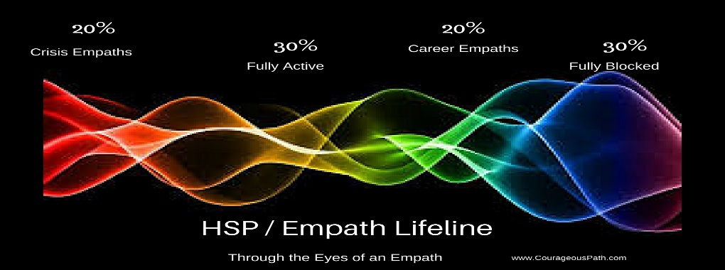

Good Wednesday Morning All you gorgeous Empaths and HSP's. Yes, you saw it right... HSP's! I've been talking to people who seemed to think there's a difference between Highly Sensitive Persons and Empaths BUT according to how energies affect our minds and bodies we are the same person. Science has given a new and improved name to the garden variety empath who graces this page.

Here's the difference... quantum energy scientists working with psychiatrists decided to investigate what makes some people (30% of the whole population) react with extreme sensitivity to the same things which the 'normals' (30% of the whole population) may have blocked or at best pay minimal attention to. Also, please not that intuitive people make up 70%, while ‘normals’ make up the remaining 30% of the whole population. A little more on this in a moment.

We, the extremely sensitive ones, are this way because our fight or flight survival vibrational boundaries pick up all the energy around us and sends that vibration frequency to our brains. Our survival (limbic) brain is wired to hyper-reactive response to all vibrational stimulate but become super hyper-reactive when the frequency received mimics danger! …BOOM - we react! With a little training, it becomes easier to control our reactions, but that isn't this article. Today is about understanding the distinctions between levels of HSP and/or Empath and how we fit in the world.

Back to the numbers…
HSP’s are actually a full 70% of the whole population. A moment ago, I related that 30% of the whole population is hyper-sensitive. You might be doing the math and noticing that 30% HSP + 30% normals = 60% not 100%.

Within the total HSP / Empath category of 70% of the population only 30% is highly- highly - highly reactive. However, there more HSPs and Empaths who actively, consciously use their abilities than the hypersensitive 30% who are not in control of their reactions!

Here's the missing 40% HSP from my original calculation:
- 20% of the whole world population are Career HSPs/Empath,
- and final 20% of the whole world population are Crisis HSPs/Empaths.

Crisis HSP/Empath
If you are someone who's sensitivity really ramps up and gets much stronger in a crisis then you are a Crisis HSP/Empath.

Career HSP/Empath
If you are someone who is in a helping profession, using your gifts to assess and treat others AND who is able to leave work... at work.. then you are a Career Empath.

So which are you?
- HSP - hyper sensitive,
- Crisis Empath,
- Career Empath?

FYI regardless of which you are... you are still an HSP and an Empath in my books.

