**CWERP**

Chichester & Worthing Enhanced Recovery Programme

*Helping You Recover From Your Operation Sooner*

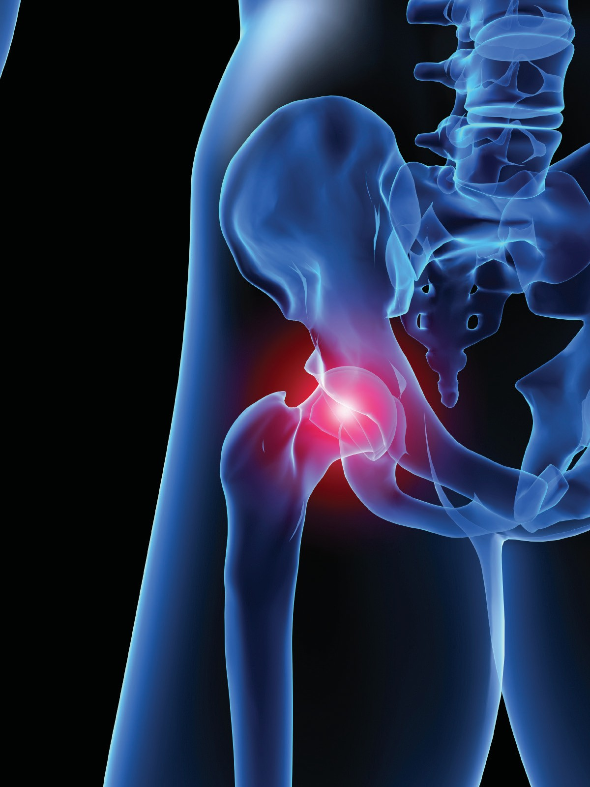

**Hip Replacement**

**Information booklet**

**Introduction**

Dear Patient

This booklet tells you about Total Hip Replacement Surgery. It is for people who have decided to have the surgery after discussing the options, benefits and possible risks with their Consultant surgeon. We have developed this booklet to help answer any questions that you may have about your operation and recovery. It will be useful during each of your hospital visits so please bring it with you.

The ERP team at Chichester Nuffield consists of;

* Consultant surgeon, RMO
* Consultant Anaesthetist,
* Ward Nurses
* Physiotherapists
* Pharmacists/Pharmacy Technicians
* Theatre & Recovery team

This booklet is a general guide and there may be alterations in your management made by your surgeon, anaesthetist, nurse or therapist. These instructions should take priority. This booklet has been planned in the order in which events will happen. Please read the booklet before you come into hospital.

All members of the team are committed to providing you with the highest standards of care and we look forward to assisting you with all your needs and will provide you with the best advice and guidance we can.

Please do not hesitate to ask any member of the team if you have any queries or concerns.

**Contents**

|  |  |
| --- | --- |
| * Introduction |  |
| * Enhanced Recovery Programme |  |
| * Preparing to come into hospital |  |
| * Pre-operative Nutrition |  |
| * Anaesthetic for your hip surgery |  |
| * Consent |  |
| * What is a Total Hip Replacement? |  |
| * Your Recovery |  |
| * Advice on how to care for your new hip |  |
| * Physiotherapy |  |
| * Going home from hospital - Discharge day |  |
| * Once you are home |  |
| * Frequently asked questions |  |
| * How to care for your wound |  |
|  |  |
| * Occupational Therapy |  |
|  |  |

Enhanced Recovery is an approach to care before, during and after an operation that we know helps people to get better quicker after surgery. Other hospitals run similar successful programmes.

Your co-operation and commitment to the programme will aid your recovery process. If there is anything you are not sure about, please ask. It is important that you understand so that you, and possibly your family and friends, can take an active role in your recovery.

The length of time that you stay in hospital varies for each patient. Most patients stay in hospital between two and four days.

You will be asked to attend pre-assessment clinic where you will have a pre-operative assessment to make sure you are fit for your surgery. You will have a blood test and heart trace (ECG) at this appointment.

The nurse in the pre-assessment clinic will advise you which medicines to take on the day of your operation. It is important that you continue

to take your usual medicines, including inhalers, unless your surgeon, anaesthetist, pharmacist or nurse has advised you not to.

### Medication Advice

Continue taking all medication as per normal unless instructed otherwise by your pre-operative nurse.

#### Medication to be stopped will be written below:

|  |  |  |  |  |
| --- | --- | --- | --- | --- |
| **Medication** | **Omit Evening Before Surgery** | **Omit Morning of Surgery** | **Omit Lunchtime of**  **Surgery** | **Other (Longer Period to Stop)** |
|  |  |  |  |  |
|  |  |  |  |  |
|  |  |  |  |  |
|  |  |  |  |  |
|  |  |  |  |  |

Please inform us if you develop any of the following between your Pre-op Assessment and the date of your surgery:

* changes to your medication
* changes to your health state
* open wounds or sores

Additionally, please contact us if, **within 7 days of surgery**, you develop any of the following:

* diarrhoea and/or vomiting
* any infection
* cough or cold
* cold sore

## On the day of Admission

If you have someone to take your coat home until your discharge that is advisable

Do bring... Don’t



|  |  |
| --- | --- |
| 3 x Underwear |  |
| 2 x Nightclothes |  |
| 1 x clean dressing gown |  |
| 1 x set of loose fitting day clothes |  |
| 1 x small toiletry bag |  |

*Wear jewellery

*Wear make-up

Entertainment (optional)

*Wear nail varnish or false nails

|  |  |
| --- | --- |
| 1 x reading / puzzle book |  |
| Mobile phone or kindle  (brought in at your own risk) |  |

Do not shave the operative area

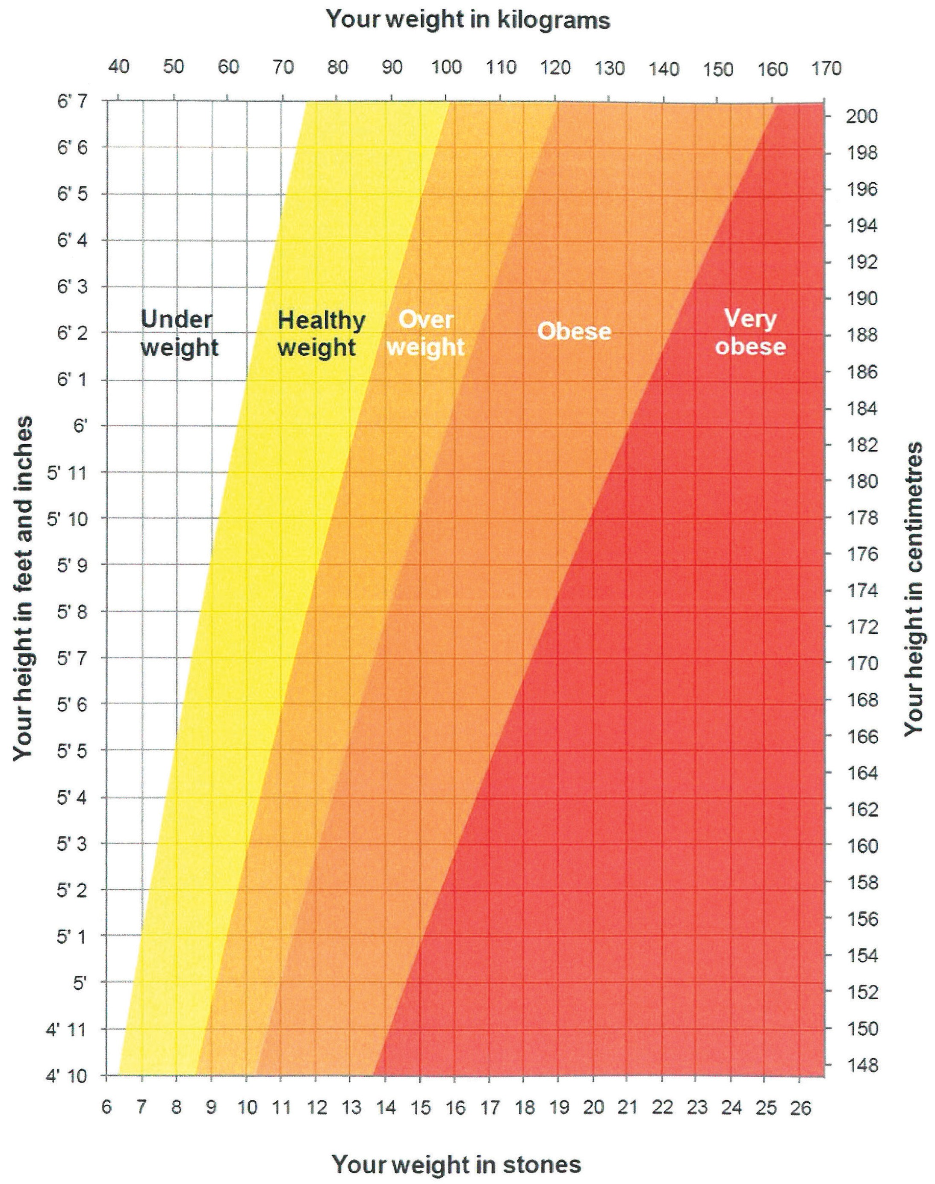

### A Healthy Diet

The eatwell guide highlights the different types of food that make up our diet, and shows the proportion that we should eat them in to have a well-balanced and healthy diet. This plate represents the balance over a whole day or a longer period of a week, not at every meal.

The eatwell guide is made up of five food groups – fruit and vegetables; bread, rice, potatoes and other starchy foods; meat, fish, eggs, beans and other non-dairy sources of protein; milk and dairy foods; and foods high in fat and/or sugar. Choosing a variety of foods from the four biggest groups and a small amount from the high fat/sugar group will achieve a healthy balance.



### How many portions should I have each day?

|  |  |
| --- | --- |
| Fruit and vegetables | At least 5 portions per day |
| Bread, rice, potatoes, pasta and other starchy foods | 8 – 10 portions per day (depending on your activity levels; greater activity levels require more portions) |
| Milk and dairy foods | 2 – 3 portions per day |
| Meat, fish, eggs, beans and other non-dairy sources of protein | 2 – 3 portions per day |

**How big is a portion?**

#### Fruit and vegetables

|  |  |
| --- | --- |
| Large sized fruit | 2 slices of mango, pineapple or papaya |
| Medium sized fruit | 1 banana, apple, orange or peach |
| Small sized fruit | 2 kiwis, plums, satsumas or clementines |
| Grapes and berries | 1 handful |
| Fruit juice / smoothies | 150ml (a small glass) – this can only count as 1 portion a day |
| Mixed vegetable | 3 heaped tablespoons of peas, carrots, sweetcorn or mixed vegetable |
| Salad leaves | 1 dessert bowl |
| Beans | 3 heaped tablespoons |

#### Bread, rice, potatoes, pasta and other starchy foods

|  |  |
| --- | --- |
| Cereal | 9 tablespoons (3 portions) |
| Bread | 2 slices of toast or a sandwich (2 portions) |
| Baked potato | 1 medium sized potato (fist sized) (2 portions) |
| Boiled potatoes | 4 small (egg sized) potatoes (2 portions) |
| Pasta | 9 tablespoons (3 portions) |
| Rice | 6 tablespoons (3 portions) |
| Noodles | 1 block of dried noodles (1 portion) |
| Pitta bread | 1 filled pitta bread (2 portions) |

**Milk and dairy foods**

|  |  |
| --- | --- |
| Milk | 200ml is a small glass |
| Yoghurt | 150ml is a small pot |
| Hard Cheese | 30g (size of a small matchbox) |
| Cottage Cheese | 90g or about 2 tablespoons |

**Meat, fish, eggs, beans and other non-dairy sources of protein**

|  |  |
| --- | --- |
| Lean meat | 100g raw / 75g cooked (size of a deck of cards) |
| Fish | 75g oily fish or 150g white fish |
| Eggs | 2 medium sized eggs |
| Baked beans | 5 tablespoons (half a 440g tin) |
| Pulses | 4 tablespoons of lentils or chickpeas (a heaped handful) |
| Nuts | 2 tablespoons (a small handful) |

### Pre-operative Nutrition

Eating a range of foods from the four main food groups will ensure you are well-nourished, which will aid your recovery post surgery.

Food and fluids are an important part of preparing for your operation. You can eat up to six hours before your operation and drink clear fluids, including the PreOp drinks, up to two hours before.

 Taking the PreOp drinks before an operation helps your body to cope with the stress of surgery.

 This means you should feel less hungry, nauseous and weak after your surgery.

 The drinks come in 200ml bottles and are gluten, lactose and fibre free.

### What You Need to Know

   You will be given the drinks at Joint School.

   The day before your operation, eat as you normally would.

   Take 4 bottles from midday onwards on the day before

surgery; you may be given a further 2 bottles to drink in hospital on the day of your surgery, depending on the time of your surgery.

The drinks are clear, non-carbonated and lemon flavoured, and taste refreshing when refrigerated.

Before your operation as well as PreOp you can also drink water, black coffee, black tea, but not as a replacement for the PreOp drinks.

You do not need to continue these drinks after your operation.

Diabetes: if you have diabetes and have concerns about taking PreOp, please contact your diabetic nurse, practice nurse or GP for advice.

12

### Anaesthetic for your Hip replacement surgery

For operations below the waist, you can have a spinal anaesthetic. **Spinal anaesthetics** are the most common type of anaesthetic used for hip replacement surgery. In this Trust, nearly 95% of all hip replacements are performed under spinal anaesthetic.

Alternatively, you can have a general anaesthetic, which produces a state of controlled unconsciousness during the operation. Use of general anesthetic alone is now uncommon for hip replacement surgery.

### Why have a spinal?

Advantages compared to having a general anaesthetic:

 Less need for strong pain relieving drugs. This is because the drugs given in the spinal injection reduce the need for other pain relieving medicines given in other ways, which tend to have more side effects – these include nausea, confusion, drowsiness and constipation

    Excellent pain relief immediately after surgery

    Less sickness and vomiting

    Earlier return to eating and drinking after surgery

 Less risk of becoming confused after the operation, especially if you are an older person

    Less risk of a chest infection after surgery

    Less effect on the lungs and breathing

13

### What is a spinal anaesthetic?

 A local anaesthetic drug is injected through a needle into the middle of your lower back.

 This injection will numb the nerves from the waist down to the toes for anything from 2-5 hours.

### During your spinal anaesthetic you can be:

    Fully awake.

    Sedated – drugs make you relaxed and sleepy but not fully unconscious, although you may have little recall of the operation. This is the most common choice.

    Fully anaesthetised – general anaesthetic (unconscious).

### How is the spinal performed?

1. At Joint School, an anaesthetist or representative will discuss the spinal anaesthetic with you.
2. You will meet your individual anaesthetist on the day of your surgery who can discuss final details with you.
3. The spinal may be done in the anaesthetic room or in the operating theatre.
4. Your anaesthetist will first insert a cannula (small plastic tube) into a vein in your hand or arm.
5. You will be helped into the correct position for the spinal. Most commonly you will sit on the side of the bed with your feet on a low stool. Alternatively you can lie curled up on your side.

14 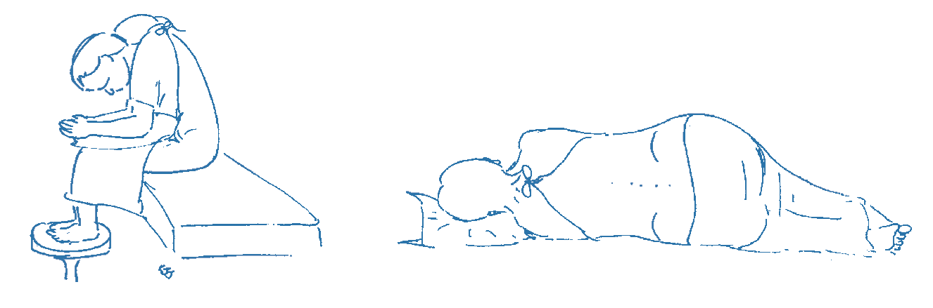

1. Your back will first be cleaned with cold alcohol based liquid.
2. The anaesthetist will then give local anaesthetic in the skin to make you comfortable, followed by the spinal injection. A nurse or health care assistant will support and reassure you during the injection.
3. After the injection is complete, you will be positioned correctly to lie on the bed. The anaesthetist will then perform checks to ensure the spinal is working correctly.

### What will I feel?

A spinal injection is usually no more painful than having a blood test or having a cannula inserted. It may take several minutes to perform.

 The spinal injection works quickly and is usually effective within 5-10 minutes.

 To start with your skin feels warm, swiftly followed by pins and needles, then numb to touch and your legs will feel heavy.

 When the injection is working fully, you will be unable to move your legs or feel any pain below the waist.

### Testing the block

* Your anaesthetist will check the block is working properly usually in 2 ways:

 Cold spray - if the feeling of cold is lost, this is a good indication the spinal will work well for the surgery.

 Trying to move your legs – if you cannot move them, then the spinal is working very well. If you still have some movement, your anaesthetist will decide if this is significant.

Only when the anaesthetist is satisfied the spinal anaesthetic has taken effect will he/she allow the surgery to begin.

15

**Anaesthetic for your hip surgery**

### During the operation

 You will be positioned on your side for your hip surgery, with your sore side upwards.

(If you are having a general anaesthetic after your spinal, you will have your general anaesthetic lying on your back and then be positioned on your side once asleep).

 Please tell your anaesthetist if there is something simple that will make you more comfortable, such as an extra pillow or armrest.

 You will be given extra oxygen to breathe via a clear plastic mask.

 Your anaesthetist will give you sedation to make you relaxed and sleepy as agreed earlier; alternatively you may choose to be awake.

 You can listen to music if you wish during the operation. Feel free to bring in your own headphones and music.

 The anaesthetist will be present throughout the operation and you can communicate with them throughout.

### You may still need a general anaesthetic if:

 Your anaesthetist cannot perform the spinal to his/her satisfaction.

    The spinal is identified as not working adequately during checks.

 The surgery becomes more complicated or takes longer than expected.

### After your surgery

It can take several hours for sensation (feeling) to return to your legs. As sensation returns, you may experience some tingling in the skin as the spinal wears off. At this point you may become aware of some pain from the operation site and you should ask for more pain relief.

16

Once your legs have returned to normal, you will be assessed by the nurses / physiotherapists for your suitability to try to get out of bed.

### Side effects and complications

As with all anaesthetic techniques, there is a possibility of unwanted side effects or complications.

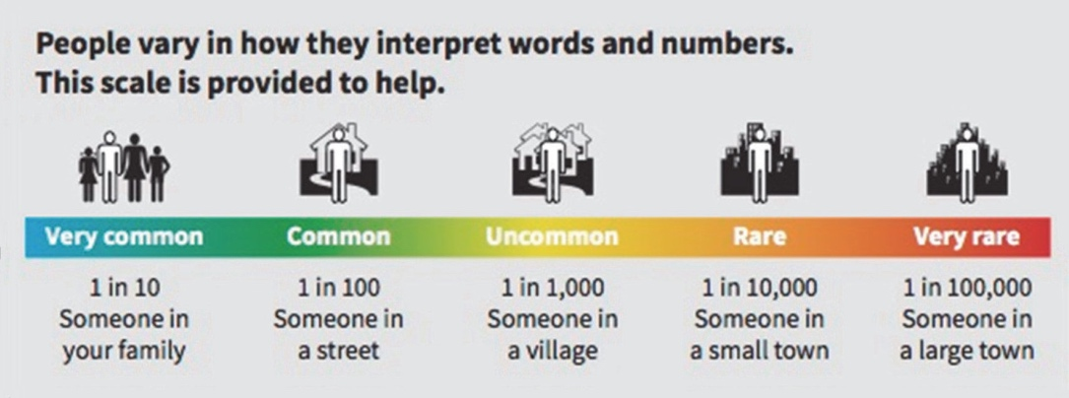

#### Very common and common side effects

These may range from trivial to unpleasant, but can be treated and do not usually last long.

1. **Low blood pressure** – as the spinal takes effect, it can lower your blood pressure. This can make you feel faint or sick. This will be controlled by your anaesthetist by fluids and drugs given through your drip to raise your blood pressure.
2. **Difficulty passing water (urinary retention)** – you may find it difficult to empty your bladder normally for as long as the spinal lasts. This may result in accidental passing of urine that you are unaware of. However, it is unusual (less than 20% of patients) to

require a urinary catheter. Your bladder function returns to normal after the spinal wears off. Bowel function is not affected by the spinal.

17

# Anaesthetic for your hip surgery

1. **Pain during the spinal injection** – if you feel pain in places other than where the needle is, you should immediately tell your anaesthetist. This might be in your legs or bottom, and

might be due to the needle touching a nerve. The needle will be repositioned.

1. **Headache** – there are many causes of headache after an operation, including the anaesthetic, being dehydrated, not eating and feeling anxious. Most headaches get better within a few hours and can be treated with pain relieving medicines.

A severe and important headache can occur after a spinal injection. This is uncommon in older people after a spinal; in young women having a spinal for childbirth it occurs in around 1 in 200 to 300 spinals.

If this happens to you, let your ward nurses know and they will organize for you to see an anesthetist for assessment.

### Rare complications

#### Nerve damage

This is a rare complication of spinal anaesthesia.

 **Temporary** loss of sensation, pins and needles and sometimes muscle weakness may last for a few days or even weeks but almost all of these make a full recovery in time.

 **Permanent** nerve damage is rare (approximately 1 in 50,000 spinals). It has about the same chance of occurring as major complications of having a general anaesthetic.

### Where can I learn more about having a spinal?

The website [www.rcoa.ac.uk/patientinfo](http://www.rcoa.ac.uk/patientinfo) has more information.

18

**Consent**

#### Consent

On the day of your surgery your consultant or their registrar will explain the risks, the benefits and alternatives to having your operation and you will be asked to sign a consent form. This information will have previously been discussed with you in the outpatients clinic when you first saw the surgeon and some of the risks and benefits will also have been discussed at Joint School.

Make sure you understand what you are consenting to and why it is necessary for you to sign.

You can always refuse treatment, even if you have signed the consent form and then change your mind. You can withdraw your consent at any time. This does not effect your right to alternative forms of treatment if available.

19

**What is a total hip replacement?**

A total hip replacement involves replacing the worn out (arthritic) parts of the joint and replacing them with a metal stem and a cemented plastic socket or plastic or ceramic lined uncemented socket. The stem can either be cemented or uncemented. The use of cement is usually surgeon preference and there are advantages and disadvantages of the different types of fixation, however both types have excellent survivorship.

Your surgeon will make a cut over the side of your hip and remove the worn out bone in the joint.

At the end of the operation your surgeon will close the skin with clips or dissolvable stitches and occasionally glue.

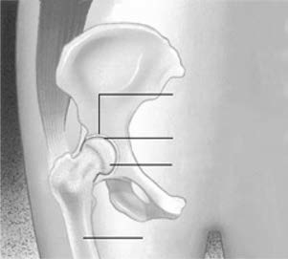

Normal Hip

Rounded Socket (acetabulum)

Articular Cartilage Femoral Head

Thighbone (femur)

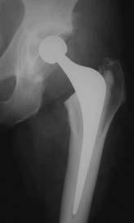

Cemented Hip

Usually the operation lasts about an hour to an hour and a half, then you will be taken to the recovery room which is close to the operating theatre. You will have a dedicated nurse / practitioner and you will not be left alone.

If you have pain or sickness this will dealt with promptly. You may need to breathe oxygen through a mask or up your nose, and you may have a drip in your arm. You may also have calf pumps on your lower legs. The recovery staff will check your blood pressure, heart rate, pain level and oxygen levels regularly.

Once the recovery staff are satisfied that you have recovered safely from your anaesthetic you will be taken back to the ward.

20

### Pain after hip surgery

Numbness from the spinal anaesthetic wears off gradually over the first few hours after the operation. You will have had some local anaesthetic injected around the new hip joint and this will keep your hip numb for a little longer.

While your leg is numb you may find it difficult to move your leg and foot but this movement will gradually return as the numbness wears off which may take up to 6 hours. It is expected that you will experience some pain following your hip surgery but you will be given

pain relief to control the pain. Please alert your nurse if you are in pain. It is important to act early as pain is harder to treat if it is allowed to become severe, and good pain control is important for your recovery.

### Nurses

The team of nurses will be there throughout your stay to guide you towards a safe discharge.

### Pharmacists

The team of ward pharmacists and technicians will be on the ward to check which medicines you are on. It would be helpful if you could bring your regular medications into hospital as this will save time when we prepare your medicines for discharge.

21

### Orthopaedic Physiotherapists

A Physiotherapist will assess you after your operation. They will advise and teach you movement and strengthening exercises to aid recovery of your new hip joint. They will also help supervise and progress your walking again

# Your stay on the ward

#### Operation day

Physiotherapist/Nursing staff to get you up day 0/1 after your operation with the aid of a zimmer frame. You will be assisted to dress in your own clothes.

Physiotherapist will teach you exercises.

22

The team will review how you are planning to manage your personal care activities. They will also assess your activities of daily living including getting on/off the bed, chair and toilet and identify any other assessments tailored to meet your needs at home.

Continue exercises.

Increase walking distance.

Physiotherapist will teach you how to use crutches or walking sticks safely.

Physiotherapist will practise steps or stairs depending on your home situation — Teach standing exercises. Discussion about ongoing physiotherapy and goals.

The Therapists will continue to practice your activities of daily living until you have confidence in your level of independence.

They will also discuss your goals in relation to your recovery.

Discharge Day.

23

**Advice on how to care for your new hip**

A small percentage of patients will have to follow the precautions below for the first 6–8 weeks after surgery, while the muscles and ligaments around the hip are healing, in order to reduce the risk of your new hip joint dislocating (i.e. coming out of the socket).

This is the decision of your surgeon You are following these; yes or no

#### Do not bend your hip past 90° (right angle).

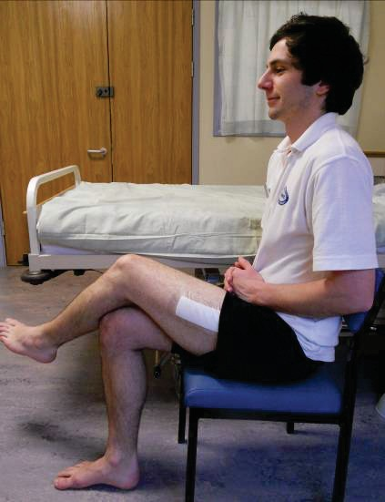

* **Do not cross your legs while sitting or lying.**
* **Do not twist your hip.**

**Sitting**

When sitting on a bed, chair or toilet, your hip joint should be higher than your knees. The Therapist may measure your lower leg length to determine the ideal sitting height for you:

24

**To stand up**

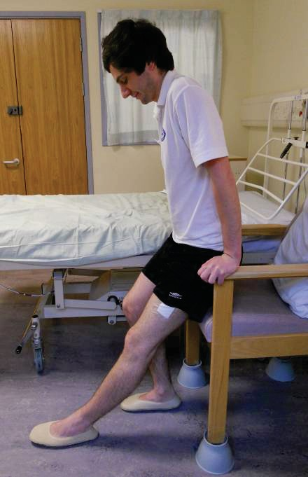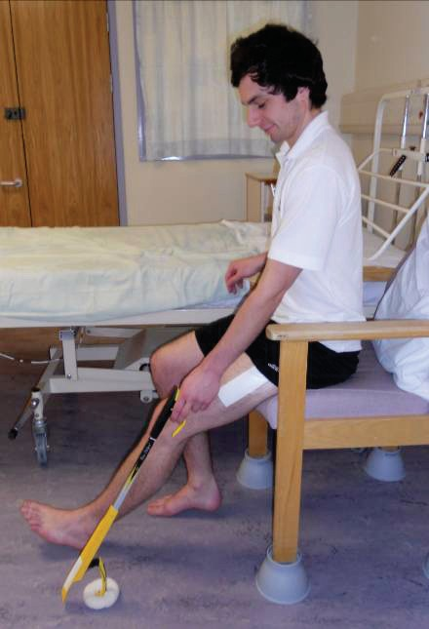

25

* to get out of the chair, move to the front of the seat,
* place your operated leg slightly in front.
* push up on the arms of the chair, so that you don’t bend forwards.
* take hold of your walking aid once you are in standing.

To get off the toilet, use the same method, pushing up on the equipment that has been provided for you.

### To sit down

* reach back for the arms of the chair,
* put your operated leg out in front.
* lower yourself down gently.

Do not twist to retrieve items out of reach – stand up and walk to get them or use your

equipment / helping hand.

**Advice on how to care for your new hip**

### Toileting

Equipment may be identified (e.g. raised toilet seat, toilet frame) by your Therapist to ensure you maintain your independence with toileting.

If you are following hip precautions don’t twist around or stretch to reach toilet paper, make sure it is in easy reach. Stand up and take small steps around to flush, do not twist on your operated leg.

### Walking

You will be shown how to walk with a walking aid by the physiotherapist. We will advise you on how to walk as normally as possible and how to progress with your walking when at home.

Most people are able to put full weight through their operated leg, but if it is different for you we will let you know. Most people are walking with elbow crutches or sticks by the time they go home.

### Walking sequence

Walking aid moves forward first. Then step your **operated leg.**

Finally step your **non-operated leg.**

### Reminders for walking

* Try not to limp.
* Bend your knee as you bring your **operated leg** forwards to take the next step.
* Straighten your knee fully when standing.
* Take small steps when turning.

26

### Stairs / Step

**Going up:**

 First take a step up with your **non-operated** leg.

* Then take a step with your **operated leg.**
* Then bring your crutches / walking stick up on the step. Always go up one step at a time.

### Going down:

 First put your crutches / walking sticks one step down.

* Then take a step with your **operated leg.**
* Then take a step down with your **non-operated leg.**
* Always go down one step at a time.

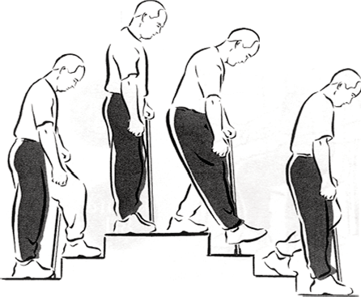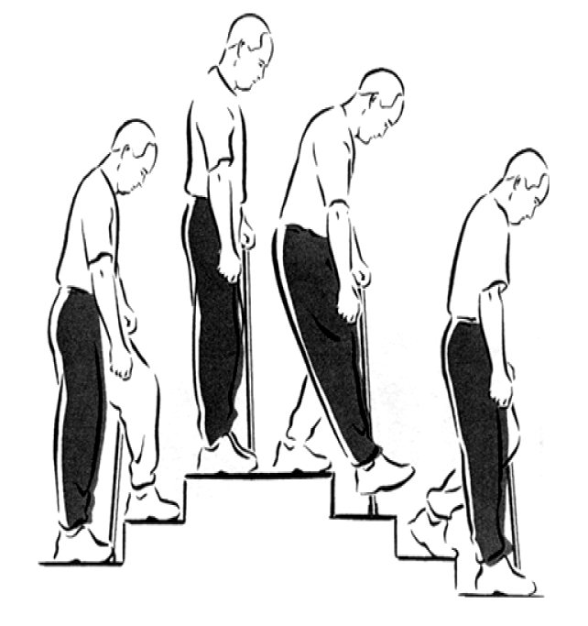

### Sleeping

Getting into bed with your unoperated leg first may be easier for you. The Occupational Therapist will practice this with you and help you work out the best side for you. Sleep on your back

for at least 2 weeks after the operation, speak with your therapist

if this is an issue. 27

**Picking up from the floor**

If your balance is good, you can bend forwards by stretching your operated leg out behind you and hold onto something solid. Use the long handled “helping hand / reacher” if you have been given one.

**Dressing**

The Therapist will teach you how to dress your lower half using long handled equipment.

* You will be given an additional leaflet to refer to.
* Dress sitting on a firm chair or bed.
* Dress your operated leg first and undress it last.
* Wear good, supportive shoes with low heels.

**Bathing / Showering**

Use a walk-in shower if possible, as it is not advisable to sit down in the bottom of a bath for the first 6 weeks. An alternative may be to strip wash for a period of time, your Occupational Therapist will advise and provide any equipment that may be of benefit.

**Getting in and out of a car**

You will be able to go home by car. It is advisable to sit in the front passenger seat. Please ensure a friend/relative adjusts the front passenger seat in preparation. Adjust the chair seat backwards to allow for maximum leg room, and place the seat into a reclined position.

**To Get in a Car**

* Turn with your back to the seat.
* Place your operated leg forwards.
* Find a good place to hold on and lower your bottom onto the seat.
* Lean back so you do not over bend your hip.
* Slide your bottom as far back towards the handbrake as possible.
* Lean back as you lift your legs up and into the car.

**To Get out of a Car**

* Move your bottom over towards the handbrake.
* Lean back as you turn and lift your legs out of the car.
* Do not pull yourself forwards, place your hands behind you and push your bottom forwards.
* Find good hand holds again.
* Place operated leg forwards.
* Stand yourself up.

28

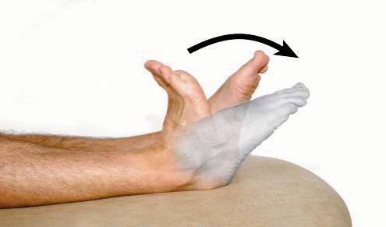Lying on your back or sitting, bend and straighten your ankles briskly. If you keep your knees straight during the exercise you will stretch your calf muscles. Repeat 10 times.

Lying on your back, squeeze your buttocks firmly together. Hold for approximately five seconds.

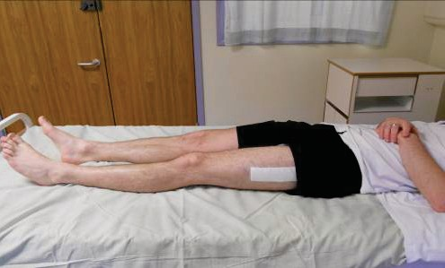

Relax. Repeat 10 times.

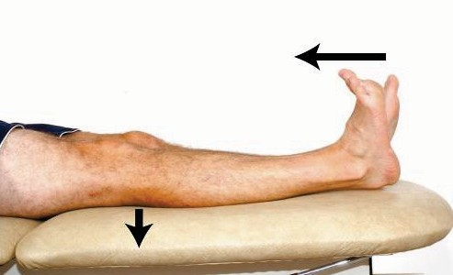Lie on your back with legs straight. Bend your ankles and push your knees down firmly against the bed. Hold for five seconds.

Relax. Repeat 10 times.

Lie on your back with a sliding board under your leg and a doughnut under your foot.

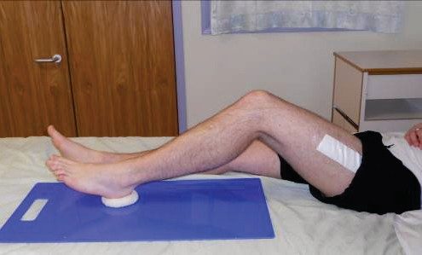

Bend and straighten your hip and knee by sliding your foot up and down the board.

Repeat 10 times.

29

Place a rolled towel under your knee. Exercise your leg by pulling your foot and toes up, tightening your thigh muscle and straightening the knee (keep knee on the towel). Hold for approximately five seconds and lower with control.

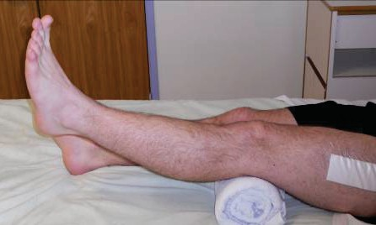

Repeat 10 times.

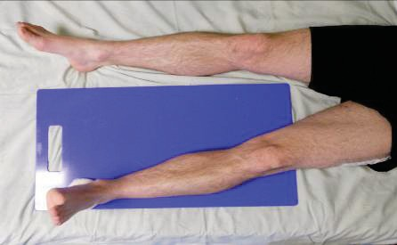

Bring your leg to the side and then back to mid position.

Repeat 10 times.

Sitting. Bend your knee as much as possible. Hold for five seconds before fully straightening your leg.

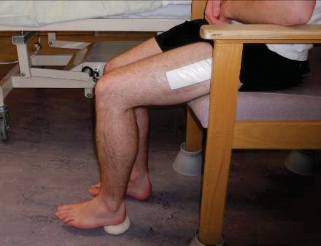

Repeat 10 times.

Stand straight holding on to a secure surface such a kitchen worktop. Lift your knee up towards your chest but do not lift beyond 90°. Hold for five seconds.

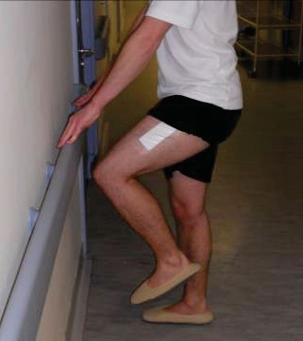

Repeat 10 times.

Stand straight holding on to a secure surface such as a kitchen worktop.

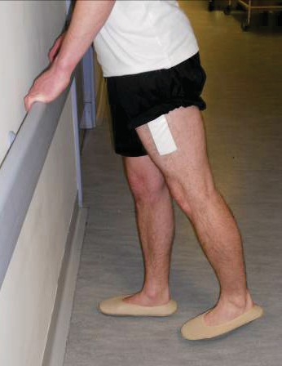

Bring your leg backwards keeping your knee straight. Do not lean forwards. Hold for five seconds.

Repeat 10 times.

Stand straight holding on to a support such as a kitchen worktop. Lift your leg sideways (keeping toes pointing forwards) and bring it back keeping your trunk straight throughout the exercise. Hold for five seconds.

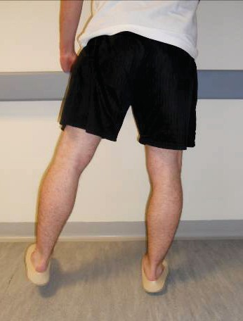

Repeat 10 times.

You should aim to do all of these exercises 3-4 times daily and continue for at least six weeks following surgery to achieve full recovery with your new hip.

During the first few days following surgery it is important to take large deep breaths, expanding your chest, right to the bottom of your lungs and repeat three times hourly. Follow with a strong cough.

31

### EXERCISE DIARY

|  |  |  |  |  |
| --- | --- | --- | --- | --- |
| Date | Session 1 | Session 2 | Session 3 | Session 4 |
|  |  |  |  |  |
|  |  |  |  |  |
|  |  |  |  |  |
|  |  |  |  |  |
|  |  |  |  |  |
|  |  |  |  |  |
|  |  |  |  |  |
|  |  |  |  |  |
|  |  |  |  |  |
|  |  |  |  |  |
|  |  |  |  |  |
|  |  |  |  |  |

32

**Going Home from Hospital**

### How long will I stay in Hospital?

The length of time that you stay in hospital varies with each patient. Most patients stay in hospital between two and four days, however you can go home as early as day one if you have achieved all of your goals, so you need to be prepared.

We give you this as a guide so that you can plan to have someone around should you need them on discharge. If you have any concerns with how you will manage when you return home, please inform the nursing staff as soon as possible so that we can discuss this with you.

### When will I be ready to go home?

You will be able to go home once all members of the

team are happy with your progress and we know that you will manage safely at home. To ensure that you are ready to go home we need to check the following:

 You must be able to walk safely around the ward with either crutches or walking sticks by yourself. (Although some patients may go home with other types of walking aid).

 You must have managed a set of stairs or a step safely (depending on what you have at home).

 You need to be able to get on and off a bed, toilet and chair by yourself (unless there is someone who can assist you at home).

 Your essential equipment must have been issued ready for use at home.

 You are able to do the strengthening exercises independently.

 Your blood results and x-ray of your new joint must be satisfactory.

 Your pain must be under control.

 You need to be medically fit.

 You are able to complete personal care and meal preparation activities independently or with assistance.

3

**Occupational Therapy - Maximising independence at home**

Once you get home you should stay active. The key is not to over do it! While you can expect some good days and some not so good days, you should notice gradual improvement over time.

### Domestic tasks

#### Cooking

* Try to plan ahead before your operation by moving essential items to waist height, re-arrange cupboards, fridge and freezer so that you can easily reach required items.
* A high stool may be beneficial so that you can sit and still reach work surfaces.

#### Shopping

* Prior to admission consider stocking up on frozen meals and essential items to ease the transition to home. Once home from hospital you may wish to consider online shopping. Supermarket shopping may be more tiring and therefore assistance may be beneficial.

#### Energy Conservation

* If you need to do all tasks yourselves, plan to do a small amount each day and avoid any non-essential tasks.
* You may need some additional help from others with some household tasks for several weeks after your surgery. It is advisable to discuss this and plan with friends and family prior to coming into hospital.
* Your Occupational Therapist may be able to refer you to community agencies who could assist/support you for up to 6-8 weeks post-op. See page 43 for further information.

35

### Transport

#### Driving

* It is advisable that you do not drive for 6 weeks following surgery. Please inform your insurance company of your surgery as it is a major operation and they will advise you of any further requirements they need you to take to ensure you can ensure you can return to driving fully insured.

#### Flying

* Flying is not recommended for at least three months after your operation due to the risk of developing a blood clot. Some consultants may vary this advice. Please contact your consultant via their secretary if you need to fly before the timescales advised. Notify the airline of your replacement joint and carry a letter from your Doctor for when you go through the X-ray searches.

### Leisure

#### Sports and hobbies

* Please discuss any sports and hobbies with your Therapy team that you may wish to return to.

#### Gardening

* Avoid gardening for 6-8 weeks, consider using long handled equipment when returning.

#### Sex

* Your usual pattern of sexual activity may be resumed when the wound is soundly healed and clips removed, unless your Doctor advises otherwise. The most stable position for your hip is on your back with your partner on top. There is an information sheet available with more details from the ward Physiotherapist or Occupational Therapist.

**Work**

* You should be able to return to work between 6-12 weeks after your surgery. Discuss your work with your Doctor, Occupational Therapist or Physiotherapist as it will depend on the nature of

36 your work. If you have a manual job it may be longer.

**Frequently Asked Questions**

### What are the visiting hours on the ward?

Visiting times are available from the staff on admission. There may be times when we need to interrupt visiting to provide aspects of

your care. Visitors are asked to sit on chairs provided rather than hospital equipment, and keep to two visitors per bed.

**Can my visitors come on the day of the operation?** Yes, but we ask that your visitors must telephone the ward prior to visiting you on the day of your surgery.

**Can my friend / relative phone to check on how I am?** Yes, of course. We understand that your friends and family are keen to check on your progress. However, we would be grateful if one member of your family or one friend could take responsibility for keeping other relatives informed of your progress. This allows the nursing staff to use their time to focus on caring for you.

### Is it safe to bring valuables into hospital with me?

We do not recommend you bring valuables into hospital with you. Anything you do bring into hospital is done so at your own risk.

### Newspapers

The newspaper trolley visits the ward daily.

### Am I allowed flowers?

We regret that we cannot allow flowers on the ward. This is because they can be a source of infection which in turn could get into your or other patients wounds. Please inform your visitors of this.

37

### Will I be able to go swimming after my operation?

Yes, swimming is a good activity to strengthen your body. However we advise that your wound needs to be fully healed before you go into the pool. You need to be confident with your walking so that you can safely manage to walk safely on a wet pool side. We recommend that you use a pool which has a staircase leading into the water, not to use a ladder to enter and exit the pool and avoid a breaststroke kick.

### How far can I walk?

As far as you feel able to and your pain allows. Build up slowly using your walking aid to start with.

### When can I walk without my crutches / sticks?

You need to progress as your pain allows you to and it will be different for everyone. You should start by progressing to one elbow crutch / walking stick (use on the opposite side to your operated leg) around your home. Then you can aim to walk longer distances outdoors with just one elbow crutch / stick. You can completely progress off of elbow crutches when you can manage to walk without a limp.

If you have been advised by your Physiotherapist that you are partial weight-bearing you must continue to use elbow crutches for at least 6 weeks.

**Will I be getting any follow-up Physiotherapy?** Please refer to page 32 where your Physiotherapist will have documented whether you need any ongoing physiotherapy.

**How long should I continue doing my exercises for?** Aim for 10 repetitions of each exercise, 3-4 times daily for at least six weeks following surgery or for as long as you feel you are benefiting from continuing with the exercises.

38

**When will I be followed Up?**

The ward nurse or a member of the ward team will arrange a follow up for a wound review at approximately 2 weeks . The surgeon who performed your operation will see you in outpatients

6-8 weeks after your operation. Sometimes the surgeon will want to see you sooner than this, but we will let you know on the day you are discharged from hospital.

### When can I sleep on my side?

Sleep on your back for 2 weeks, you can lie on your **operated** side with a pillow between your knees after your wound is healed and clips removed at 12-14 days. It will not be comfortable to lie on your side before this time.

Do not lie on your unoperated side for 6 weeks if you have been told you are to follow hip precaution guidelines.

### What can be done to minimise the risk of a blood clot forming (Deep Vein Thrombosis)?

The Doctor will prescribe either aspirin or dalteparin or both according to protocol, to prevent blood clots forming. Dalteparin is given as an injection once a day after your operation. You will be shown how to inject yourself or a relative could do this for you.

You will wear TED stockings while in hospital.

39

### My leg is swollen what should I do?

The swelling may last for several months and is often worse a few weeks after the operation. This is because we rely on the pumping action of our calf muscle as we walk to return blood to the heart.

If we are less mobile, or put less weight through the leg, the calf pump is less effective and fluid builds up around the ankle and the lower leg. When sitting, the ankle pump exercises help to move

fluid about. Make sure that you rest for at least 30 mins everyday and elevate your feet to hip height on a bed.

### Why is my scar warm?

The healing process creates heat because the body is repairing the area. This may continue for up to 6 months. If there is an increase in swelling or redness, discharge, increase in pain or fever then see below for who to contact.

### How will I know if something is wrong?

Some people have an increase in pain and swelling after being home a short time. This is often due to increasing your activity. Please take your pain relief regularly as prescribed for 7 days.

If you are concerned then please do not hesitate to contact the team.

If you have any questions before you come into hospital, or once you are home, please do not hesitate to contact us and we can put you in touch with the relevant person.

40

**How to care for your wound**

### How to care for your wound

**How to care for your wound**

Your dressing is splash proof so you CAN take a shower it is NOT waterproof do not submerge into a bath.

The dressing stays on for 12-14 days after your surgery. On your discharge please make an appointment with your practice nurse for removal of the

dressing / sutures / clips

### These pictures show how the dressing works.

Picture 1 Picture 2 Picture 3

Normal dressings does NOT need changing (1 & 2) This dressing DOES NEED changing (3)

Your wound will leak into your dressing as in picture 2, and then will dry up. This is normal and does not need changing.

If the dressing lifts at the edge, develops ooze from the edge of the dressing as in picture 3. This needs to be changed.

An infection at the site of your wound is unusual but may present with discharge from the wound, redness, swelling and heat, increased pain or an offensive smell.

#### Do not change the dressing yourself.

If you are concerned about your wound it is essential you contact us:

Copyright © Western Sussex Hospitals NHS Foundation Trust 2015 All rights reserved