**CWERP**

Chichester & Worthing Enhanced Recovery Programme

*Helping You Recover From Your Operation Sooner*

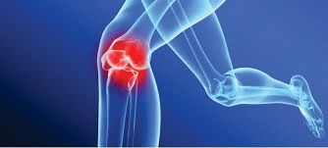

**Knee Replacement**

**Information booklet**

**Introduction**

Dear Patient

This booklet tells you about Total Knee Replacement Surgery. It is for people who have decided to have the surgery after discussing the options, benefits and possible risks with their Consultant surgeon. We have developed this booklet to help answer any questions that you may have about your

operation and recovery. It will be useful during each of your hospital visits so please bring it with you.

The ERP team at Chichester Nuffield consists of;

* Consultant surgeon, RMO
* Consultant Anaesthetist
* Ward Nurses
* Physiotherapists
* Pharmacists/Pharmacy Technicians
* Theatre & Recovery team

This booklet is a general guide and there may be alterations in your management made by your surgeon, anaesthetist, nurse or therapist. These instructions should take priority. This booklet has been planned in the order in which events will happen. Please read the booklet before you come into hospital.

All members of the team are committed to providing you with the highest standards of care and we look forward to assisting you with all your needs and will provide you with the best advice and guidance we can.

Please do not hesitate to ask any member of the team if you have any queries or concerns.

**Contents**

|  |  |
| --- | --- |
| * Introduction |  |
| * Enhanced Recovery Programme |  |
| * Preparing to come into hospital |  |
| * Pre-operative Nutrition |  |
| * Anaesthetic for your knee surgery |  |
| * Consent |  |
| * What is a Total Knee Replacement? |  |
| * Your recovery following surgery |  |
| * Physiotherapy Exercise Programme |  |
| * General Physiotherapy |  |
| * Going home from hospital |  |
| * Once you are home - the first 6-8 weeks |  |
| * Frequently asked questions |  |
|  |  |
| * How to care for your wound |  |
| * Occupational Therapy |  |
|  |  |

3

Enhanced Recovery is an approach to care before, during and after an operation that we know helps people to get better quicker after surgery. Other hospitals run similar successful programmes.

Your co-operation and commitment to the programme will aid your recovery process. If there is anything you are not sure about,

please ask. It is important that you understand so that you, and possibly your family and friends, can take an active role in your recovery.

The length of time that you stay in hospital varies for each patient. Most patients stay in hospital between two and four days.

You will be asked to attend pre-assessment clinic where you will have a pre-operative assessment to make sure you are fit for your surgery. You will have a blood test and heart trace (ECG) at this appointment.

The nurse in the pre-assessment clinic will advise you which medicines to take on the day of your operation. It is important that you continue

to take your usual medicines, including inhalers, unless your surgeon, anaesthetist, pharmacist or nurse has advised you not to.

### Medication Advice

Continue taking all medication as per normal unless instructed otherwise by your pre-operative nurse.

#### Medication to be stopped will be written below:

|  |  |  |  |  |
| --- | --- | --- | --- | --- |
| **Medication** | **Omit Evening Before Surgery** | **Omit Morning of Surgery** | **Omit Lunchtime of**  **Surgery** | **Other (Longer Period to Stop)** |
|  |  |  |  |  |
|  |  |  |  |  |
|  |  |  |  |  |
|  |  |  |  |  |
|  |  |  |  |  |

6

Please inform us if you develop any of the following between your Pre-op Assessment and the date of your surgery:

* changes to your medication
* changes to your health state
* open wounds or sores

Additionally, please contact us if, **within 7 days of surgery**, you develop any of the following:

* diarrhoea and/or vomiting
* any infection
* cough or cold
* cold sore

## On the day of Admission

If you have someone to take your coat home until your discharge that is advisable

Do bring... Don’t



|  |  |
| --- | --- |
| 3 x Underwear |  |
| 2 x Nightclothes |  |
| 1 x clean dressing gown |  |
| 1 x set of loose fitting day clothes |  |
| 1 x small toiletry bag |  |

*Wear jewellery

*Wear make-up

Entertainment (optional)

*Wear nail varnish or false nails

|  |  |
| --- | --- |
| 1 x reading / puzzle book |  |
| Mobile phone or kindle  (brought in at your own risk) |  |

Do not shave the operative area

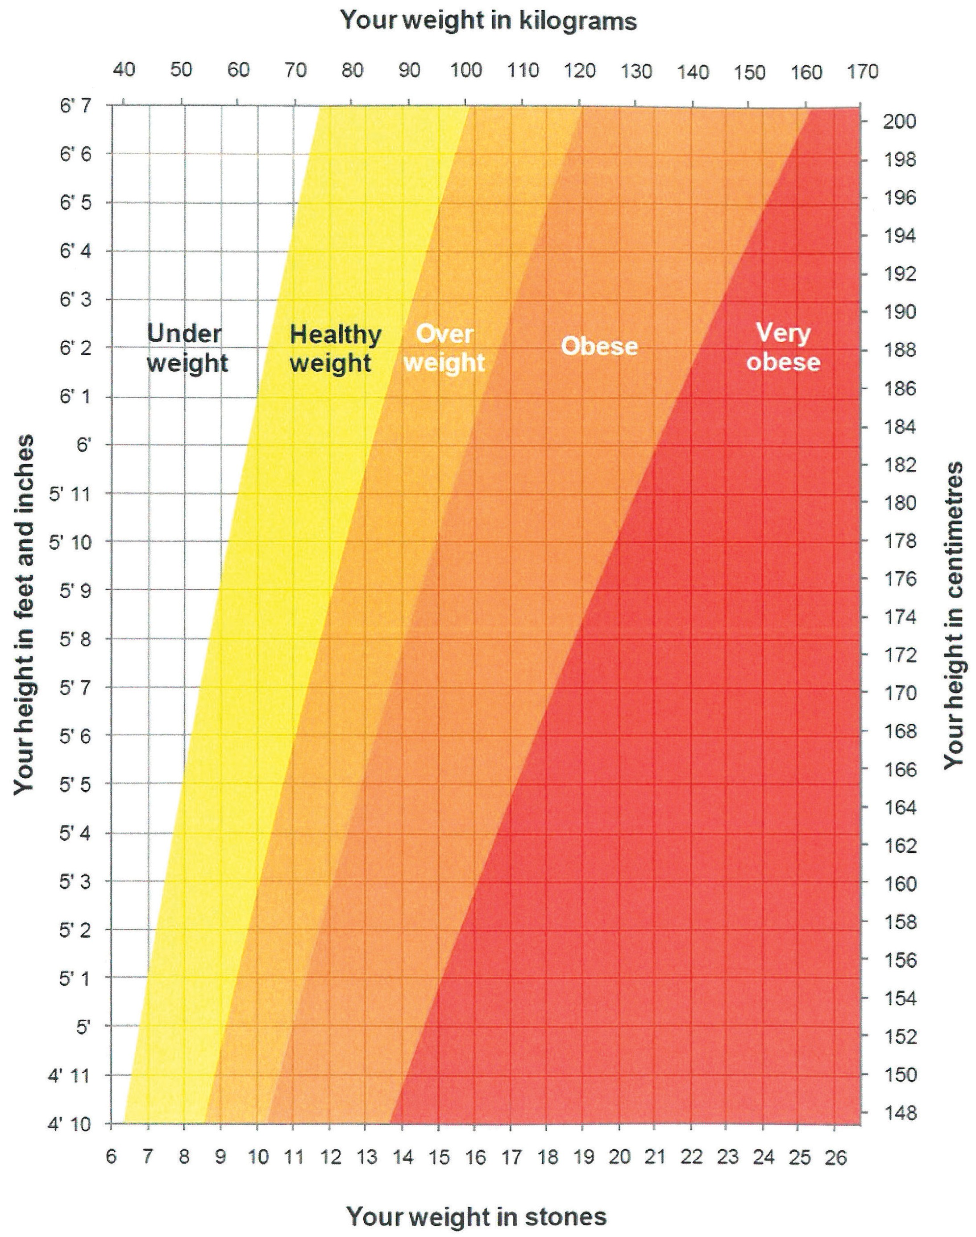

### A Healthy Diet

The eatwell guide highlights the different types of food that make up our diet, and shows the proportion that we should eat them in to have a well-balanced and healthy diet. This plate represents the balance over a whole day or a longer period of a week, not at every meal.

The eatwell guide is made up of five food groups – fruit and vegetables; bread, rice, potatoes and other starchy foods; meat, fish, eggs, beans and other non-dairy sources of protein; milk and dairy foods; and foods high in fat and/or sugar. Choosing a variety of foods from the four biggest groups and a small amount from the high fat/sugar group will achieve a healthy balance.



### How many portions should I have each day?

|  |  |
| --- | --- |
| Fruit and vegetables | At least 5 portions per day |
| Bread, rice, potatoes, pasta and other starchy foods | 8 – 10 portions per day (depending on your activity levels; greater activity levels require more portions) |
| Milk and dairy foods | 2 – 3 portions per day |
| Meat, fish, eggs, beans and other non-dairy sources of protein | 2 – 3 portions per day |

**How big is a portion?**

#### Fruit and vegetables

|  |  |
| --- | --- |
| Large sized fruit | 2 slices of mango, pineapple or papaya |
| Medium sized fruit | 1 banana, apple, orange or peach |
| Small sized fruit | 2 kiwis, plums, satsumas or clementines |
| Grapes and berries | 1 handful |
| Fruit juice / smoothies | 150ml (a small glass) – this can only count as 1 portion a day |
| Mixed vegetable | 3 heaped tablespoons of peas, carrots, sweetcorn or mixed vegetable |
| Salad leaves | 1 dessert bowl |
| Beans | 3 heaped tablespoons |

#### Bread, rice, potatoes, pasta and other starchy foods

|  |  |
| --- | --- |
| Cereal | 9 tablespoons (3 portions) |
| Bread | 2 slices of toast or a sandwich (2 portions) |
| Baked potato | 1 medium sized potato (fist sized) (2 portions) |
| Boiled potatoes | 4 small (egg sized) potatoes (2 portions) |
| Pasta | 9 tablespoons (3 portions) |
| Rice | 6 tablespoons (3 portions) |
| Noodles | 1 block of dried noodles (1 portion) |
| Pitta bread | 1 filled pitta bread (2 portions) |

**Milk and dairy foods**

|  |  |
| --- | --- |
| Milk | 200ml is a small glass |
| Yoghurt | 150ml is a small pot |
| Hard Cheese | 30g (size of a small matchbox) |
| Cottage Cheese | 90g or about 2 tablespoons |

**Meat, fish, eggs, beans and other non-dairy sources of protein**

|  |  |
| --- | --- |
| Lean meat | 100g raw / 75g cooked (size of a deck of cards) |
| Fish | 75g oily fish or 150g white fish |
| Eggs | 2 medium sized eggs |
| Baked beans | 5 tablespoons (half a 440g tin) |
| Pulses | 4 tablespoons of lentils or chickpeas (a heaped handful) |
| Nuts | 2 tablespoons (a small handful) |

**Pre-operative Nutrition**

### Pre-operative Nutrition

Eating a range of foods from the four main food groups will ensure you are well-nourished, which will aid your recovery post surgery.

Food and fluids are an important part of preparing for your operation. You can eat up to six hours before your operation and drink clear fluids, including the PreOp drinks, up to two hours before.

 Taking the PreOp drinks before an operation helps your body to cope with the stress of surgery.

 This means you should feel less hungry, nauseous and weak after your surgery.

 The drinks come in 200ml bottles and are gluten, lactose and fibre free.

### What You Need to Know

   You will be given the drinks at Joint School.

   The day before your operation, eat as you normally would.

   Take 4 bottles from midday onwards on the day before

surgery; you may be given a further 2 bottles to drink in hospital on the day of your surgery, depending on the time of your surgery.

The drinks are clear, non-carbonated and lemon flavoured, and taste refreshing when refrigerated.

Before your operation as well as PreOp you can also drink water, black coffee, black tea, but not as a replacement for the PreOp drinks.

You do not need to continue these drinks after your operation.

Diabetes: if you have diabetes and have concerns about taking PreOp, please contact your diabetic nurse, practice nurse or GP for advice.

**Anaesthetic for your Knee Surgery**

You will be asked to come into hospital on the morning of your operation. When you arrive a nurse will talk you through what will happen on that day. You will be seen by the surgeon and the anaethetist before your operation. You will be told which ward you will be going to after your operation and your property will be taken there while you are in theatre.

#### Anaesthetic for your Knee replacement surgery

For operations below the waist, you can have a spinal anaesthetic. **Spinal anaesthetics** are the most common type of anaesthetic used for knee replacement surgery. In this Trust, nearly 95% of all knee replacements are performed under spinal anaesthetic.

Alternatively, you can have a general anaesthetic, which produces a state of controlled unconsciousness during the operation. Use of general anaesthetic alone is now uncommon for knee replacement surgery.

Rarely, some anaesthetists may offer a “nerve block” in addition to your spinal or general anaesthetic. This involves injecting additional local anaesthetic around the nerves that supply your knee joint. This is commonly performed in the groin area. Your anaesthetist will discuss this on an individual basis should this be necessary.

#### Why have a spinal?

Advantages compared to having a general anaesthetic:

* + Less need for strong pain relieving drugs. This is because the drugs given in the spinal injection reduce the need for other pain relieving medicines given in other ways, which tend to have more side effects – these include nausea, confusion, drowsiness and constipation
  + Excellent pain relief immediately after surgery
  + Less sickness and vomiting
  + Earlier return to eating and drinking after surgery
  + Less risk of becoming confused after the operation, especially if you are an older person
  + Less risk of a chest infection after surgery
  + Less effect on the lungs and breathing

### What is a spinal anaesthetic?

 A local anaesthetic drug is injected through a needle into the middle of your lower back.

 This injection will numb the nerves from the waist down to the toes for anything from 2-5 hours.

### During your spinal anaesthetic you can be:

    Fully awake.

    Sedated – drugs make you relaxed and sleepy but not fully unconscious, although you may have little recall of the operation. This is the most common choice.

    Fully anaesthetised – general anaesthetic (unconscious).

### How is the spinal performed?

1. At Joint School, an anaesthetist or representative will discuss the spinal anaesthetic with you.
2. You will meet your individual anaesthetist on the day of your surgery who can discuss final details with you.
3. The spinal may be done in the anaesthetic room or in the operating theatre.
4. Your anaesthetist will first insert a cannula (small plastic tube) into a vein in your hand or arm.
5. You will be helped into the correct position for the spinal. Most commonly you will sit on the side of the bed with your feet on a low stool. Alternatively you can lie curled up on your side.

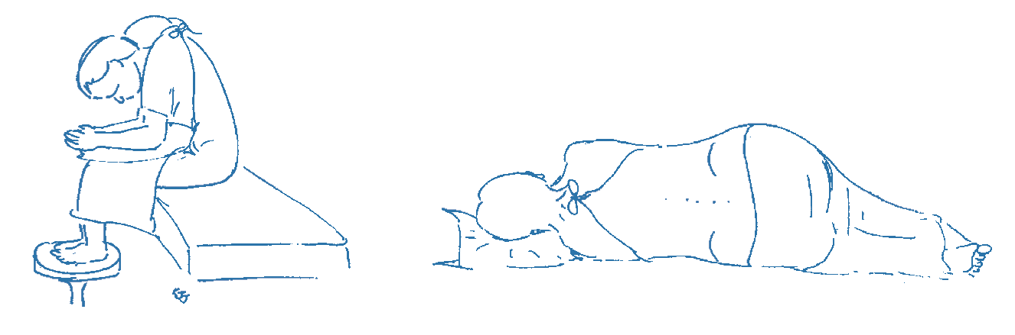

1. Your back will first be cleaned with cold alcohol based liquid.
2. The anaesthetist will then give local anaesthetic in the skin to make you comfortable, followed by the spinal injection. A nurse or health care assistant will support and reassure you during the injection.
3. After the injection is complete, you will be positioned correctly to lie on the bed. The anaesthetist will then perform checks to ensure the spinal is working correctly.

### What will I feel?

A spinal injection is usually no more painful than having a blood test or having a cannula inserted. It may take several minutes to perform.

 The spinal injection works quickly and is usually effective within 5-10 minutes.

 To start with your skin feels warm, swiftly followed by pins and needles, then numb to touch and your legs will feel heavy.

 When the injection is working fully, you will be unable to move your legs or feel any pain below the waist.

### Testing the block

* Your anaesthetist will check the block is working properly usually in 2 ways:

 Cold spray - if the feeling of cold is lost, this is a good indication the spinal will work well for the surgery.

 Trying to move your legs – if you cannot move them, then the spinal is working very well. If you still have some movement, your anaesthetist will decide if this is significant.

Only when the anaesthetist is satisfied the spinal anaesthetic has taken effect will he/she allow the surgery to begin.

**Anaesthetic for your knee surgery**

### During the operation

    You will be positioned lying on your back for your knee surgery.

 Please tell your anaesthetist if there is something simple that will make you more comfortable, such as an extra pillow or armrest.

 You will be given extra oxygen to breathe via a clear plastic mask.

 Your anaesthetist will give you sedation to make you relaxed and sleepy as agreed earlier; alternatively you may choose to be awake.

 You can listen to music if you wish during the operation. Feel free to bring in your own headphones and music.

 The anaesthetist will be present throughout the operation and you can communicate with them throughout.

### You may still need a general anaesthetic if:

 Your anaesthetist cannot perform the spinal to his/her satisfaction.

     The spinal is identified as not working adequately during checks.

 The surgery becomes more complicated or takes longer than expected.

### After your surgery

It can take several hours for sensation (feeling) to return to your legs. As sensation returns, you may experience some tingling in the skin as the spinal wears off. At this point you may become aware of some pain from the operation site and you should ask for more pain relief.

Once your legs have returned to normal, you will be assessed by the nurses / physiotherapists for your suitability to try to get out of bed.

### Side effects and complications

As with all anaesthetic techniques, there is a possibility of unwanted side effects or complications.

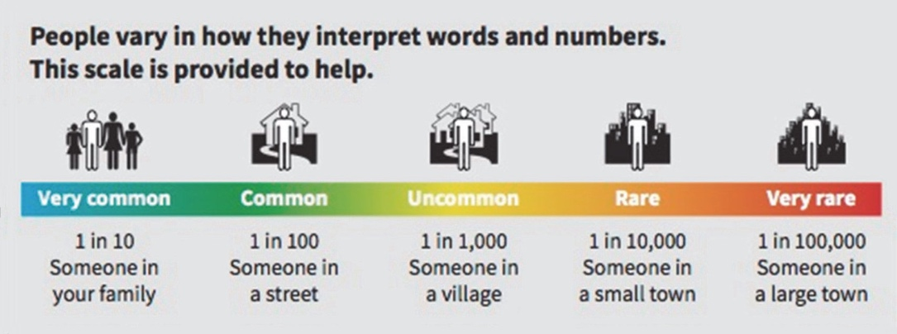

#### Very common and common side effects

These may range from trivial to unpleasant, but can be treated and do not usually last long.

**1. Low blood pressure** – as the spinal takes effect, it can lower your blood pressure. This can make you feel faint or sick. This will be controlled by your anaesthetist by fluids and drugs given through your drip to raise your blood pressure.

**2. Difficulty passing water (urinary retention)** - you may find it difficult to empty your bladder normally for as long as the spinal lasts. This may result in accidental passing of urine that you are unaware of. However, it is unusual (less than 20% of patients) to require a urinary catheter. Your bladder function returns to normal after the spinal wears off. Bowel function is not affected by the spinal.

1. **Pain during the spinal injection** – if you feel pain in places other than where the needle is, you should immediately tell your anaesthetist. This might be in your legs or bottom, and

might be due to the needle touching a nerve. The needle will be repositioned.

1. **Headache** – there are many causes of headache after an operation, including the anaesthetic, being dehydrated, not eating and feeling anxious. Most headaches get better within a few hours and can be treated with pain relieving medicines.

A severe and important headache can occur after a spinal injection. This is uncommon in older people after a spinal; in young women having a spinal for childbirth it occurs in around 1 in 200 to 300 spinals.

If this happens to you, let your ward nurses know and they will organize for you to see an anaesthetist for assessment.

### Rare complications

#### Nerve damage

This is a rare complication of spinal anaesthesia.

 **Temporary** loss of sensation, pins and needles and sometimes muscle weakness may last for a few days or even weeks but almost all of these make a full recovery in time.

 **Permanent** nerve damage is rare (approximately 1 in 50,000 spinals). It has about the same chance of occurring as major complications of having a general anaesthetic.

### Where can I learn more about having a spinal?

The website [www.rcoa.ac.uk/patientinfo](http://www.rcoa.ac.uk/patientinfo) has more information.

#### Consent

On the day of your surgery your consultant or their registrar will explain the risks, the benefits and alternatives to having your operation and you will be asked to sign a consent form. This information will have previously been discussed with you in the outpatients clinic when you first saw the surgeon and some of the risks and benefits will also have been discussed at Joint School

Make sure you understand what you are consenting to why it is necessary for you to sign.

You can always refuse treatment, even if you have signed the consent form and then change your mind. You can withdraw your consent at any time. This does not effect your right to alternative forms of treatment if available.

**What is a total knee replacement?**

A total knee replacement involves removing the damaged surfaces of the knee joint and replacing them with an artificial joint. This joint is usually made of metal and plastic.

Your surgeon will make a cut over the front of your knee and remove the damaged bone in the joint. Most artificial knee joints will be fixed in place with cement.

At the end of the operation, your surgeon will close the skin with clips or dissolvable stitches and occasionally glue.

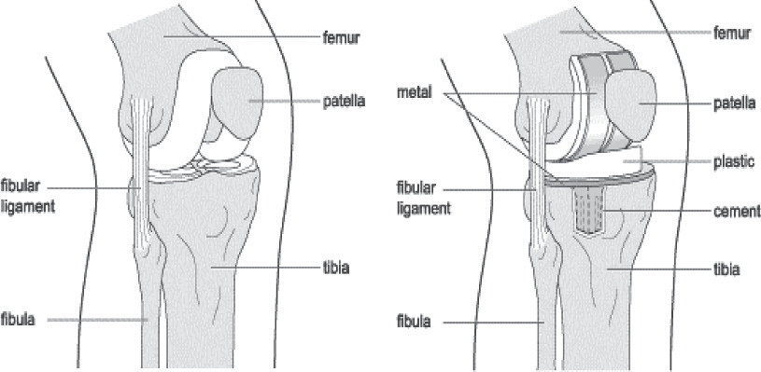

Usually the operation lasts about an hour to an hour and a half, then you will be taken to the recovery room which is close to the operating

theatre. You will have a dedicated nurse / practitioner and you will not be left alone.

If you have pain or sickness this will dealt with promptly. You may need to breathe oxygen through a mask or up your nose, and you may have a drip in your arm. You may also have calf pumps on your lower legs. You will have a blue ice pack applied to your knee - this

is called a Cryocuff. The recovery staff will check your blood pressure, heart rate, pain levels and oxygen levels regularly.

Once the recovery staff are satisfied that you have recovered safely from your anaesthetic you will be taken back to the ward.

**Your recovery following surgery**

**Pain after knee surgery**

Numbness from the spinal anaesthetic wears off gradually over the first few hours after the operation. You will have had some local anaesthetic injected around the new knee joint and this will keep

your knee numb for a little longer. Your ice pack will be refilled regularly to provide pain relief and reduce swelling.

While your leg is numb you may find it difficult to move your leg and foot but this movement will gradually return as the numbness wears

off which may take up to 6 hours. It is expected that you will experience some pain following your knee surgery but you will be given pain relief to control the pain. Please alert your nurse if you are in pain. It is important to act early as pain is harder to treat if it is allowed to become severe, and good pain control is important for your

recovery.

### Orthopaedic Doctors

Your allocated Consultant will be responsible for your post-operative recovery.

### Nurses

The team of nurses will be there throughout your stay to guide you towards a safe discharge.

### Pharmacists

The team of ward pharmacists and technicians will be on the ward to check which medicines you are on. It would be helpful if you could bring your regular medications into hospital as this will save time when we prepare your medicines for discharge.

### Orthopaedic Physiotherapists

A Physiotherapist will assess you after your operation. They will advise and teach you movement and strengthening exercises to aid recovery of your new knee joint. They will also help supervise and progress your walking again.

The Therapist will assess your ability to manage at home and, where necessary, give advice regarding equipment. They will support and advise you on how to adapt ways of completing tasks to enable you to manage as independently as possible.

# Your stay on the ward

#### Operation day

Physiotherapist / Nursing staff get you up day 0/1 after your operation with the aid of a zimmer frame.

You will be assisted to dress in your own clothes.

Physiotherapist will teach you exercises.

The Physiotherapist will assess and progress your exercises and increase your walking distance.

You are aiming for a 90° knee bend and lift your leg off the bed as soon as possible.

**Your recovery following surgery**

The Therapy Team member will meet with you to discuss your home situation and may ask you to fill in a questionnaire.

The Therapist will review how you are planning to manage your personal care activities, but will also practice your bed, chair and toilet transfers with you and identify any other assessments tailored to meet your individual needs.

The Physiotherapist will teach you how to use elbow crutches or walking sticks. They will continue to review your exercises and courage you to maintain your knee bend and thigh muscle strength.

Physiotherapist to practice steps and stairs depending on home situation.

Discussion about ongoing physiotherapy and goals.

Discharge Day (see page 33)

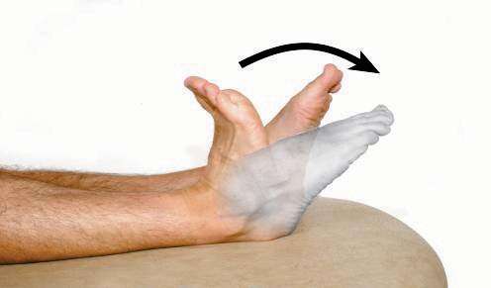Lying on your back or sitting, bend and straighten your ankles briskly. If you keep your knees straight during the exercise you will stretch your calf muscles.

Repeat 10 times.

Lying on your back, squeeze your buttocks firmly together. Hold for approximately five seconds.

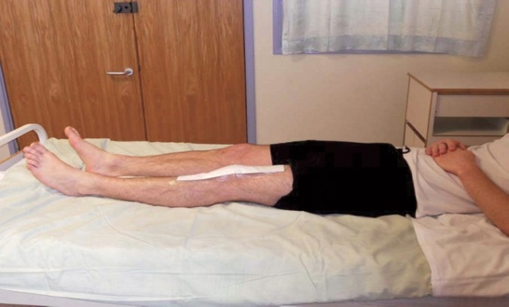

Relax. Repeat 10 times.

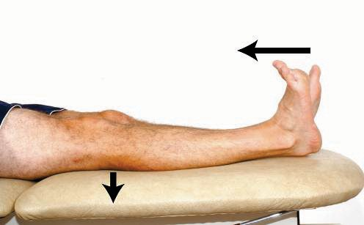Lie on your back with your legs straight. Pull your foot towards you and push your knee down firmly against the bed. Hold for 5 seconds.

Relax. Repeat 10 times

Lying on your back or propped up with pillows, with a sliding board under your leg. Bend and straighten your hip and knee by sliding your foot up and down the board. Repeat 10 times.

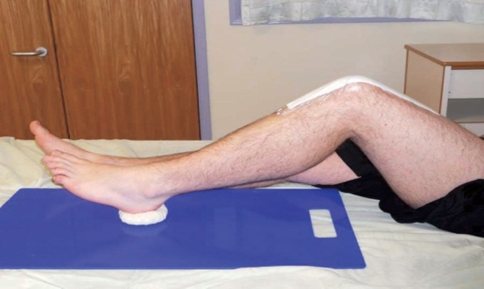

Place a rolled towel under your knee. Exercise your leg by pulling your foot and toes up, tightening your thigh muscle and straightening the knee (keep knee on the towel).

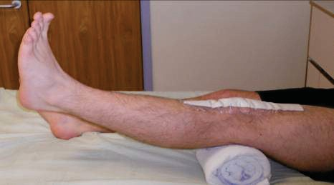

Hold for approximately five seconds

and lower with control. Repeat 10 times.

Lying on your back, exercise your operated leg by pulling the toes up, straightening the knee and lifting the foot off the bed. Hold for approximately five seconds and lower with control.

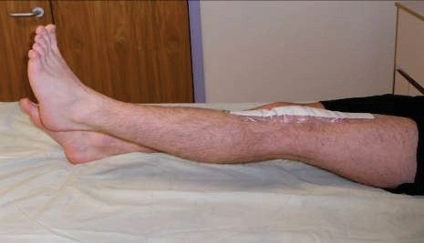

Repeat 10 times.

Sit on a chair with your feet on the floor. Bend your knee back as

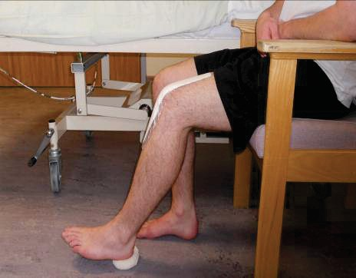

much as possible. Hold for five seconds before fully straightening your leg.

Repeat 10 times.

Sit on a chair. Pull your toes up, tighten your thigh muscle and straighten your knee. Hold for approximately five seconds and lower with control.

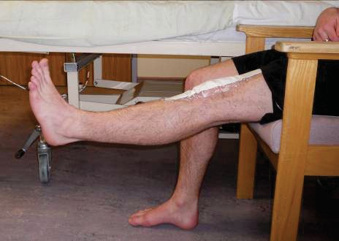

Repeat 10 times.

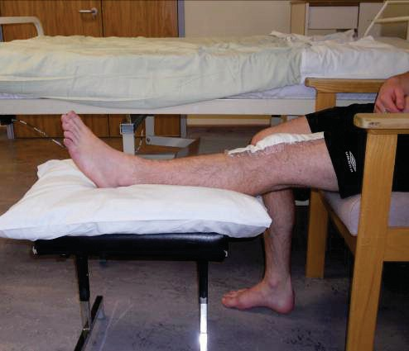When resting in the chair have your leg on a stool with no support behind your knee.

Practice pushing your knee down into the floor and let it relax in this position. When it starts to ache, pull the stool under your knee for support.

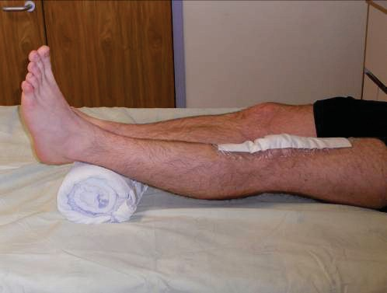When resting on the bed

Have your ankle on a rolled up towel. Practice pushing your knee down into the bed and let it relax in this position.

When it starts to ache, take your leg off the towel.

You should aim to do all of these exercises 3-4 times daily and continue for at least six weeks following surgery to achieve full recovery with your new knee.

During the first few days following surgery it is important to take large deep breaths, expanding your chest, right to the bottom of your lungs and repeat three times hourly. Follow with a strong cough.

**EXERCISE DIARY**

|  |  |  |  |  |
| --- | --- | --- | --- | --- |
| Date | Session 1 | Session 2 | Session 3 | Session 4 |
|  |  |  |  |  |
|  |  |  |  |  |
|  |  |  |  |  |
|  |  |  |  |  |
|  |  |  |  |  |
|  |  |  |  |  |
|  |  |  |  |  |
|  |  |  |  |  |
|  |  |  |  |  |
|  |  |  |  |  |
|  |  |  |  |  |
|  |  |  |  |  |

**General Physiotherapy & Occupational Therapy advice**

### General Physiotherapy advice for the next 6-8 weeks

**avoid** “Squatting”down as this forces too much bend in your new knee

**avoid** All jerking, vigorous twisting actions and sudden changes in direction

**avoid** Crossing your legs

**avoid** Kneeling on your new knee

**do not** attempt to carry anything too heavy (over30lbs).   
If advised to do so use a trolly and limit yourself carrying items upstairs.

**Swelling** Your knee may swell, particularly after long periods on your feet. If this occurs, support the full length of your leg on a stool, bed or sofa when you are sitting. Do the ankle exercises as shown to increase the circulation.

Use ice packs (place a bag of frozen peas in a damp towel) or Cryocuff from the fridge regulary at home, place around the knee joint for 15-20 minutes, to help reduce swelling around the knee.

Ensure the ice does not cause a burn by checking the skin regularly. Repeat this process as required.

**Progress** your walking as advised by the physiotherapist.

28

### Advice for daily activities for the next 6-8 weeks

#### Bed

This should be firm and at the correct height for ease of getting in and out. Getting into bed with the operated leg first may be easier for you. Ask your therapist to work out the best side for you.

#### Sitting

Avoid low chairs / furniture. Ideally chairs should be easy for you to get out of. They should be firm, support your thighs and have arms to help you rise.

#### Toileting

If you are having difficulty getting on and off the toilet, your Occupational Therapist will assess you and make recommendations about ways to help you with this.

#### Dressing

* Dress sitting on a firm chair or bed.
* Dress your operated leg first and undress it last.
* Wear good, supportive shoes with low heels.

If you are having difficulty getting dressed, discuss this with the Occupational Therapist on the ward.

#### Bathing and showering

Use a walk-in shower if possible (your dressing is splash proof), as it is not advisable to sit down in the bottom of a bath for the first 6 weeks. An alternative is using an over-bath shower and sitting on a 'bath board', this can be assessed during your inpatient stay.

29

Your Therapist can advise you and provide equipment to assist you if necessary. After 6 weeks and once your confidence and ability have improved, practice getting in and out of a dry bath first, use a nonslip mat and step into a bath with your un-operated leg first.

#### Walking

You will be shown how to walk with a walking aid by the Physiotherapist. We will advise you on how to walk as normally as possible and how to progress with your walking when at home.

#### Walking sequence

Walking aid moves forward first. Then step your **operated leg.**

Finally step your **non-operated leg.**

#### Reminders for walking

Try not to limp.

Aim to set your heel down first and straighten your operated leg before stepping with the other leg.

30

### Stairs / Step Going up:

* First take a step up with your **non-operated** leg.
* Then take a step with your **operated leg**.
* Then bring your crutches / walking stick up on the step.
* Always go up one step at a time.

### Going down:

* First put your crutches / walking sticks one step down.
* Then take a step down with your **operated leg**.
* Then take a step down with your **non-operated leg**.
* Always go down one step at a time.

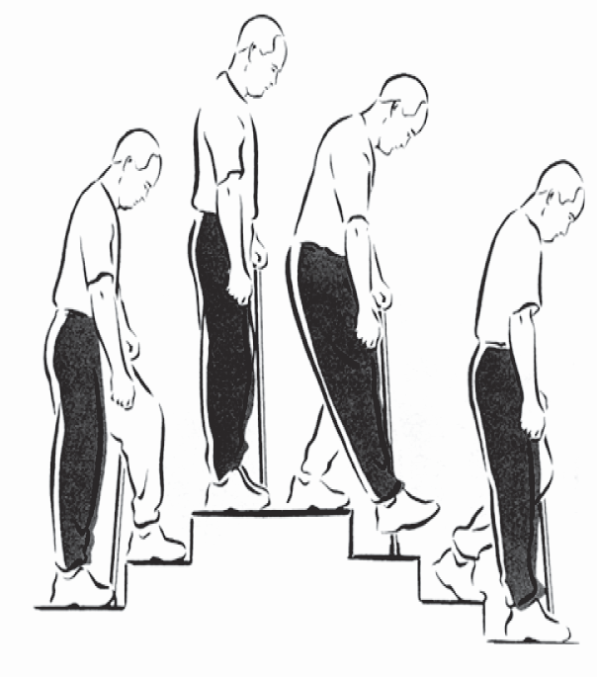

31

#### How long will I stay in Hospital?

The length of time that you stay in hospital varies with each patient. Most patients stay in hospital between two and four days, however you can go home as early as day one if you have achieved all of your goals, so you need to be prepared.

We give you this as a guide so that you can plan to have someone around should you need them on discharge. If you have any concerns with how you will manage when you return home, please inform the nursing staff as soon as possible so that we can discuss this with you.

#### When will I be ready to go home?

You will be able to go home once all members of the Orthopaedic team are happy with your progress and we know that you will manage safely at home. To ensure that you are ready to go home we need to check the following:

* + You must be able to walk safely around the ward with either crutches or walking sticks by yourself. (Although some patients may go home with other types of walking aid).
  + You must have managed a set of stairs or a step safely (depending on what you have at home).
  + You need to be able to get on and off a bed, toilet and chair by yourself (unless there is someone who can assist at home).
  + Your essential equipment must have been installed at home.

    



     



                                                          

   



  to be medically fit

* You are able to complete personal care and meal preparation activities independently or with assistance.

### Discharge Day

#### Before you leave the ward you will be given:

* A telephone number which you can use to contact us if you have any questions or problems once you are home.

Any equipment loaned to you for home such as walking aids or toilet frames.

A copy of your GP letter informing them about your hospital

**Occupational Therapy - Maximising independence at home**

Once you get home you should stay active. The key is not to over do it! While you can expect some good days and some not so good days, you should notice gradual improvement over time.

### Domestic tasks

#### Cooking

* Try to plan ahead before your operation by moving essential items to waist height, re-arrange cupboards, fridge and freezer so that you can easily reach required items.
* A high stool may be beneficial so that you can sit and still reach work surfaces.

#### Shopping

* Prior to admission consider stocking up on frozen meals and essential items to ease the transition to home. Once home from hospital you may wish to consider online shopping. Supermarket shopping may be more tiring and therefore assistance may be beneficial.

#### Energy Conservation

* If you need to do all tasks yourselves, plan to do a small amount each day and avoid any non-essential tasks.
* You may need some additional help from others with some household tasks for several weeks after your surgery. It is advisable to discuss this and plan with friends and family prior to coming into hospital.
* Your Occupational Therapist may be able to refer you to community agencies who could assist/support you for up to 6-8 weeks post-op. See page 43 for further information.

35

### Travel

#### Transport - as a car passenger

Allow yourself plenty of room so that you are not sitting in a cramped position. Sit in the front passenger seat as this is the seat which can be best adjusted to your needs i.e. reclined and moved back.

For any other long distance travel (car, train, coach) make sure you are able to walk around regularly. Take care when travelling by bus or getting into a car with a high step.

#### Driving

* It is advisable that you do not drive for 6 weeks following surgery. Please inform your insurance company of your surgery as it is a major operation and they will advise you of any further requirements they need you to take to ensure you can ensure you can return to driving fully insured.
* You are safe to drive when you are able to fulfil all the requirements of driving safely such as performing an emergency stop.
* If you drive an automatic car and have had your left knee replaced, you may be able to drive between 4 and 6 weeks after the operation, if you feel confident. Please check with your Doctor first.

#### Flying

* Flying is not recommended for at least three months after your operation due to the risk of developing a blood clot. Some consultants may vary this advice. Please contact your consultant via their secretary if you need to fly before the timescales advised. Notify the airline of your replacement joint and carry a letter from your Doctor for when you go through the X-ray searches.

### Leisure

#### Sports and hobbies

* Please discuss any sports and hobbies with your Therapy team that you may wish to return to. As long as you have satisfactory movement in your knee joint and the activity is pain free, there is no limitation in activities you choose to do.

#### Gardening

* Avoid gardening for 6-8 weeks, consider using long handled equipment when returning as you should avoid kneeling positions.

#### Sex

* Your usual pattern of sexual activity may be resumed when the wound is soundly healed and clips removed, unless your Doctor advises otherwise. Avoid kneeling positions and let your partner take the active role.

**Work**

* You should be able to return to work between 6-12 weeks after your surgery. Discuss your work with your Doctor, Occupational Therapist or Physiotherapist as it will depend on the nature of your work. If you have a manual job it may be longer.

**Frequently Asked Questions**

### What are the visiting hours on the ward?

Visiting times are available from the staff on admission. There may be times when we need to interrupt visiting to provide aspects of

your care. Visitors are asked to sit on chairs provided rather than hospital equipment, and keep to two visitors per bed.

**Can my visitors come on the day of the operation?** Yes, but we ask that your visitors must telephone the ward prior to visiting you on the day of your surgery.

**Can my friend / relative phone to check on how I am?** Yes, of course. We understand that your friends and family are keen to check on your progress. However, we would be grateful if one member of your family or one friend could take responsibility for keeping other relatives informed of your progress. This allows the nursing staff to use their time to focus on caring for you.

### Is it safe to bring valuables into hospital with me?

We do not recommend you bring valuables into hospital with you. Anything you do bring into hospital is done so at your own risk.

### Newspapers

Newspapers are available daily.

### Am I allowed flowers?

We regret that we cannot allow flowers on the ward. This is because they can be a source of infection which in turn could get into your or other patients wounds. Please inform your visitors of this.

38

### Will I be able to go swimming after my operation?

Yes, swimming is a good activity to strengthen your body. However we advise that your wound needs to be fully healed before you go into the pool. You need to be confident with your walking so that you can safely manage to walk safely on a wet pool side. We recommend that you use a pool which has a staircase leading into the water, not to use a ladder to enter and exit the pool and avoid a breaststroke kick.

### How far can I walk?

As far as you feel able to and your pain allows. Build up slowly using your walking aid to start with.

### When can I progress off of my elbow crutches /

**walking sticks?**

You need to progress as your pain allows you to and it will be different for everyone. You should start by progressing to one elbow crutch / walking stick (use on the opposite side to your operated leg) around your home. Then you can aim to walk longer distances outdoors with just one elbow crutch. You can completely progress off of elbow crutches when you can manage to walk without a limp.

If you have been advised by your Physiotherapist that you are partial weight-bearing you must continue to use elbow crutches for at least 6 weeks.

**Will I be getting any follow-up Physiotherapy?**

Your Physiotherapist will organise any ongoing physiotherapy if they feel it is needed.

**How long should I continue doing my exercises for?** Aim for 10 repetitions of each exercise, 3-4 times daily for at least six weeks following surgery or for as long as you feel you are benefiting from continuing with the exercises.39

### When will I be followed Up?

The ward nursesor a member of the ward team will organize a wound check appointment at approximately 2 weeks. The surgeon who performed your operation will see you in outpatients 6-8 weeks after your operation. Sometimes the surgeon will want to see you sooner than this, but we will let you know on the day you

are discharged from hospital.

### What can be done to minimise the risk of a blood clot forming (Deep Vein Thrombosis)?

The Doctor will prescribe either aspirin or dalteparin or both according to protocol, to prevent blood clots forming. Dalteparin is given as an injection once a day after your operation. You will be shown how to inject yourself or a relative could do this for you.

You will wear TED stockings while in hospital.

### My leg is swollen what should I do?

The swelling may last for several months and is often worse a few weeks after the operation. This is because we rely on the pumping action of our calf muscle as we walk to return blood to the heart. If we are less mobile, or put less weight through the leg, the calf pump is less effective and fluid builds up to around the ankle and the lower leg. When sitting, the ankle pump exercises help to move fluid about. Make sure that you rest for at least 30 minutes everyday and elevate your feet to hip height either on a bed or

in a chair with a foot stool. Use your Cryocuff at home by cooling it in the fridge. The Cryocuff is only for use at rest, you must not walk while wearing it.

**How to care for your wound**

### How to care for your wound

**How to care for your wound**

Your dressing is splash proof so you CAN take a shower it is NOT waterproof do not submerge into a bath.

The dressing stays on for 12-14 days after your surgery. On your discharge please make an appointment with your practice nurse for removal of the

dressing / sutures / clips

### These pictures show how the dressing works.

Picture 1 Picture 2 Picture 3

Normal dressings does NOT need changing (1 & 2) This dressing DOES NEED changing (3)

Your wound will leak into your dressing as in picture 2, and then will dry up. This is normal and does not need changing.

If the dressing lifts at the edge, develops ooze from the edge of the dressing as in picture 3. This needs to be changed.

An infection at the site of your wound is unusual but may present with discharge from the wound, redness, swelling and heat, increased pain or an offensive smell.

#### Do not change the dressing yourself.

If you are concerned about your wound it is essential you contact us

Copyright © Western Sussex Hospitals NHS Foundation Trust 2015 All rights reserved

44

Department:

3/2019