C ^{L}A⁻⁻h_{ift}, Department of
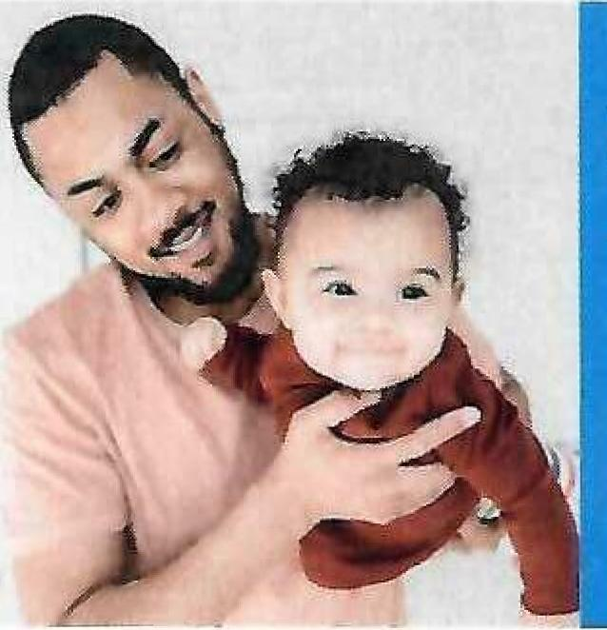
Children & Youth
Who can get child care
payment assistance?

Know the Facts
The Ohio Department of Children and Youth offers financial assistance to eligible parents and guardians to help them with child care costs while they engage in work, education, or job training. Families can be eligible to have all or part of their monthly child care expenses paid on their behalf.

Are you a parent or guardian who is:
- Employed
TO APPLY:
- Find a Provider
Search and find a licensed provider at
childcaresearch.ohio.gov
- Have Your Verifications Ready
- Household information
- Income (pay stub) information
- Employer/school
information: Teach & Learn Childcare
2686 S. Hamilton Rd. 43232
- Birth verification(s) for children) needing care
3.) Apply
- Online at ssp.benefits.ohio.gov
- In person at your local
county JFS office
- Complete an electronic form and submit it to your county JFS office
- In school
- In Job Training
- Receiving Ohio Works First cash assistance
- Homeless
- Required by a children's services case plan to have protective childcare for children living in the home
AND
- Your income is at or below 145% of the federal poverty level
OR
- Your family needs care for a child with a county-agency-verified special need, and your income is below 150% of the federal poverty level
You may qualify for childcare payment assistance. Applying is easy as 1,2,3.

Questions and Answers
What is the Ohio Benefits Self-Service Portal (OBSSP)?
It is an online site you may use to apply for public benefit assistance, get information about your existing benefits, manage your benefits, and renew your benefits.
Can I submit my needed verifications through OBSSP once my application is submitted? Yes, you can upload and update your case information using your OBSSP account.
Can I report provider changes through OBSSP?
Yes, you may report provider changes by using the "report a change to my case" tab in your OBSSP account.
What is an authorized representative?
An adult other than yourself, who has your permission to submit case information on your behalf. You must submit a written statement to the county department of job and family services (CDJFS) agency informing them of your authorized representative.
Who can be my authorized representative?
You may choose an adult, at least 18 years of age. This individual will have access to your
information and the ability to report changes to your case which may affect other benefits you may be receiving such as Cash, SNAP (food), and medical eligibility. It is not recommended to name your childcare provider as your authorized representative.
How long will it take to process my application?
Your local county agency has up to 30 days from receipt of a valid application to determine eligibility.
What is the difference between a valid and a complete application?
Important: You are responsible for your benefits, including reporting all changes to your local CDJFS. Changes must be reported within 10 days, changes to your child care provider must be reported prior to starting or within the same week.

Valid Application
Must have the following:
- Name
- Address
- Applicant's Signature
A valid application:
- Allows up to 30 days for all verifications
needed (see complete application)
- Eligibility will go back to the valid application date if you are found eligible
Complete Application
Is a valid application with the following submitted to the CDJFS:
- Verification of citizenship for children needing care
- Verification of income for all household members
- Verification of qualifying activity for all caretakers
- Name and address of eligible see below complete application allows the CDJFS to determine your eligibility for Publicly Funded Child Care. See Below.
Eligible Provider: Teach & Learn Childcare Cols. OH. 43232. 614-863-0017
Ohio Department of Children and Youth
DCY 01309 (Rev. 11/2025)
This institution is an equal opportunity provider and employer

