175th Anniversary

AuSable Grove Presbyterian Church

1848-2023

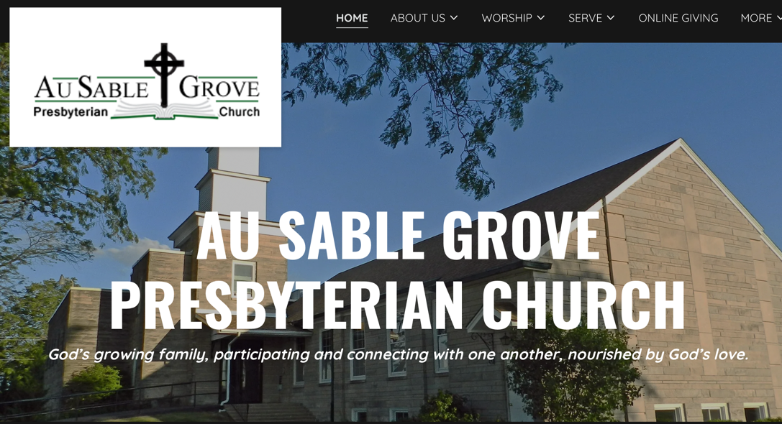

175th Anniversary Program

November 12, 2023

Welcome from the Anniversary Committee

Invocation- Rev. Jenny Hubbard

Meal

1954-1959 Church Construction and Dedication Pictures

Honored Guests and Greetings

Dedication of the Anniversary Trees (artist Diana Hester)

New Member Sharing- Laura Main

Benediction

Blest Be the Tie that Binds

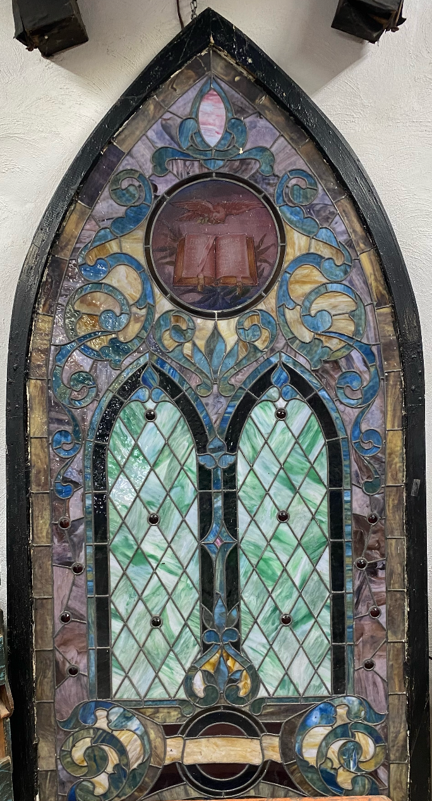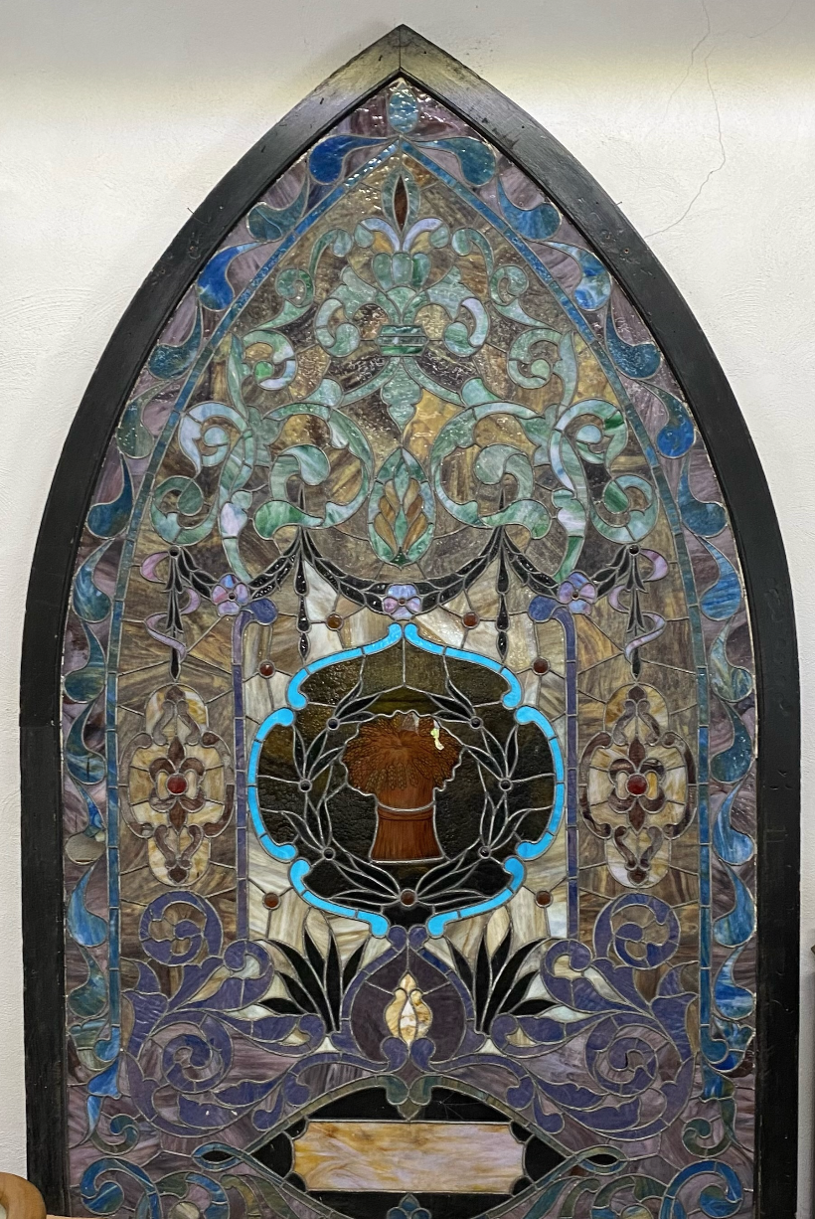

Stained glass windows from the old white church (1866-1956) now on display at the Stone Mill Museum in Sandwich, Illinois.
Land Acknowledgement

While we prepare to celebrate the 175 years that this church has been on this land, we humbly remember this land was cherished, as long ago as 10,000 years before the birth of Christ Jesus, by Indigenous People.
These people are gone because, with the power of the Indian Removal Act of 1830, Native Americans were forced to move west losing the Mo-Ah-Way and Waish-Kee-Shaw Reservations parts of which have become known as the Waa Kee Sha Park just north of us on Reservation Road.

Sadly, the only local sign of these native people is in their influence on the names we take for granted: “Na-Au-Say” Township after “Chief Na-On-Say” and “Nay-On-Say’s Village” just north of us, and “Illinois” the French version of the tribal name “Illini.” Native Americans may also be indirectly reflected in the name, “AuSable” surmising they told the first French explorers about the “Sandy Creek” which in French is called “AuSable Creek.” The “AuSable Grove,” shown on maps as a large area of trees, included the Mo-Ah-Way and Waish-Kee-Shaw Reservations.
We are thankful for those who cared for this land before us and acknowledge and respect their history.

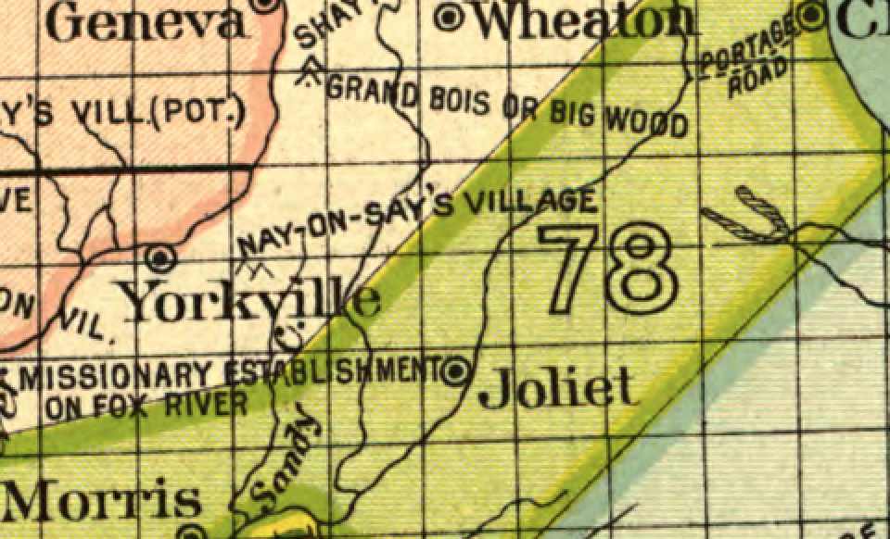

See the Sandy Creek, known today as AuSable Creek, and see Nay-On-Say’s Village located in the AuSable Grove of trees.

History

In 1846, Dr. Townsend Seely invited his neighbors to his 16’x20’ log cabin near the current location of Rich and Shirley Schobert’s home. The small group of neighbors grew. In 1848, they moved to the Union School (24’x34’) when the church of the AuSable Grove was organized.

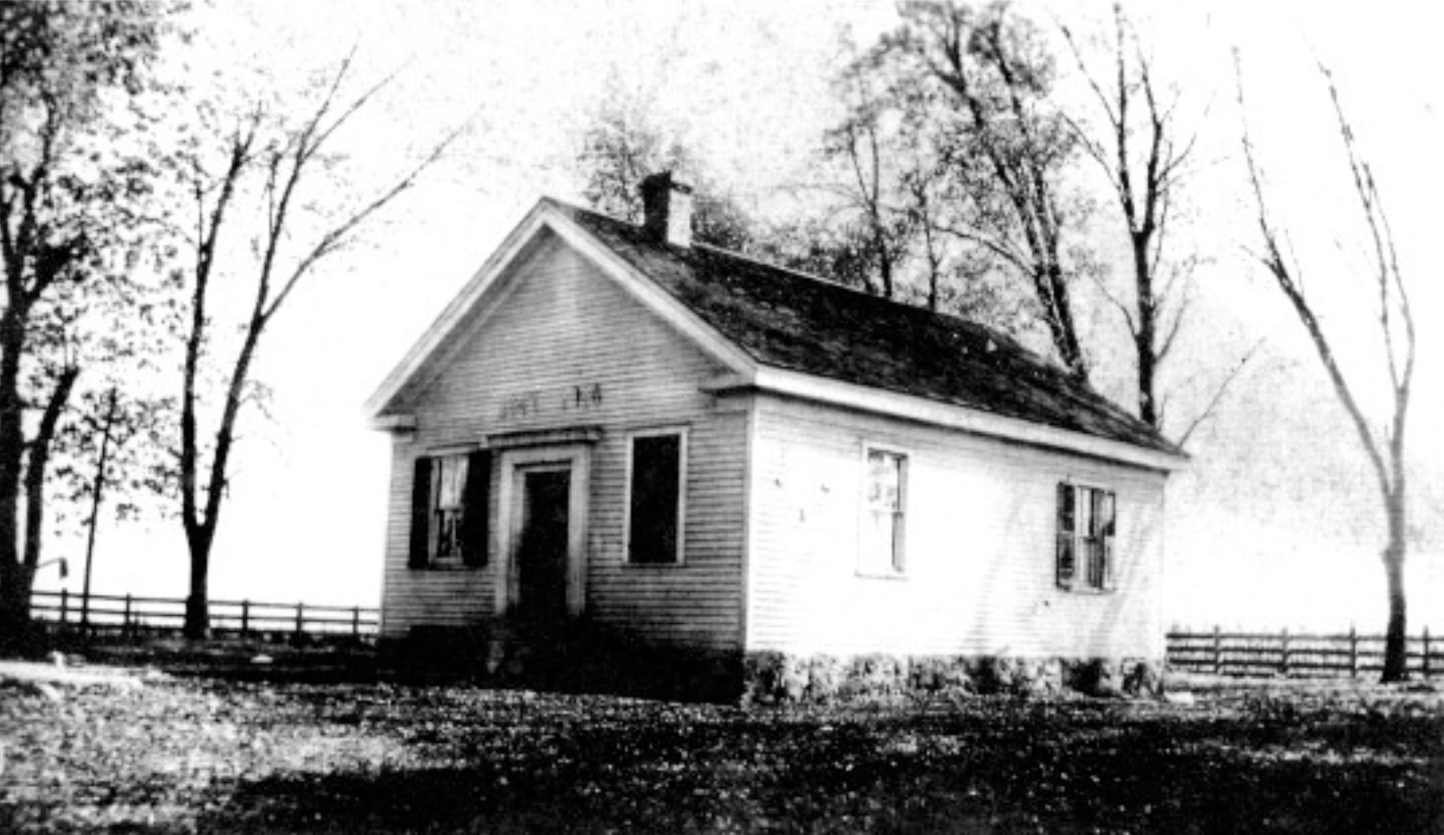

The first parsonage was built in 1857 on the same site as the current manse on property donated by Dr. Seely. They made use of donated nails, planks, and walnut logs in the construction of the two-story parsonage that cost an estimated $700 to $800.

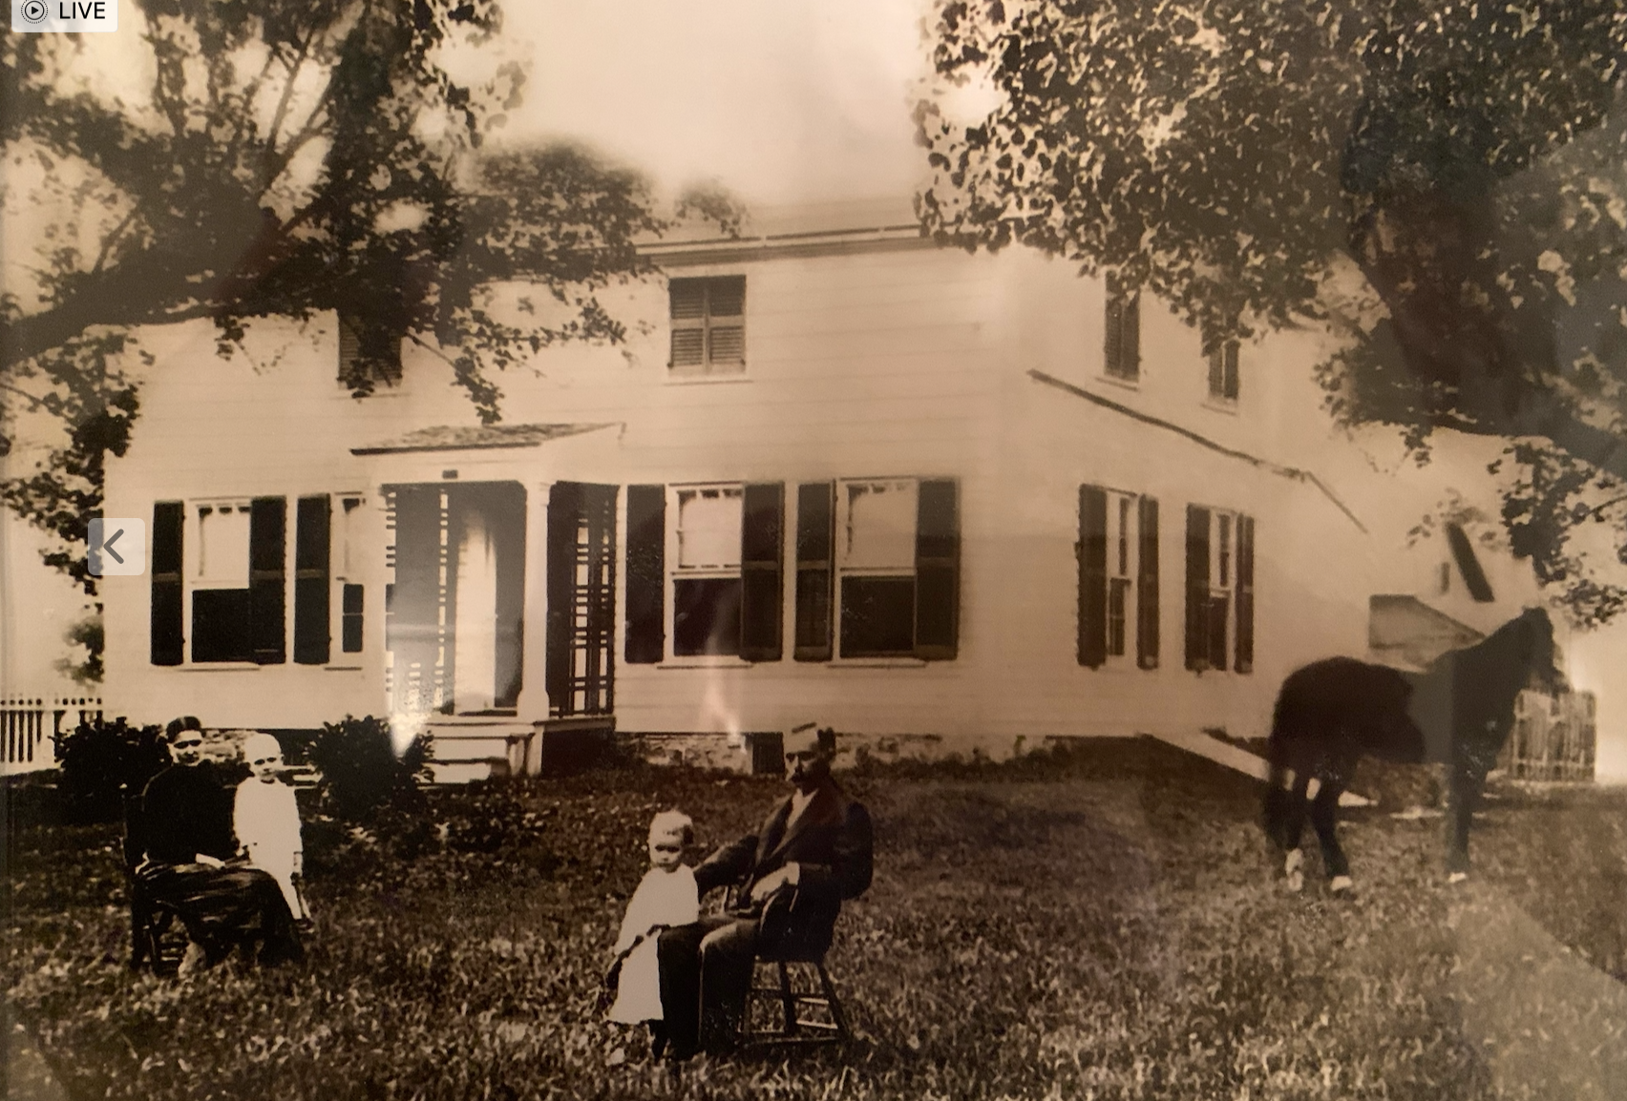

In 1863, plans began for building a church. In 1866 a contract was signed to build a church for $3,300 which was dedicated October 4, 1866. 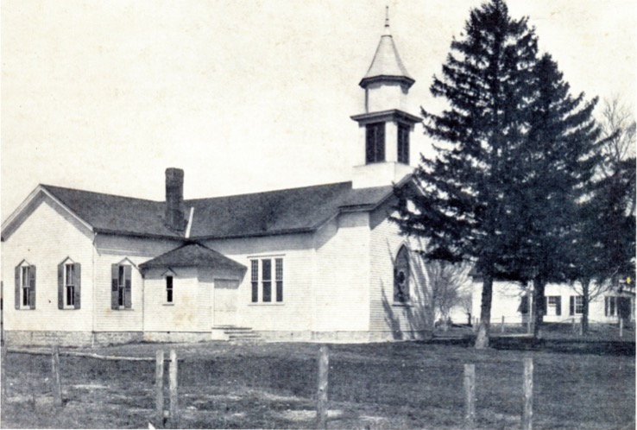

A chapel was added in 1891 for a Sunday School Department. In the early 1900’s the entrance was changed from the south to the west; the pulpit and choir were moved to an addition (Chancel) on the east side; a furnace was installed and sheds were built for the horses. The steeple was removed for safety in 1931.

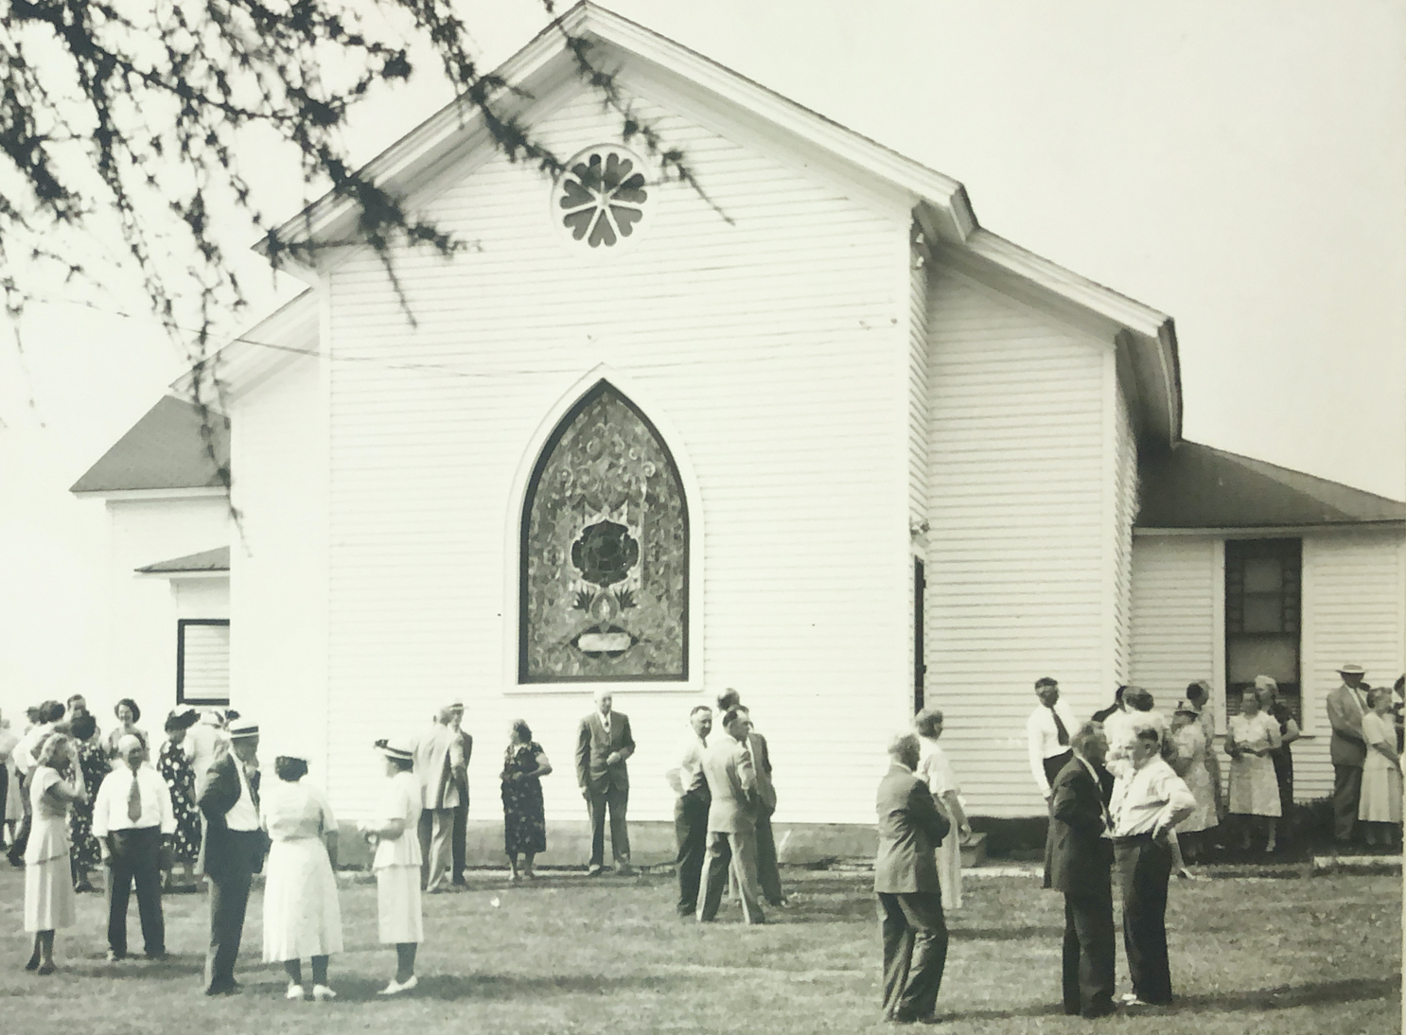

In 1916, the current manse was built at a cost of $3,592. The old manse was moved to create an addition to the old church for additional Sunday School rooms. In the early 1920’s electric lights were installed in the manse and the church.

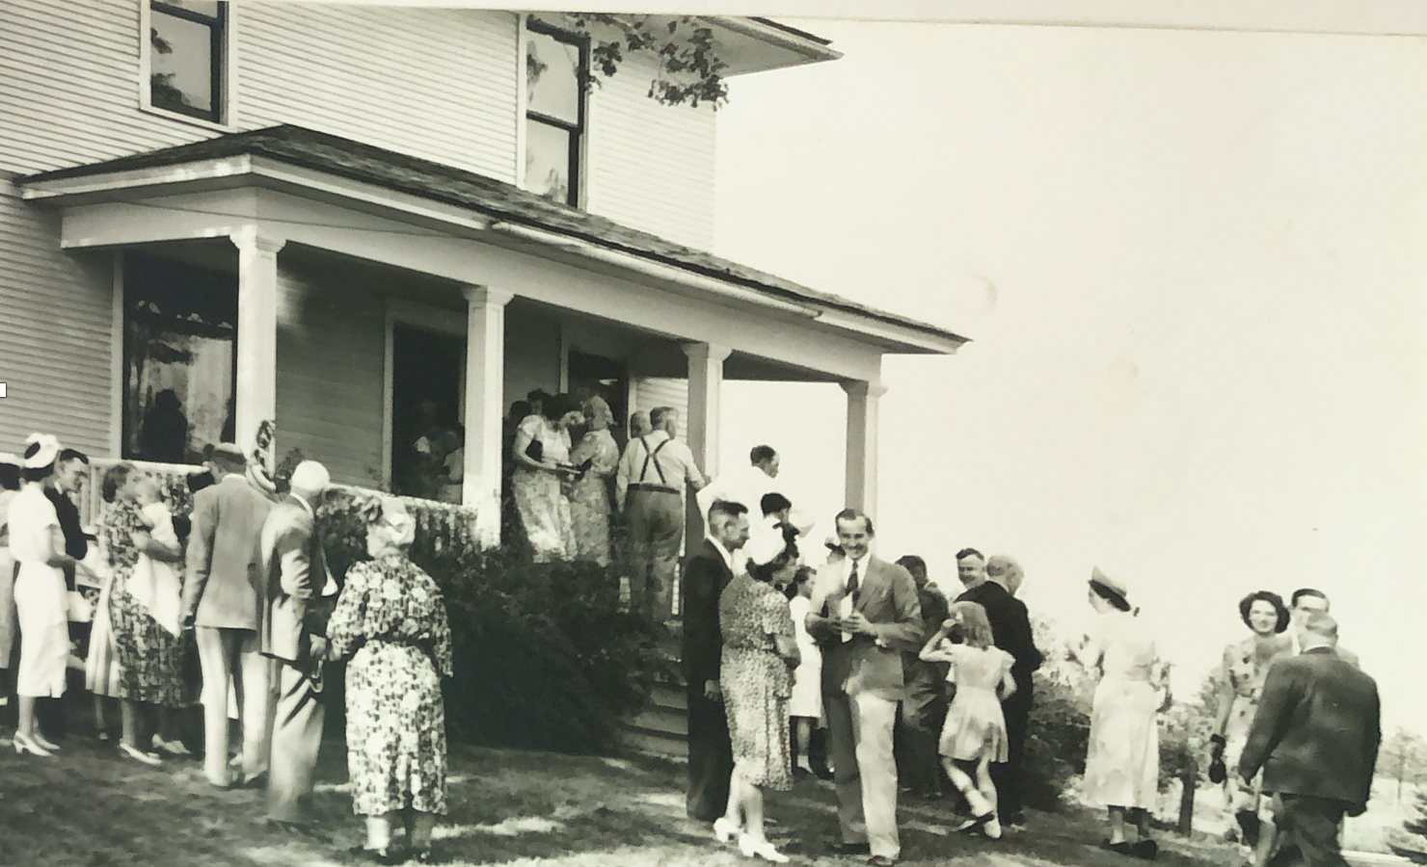

Even with the church additions and new seating arrangement, we can see a new larger church was needed. From records in 1926, the first pledge of $25 for the new church was given by the young folks of the Christian Endeavor Society. The Great Depression, however, deferred the building.

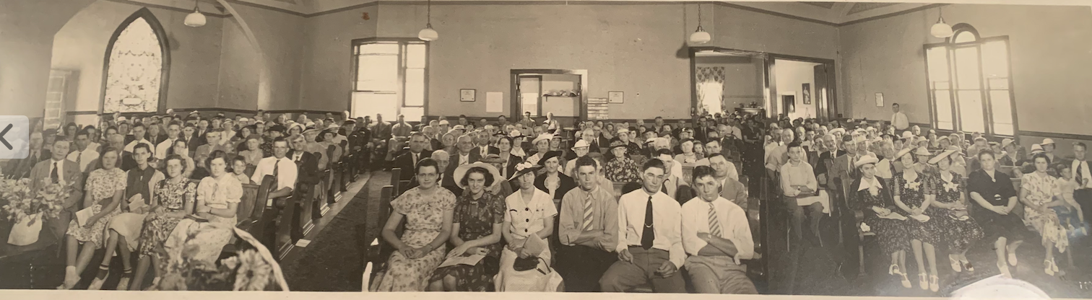

The 1951 building campaign slogan was “Tomorrow Is Our Job Now!” Citing the fact that the old white church did not have a place for the common Christian meal and that the church needed to either be the center of our community or it would disappear, the campaign began.

The plan was to save two-thirds of the cost of the “Christian Education Unit” before beginning construction. They had already saved $20,000 so needed to raise another $50,000. They did so by the ground breaking in September 1954.

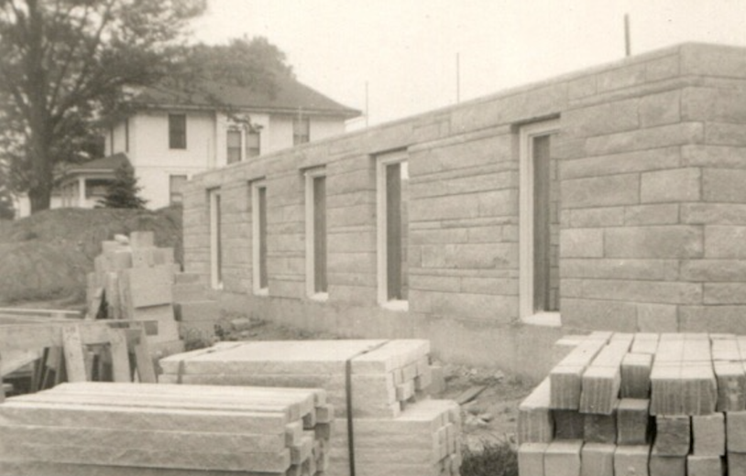
Old church
New church

The dedication of the “Christian Education Unit” of the church was held on May 13, 1956. The total cost of this portion of the building was $69,000 plus a tremendous donation of labor. The Fellowship Hall served as the church sanctuary from April 8, 1956-1959.

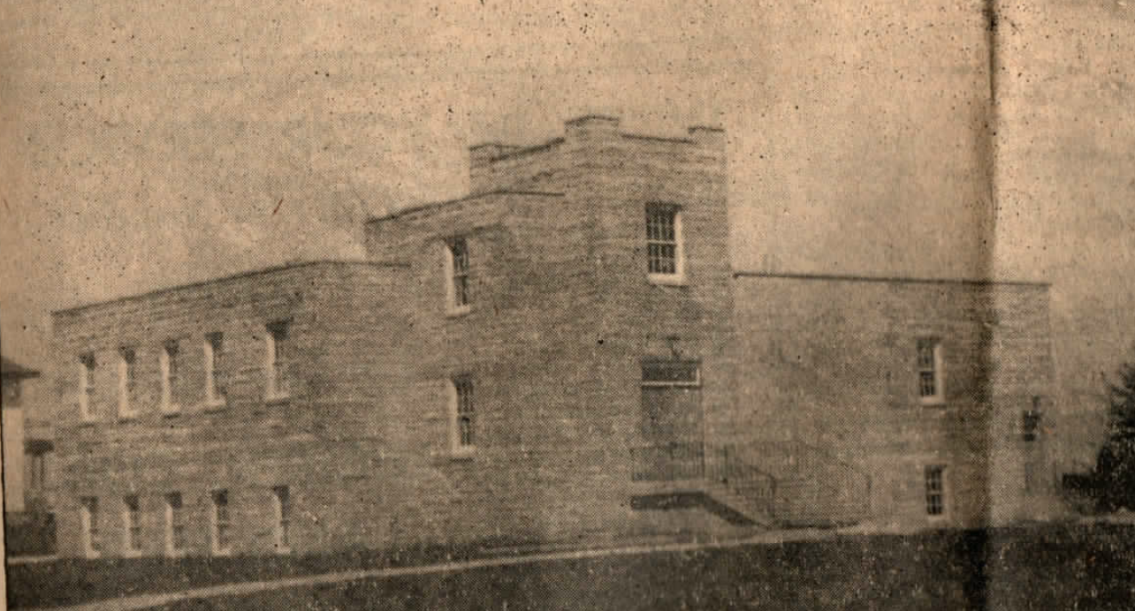

The design of the later-added sanctuary was “one of simple dignity and beauty… very attractive amid its natural surroundings … moderate in size, without excessive ornamentation, reverent in atmosphere…”

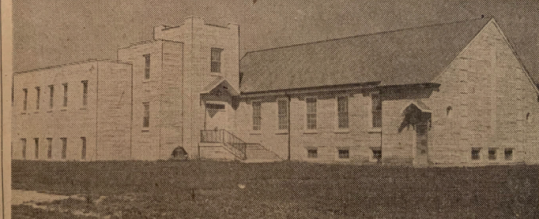

September 20, 1959 the new sanctuary was dedicated. The financial report follows:
Christian Education Unit……………...$ 68,750
Sanctuary and Classrooms…………..$ 56,250
Total Construction and Furnishings……………..$125,000

The steeple came later…

It was said in 1998 and it can be said today, “Just as important as the building and maintenance of the physical structure, the church has a long history of doing God’s work and building a community of faithful people”…our history continues today…

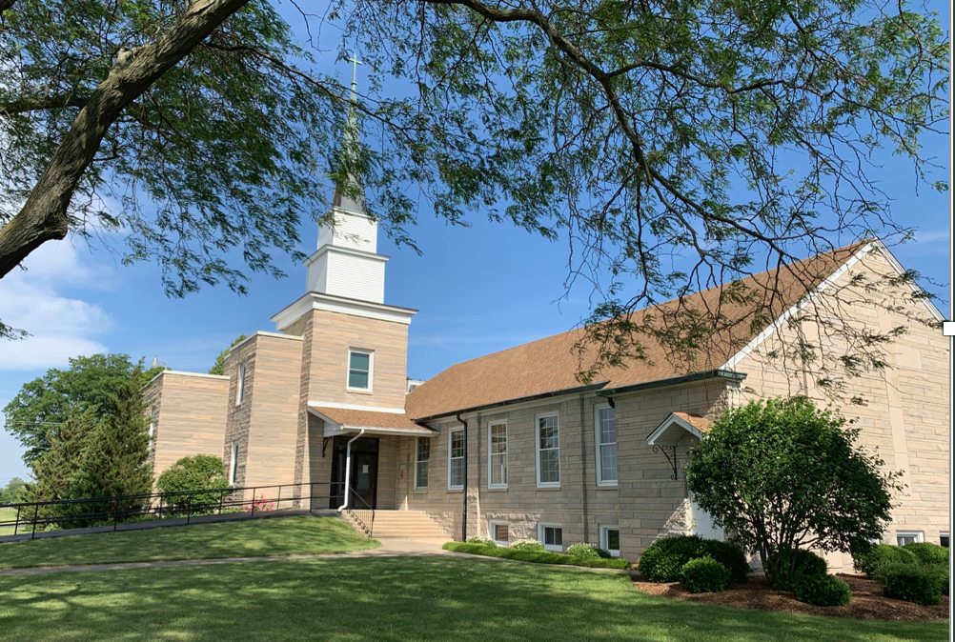

Thank you to all who joined in the celebration of this 175th anniversary of AuSable Grove. The gift of the church is one of God’s greatest gifts! While the church building shelters us, the church is defined by us. We form its history and we realize its future. May the memories of the saints who have gone before us provide a foundation for our future. May we be inspired to serve as they served and may we continue to be bound together in the unity of Christ as God’s eternal family. And, may the Holy Spirit continue to transform us to be the church that God means for us to be.

By the grace of God go we….

Pastors
Rev. Mr. Chapman 1848-1850
Rev. Royal Reed 1853-1856
Rev. John Walker 1856-1859
Rev. James H. Board 1860-1861
Rev. L.N. Loss 1861
Rev. Daniel Bassett 1861-1864
Rev. A. K. Wood 1864-1866
Rev. E. J. Stewart 1866-1870
Rev. A. W. Colver 1871-1873
Rev. Theodore F. Jessup 1873-1887
Rev. Robert Carson 1888-1891
Rev. J. H. Read 1892-1893
Rev. Henry Arlen 1893-1898
Rev. James A. Smith 1898-1900
Rev. M. E. Todd 1900-1903
Rev. D. T. Robertson 1903-1905
Rev. Robert McCain 1906-1908
Rev. George H. Harris 1909-1912
Rev. W. H Liggett 1912-1915
Rev. E. S. Martin 1915-1920
Rev. S. R. Bingaman 1920-1924
Rev. J. C. Nansen 1924-1935
Rev. Wesley L. Kosin 1936-1940
Rev. H. C. Chapin 1941-1947
Rev. Ed Essler 1948-1954
Student/Rev. Don Roper 1954-1961
Rev. Albert Ossentijick 1961-1966
Rev. A. McLaughlin of Scotland Summer 1966
Student Pastor Eddie Wells 1966-1968
Rev. Dr. John DiGiacomo 1968-1976
Rev. Gerald Johnson 1976-1977
Rev. David Fredrick 1977-1982
Rev. Ed Houck Interim 1982
Rev. Gerald Johnson Interim 1982-1983
Rev. Martha Ross-Mockaitis 1984-1987
Rev. Gary Peluso Interim 1987
Rev. Gerald Johnson Interim 1988
Rev. Kathy Keener-Han 1989-1994
Student Pastor Roland Slater 1995-1997
Rev. Dr. Paul Salansky Interim 1997-1999
Rev. Daniel Bloesch 2000-2003
Pastor Patrick Demerath Commissioned 2004-2014
Rev. Betty Weidert Stated Supply 2014-2016
Rev. Jennifer Olson 2016-2017
Rev. Betty Weidert Stated Supply 2017-2018
Pastor Laurie Walker Commissioned 2017-2018
Rev. Aline Russell Interim 2018-2019
Pastor Laurie Walker Commissioned 2019-2020
Rev. Jenny Hubbard 2020-Present

Current Pastor

Rev. Jenny Hubbard

Pianist

Carole Griesinger

Current Elders

Jessica Alltop - Christian Education
Lynette Bayer - Finance & Nominating
Sheryl Fitzgerald - Mission
Francine Konow - Clerk of Session & Communications
Jan Lauwers - Social Life
Gerry Weidert - Worship & Music

Current Trustees

Dan Alltop
Doug Fitzgerald
Diana Hester - Secretary
Dave Kellogg
Kurt Schobert – President
Linda Wissmiller

Sexton

Linda Wissmiller

Anniversary Committee

Linda Fitzgerald
Rev. Jenny Hubbard
Marcia Karol
Laura Main
Judy Sleezer
Laurie Walker
Rev. Betty Weidert (Hon. Retired)
Judy Wheeler

Blest Be the Tie That Binds

1 Blest be the tie that binds
our hearts in Christian love;
the fellowship of kindred minds
is like to that above.

2 Before our Father's throne
we pour our ardent prayers;
our fears, our hopes, our aims are one,
our comforts and our cares.

3 We share our mutual woes,
our mutual burdens bear,
and often for each other flows
the sympathizing tear.

4 From sorrow, toil, and pain,
and sin, we shall be free;
and perfect love and friendship reign
through all eternity.

