

1. Course Information

Course Title: Principles of Marketing
Course number: 2994
Credit hours: 3
Semester: Fall ‘25
Course Section: D
Prerequisites:
Room #: Online only
Days & hours:
Online Asynchronous
BlackBoard site: MKTG 3343

2. Instructor Information
Name: Dr. John Story Office: TBA Phone: 713-525-2139
Office hours: Office hours will be flexible to accommodate various course formats. In general, you can just send me an email and I will meet with you most days.

Online (e-mail in advance to let me know you’re coming storyjw@stthom.edu)
T & Th 9 am – 12 pm in Dr. Story’s Zoom or Teams Meeting Room

In-Person
By appointment only (email to reserve)

Other days and times are available, just e-mail to schedule a meeting: (storyjw@stthom.edu)
Note: These are subject to change. Use the link below, to see current office hours.
https://storyedsolutions.com/prof

Getting in touch with me:
- E-mail storyjw@stthom.edu
- E-mail johnwstory@gmail.com (use the stthom e-mail first)
- Cell phone 208-220-2631 – I accept text messages on my cell phone. Be sure to identify yourself in the text, as only a phone number usually shows up. If you really need to talk to me, send me a text with a call-back number and a couple of times.

3. Course Catalog Description

The course analyzes marketing strategy and product decisions, pricing policy, sales promotion and distribution in the business environment.

4. Program Goals
The Bachelors in Business Administration programs have the following goals:

Goal 1: Students communicate effectively.
Objective 1: Students deliver a compelling oral presentation
Objective 2: Students use technology to convey a clear message and engage an audience
Objective 3: Students write professional quality documents

Goal 2: Students are adept at critical thinking
Objective 1: Students analyze problems in depth
Objective 2: Students analyze data thoroughly using technology
Objective 3: Students present feasible solutions for the problems

Goal 3: Students work effectively in teams
Objective 1: Students work collectively towards team objectives
Objective 2: Students demonstrate professional interpersonal relations with other team members.
Objective 3: Students use technology to create shared goals and organize and complete shared tasks

Goal 4: Students are ethical decision makers
Objective 1: Students recognize the ethical issues implicit in a business decision
Objective 2: Students describe and use ethical frameworks applicable to business situations

Goal 5: Students are knowledgeable about fundamental business issues, processes, and global business
Objective 1: Students demonstrate knowledge of business concepts and principles in a global environment
Objective 2: Students demonstrate knowledge in the areas covered by the required courses in their major.”
Objective 3: Students apply business theories and concepts to address business problems
Objective 4: Students recognize global issues and perspectives that impact business activities

5. Course Learning Objectives
Upon completion of this course, students should be able to:
- Students will understand and be able to communicate the basic principles of marketing.
- Students will be able to identify and develop solutions to marketing challenges.
- Students will develop an appreciation of the ethical implications of marketing activities.
- Students will understand and be able to apply the models used in marketing strategy.
.
IMPORTANT NOTE: This course MKTG 3343 is a required core course for your BBA and a pre-requisite course for the Senior Seminar, MGMT 4399, which you will be taking in the semester you are graduating. This one of the seven pre-requisites for MGMT 4399. The other courses are DEIS 4333, FINA 3339, MGMT 2347, MGMT 3320, MGMT 3390 (or ACCT 4338 if an Accounting major), and MKTG 3343. You need to complete ALL of these pre-reqs prior to the semester you are taking MGMT 4399. You will NOT be allowed to take any of the pre-reqs concurrently with MGMT 4339. Plan accordingly! Note also that the content of this course includes material for the comprehensive test included in the Senior Seminar.

IMPORTANT NOTE: The content in this course includes material for the knowledge test included in the Senior Seminar

6. Texts, Readings, Materials
Principles of Marketing (available at no charge)
https://openstax.org/details/books/principles-marketing

7. Important Dates:

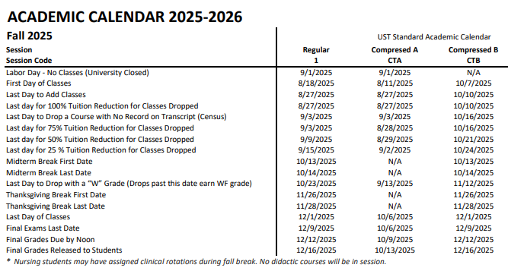
8. Use of Technology
- You must use Blackboard to retrieve and submit assignments.
- You should have basic technology skills related to Microsoft Office.
- You must use e-mail to receive messages to your StThom email account from the professor.
- You will need to have basic Internet search skills.
- You may use Zoom and/or Microsoft Teams for online meetings

9. Course Tentative Schedule:

Day | Date | Readings/ Assignments
Mo | 6-Oct
Tu | 7-Oct | Course opens in Blackboard
W | 8-Oct | Module 1
Th | 9-Oct | Chapters 1 & 2
Fr | 10-Oct
Sa | 11-Oct
Su | 12-Oct
Mo | 13-Oct | Practice Quiz 1 & Discussion Forum Deadline
Tu | 14-Oct | Quiz 1 and Assignment 1 Deadline
W | 15-Oct
Th | 16-Oct
Fr | 17-Oct | Module 2
Sa | 18-Oct | Chapters 3, 4, 5
Su | 19-Oct
Mo | 20-Oct
Tu | 21-Oct | Practice Quiz 2 & Discussion Forum Deadline
W | 22-Oct | Quiz 2 and Assignment 2 Deadline
Th | 23-Oct | Module 3
Fr | 24-Oct | Chapters 6, 7, 8
Sa | 25-Oct
Su | 26-Oct
Mo | 27-Oct
Tu | 28-Oct
W | 29-Oct | Practice Quiz 3 & Discussion Forum Deadline
Th | 30-Oct | Quiz 3 and Assignment 3 Deadline
Fr | 31-Oct | Module 4
Sa | 1-Nov | Chapters 9, 10, 11, 12
Su | 2-Nov
Mo | 3-Nov
Tu | 4-Nov
W | 5-Nov
Th | 6-Nov
Fr | 7-Nov
Sa | 8-Nov
Su | 9-Nov | Practice Quiz 4 & Discussion Forum Deadline
Mo | 10-Nov | Quiz 4 and Assignment 4 Deadline
Tu | 11-Nov | Module 5
W | 12-Nov | Chapters 13, 14, 15, 16
Th | 13-Nov
Fr | 14-Nov
Sa | 15-Nov
Su | 16-Nov
Mo | 17-Nov
Tu | 18-Nov
W | 19-Nov | Practice Quiz 5 & Discussion Forum Deadline
Th | 20-Nov | Quiz 5 and Assignment 5 Deadline
Sa | 21-Nov | Module 6
Su | 22-Nov | Chapters 17, 18, 19
Su | 23-Nov
Mo | 24-Nov
Tu | 25-Nov
W | 26-Nov | Recommended Module 6 submission date
Th | 27-Nov
Fr | 28-Nov
Sa | 29-Nov
Su | 30-Nov | Practice Quiz 6 & Discussion Forum Deadline
Mo | 1-Dec | Quiz 6 and Assignment 6 Deadline
 | TBA | Online Final Exam

The above schedule and procedures in this course are subject to change. The most up-to-date schedule is the one on Blackboard.

Course Structure:
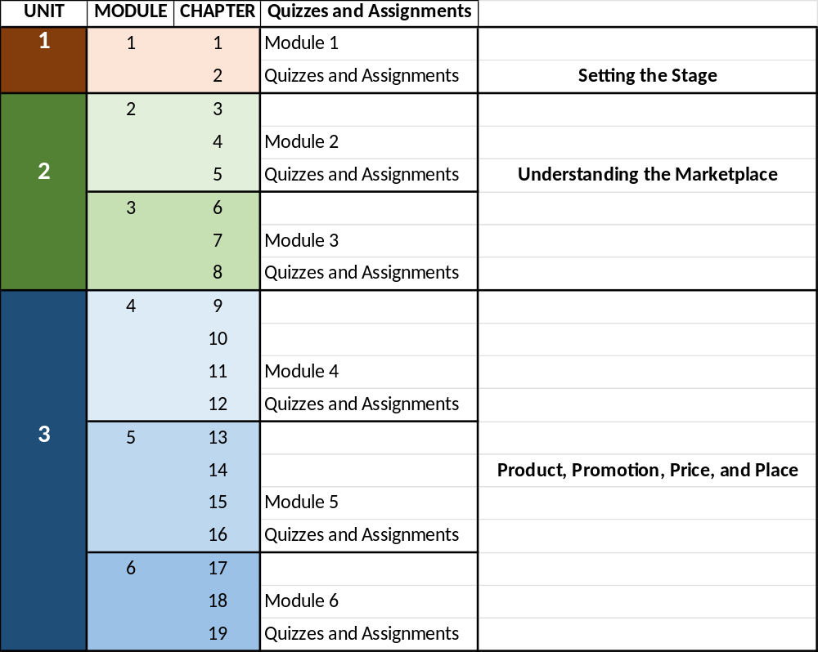

10. Course Policies
- Class participation
  - Participation counts toward students’ grades. Students should log into Blackboard regularly, at least twice per week. Students should complete all of the practice quizzes before the deadline and strive for 100%.
  - Discussion Forum – Each module includes a discussion forum that is due the day before the practice quiz. Completing all of the discussion assignments can add up to 3 points (out of 100) to your overall grade.
- Use of textbook Blackboard materials
  - You are allowed to use your textbook and any materials in Blackboard while taking quizzes, exams, or doing assignments. You are not allowed to collaborate with other students or artificial intelligence.
- Quizzes
  - There will be online quizzes for each learning module. Some of these will be untimed Practice Quizzes with unlimited attempts, while others will be Timed Quizzes that only allow two attempts. Both will count toward students’ grades, but the timed quizzes will carry significantly more weight as a component of student grades.
- Make-up exams/quizzes
  - All quizzes, assignments, and exams will be online. There are no make-up exams, assignments, or quizzes. Plan to take the online quizzes and exams, and submit the assignments, before the deadline. Quizzes and assignments are available well before the due date. Don’t wait until the last minute to submit these.
  - No submissions will be accepted after those deadlines.
- What if the online technology is not working?
  - All assignments, quizzes, and exams will be assigned and completed in Blackboard. Sometimes, technology fails. If there are technical problems, e-mail me evidence of your attempt before the deadline. E-mails sent after the deadline will not eliminate the requirement and there will be no makeups. You can email me at storyjw@stthom.edu and at johnwstory@gmail.com to report your inability to access the online system, but it must be received before the deadline.
  - LATE ASSIGNMENTS, quizzes, or exams will not be accepted. You will receive a grade of 0 for assignments, exams, or quizzes not submitted before their deadline.
- Communication
  - I will communicate with you through Blackboard, e-mail, and possibly using other collaboration software/apps.
  - My preferred communication media from students is the stthom e-mail account, storyjw@stthom.edu. If you do not get a response from that, use the Gmail address, johnwstory@gmail.com.
- Academic dishonesty
  - Academic dishonesty will result in a poor grade, or failing the class. Cheating will result in a significant grade reduction, or a grade of F for the class, at the professor’s discretion.
- Student Conduct in a Learning Environment:
Membership in the academic community places a special obligation on all members to preserve an atmosphere conducive to the freedom to teach and to learn. Therefore, it is the responsibility of each member of this class to maintain a positive learning environment in which the behavior of any individual does not disrupt the learning opportunities for others. Students are expected to work, individually and together, to create an atmosphere that is safe, valuing of one another, and open to divershylyse perspectives. Students are expected to show courtesy, civility, and respect for one another and for the instructor. The UST Student Handbook contains important information and expectations that all students should know, including University policies and the Code of Student Conduct; these documents are available at www.stthom.edu/dos.

It is the responsibility of the individual faculty member to determine, maintain, and enforce the standards of behavior acceptable to preserving an atmosphere appropriate for all teaching and learning activities in the course. Students will be warned if their behavior is evaluated as not meeting the expected standards.

Sanctions for such behavior may include a range of responses from immediate removal from class (or a student group meeting) to referral to the appropriate academic unit and/or the Office of the Dean of Students for review of violations of behavioral standards. Significant and/or continued violations will result in administrative withdrawal from the course

- Student Feedback
The online course evaluation system is available to students towards the end of the semester. This system provides a tool for students to provide feedback regarding their learning experiences in courses at CSB and UST. Students are strongly encouraged to participate in this course evaluation process. Student feedback is crucial for curriculum development, faculty development, and continuous improvement of the programs offered by the Cameron School of Business.

11. Student Grading Processes: (including weighting of factors)

Exam 30%
Assignments 30%
Quizzes 30%
Participation 10%

Grading Scale
A 93-100
A- 90-92
B+ 87-89
B 83-86
B- 80-82
C+ 77-79
C 73-76
C- 70-72
D+ 67-69
D 65-66
F <65

12. Available Support Services:
- Tutorial Services Center (TSC)
The Tutorial Services Center offers assistance to all current UST students in a variety of content areas, including academic subjects, general concepts, and writing skills. Tutors are available anytime the center is open. The TSC offers on-site tutoring, online tutoring, and tutorial workshops. Office hours and schedules can be found at https://www.stthom.edu/Academics/Tutorial-Services-Center/Index.aqf . Please contact the center at 713-525-3878 or tutoring@stthom.edu.
- CSB Tutorials
The Cameron School of Business offers tutoring in business subjects. Please visit http://libguides.stthom.edu/cameron (under the “CSB Tutorial Services” tab) for the most current tutorial schedule and available subjects.
- Information Technology Services
The UST IT Solution Center offers assistance with technical issues related to general computer issues, software, email, passwords, MyStThom, and blackboard.
Main Help Desk: 713 525 6900; Email: ithelpdesk@stthom.edu
Blackboard Support: 713 942 5965; www.stthom.edu/bbhelp

The Cameron School of Business at the
University of St. Thomas

MISSION STATEMENT

Inspired by the Basilian Fathers’ motto of Goodness, Discipline and Knowledge, and supported by research, the Cameron School of Business provides a comprehensive, high quality, ethically oriented business education to a diverse student body enabling graduates to serve as leaders of faith and character in a global economy.

ACADEMIC HONESTY

Ethical conduct is essential to a community of scholars and students searching for truth. Anything less than total commitment to honesty and honorable conduct undermines the efforts of the entire community. Academic integrity lies at the very heart of any institution of higher learning. In the Cameron School of Business, students and faculty are expected to commit to a code that exemplifies each individual's honor and integrity. Any conduct that violates this standard and betrays the respect of others is a matter of grave concern and, accordingly, is deemed unacceptable. The tests/exams will be individual efforts. Students may work together on homework assignments, but must submit their own assignments. The penalty for an incident of academic dishonesty is, at the discretion of the professor, either a mark of zero for the work in question or a grade of F for the course.

ACCOMMODATIONS
University of St. Thomas- Houston is committed to making reasonable accommodations to assist individuals with disabilities in reaching their academic potential. If you have a disability which may impact your performance, attendance, or grades in this course and require accommodations, you must first register with the Office of Counseling and Disability Services Disability Services | University of St. Thomas Houston . Disability Services is responsible for coordinating classroom accommodations and other services for students with disabilities. Please note that classroom accommodations cannot be provided prior to your instructor’s receipt of an accommodations letter from Disability Services.

For more information about accommodations, please contact Disability Services:
Disability Services | University of St. Thomas Houston
713.525.2169 or email cds@stthom.edu

CSB ACADEMIC PROCESS:
The Cameron School of Business at University of St. Thomas is committed to helping each student reach his or her full academic potential.

In case of any questions or concerns related to a course, students should first meet with the instructor to request for help. If the student needs assistance to contact the instructor, he or she may contact the Cameron School of Business office, P: 713-525-2100 or email csbaction@stthom.edu

If the student has additional concerns after consulting with the instructor, student may then contact the Chair of the Department:

Accounting Chair
Dr. John Leavins
- Phone: 713-942-3479
- Email: leavinj@stthom.edu

Finance Chair
Dr. Joe Ueng
- Phone: 713-525-2114
- Email: ueng@stthom.edu

Management & Marketing Chair
Dr. Elham Mousavidin
- Phone: 713-942-5914
- Email: mousave@stthom.edu

If the student cannot consult the Department Chair or concerns still remain, the student may contact the Associate Dean, Dr. Ramaswamy (vinitar@stthom.edu) to determine a solution. Finally, the student may contact the Dean, Robert Keith at robert.keith@stthom.edu

If the student is not satisfied with the action taken at the internal level, then the student may contact Student Services.

