Learning Guide for Principles of Marketing

Purpose
This guide will introduce you to the learning tools available for this class and recommend methods of study to optimize your learning experience, minimize the amount of time you will have to invest, and help you earn the grade to which you aspire.
A few minutes spent reviewing this guide will save you a lot of time and effort over the next few weeks.

Learning Tools
Everything you need for this course is available in Blackboard. The primary learning tools include:
- Syllabus
- Textbook
- Learning Modules
- Practice and Review Materials
- Quizzes, Tests, and Assignments
- Discussion Forum
- Quizlet study materials (Flashcards)

Recommended Process
For each chapter:
- Read the chapter and use the highlighting tools (see instructions below)
- Review the PowerPoint slides
- Use the Flashcards to review Key Terms (see hints below)
Before taking the Module Quiz and doing the Assignment
- Review the Key Terms
- Scan the PowerPoint slides
- Scan the Textbook chapters (and any highlights)
- Take the Practice Quiz
Practice Quiz
- You can take it as many times as you like
- Use the PowerPoint slides to help you
- You don’t have to answer every question, every time. You can try an answer to a few questions and submit the quiz to check your answers.
Quiz
- You get two chances on the quiz and your higher grade counts.
- These are open book, open notes. There is a time limit, but this is meant to be a learning experience.
Assignment
- You get two chances. These are not timed, so you can use all of your learning resources.

Using the Online Textbook
- You can use the textbook online, or you can download a pdf file.

Online Version
- If you use the online version, you can navigate to where you want by clicking on “Contents” in the upper left corner and then clicking on the section you want to see
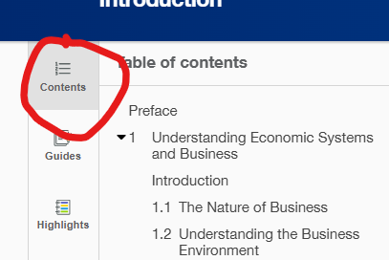
- You can highlight a word, or group of words, and then click on a color to highlight them.
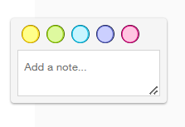

PDF Version
- You can download a PDF version and save it to your computer, or a cloud location (e.g., OneDrive).
- If you use the PDF version, you can navigate to where you want by using the “bookmarks” in the upper right.
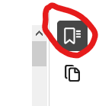
- You can highlight text and click on the highlight tool for ighlighting.

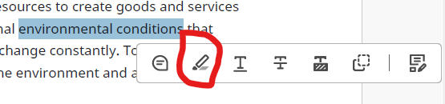
- You can click on highlighted text and click on the color to change the color
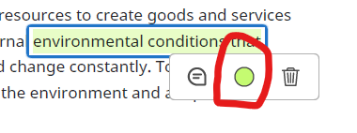
- You can also add notes to yourself
- Take some time and play with the textbook to get used to all of the tools

Using the PowerPoint Slides
Each chapter has a set of PowerPoint slides. These are one of the primary learning tools. They provide a summary of the chapter, review key terms, and have audio clips for most of the key terms.

Download the slides
Some of the PowerPoints will display in Blackboard, but none of the learning tools work. You need to download them to your local computer or a cloud storage location.
For each chapter, you download the slides by clicking on the three dots and selecting Download Original File

Normal View
In Normal View you can work through the slides and listen to the sound bytes by hovering over the highlighted word and clicking on the Play button.
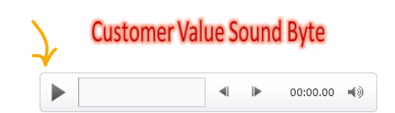

Slide Show
You can also use the slide show
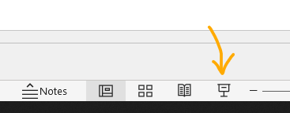
In that mode, clicking the slide plays any sound bytes, one at a time. You can hover over the highlighted words to open a control bar.
You should play with these in both modes to decide what works best for you.

Quizlet
For each chapter there is a link to Flashcards in Quizlet. You should use these to learn, review, and quiz yourself over the key terms. You can set up a free account to access the full range of learning.
In addition to flashcards, you can use the menu to try out different learning tools.
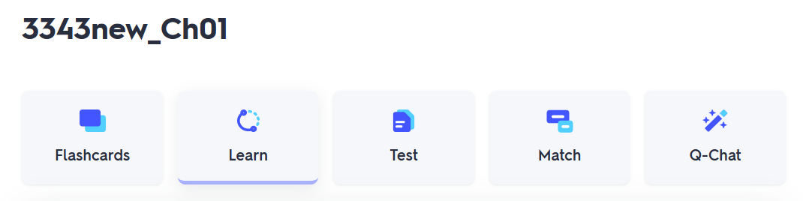
For each chapter, there is also a link to a Study Guide created by Quizlet from the list of key terms.

Quizzes and Assignments
Each module has a Practice Quiz, a Quiz, and an Assignment.

Practice Quizzes
The practice quizzes are untimed and you can take the quiz as many times as you like. Only your highest score will count toward your overall grade.

Quizzes
The quizzes are timed and you get two chances. Only your highest score will count toward your overall grade.

Assignments
You only get one chance on each assignment, but there is no time limit and you can use all of your learning tools.

Discussion Forum
Each module includes a discussion forum. These are not required, but if you complete all of them before the deadline you can earn up to three percent bonus points toward your grade.

Course Organization
The course covers 19 chapters divided into 6 learning modules
