LAVERNE 4TH OF JULY
PARADE INSTRUCTIONS

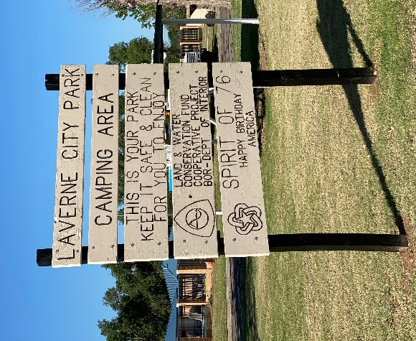
- ALL PARADE PARTICIPANTS MUST PICK UP THEIR PARADE NUMBERS AND LINE UP INSTRUCTIONS BETWEEN 9:00-9:30 AM FROM THE CHAMBER TABLE LOCATED AT THE LAVERNE CITY PARK CAMPING AREA ON THE NORTHEAST CORNER OF THE PARK.

- Please be lined up by 9:30 in your designated area. THE PARADE STARTS PROMPTLY AT 10:00!

- The parade will start at the park area, travel east down Jane Jayroe Blvd., and return to the park on the parade route on 1st & 2nd streets.

- The parade emcee will announce the parade participants from a stage in front of the Laverne United Methodist Church. Please slow down, smile, and wave as they read your write-up as we will also be filming the parade from this location!

**THANK YOU FOR YOUR PARTICIPATION IN LAVERNE’S ANNUAL 4TH OF JULY PARADE**
FOR MORE INFORMATION: HELENA MCLAURINE – 580.822.1328

