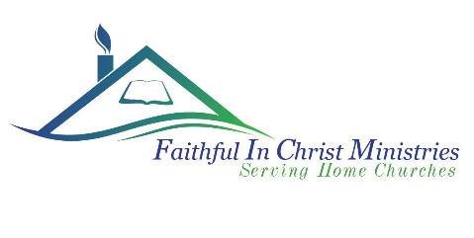
Weekend In The Word
November 18-20, 2022
Our theme is Your Understanding Being Enlightened from Ephesians 1:18

Hello and God bless you,
We will be at the beautiful Wonderland Camp and Conference Center in Salem, Wisconsin. You can find directions and other info on their website at https://centralusa.salvationarmy.org/wonderland/
The weekend will start with Registration at 4-6pm on Friday November 18th with a “Taco Night” dinner at 5:30pm and will end on Sunday November 20th with a noon lunch.
You will want to bring casual/comfortable warm clothing and a jacket, your Bible, and paper and pen. You won’t need to bring towels or bedding as they are provided by the camp.
Housing and payment are based on double occupancy. Registration and payment by the deadline are required to reserve your room and meals.
The cost for the camp is $125 for adults, $65 for children 6-12yrs, $35 for children 3-5yrs, and children under 3yrs are free.
We are anticipating a sweet and joyful fellowship with some hot Bible teachings!
Registration & Payment deadline October 30
Please register ASAP for maximum blessings
Make checks out to: Faithful in Christ Ministries, and mail to:
Charlie Quillen, 5610 Lambeth Lane Rockford IL 61107
Or pay on website with credit card/PayPal at www.faithfulinchrist.org

Name of all attending (ages required for anyone under 18) Age Cost
____________________________________ ______ ______
____________________________________ ______ ______
____________________________________ ______ ______
____________________________________ ______ ______
____________________________________ ______ ______
Total Payment ______

Food allergies/dietary needs (If you have a food allergy we need to know before you arrive) print name here _____________________________
Please print name of roommate request______________________________________________

Address_____________________________ City/State: _______________________ Zip_____
Email: _____________________________________Ph #: ____________
Contacts: Charlie Quillen cq@faithfulinchrist.org Mike Lorence mike.lorence@faithfulinchrist.org

