Plain Language Summary: Financial Assistance Program 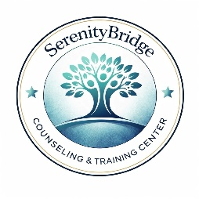
SerenityBridge Counseling and Training Center
What is the Financial Assistance Program?
Our nonprofit organization is dedicated to providing high-quality, accessible mental health and behavioral health services. If you cannot afford our standard fees due to financial hardship, you can apply for our Financial Assistance Program.
Do you accept health insurance?
No. Our organization operates on a no-insurance model. We do not accept, participate in, or bill any health insurance plans, commercial insurance, Medicaid, or Medicare. All of our discounts apply directly to our standard flat-rate service fees.
Who qualifies for financial assistance?
Financial assistance is granted based on your household size and total annual household income compared to the Federal Poverty Level (FPL):
- Income at or below 200% FPL: You qualify for a 100% discount. Your mental health services will be completely free ($0).
- Income between 201% and 400% FPL: You qualify for a sliding scale discount ranging from 50% to 75% off our standard flat fees.
- Income over 400% FPL: You are responsible for paying our standard flat fee in full.
How do I apply?
- Ask our intake staff for a Financial Assistance Application or download it from our website.
- Complete the application and attach proof of income (such as two pay stubs, tax returns, or W-2s). If you do not have these documents, you may complete our Income Self-Attestation Form.
- Submit the documents to our office in person or by email.
No one will be denied emergency or medically necessary mental health care due to an inability to pay. For help with the application process, please speak directly with our intake coordinator.

