SerenityBridge Counseling and Training Center 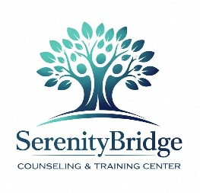
Notice of Patient Rights & Financial Assistance
YOUR RIGHTS & ACCESS TO CARE
Our nonprofit organization is committed to providing high-quality, accessible mental health and behavioral health services to everyone in our community.
1. No-Insurance Care Model
We do not accept, participate in, or bill any health insurance plans, commercial insurance, Medicaid, or Medicare. We keep our administrative overhead low so we can pass savings directly to you.
2. Right to Financial Assistance
You have the right to request financial assistance if you cannot afford our standard fees.
- Free Care ($0): If your household income is at or below 200% of the Federal Poverty Level, your care is 100% free.
- Sliding Fee Scale: If your income is between 201% and 400% of the poverty level, you will receive a discount of 50% to 75% off our standard flat fees.
3. Protection From Discrimination
You have the right to receive care regardless of your race, color, national origin, religion, age, sex, gender identity, sexual orientation, disability, or your ability to pay for services.
4. Simple Application Process
Applying for assistance is private and straightforward. You only need to fill out a one-page form and provide proof of income. If you do not have pay stubs or tax documents, you can complete a simple self-attestation form.
5. Fair Billing Policies
We will never send your account to aggressive collections agencies, report your account to credit bureaus, or take legal action against you for unpaid bills. If your financial situation changes, we will work with you to find a solution.
To request a copy of our full Financial Assistance Policy or an application form, please speak directly with our Intake Desk or visit our website at www.serenitybridgectc.org.

