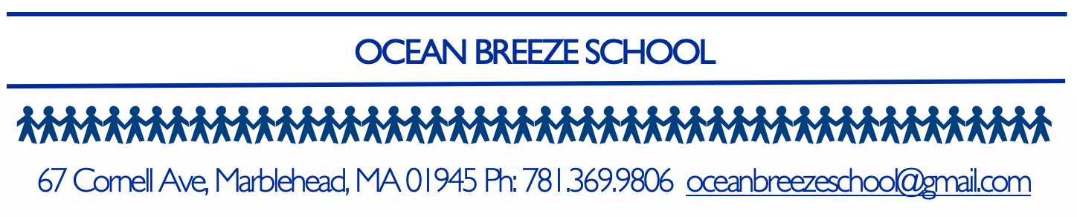
2021-22 School Calendar
First Day of School | August 30 | Welcome!
Labor Day | September 6 | No School
Rosh Hashanah | September 7-8 | No School
Yom Kippur | September 16 | No School
Open House | September 28 | 7:00-8:00 PM
Toddler-Fall Picnic | October 1 | 11:30-12:00
Preschool-Fall Fair | October 8 | School Closes at 12:15
Indigenous Peoples’ Day | October 11 | No School
Veteran’s Day | November 11 | No School
Thanksgiving Break | November 24 | School Closes at 12:15
Thanksgiving Break | November 25-26 | No School
Toddler- Winter Party | December 23 | School Closes at 12:15
Preschool-Winter Show | December 23 | School Closes at 12:15
Winter Break | December 24-December 31 | No School
MLK Day | January 17 | No School
Preschool-Science Fair | February 11 | School Closes at 12:15
February Vacation | February 21-25 | No School
Teacher Professional Development Day | March 16 | No School
Good Friday | April 15 | No School
Toddler-Spring Picnic | May 13 | 11:30-!2:00
April Vacation | April 18-22 | No School
All School Beach Day | May 20 | No School
Memorial Day | May 30 | No School
Last Day of School | June 10 | School Closes at 12:15

Please note that if the Marblehead Public Schools are closed or switch to a virtual day due to inclement weather, Ocean Breeze School will be closed for the day. Please check your email and the local news for these announcements.

