Quilt Club
Quilt Club
Instructor: Monika Openshaw
e-mail: monika@orangeblossomquilting.com
Dresden Turkey Placemat/ Wall Hanging
September 18, 2021
Supply List
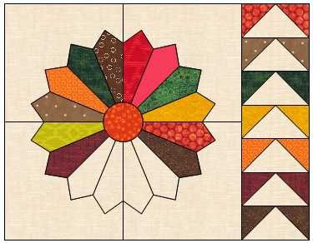
Learn how to make a whimsical Dresden block dressed up as a turkey. The sample is for a placemat, but you could easily turn this into a wall hanging or table runner.
I used a fat quarter bundle to make a set of placemats, but you could easily use up scraps for this project.
Dresden Ruler | Darlene Zimmerman or Creative Grids
Pencil for tracing applique shapes
Fabric | 1 Placemat | Rough Cut | 4 Placemats
Background | 1 fat quarter |  | 1 yard
Binding | (2) 2 ½” strips |  | ¾ yard
Dresden Blades  NOTE: If you are making a set of placemats, you may want to cut a 5” strip x wof instead of the suggested individual rough cuts. Not sure what to do? Wait until class! | 14 assorted fall colors—may be two of seven colors | (14) 2 1/5” x 5”  Or  (7) 5” x 5” | (56) 2 1/5” x 5”  Or  (28) 5” x 5”
Steam A Seam or other Fusible Paper Backed Bonding Material | ½ yard
Center/ Turkey Body | Orange | 5” x 5” | (4) 5” x 5”
Turkey Head | Brown | 5” x 4” | (4) 5” x 4”
Legs | Gold | 3” x 3” | (4) 3” x 3”
Beak | Gold | 1 ½” x 1 ½” | (4) 1 ½” x 1 ½”
Waddle | Red | 1 ½” x 1 ½” | (4) 1 ½” x 1 ½”
Eyes | Black | 2 small buttons | 8 small buttons
Flying Geese”Geese” | Background | (7) 2 ½” x 4 ½” | (28) 2 ½” x 4 ½”
Flying Geese “Sky” | Assorted fall colors | (14) 2 ½” x 2 ½” | (56) 2 ½” x 2 ½”

