AccuQuilt Club
AccuQuilt Club
Instructor: Monika Openshaw
monika@orangeblossomquilting.com
November 3, 2021
Supply List
BOBing Leaves

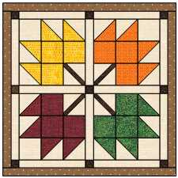
22” x 22”
Join us as we learn how to use a Block on Board die, also known as a BOB die.
We’ll be using the Maple Leaf BOB to create a charming autumn table topper or wall hanging.
Fabric | Yardage | Rough Cut for 4 Maple Leaf Blocks
Background & Sashing | ½ yard | Cut two strips 4” x wof
Dark Brown- for stems and cornerstones | Fat eighth | Cut one strip 2” x wof
Red | Fat eighth | Cut two strips 4” x 20”
Orange | Fat eighth | Cut two strips 4” x 20”
Green | Fat eighth | Cut two strips 4” x 20”
Yellow | Fat eighth | Cut two strips 4” x 20”
Border & Binding | ½ yard
Backing | ¾ yard

