Tumbling Leaves
Quilt Club
September 2021
Instructor: Monika Openshaw
monika@orangeblossomquilting.com

Table Runner
By Monika Openshaw
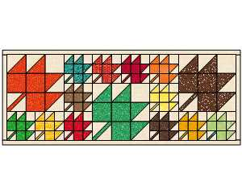
20” x 50”

Fabric | Yardage
Background | ¾ yard | Cut (4) 1 ½” x wof strips for border first & set aside
Assorted fall colors for leaves | 5-6 fat quarters or use scraps
Binding | ¼ yard | Cut (4) 2 ½” x wof strips
Backing | 1 ½ yard
Batting to fit
Supply List

