Snapdone

Administration Manual
© 2001 Inspired Computing, Inc.
This manual helps administrators manage Snapdone. For help on using Snapdone, see the other online manuals (Snap Help).

Table of Contents
I. Table of Contents 1
II. Forms 2
A. Managing Forms 2
1. Templates 3
2. Boilerplates 5
3. Snapdone forms 8
B. Form Codes 10
1. MS Word’s Form Fields 10
2. Repeating Fields: &&FieldName&& 11
3. Snapdata Merge Fields: <<FieldName>> 11
4. Profile Fields: <<PD:Constants:FieldName>> 13
5. Multiple Snapdata Records in One Document 13
III. Users 14
A. Adding a New User 14
1. Support Your Software 14
2. Add a New Profile 14
3. Set Up the New Workstation 15
a. Find Out Your Snapdone Path 15
b. Install Word Viewer 15
c. Install Snapdone 15
B. Managing Users 16
IV. Configuring Snapdone 19
A. Global Snapdone Settings 19
B. Paper Types and ID Stamps 21
V. Archiving 25
VI. Snapdata Management 25
VII. Global Template 28
VIII. Troublesome Paper Trays 28

Forms

Managing Forms
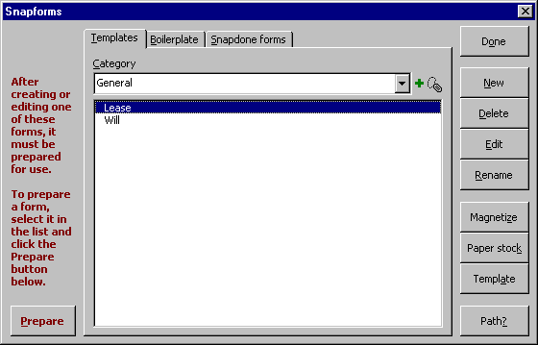
Click Snap Setup Administration Forms to work with Snapdone forms.
A.1
A.4
A.3
A.2
Figure A
A.1 Templates are custom forms for your office. Unlike boilerplates, templates are used to create documents, such as wills, leases, and agreements. Templates are used by clicking Snap New Template.
A.2 Boilerplates are also custom forms for your office. Unlike templates, boilerplates are inserted into documents. Typical boilerplates include letters (inserted into a letter which was created with Snap New Letter or Snap Snapdata Letter), pleadings (inserted into a caption which was created with Snap Caption Bank), and signature blocks and acknowledgements (inserted into all sorts of documents). Boilerplates are used by clicking Snap Insert Boilerplate.
A.3 Snapdone forms are subdivided onto nine more tabs. These forms are typically created when Snapdone is installed in your office, but you may alter them or create new ones at any time. See Section II.A.3 on page 7.

Templates
Click Snap Setup Administration Forms Templates to work with your office’s custom templates.
B.1
B.2
B.3
B.5
B.4
B.13
B.12
B.11
B.10
B.9
B.8
B.7
B.6
B.1 Add category icon: Click this icon to add a new category to the list of template categories in box B.3 .
Figure B
B.2 Rename category icon: To rename a category, select it in box B.3 and click this icon.
B.3 Category: Templates are divided into categories. Select a category in this box to see its contents in box B.4 .
B.4 Template list: This list shows the templates contained in the category selected in box B.3 .
B.5 Prepare: After creating, editing or renaming a template, it must be prepared for use (otherwise an error message will be displayed when the template is used). To prepare the template, select it in box B.4 and click Prepare.
B.6 New: To create a template, first select the category B.3 in which it should appear. If the new template is to be modeled on an existing template, select the model template in box B.4 . Then click New to create the new template.
The new template appears on screen (if it was not based on an existing template, the new template is empty). Make any desired changes to the template (you may paste text from other documents and templates if desired, or type it from scratch), then click File Close Yes to save the new template. Remember to return to the Snapforms screen and Prepare B.5 the template before using it.
B.7 Delete: To delete a template, select it in box B.4 and click Delete.
B.8 Edit: To edit a template, select it in box B.4 and click Edit. The template appears on screen. Make any desired changes, then click File Close Yes to save changes. Remember to return to the Snapforms screen and Prepare B.5 the template before using it.
B.9 Rename: To rename a template, select it in box B.4 and click Rename. After renaming, remember to Prepare B.5 the template before using it.
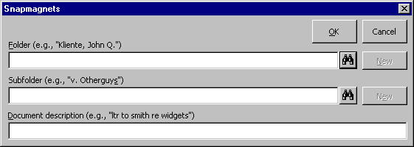
B.10 Magnetize: Templates may be “magnetized” with a default Folder, Subfolder, and/or document description. To magnetize a template, select it in box B.4 and click Magnetize to display the Snapmagnets screen.
B.10c
B.10b
B.10a
Subfigure B.10
B.10a Folder: If documents created with this template should generally be saved in a particular folder, select the folder here. When this template is used to create a document and the document is Snapsaved, the Snapsave screen will be prefilled with this folder (Snapdone User’s Manual 8.2 ).
B.10b Subfolder: If you have chosen a folder in box B.10a and documents created with this template should also generally be saved in a particular subfolder, select the subfolder here. When this template is used to create a document and the document is Snapsaved, the Snapsave screen will be prefilled with this subfolder (Snapdone User’s Manual 8.3 ).
B.10c Document description: If documents created with this template should generally be named with a particular document description, enter the description here. When this template is used to create a document and the document is Snapsaved, the Snapsave screen will be prefilled with this description (Snapdone User’s Manual 10.2 ).
B.11 Paper stock: Every template is assigned a default paper stock. Paper stock controls the format of document ID stamps ( Fig. L ) and paper trays (Snapdone User’s Manual 34.8 ). To view or change the paper stock for a particular template, select it in box B.4 and click Paper stock.
B.12 Template: By default, when Snapdone uses a template to create a document, the template is immediately “detached” from the document. This makes it easier to revise templates – since the connection between the template and the document is broken, the template is not considered “busy” whenever the document is open on someone’s screen. But if a template contains macros, autotext entries, keyboard mappings and/or toolbars, the connection between document and template must be maintained so that those custom tools will be available to the user. To change a template’s attached/detached behavior, select it in box B.4 and click Template.
B.13 Path?: Click here to find out where the selected template is stored on your system.

Boilerplates
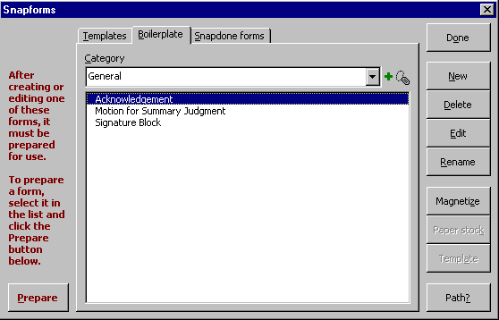
Click Snap Setup Administration Forms Boilerplate to work with your office’s custom boilerplates.
C.1
C.2
C.3
C.5
C.4
C.11
C.10
C.9
C.8
C.7
C.6
C.1 Add category icon: Click this icon to add a new category to the list of boilerplate categories in box C.3 .
Figure C
C.2 Rename category icon: To rename a category, select it in box C.3 and click this icon.
C.3 Category: Boilerplates are divided into categories. Select a category in this box to see its contents in box C.4 .
C.4 Boilerplate list: This list displays the boilerplates contained in the category selected in box C.3 .
C.5 Prepare: After creating, editing or renaming a boilerplate, it must be prepared for use (otherwise an error message will be displayed when the boilerplate is used). To prepare the boilerplate, select it in box C.4 and click Prepare.
C.6 New: To create a new boilerplate, first select the category C.3 in which it should appear. If the new boilerplate is to be modeled on an existing boilerplate, select the model boilerplate in box C.4 . Then click New to create the new boilerplate.
The new boilerplate appears on screen (if it was not based on an existing boilerplate, the new boilerplate is empty). Make any desired changes to the boilerplate (you may paste text from other documents and templates if desired, or type it from scratch), then click File Close Yes to save it. Remember to return to the Snapforms screen and Prepare C.5 the boilerplate before using it.
C.7 Delete: To delete a boilerplate, select it in box C.4 and click Delete.
C.8 Edit: To edit a boilerplate, select it in box C.4 and click Edit. The boilerplate appears on screen. Make any desired changes, then click File Close Yes to save changes. Remember to return to the Snapforms screen and Prepare C.5 the boilerplate before using it.
C.9 Rename: To rename a boilerplate, select it in box C.4 and click Rename. After renaming, remember to Prepare C.5 the boilerplate before using it.
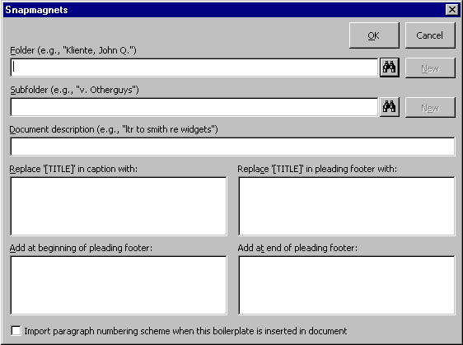
C.10 Magnetize: Boilerplates may be “magnetized” with default information. To magnetize a boilerplate, select it in box C.4 and click Magnetize to display the Snapmagnets screen.
C.10h
C.10g
C.10f
C.10e
C.10d
C.10c
C.10b
C.10a
Subfigure C.10
C.10a Folder: If documents created with this boilerplate should generally be saved in a particular folder, select the folder here. When this boilerplate is inserted in a document and the document is Snapsaved, the Snapsave screen will be prefilled with this folder (Snapdone User’s Manual 8.2 ).
C.10b Subfolder: If you have chosen a folder in box C.10a and documents created with this boilerplate should also generally be saved in a particular subfolder, select the subfolder here. When this boilerplate is inserted in a document and the document is Snapsaved, the Snapsave screen will be prefilled with this subfolder (Snapdone User’s Manual 8.3 ).
C.10c Document description: If documents created with this boilerplate should generally be named with a particular document description, enter the description here. When this boilerplate is inserted in a document and the document is Snapsaved, the Snapsave screen will be prefilled with this description (Snapdone User’s Manual 10.2 ).
C.10d Replace ‘[TITLE]’ in caption with: If this boilerplate is a pleading which will be inserted into captions from the Caption Bank, this box can be used to determine the contents of the right side of the caption (for example, MOTION FOR SUMMARY JUDGEMENT; CLERK’S ACTION REQUIRED). Then when a caption is used from the Caption Bank, if the user tabs past [TITLE] in the caption without altering it and then inserts this boilerplate, the text entered in this box C.10d will automatically be inserted in the caption.
C.10e Add at beginning of pleading footer: If this boilerplate is a pleading which will be inserted into captions from the Caption Bank, this box can be used to specify text which needs to appear before the title of the document in the footer (as required in some dissolution forms, for example). Then when a caption is used from the Caption Bank, if the user tabs past [TITLE] in the caption without altering it and then inserts this boilerplate, the text entered in this box C.10e will automatically be inserted before the pleading title in the footer. Note: if this text should appear on a separate line before the title, include a hard return as the last character.
C.10f Import paragraph numbering scheme when this boilerplate is inserted in a document: By default, the Snapnumbering scheme of a document overrules the Snapnumbering scheme of a boilerplate inserted into that document. Check this checkbox C.10f if the boilerplate contains a Snapnumbering scheme which should be preserved when it is inserted into a document.
C.10g Replace ‘[TITLE]’ in pleading footer with: If this boilerplate is a pleading which will be inserted into captions from the Caption Bank, this box can be used to specify the title which appears in the footer (for example, MOTION FOR SUMMARY JUDGMENT). Then when a caption is used from the Caption Bank, if the user tabs past [TITLE] in the caption without altering it and then inserts this boilerplate, the title entered in this box C.10g will automatically be inserted in the document footer.
C.10h Add at end of pleading footer: If this boilerplate is a pleading which will be inserted into captions from the Caption Bank, this box can be used to specify text which needs to appear after the title of the document in the footer (as required in some dissolution forms, for example). Then when a caption is used from the Caption Bank, if the user tabs past [TITLE] in the caption without altering it and then inserts this boilerplate, the text entered in this box C.10h will automatically be inserted after the pleading title in the footer. Note: if this text should appear on a separate line after the title, include a hard return as the first character.
C.11 Path?: Click this button to find out where the selected boilerplate is stored on your system.

Snapdone forms
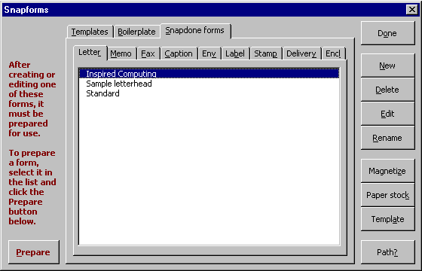
Click Snap Setup Administration Forms Snapdone forms to work with the forms which were installed with Snapdone in your office.
D.1
D.10
D.11
D.18
D.17
D.9
D.8
D.7
D.6
D.5
D.4
D.3
D.2
D.19
D.16
D.15
D.14
D.13
D.12
Figure D
D.1 Letter: This tab contains the letter forms which are used with Snap New Letter or Snap Snapdata Letter.
D.2 Memo: This tab contains the memo forms which are used with Snap New Memo or Snap Snapdata Memo.
D.3 Fax: This tab contains the fax forms which are used with Snap New Fax Cover or Snap Snapdata Fax. If one of these forms contains the word multiple in its name, it is selected by default when a fax to multiple recipients is created.
D.4 Caption This tab contains the caption forms which appear as venue choices when captions are created in the Caption Bank.
D.5 Env: This tab contains the envelope forms which are used with Snap New Envelope or Snap Snapdata Env.
D.6 Label: This tab contains the label forms which are used with Snap New Labels or Snap Snapdata Label.
D.7 Stamp: This tab contains the stamp forms which appear in several Snapdone menus, such as Snapdone User’s Manual 1.19 .
D.8 Delivery: This tab contains the delivery forms which appear in several Snapdone menus, such as Snapdone User’s Manual 1.20 .
D.9 Encl: This tab contains the enclosure forms which appear in several Snapdone menus, such as Snapdone User’s Manual 1.21 .
D.10 Form list: This list displays the Snapdone forms contained in the selected tab D.1 through D.9 .
D.11 Prepare: Most Snapdone forms must be prepared after they are created, edited or renamed (the exceptions are stamps D.7 , deliveries D.8 , and enclosures D.9 ). To prepare a form, select it in box D.10 and click Prepare.
D.12 New: To create a new form, first select the appropriate tab D.1 through D.9 . If the new form is to be modeled on an existing form, select the model form in box D.10 . Then click New to create the new form.
The new form appears on screen (if it was not based on an existing form, it is empty). Make any desired changes to the form (you may paste text from other documents and templates if desired).
If the form is a stamp, delivery or enclosure, select the text of the form (excluding the final paragraph mark) then click Insert Bookmark, type the word All in the Bookmark name box, and click Add.
Click File Close Yes to save the changes.
If the form is not a stamp, delivery or enclosure, remember to return to the Snapforms screen and Prepare D.11 it.
D.13 Delete: To delete a form, select it in box D.10 and click Delete.
D.14 Edit: To edit a form, select it in box D.10 and click Edit. The form appears on screen. Make any desired changes to the form.
If the form is a stamp, delivery or enclosure, select the text of the form (excluding the final paragraph mark) then click Insert, Bookmark, type the word All in the Bookmark name box, and click Add.
Click File Close Yes to save the changes.
If the form is not a stamp, delivery or enclosure, remember to return to the Snapforms screen and Prepare D.11 it.
D.15 Rename: To rename a form, select it in box D.10 and click Rename. Remember to Prepare D.11 the renamed form before using it.
D.16 Magnetize: Forms can be “magnetized” with a default folder and subfolder. To magnetize a form, select it in box D.10 and click Magnetize to display the Snapmagnets screen.
D.16c
D.16b
D.16a
Subfigure D.16
D.16a Folder: If documents created with this form should generally be saved in a particular folder, select the folder here. When this form is used to create a document and the document is Snapsaved, the Snapsave screen will be prefilled with this folder (Snapdone User’s Manual 8.2 ).
D.16b Subfolder: If you have chosen a folder in box D.16a and documents created with this form should also generally be saved in a particular subfolder, select the subfolder here. When this form is used to create a document and the document is Snapsaved, the Snapsave screen will be prefilled with this subfolder (Snapdone User’s Manual 8.3 ).
D.16c Document description: Leave this box blank. Snapdone automatically generates document descriptions for each of the Snapdone form types, so you do not need to enter a description here.
D.17 Paper stock: Every form is assigned a particular paper stock. Paper stock controls the format of document ID stamps ( Fig. L ) and paper trays (Snapdone User’s Manual 34.8 ). To view or change the paper stock for a particular form, select it in box D.10 and click Paper stock.
D.18 Template: By default, when a Snapdone form is used to create a document, the form is immediately “detached” from the document. This makes it easier to revise forms – since the connection between the form and the document is broken, the form will not be considered “busy” every time the document is open on a user’s screen. But if a form contains macros, autotext entries, keyboard mappings and/or toolbars, the connection between document and form must be maintained so that those custom tools will be available to the user. To change a form’s attached/detached behavior, select it in box D.10 and click Template.
D.19 Path?: Click this button to find out where the selected form is stored on your system.

Form Codes

MS Word’s Form Fields
Word’s text form fields, checkbox form fields and drop-down form fields can be used in Snapdone templates and boilerplates. Typically, when the template or boilerplate is used, Snapdone turns on document protection so that the user can tab from field to field. When the user tabs out of the final field, Snapdone turns off document protection and converts the form fields to hard text so that they are not in danger of reverting to their default state. Alternately, some users may choose to leave forms unprotected (Snapdone User’s Manual 34.8e ), so that they are not locked into the form fields and can move the cursor freely through the document. They may then use the Alt+J keystroke (Snapdone User’s Manual 34.8p ) to jump from one field to the next instead of tabbing.

Repeating Fields: &&FieldName&&
Repeating field codes are used to repeat the typist’s input at several locations in a document. For example, suppose a declaration form requires the declarant’s name, city and state to appear in two locations. If the form is prepared with repeating field codes, as in Figure E, the typist will only need to type the information once (Snapdone User’s Manual Fig. 6 ). Repeating field codes consist of a field name surrounded by double ampersands: &&FieldName&&.
Figure E
DECLARATION OF &&Name of Declarant&&
I, &&Name of Declarant&&, declare as follows:
1. I live in &&City&&, &&State&&.
2. [contents of declaration]
I swear the foregoing is true and correct.
Signed in &&City&&, &&State&&, this ____ day of _________, 20__.
_____________________
&&Name of Declarant&&

You may add a default response to a repeating field code with this format: &&FieldName|DefaultText&& (the vertical line character is Shift+\ on your keyboard). For example, if your office is in Seattle, Washington, change the first &&City&& code to &&City|Seattle&& and the first &&State&& code to &&State|Washington&&, as shown in Figure F. When this form is used, the typist will be presented with Seattle and Washington as default responses for the city and state.
Figure F
DECLARATION OF &&Name of Declarant&&
I, &&Name of Declarant&&, declare as follows:
1. I live in &&City|Seattle&&, &&State|Washington&&.
2. [contents of declaration]
I swear the foregoing is true and correct.
Signed in &&City&&, &&State&&, this ____ day of _________, 20__.
_____________________
&&Name of Declarant&&

Snapdata Merge Fields: <<FieldName>>
To create a form which can be merged with Snapdata cards, add Snapdata merge fields to the form. To create a Snapdata merge field, type two less-than symbols, the name of the field, and two greater-than symbols. Below is a list of Snapdata merge field codes, along with references to the Snapdone User’s Manual showing where the corresponding information is found on a Snapdata card.
Snapdata Merge Field Code Location in Snapdone User’s Manual
<<Name and Address>> 19.6
<<Address One Line>> 19.7g
<<Address Block>> 19.7g
<<Blind Carbon Copy>> 19.14
<<Carbon Copy>> 19.13
<<Card Name>> 16.16
<<City>> 19.7c
<<Client>> 18.7
<<Client Number>> 18.2
<<Company>> 19.7b
<<Country>> 19.7j
<<Delivery>> 19.10
<<Email>> 19.15
<<Fax>> 20.4
<<Fax Company>> 20.6
<<Fax Name>> 20.5
<<Fax Re>> 20.7
<<Header>> 19.12
<<ID>> 16.5
<<Letter Re>> 19.8
<<Matter>> 18.8
<<Matter Number>> 18.5
<<Name>> 19.7a
<<Note>> 21.1
<<Other Phone>> 20.2
<<Phone>> 20.1
<<Salutation>> 19.11
<<Stamp>> 19.9
<<State>> 19.7i
<<State Abbreviation>> 19.7d
<<Zip>> 19.7e
<<name of custom field>> 22.2

Rather than require the typist to enter the declarant’s name, city and state, you could prepare a form with Snapdata merge fields, as shown here, and the typist could then merge the form with one or more Snapdata cards to fill in the information (Snapdone User’s Manual 25.11 ).
Figure G
DECLARATION OF <<Name>>
I, <<Name>>, declare as follows:
1. I live in <<City>>, <<State>>.
2. [contents of declaration]
I swear the foregoing is true and correct.
Signed in <<City>>, <<State>>, this ____ day of _________, 20__.
_____________________
<<Name>>
You may add a default response to a Snapdata merge code with this format: <<FieldName|Text>> (the vertical line character is Shift+\ on your keyboard). If the referenced field on a Snapdata card is empty, the default text will be used.

Profile Fields: <<PD:Constants:FieldName>>
Some forms may require information about the author of the document – for example, the signature block in a pleading form may include the authoring attorney’s name and bar number. This information can be accessed with a profile field code in this format: <<PD:Constants:FieldName>>.
Below is a list of profile field codes, along with references showing where the corresponding information is found.
Profile Field Code Location
<<PD:Constants:PersonalName>> Snapdone User’s Manual 34.4a
<<PD:Constants:PersonalInitialsUC>> Snapdone User’s Manual 34.4g
<<PD:Constants:PersonalInitialsLC>> Snapdone User’s Manual 34.4h
<<PD:Constants:PersonalPosition>> Snapdone User’s Manual 34.4b
<<PD:Constants:PersonalPhone>> Snapdone User’s Manual 34.4c
<<PD:Constants:PersonalExtension>> Snapdone User’s Manual 34.4k
<<PD:Constants:PersonalFax>> Snapdone User’s Manual 34.4d
<<PD:Constants:PersonalEmail>> Snapdone User’s Manual 34.4e
<<PD:Constants:BarNum>> Snapdone User’s Manual 34.4j
<<PD:Constants:LetterClosing>> Snapdone User’s Manual 34.8f
<<PD:Constants:UserName>> Snapdone Administration Manual J.13
<<PD:Constants:Custom1>> Snapdone User’s Manual 34.4f
through <<PD:Constants:Custom6>>

This sample form asks the typist to choose an author (Snapdone User’s Manual Fig. 6 ), then fills in both the author’s name and bar association number in the document.
Figure H
Signed this ___ day of _________, 20__.

TIC, TAC & TOE

By: _________________________
<<PD:Constants:PersonalName>>
WSBA #<<PD:Constants:BarNum>>

Multiple Snapdata Records in One Document
The Snapdata merge fields described above allow users to either merge a single card with a form to produce a single document; or merge several cards with a form to produce several documents. But occasionally you may need to merge several cards into a single document. This is done by surrounding the fields which are to be repeated with these characters: {+ and +}. The example shown here generates a list of names and phone numbers for each Snapdata card which is merged into it.
Figure I
NAME PHONE #
{+<<Name>> <<Phone>>
+}

Users

Adding a New User
This section walks you through a basic new user setup. For more details, refer to Section III.B on page 15.

Support Your Software
Before adding a new Snapdone workstation in your office, call 206­567­5327 or email info@snapdone.com to find out if an additional Snapdone license must be purchased. If so, your firm will be billed for the license, but you may proceed with the installation before receiving the bill.

Add a New Profile
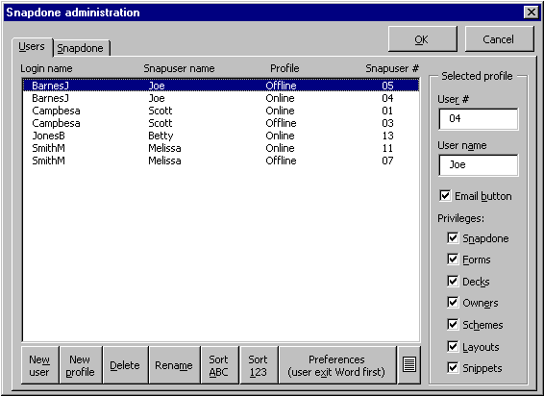
In this example, we will set up a new paralegal named Jane Doe, whose network login name is DoeJ. First click Snap Setup Administration Snapdone to see a list of current Snapdone users.
When setting up a new user, Snapdone uses an existing user as a model for the new user. Click a name on the list to select someone who is similar to Jane (for example, another paralegal), then click New user Yes.
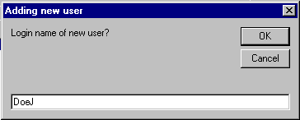
You will be asked for Jane’s login name. Be sure to enter her network login name. If you are uncertain, go to Jane’s computer, boot it up, and note the exact spelling of her login name in the login screen. After returning to your own computer and entering the correct login name, click OK, then wait for Jane to appear at the bottom of the list of users (it may take as long as a minute or so).
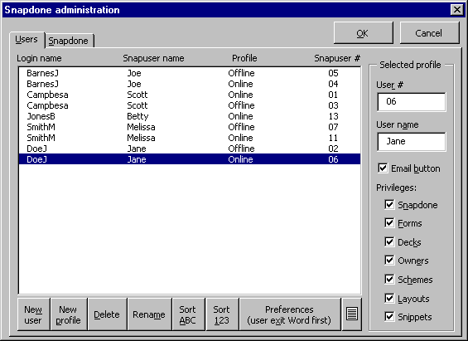
When Jane appears at the bottom of the list, click on her name to select her, then type her Snapuser name in the box on the right side of the screen. Most small offices use only a first name here; larger offices might use a full name. Do not use a name identical to someone else’s Snapuser name (shown in the second column on the list).
Make sure Jane is still selected in the list of users, then click the button labeled Preferences (user exit Word first) to advance to Jane’s SnapPreferences screen. You will see that it contains information relating to the “model” user whose profile was used to create Jane’s profile. Change this information so that it applies to Jane instead. When finished, click OK twice to exit the administration screens.

Set Up the New Workstation

Find Out Your Snapdone Path
On a computer which is already running Snapdone, click Snap Setup Preferences Folders Network Snapdone folder, and write down the displayed path. This is your SNAPDONE PATH. In the instructions below, each time the phrase “SNAPDONE PATH” appears, it is referring to this path.

Install Word Viewer
Run the Word Viewer installation program found at SNAPDONE PATH\Set Up Local\wd97vw32.exe. As the installation proceeds, you will be asked a series of questions, to which you should give the default responses. (When in doubt, pressing Enter will always choose the default response.)

Install Snapdone
After finishing the Word Viewer installation, make sure Word and Outlook are not running, then copy SNAPDONE PATH\Set Up Local\Snapstartup.dot to C:\Program Files\Microsoft Office\Office\Startup. Start Word, and you will be asked a series of questions:

Q: What is the network Snapdone folder?
A: SNAPDONE PATH
 |  |  |  |  |  | Q: Is this a notebook computer?
 | YES  Q: What is the local Snapdone folder?  A: C:\Snapdone |  |  |  |  |  | NO
Q: What is the local Snapuser folder?
A: C:\Snapuser
After completing the questions, a Synchronizing… message appears in the lower-left corner of the screen while Snapdone downloads program files to the local drive. When the message disappears, Snapdone is ready to use.

Managing Users
Click Snap Setup Administration Snapdone to display the Snapdone administration screen:
J.1
J.19
J.20
J.21
J.18
J.17
J.16
J.15
J.14
J.13
J.12
J.11
J.6
J.10
J.9
J.8
J.4
J.7
J.5
J.3
J.2
Figure J

J.1 Users: This tab shows all profiles for all Snapdone users in your office.
J.2 Snapdone: This tab controls global Snapdone settings which affect all Snapdone users in your office. See Section IV.A on page 18 for details.
J.3 List of Snapdone users: To view or modify settings for a particular user or profile, select the user or profile in this list.
J.4 New user: See Section III.A on page 13 for step-by-step instructions to add a new user.
J.5 New profile: A single user may have several profiles. Each profile stores paths and preferences for the user in a different situation. A standard user with a desktop computer has one profile named Online. A notebook user who sometimes uses Snapdone out of the office has an additional profile named Offline. A notebook user who sometimes dials into the office via a remote connection has yet another profile named Remote. If needed, you may add other profiles for special situations.
To create a new profile for an existing user, select the user in J.3 then click New profile. You will be asked for the name of the new profile – be sure to use the profile name Online, Offline or Remote when they are applicable. Each time the user starts Word, Snapdone automatically selects one of the available profiles for that user. Snapdone chooses the Online profile if the network Snapdone drive is available and the user is not dialed into the server from a remote location; the Offline profile if the network Snapdone drive is not available; or the Remote profile if the drive is available and the user is dialed into the server from a remote location. Once Word is running, the user may manually change to a different profile at any time by clicking Snap, Setup, Preferences, and selecting a profile in the Profile box at the top of the SnapPreferences screen.
J.6 Delete: To delete a profile, select it in J.3 and click Delete. Note that the Online profile is required for each user – if you try to delete it, you will be asked if you want to delete the whole user.
J.7 Rename: The login name shown in the left column of the list J.3 must match the network login name of the Snapdone user. If it does not match, rename it by selecting it in the list and clicking Rename.
J.8 Sort ABC: As the list of users is manipulated, the order changes. Click this button to reorder them alphabetically by login name.
J.9 Sort 123: Click this button to reorder the list of users numerically by Snapuser number (shown in the right-hand column).
J.10 Preferences (user exit Word first): Select a user in J.3 and click this button to work with that user’s SnapPreferences screen. First make sure the user is not using Word, or your changes may not be saved. For details on the SnapPreferences screen, see Snapdone User’s Manual Fig. 34 .
J.11 Save this list in a document: Click this button to create a Word document which ***lists the Snapdone users in your office.
J.12 User #: The Snapdone user number is used as the fifth and sixth characters in the ID code generated for each Snapsaved document (for example, the document with ID code BD041123 was created by Snapdone user number 11). Each Snapdone user number must be unique and must be two characters long. You may use both alpha and numeric characters, if desired. To change a user’s number, select the user in J.3 and type the new number in the User # box.
J.13 Snapuser name: The Snapdone user name is shown in Snapdone menus which allow users to choose another user (for example, when choosing the sender of a letter). User names should be unique and familiar to everyone in your office. Small offices usually use only first names. Larger offices often use full names to avoid duplicates. To change a user name, select a user in J.3 and type the new name in the Snapser name box.
J.14 Email button: This checkbox determines whether the Email button appears in each user’s Snapdata screen (Snapdone User’s Manual 25.10 ). The email function only works on computers which use Microsoft Outlook for email, so make sure this checkbox is unchecked for users who do not use Microsoft Outlook for emailing. To change the setting for a particular user, select the user in J.3 and click the Email button checkbox.
J.15 Privileges - Snapdone: This checkbox determines whether the user has permission to configure Snapdone with the Snapdone administration screen. If unchecked, the user will see a “permission not granted” message when they click Snap Setup Administration Snapdone. To change the setting for a particular user, select the user in J.3 and click the Snapdone checkbox.
J.16 Privileges - Forms: This checkbox determines whether the user has permission to create, modify and delete Snapdone forms with the Snapforms screen. If unchecked, the user will see a “permission not granted” message when they click Snap Setup Administration Forms. To change the setting for a particular user, select the user in J.3 and click the Forms checkbox.
J.17 Privileges - Decks: A Snapdone “deck” is a set of Snapdata cards and clips. Your office may only have one deck, or it may have many. This checkbox determines whether the user has permission to create, modify and delete Snapdone decks with the Snapdata deck management screen. If unchecked, the user will see a “permission not granted” message when they click the Manage Snapdata decks icon in the Snapdata screen (Snapdone User’s Manual 15.6 ). To change the setting for a particular user, select the user in J.3 and click the Decks checkbox.
J.18 Privileges - Owners: Snapdata cards and clips are assigned “owners” so that other users can see who is responsible for them. The list of owners can be modified with the pencil icon in the Snapdata screen (Snapdone User’s Manual 17.2 and 24.7 ). This checkbox determines whether or not the user can add and remove other users from the list of owners. In other words, if this checkbox is checked, the user can add or remove anyone from a card’s list of owners; if unchecked, the user can only add or remove his or her own name from a card’s list of owners. To change the setting for a particular user, select the user in J.3 and click the Owners checkbox.
J.19 Privileges - Schemes: Snapnumbering schemes are selected in the Snapnumber schemes screen (Snapdone User’s Manual 28.5 ). They can either be stored as public schemes, appearing on everyone’s menu, or as private schemes, only appearing on the menu of the user who created the scheme. If this checkbox is checked, the user has permission to create, modify and delete both public and private schemes; if unchecked, the user can only create, modify and delete private schemes (but can still use public schemes that have been created by others). To change the setting for a particular user, select the user in J.3 and click the Schemes checkbox.
J.20 Privileges - Layouts: Layouts are used to arrange fields inserted with the Snapdata Insert button (Snapdone User’s Manual 25.5a ). Layouts can either be stored as public layouts, appearing on everyone’s menu, or as private layouts, only appearing on the menu of the user who created the layout. If this checkbox is checked, the user has permission to create, modify and delete both public and private layouts; if unchecked, the user can only create, modify and delete private layouts (but can still use public layouts that have been created by others). To change the setting for a particular user, select the user in J.3 and click the Layouts checkbox.
J.21 Privileges - Snippets: Snippets are used to store frequently used text for retrieval in various Snapdone screens (Snapdone User’s Manual 26.2 ). Snippets can either be stored as public Snippets, appearing on everyone’s menu, or as private Snippets, only appearing on the menu of the user who created the Snippet. If this checkbox is checked, the user has permission to create, modify and delete both public and private Snippets; if unchecked, the user can only create, modify and delete private Snippets (but can still use public Snippets that have been created by others). To change the setting for a particular user, select the user in J.3 and click the Snippets checkbox.

Configuring Snapdone

Global Snapdone Settings
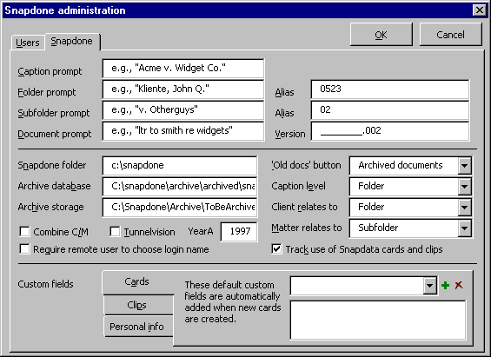
Click Snap Setup Administration Snapdone Snapdone to display the Snapdone configuration tab in the Snapdone administration screen:
K.1
K.21
K.20
K.19
K.18
K.17
K.16
K.28
K.25
K.26
K.27
K.24
K.23
K.22
K.15
K.14
K.13
K.12
K.11
K.6
K.10
K.9
K.8
K.4
K.7
K.5
K.3
K.2
Figure K

K.1 Users: This tab shows all profiles for all Snapdone users in your office. See Section III.B on page 15 for details.
K.2 Snapdone: This tab controls global Snapdone settings which affect all Snapdone users in your office.
K.3 Caption prompt: This box sets the parenthetical Short name of caption prompt which appears in the Snapcaption screen (Snapdone User’s Manual 4.3 ).
K.4 Folder prompt: This box sets the parenthetical Folder prompt which appears in the Snapsave and Snapopen screens (Snapdone User’s Manual 8.2 ).
K.5 Subfolder prompt: This box sets the parenthetical Subfolder prompt which appears in the Snapsave and Snapopen screens (Snapdone User’s Manual 8.3 ).
K.6 Document prompt: This box sets the parenthetical Document prompt which appears in the Snapsave and Snapopen screens (Snapdone User’s Manual 10.2 and 12.3 ).
K.7 Snapdone folder: This is the main network Snapdone folder where the Snapdone program is stored in your office. It appears in this menu for reference only.
K.8 Archive database: When Snapdone archives documents (Section V, page 25), it stores information about the archived documents in a database file stored at this location.
K.9 Archive storage: When Snapdone archives documents (Section V, page 25), they are moved into the temporary storage folder specified here. The administrator then moves them from the temporary folder to a permanent archive location, such as an external disk or CD.
K.10 Combine C/M: Snapdone supports several folder/subfolder organization schemes when storing documents. In a typical office, each folder corresponds to a client and each subfolder corresponds to a matter – in which case the Combine C/M checkbox should be unchecked, because the client/matter numbers are divided between the folder and subfolder. But, for example, in an atypical office where each folder corresponds to a matter and each subfolder corresponds to an author, the Combine C/M checkbox should be checked, because the client/matter numbers are combined in the folder name. This setting affects the way searches for client and matter names are performed in several Snapdone screens, such as Snapdone User’s Manual 1.14 and 18.3 .
K.11 Require remote user to choose login name: Depending on how remote connections are handled in your office, Snapdone may or may not be able to automatically determine the login name of a user when Word starts. Checking this checkbox requires remote users to manually enter their login name each time they start Word.
K.12 Tunnelvision: This checkbox determines whether Snapdone’s Tunnelvision feature is allowed in your office. For a description of Tunnelvision, see the Snapdone User’s Manual, Section VI.E.
K.13 Custom fields - Cards: Use this tab to manage the default list of custom fields which are added to Snapdata cards with the Add default custom fields to this card icon (Snapdone User’s Manual 22.3 ).
K.14 Custom fields - Clips: Use this tab to manage the default list of custom fields which are added to Snapdata clips with the Add default custom fields to this clip icon (similar to the same function on cards, described at the Snapdone User’s Manual 22.3 ).
K.15 Custom fields – Personal info: Use this tab to manage the custom fields which are included in the SnapPreferences screen (Snapdone User’s Manual 34.4f ).
K.16 YearA: When Snapdone creates ID codes for Snapsaved documents, the first character indicates the year in which the document is being saved. The letter A represents the first year Snapdone is used in your office, B the second year, and so on. The year in this box K.16 indicates the first year for Snapdone in your office (the year which corresponds to the letter A).
K.17 Track use of Snapdata cards and clips: If this box is checked, Snapdone keeps a record every time a Snapdata card or clip is viewed. An administrative macro can then be used to generate reports which show when cards were last used, or who used them (see M.2d ). Leave this checkbox unchecked if you are not interested in generating such reports and wish to keep network traffic to a minimum.
K.18 Name of custom field: To change the contents of a default custom field, select the field name in this box, then enter the contents of the field in K.19 .
K.19 Contents of custom field: To change the contents of a default custom field, select the field name in box K.18 , then enter the contents of the field in this box K.19 .
K.20 Add custom field: Click this icon to add a new default custom field to the list in box K.18 .
K.21 Delete custom field: Click this icon to delete the custom field selected in box K.18 .
K.22 Alias (prompt for folder alias): Use this box to set the parenthetical Alias prompt which appears in the Create Folder screen (Snapdone User’s Manual 8.6 ).
K.23 Alias (prompt for subfolder alias): Use this box to set the parenthetical Alias prompt which appears in the Create Subfolder screen (Snapdone User’s Manual 8.7 ).
K.24 Version (prompt for document version): Use this box to set the parenthetical Version prompt which appears in the Save as new version screen (Snapdone User’s Manual 11.2c ).
K.25 ‘Old docs’ button: Use this box to choose the function of the file drawer icon in the Snapopen screen (Snapdone User’s Manual 12.13 ). If Pre-Snapdone documents is chosen, the file drawer icon sends the user to Word’s standard File Open screen, with your office’s pre-Snapdone document folder selected. If Archived documents is chosen, the file drawer icon sends the user to Snapdone’s Find archived document screen (Snapdone User’s Manual Fig. 13 ).
K.26 Caption level: Depending on your office’s choice, Snapdone can store all Caption Bank captions in a single folder, subdivide them according to folder, or further subdivide them according to subfolder. Choose the desired level of subdivision with this box.
K.27 Client relates to: Snapdone supports several folder/subfolder organization schemes when storing documents. In a typical office, each client is assigned a particular folder. Choose Folder, Subfolder, or Neither in this box, depending on which applies in your office. This setting affects the way searches for client names are performed in several Snapdone screens, such as Snapdone User’s Manual 1.14 and 18.3 .
K.28 Matter relates to: Snapdone supports several folder/subfolder organization schemes when storing documents. In a typical office, each matter is assigned a particular subfolder. Choose Folder, Subfolder, or Neither in this box, depending on which applies in your office. This setting affects the way searches for matter names are performed in several Snapdone screens, such as Snapdone User’s Manual 1.12 and 18.6 .

Paper Types and ID Stamps
Every Snapdone document and template is assigned a “paper type.” (To assign a paper type to a template, see B.11 . To assign a paper type to a document, see Snapdone User’s Manual Fig. 33 .) When a document is Snapsaved, it is stamped with a document ID stamp which may contain the eight-character document ID code, client/matter number, author, typist, date and/or other information. The appearance of the stamp on various types of documents is controlled by creating different paper types. For example, your office may print final letters with an unobtrusive ID stamp in the bottom left corner of the last page, while it prints draft pleadings with a bulky ID stamp across the top of every page. To achieve this, you would create both a “letter” paper type and a “pleading” paper type, and format them differently with the SnapID format screen.
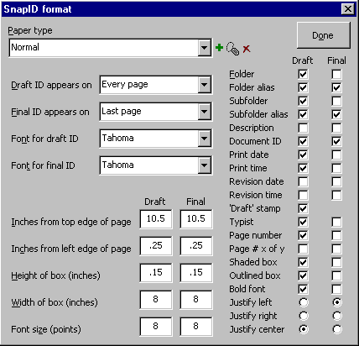
Click Snap Setup Administration Paper and ID to see the SnapID format screen. NOTE: Changes made in this screen do not take effect until after you have exited and restarted Word. To test new settings you have made in this screen, be sure to exit and restart Word first.
L.1
L.37
L.36
L.35
Figure L
L.34
L.33
L.32
L.31
L.30
L.27
L.28
L.29
L.26
L.25
L.24
L.6
L.5
L.21
L.22
L.23
L.20
L.19
L.18
L.17
L.16
L.15
L.14
L.13
L.8
L.12
L.11
L.10
L.9
L.7
L.4
L.3
L.2

L.1 Paper type: To work with a particular paper type, first select it in this box.
L.2 Add paper type: To create a new paper type, first select a similar paper type in box L.1 then click this icon.
L.3 Rename paper type: To rename an existing paper type, first select it in box L.1 then click this icon. Documents and templates which were associated with the old paper type will need to be reassigned with the new paper type. In the meantime, they will revert to the Normal paper type.
L.4 Delete paper type: To delete a paper type, first select it in box L.1 then click this icon. Any documents and templates which were associated with the deleted paper type will revert to the Normal paper type.
L.5 Draft column: The choices in this column apply to documents which are Snapsaved as draft documents (Snapdone User’s Manual 10.4 ).
L.6 Final column: The choices in this column apply to documents which are Snapsaved as final documents (Snapdone User’s Manual 10.4 ).
L.7 Draft ID appears on: You may choose to have draft ID stamps appear on Every page, First page, or Last page. This choice applies to documents which are Snapsaved as draft documents (Snapdone User’s Manual 10.4 ).
L.8 Final ID appears on: You may choose to have final ID stamps appear on Every page, First page, or Last page. This choice applies to documents which are Snapsaved as final documents (Snapdone User’s Manual 10.4 ).
L.9 Font for draft ID: Use this box to choose a font for ID stamps on documents which are Snapsaved as draft documents (Snapdone User’s Manual 10.4 ). The font is also affected by L.17 and L.34 .
L.10 Font for final ID: Use this box to choose a font for ID stamps on documents which are Snapsaved as final documents (Snapdone User’s Manual 10.4 ). The font is also affected by L.17 and L.34 .
L.11 Final column: The settings in this column apply to documents which are Snapsaved as final documents (Snapdone User’s Manual 10.4 ).
L.12 Draft column: The settings in this column apply to documents which are Snapsaved as draft documents (Snapdone User’s Manual 10.4 ).
L.13 Inches from top edge of page: This number determines vertical position of the ID stamp. For example, the number 0.5 would position the stamp in the top margin, while 10.5 would position it in the bottom margin. Note this is a measurement from the top edge of the paper to the top edge of the text box which contains the stamp – the Height of box L.15 will also affect the vertical position of the text contained within the text box.
L.14 Inches from left edge of page: This number determines horizontal position of the ID stamp. Note this is a measurement from the left edge of the paper to the left edge of the text box which contains the stamp – Width of box L.16 , Justify left L.35 Justify right L.36 and Justify center L.37 also affect the horizontal position of text within the text box.
L.15 Height of box (inches): This number determines the height of the text box which contains the ID stamp.
L.16 Width of box (inches): This number determines the width of the text box which contains the ID stamp.
L.17 Font size (points): This number determines the size of the font used for the ID stamp. The ID stamp font is also affected by L.9 , L.10 and L.34 .
L.18 Folder: Check one or both of these checkboxes to include the long descriptive folder name in the ID stamp on draft and final documents.
L.19 Folder alias: Check one or both of these checkboxes to include the short folder alias (typically a client number) in the ID stamp on draft and final documents.
L.20 Subfolder: Check one or both of these checkboxes to include the long descriptive subfolder name in the ID stamp on draft and final documents.
L.21 Subfolder alias: Check one or both of these checkboxes to include the short subfolder alias (typically a matter number) in the ID stamp on draft and final documents.
L.22 Description: Check one or both of these checkboxes to include the document’s long descriptive name in the ID stamp on draft and final documents.
L.23 Document ID: Check one or both of these checkboxes to include the document’s unique, eight-character ID code in the stamp on draft and final documents.
L.24 Print date: Check one or both of these checkboxes to include the date of printing in the ID stamp on draft and final documents. This date may not be accurate when viewing the document on screen, but updates automatically when the document is printed.
L.25 Print time: Check one or both of these checkboxes to include the time of printing in the ID stamp on draft and final documents. This time may not be accurate when viewing the document on screen, but updates automatically when the document is printed.
L.26 Revision date: Check one or both of these checkboxes to include the date the document was last saved in the ID stamp on draft and final documents.
L.27 Revision time: Check one or both of these checkboxes to include the time the document was last saved in the ID stamp on draft and final documents.
L.28 ‘Draft’ stamp: Check this checkbox to include the word DRAFT in the ID stamp on draft documents.
L.29 Typist: Check one or both of these checkboxes to include the typist’s initials in the ID stamp on draft and final documents. The typist’s initials are determined in Word with Tools Options User Information Initials.
L.30 Page number: Check one or both of these checkboxes to include page numbers in the ID stamp on draft and final documents.
L.31 Page # x of y: Check one or both of these checkboxes to include page numbers and total pages in the ID stamp on draft and final documents (for example, Page 2 of 5).
L.32 Shaded box: The text of the ID stamp is contained inside a text box. Check one or both of these checkboxes to make the interior of the box shaded gray on draft and final documents.
L.33 Outlined box: The text of the ID stamp is contained inside a text box. Check one or both of these checkboxes to make the outline of the box visible on draft and final documents.
L.34 Bold font: Check one or both of these checkboxes to use a bold font for the ID stamp on draft and final documents. The ID stamp font is also affected by L.9 , L.10 and L.17 .
L.35 Justify left: The text of the ID stamp is contained within a text box. Select this option for drafts, finals or both to align the text on the left side of the text box. Use L.14 and L.16 to change the horizontal position and width of the text box.
L.36 Justify right: The text of the ID stamp is contained within a text box. Select this option for drafts, finals or both to align the text on the right side of the text box. Use L.14 and L.16 to change the horizontal position and width of the text box.
L.37 Justify center: The text of the ID stamp is contained within a text box. Select this option for drafts, finals or both to center the text horizontally within the text box.. Use L.14 and L.16 to change the horizontal position and width of the text box.

Archiving
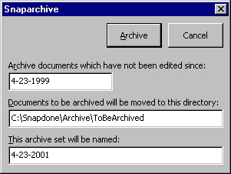
Snapdone can archive documents which have not been edited recently. Documents which have been marked Don’t archive in the Snapsave screen (Snapdone User’s Manual 10.7 ) are excluded from the archiving process. Click Snap Setup Administration Archiving to display the Snaparchive screen.
Enter a date in the Archive documents which have not been edited since box. Any documents which have been revised since this date will not be archived.
Note the path in the Documents to be archived will be moved to this directory box. Snapdone moves archived documents into this folder during the archiving process. After archiving is complete, you will need to move the archived documents from this folder to your archive media – for instance, external disk or writable CD-ROM. Note the date in the This archive set will be named box. When users look up archived documents, they will be referred to a particular archive “set.” Typically, the archive set is named with the date on which the archive was performed.
Click Archive to begin the archiving process. An indicator in the bottom left corner of the screen shows progress. After the archive is complete, remember to move the archived documents from the folder indicated in the Documents to be archived will be moved to this directory box to your archive media, and label the media with the name shown in the This archive set will be named box.
If you have not already done so, use K.25 to be sure the Old documents icon in the Snapopen screen (Snapdone User’s Manual 12.13 ) refers to archived documents, so that users will have access to the Find archived document screen (Snapdone User’s Manual Fig. 13 ) to locate archived documents.

Snapdata Management
To enter the Snapdata deck management screen, you must have privileges to manage Snapdata J.17 , decks must be turned on in your SnapPreferences screen (Snap Setup Preferences Miscellaneous Decks), and you must be using the unlimited mode of Snapdata (Snapdone User’s Manual Fig. 14 ).
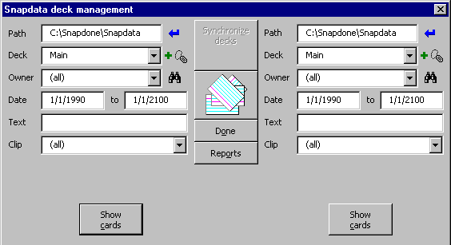
Click Snap Snapdata, then click the Manage Snapdata decks icon (Snapdone User’s Manual 15.6 ) to display the Snapdata deck management screen.
M.1
M.2
Figure M
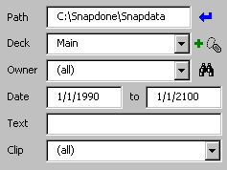
M.1 The duplicate controls on the left and right sides of the screen allow you to work with two sets of Snapdata cards or clips at the same time.
M.1j
M.1i
M.1h
M.1g
M.1f
M.1e
M.1d
M.1c
M.1b
Subfigure M.1
M.1a
M.1a Path: This is the path to the Snapdata folder on your system. Typically, all Snapdata decks are contained in one folder, but there may be circumstances when you need to specify different paths (for example, to coordinate data between a network and the local drive on a notebook computer). After specifying a new path in this box, click the Enter icon M.1g to refresh the screen.
M.1b Deck: Use this box to choose which Snapdata deck you are working with on this side of the screen. Each deck contains a set of Snapdata cards and clips which can be manipulated independent of other decks.
M.1c Owner: Choose an owner in this box if you want to restrict the view of cards and clips on this side of the screen to only those which have a certain owner.
M.1d Add deck icon: Click this icon to create a new Snapdata deck. The deck will be empty when it is first created. Anyone wanting to use the new deck will have to select it in their Snapdata screen (Snapdone User’s Manual 15.5 ).
M.1e Date: Use these two date boxes if you want to restrict the view of cards and clips on this side of the screen to only those which were last edited within a certain date range.
M.1f Text: Use this box if you want to restrict the view of cards and clips on this side of the screen to only those which contain a specific word or phrase. The word or phrase may be found anywhere on the card or clip.
M.1g Enter path icon: Click this icon to refresh the screen after typing a new path in box M.1a .
M.1h Rename deck icon: To rename a deck, first select it in box M.1b then click this icon.
M.1i Search for owners icon: When the Snapdata deck management screen first appears, box M.1c contains a list of all current Snapdone users in your office. To refer to past owners who are no longer Snapdone users in your office, click this icon M.1i , and all previous Snapdone users are added to the list (based on a search of the owners of all cards and clips in the selected deck).
M.1j Clip: This box is only visible when working with cards (see M.2b ). Use this box if you want to restrict the view of cards on this side of the screen to only those which are contained in a specific clip.
M.2 Show cards/clips: After choosing the selection criteria on each side of the screen, click this button to display card or clip lists, as shown below. The lists can then be manipulated using the buttons down the middle and along the bottom of the screen.
M.2d
M.2j
M.2m
M.2l
M.2k
M.2i
M.2e
M.2h
M.2g
M.2f
M.2c
M.2b
Subfigure M.2
M.2a
M.2a Synchronize decks: This button appears when two different decks are selected in M.1b and both lists M.2e are visible. Click Synchronize decks to make the two sets of items (cards or clips) shown in M.2e identical. Items which exist in one deck but not the other are copied to the other deck. If an item exists in both decks, the more recently edited item overwrites the older item.
M.2b Cards/clips icon: Click this icon to choose whether you are working with Snapdata cards or clips.
M.2c Done: Click this button to exit the Snapdata deck management screen.
M.2d Reports: Click this button to generate one of two reports: list all cards and clips, or track use of all cards and clips.
M.2e Card/clip lists: Select cards or clips in these lists before using the buttons in the middle of the screen. Use button M.2b to choose whether you are working with cards or clips.
M.2f Nonduplicates: Click this button to select all the items in this list which do not appear in the other list.
M.2g Duplicates: Click this button to select all the items in this list which also appear in the other list.
M.2h All/None: Click this button to select all or none of the items in the list.
M.2i Copy cards/clips: This button appears when two different decks are selected in M.1b , both lists M.2e are visible, and one or more items are selected in M.2e . Click this button M.2i to copy items selected in one list to the other list. The green arrows indicate the direction of copying – from the left list to the right list or vice versa. To change the direction of the green arrows, click on an item in the list from which items are to be copied.
M.2j Delete cards/clips: This button appears when one or more items are selected in M.2e . Click this button M.2j to delete the selected items. The red arrow indicates which items will be deleted – either the items selected in the left list or the right list. To change the direction of the red arrow, click on an item in the list from which items are to be deleted.
M.2k Add Owner: This button appears when one or more items are selected in M.2e . Click this button M.2k to add an owner to the selected items. The green arrow indicates which items will be affected – either the items selected in the left list or the right list. To change the direction of the green arrow, click on an item in the list which contains the relevant items.
M.2l Remove Owner: This button appears when one or more items are selected in M.2e . Click this button M.2l to remove an owner from the selected items. The red arrow indicates which items will be affected – either the items selected in the left list or the right list. To change the direction of the red arrow, click on an item in the list which contains the relevant items.
M.2m View cards: This button appears when cards are selected with button M.2b and one or more cards are selected in M.2e . Click this button M.2m to display the selected cards in the Snapdata screen. The green arrow indicates which cards will be displayed – either the cards selected in the left list or the right list. To change the direction of the green arrow, click on a card in the relevant list.

Global Template
If the user has turned on the Snapglobal template (Snap Setup Preferences Miscellaneous Use Snapglobal.dot template), you may use it as a repository for office-wide macros, autotext, styles, keyboards, and toolbars. It is located at SNAPDONE PATH\Set Up Local\Snapuser\Mirror\Program\Snapglobal.dot (if you do not know your Snapdone path, click Snap Setup Preferences Folders Network Snapdone folder). Changes made to this file are automatically downloaded to local workstations each time Word is opened.

Troublesome Paper Trays
Unlike other Snapdone features, SnapPaper Control must be configured at each individual workstation. Changes in printer drivers, printer servers, and even other software sometimes throws SnapPaper Control out of whack. Below are some tips to get it working again.
Is the printer configured properly in Windows?
Click Start, Settings, Printers, right-click on the printer icon, choose Properties. The Properties screen sometimes contains options concerning envelope feeders, extra paper trays, and so forth (often on a tab labeled Configuration). Make sure all of these settings are correct.
Is Snapdone seeing the printer?
Click File, Print, make sure the correct printer is selected in the Name box, and click Cancel.
Click Snap Setup Preferences Paper .
Click the green + icon beside the Printer box. If the message says Add the current printer to Snapdone’s list of printers? then click Yes and continue setting up the printer trays as described in Snapdone User’s Manual 34.7 .
Is Snapdone using the proper bin set for this printer?
Click File, Print, make sure the correct printer is selected in the Name box, and click Cancel.
Click File, Page Setup, Paper Source and write down the list in the First page box. Spelling and capitalization must be exact. You can safely ignore entries in the list which you will never use. Click Cancel to exit the screen.
Click Snap Setup Preferences Paper and select the printer in the Printer box.
Look in the list of available trays in the Print drafts to box. If the choices do not exactly match what you wrote down earlier, then click Change bin set for selected printer and find a bin set which does match.
If there is no bin set which matches exactly, then you need to create a new bin set: Exit Word and look in SNAPDONE PATH\Set Up Local\Printers (if you do not know your Snapdone path, click Snap Setup Preferences Folders Network Snapdone folder). Each of the text files in this folder is a bin set. Open one as a model, revise it to exactly match your list of printer trays, and save it as a new file. When you restart Word and go to the SnapPaper control screen, the newly created bin set will be available with the Change bin set for selected printer button.
Once the proper bin set is selected, continue setting up the printer trays as described in Snapdone User’s Manual 34.7 .

http:\\snapdone.org
Snapdone7

