Snapdata Mastery
© 2005 Snapdone, Inc.
Prerequisites: You have created and used Snapdata cards and Snapdata clips.
Searching for Details With Hunt (Snapdone 5)
Decks and the Deck Management Screen - Trick to select range of cards
Wider view, List in Document, “Jump To” (Snapdone 5)
Owners (Snapdone 5)
Copying Cards, Copying Clips, “Subclips”
Using Clip Fields - Case Sheet Example
Snippets
Layouts - List of Parties Example
Clip Tools: Card IDs, ID searches (Snapdone 5), Card Order
More Card Fields: Alerts, Client/Matter Info, Custom Fields, Notes, Related Parties (Snapdone 5), Address Parts
Multiple Pages, Multiple Emails, and Targets
Snapdata Preferences
Multiple Recipients - envelopes, labels, letters, faxes, emailing with attachments
Default custom fields, default clips (Snapdone 5)
Notification (Snapdone 5)
Adding Stamps and Delivery Methods
Formatting and Special Characters - http://www.starr.net/is/type/altnum.htm
Busy or Locked Cards and Clips

- PART ONE: BASICS -

EXERCISE : Snap on your menu
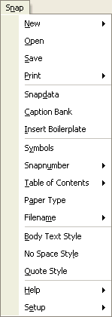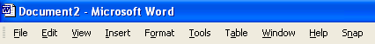Click Snap (or press Alt + N) to see the Snapdone commands. The other exercises in this workbook will walk you through many of them as you follow the progress of an imaginary case. After working through the exercises, you will have no trouble applying Snapdone to real-life projects.

THE CASE: Towne v. Livingston
New client Ramona Towne has retained attorney Everett Humble to represent her in a personal injury case. Ms. Towne was rear-ended by a car driven by Bill Livingston and complains of severe back pain. Mr. Livingston is insured by Friendly Insurance Company, which has declined to compensate Ms. Towne for her alleged injuries. Mr. Livingston and Friendly Insurance are represented by attorney Betty Kugland.

EXERCISE : Type a letter

Create a Snapdata card
You need to send an engagement letter to the new client, Ms. Towne. Since you will be sending many letters to Ms. Towne in the upcoming months, you will create a Snapdata card for her. The card will be used repeatedly to quickly create letters, fax covers, envelopes, labels, and many other projects over the span of the case.
This will be the first and last time you or anyone else in your office needs to type Ms. Towne’s address and related information.
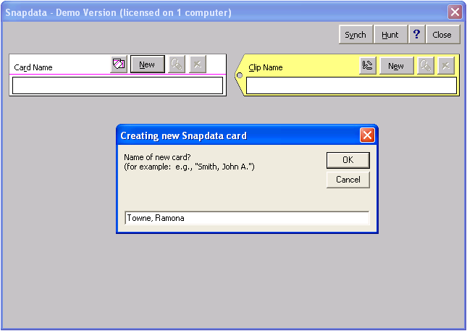Click Snap / Snapdata to open the Snapdata screen. Do not be concerned if your screen looks different than the picture here — the Snapdata screen changes depending on how it was last used. Click New (or press Alt + N) to create a new card, type Towne, Ramona, and click OK.

NOTE: Someone else in your office may have already done the exercises in this workbook. If you see messages like “There is already a card by that name,” you will need to make up your own imaginary client names as you work through these exercises.
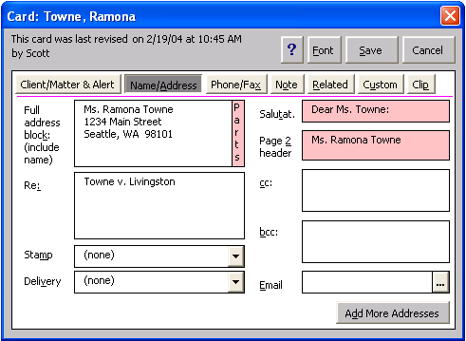You are now editing a new, blank Snapdata card named Towne, Ramona. Type Ms. Towne’s name and address in the Full address block box just as you would type them on an envelope. Press Tab to move to the Re box, and notice that Snapdone automatically adds a salutation and second-page header. (The boxes turn pink to remind you to double-check Snapdone’s guesses.) Type Towne v. Livingston in the Re box — this will be the default re line used on letters to Ms. Towne. Click Save to save the card and return to the Snapdata screen.

Use a Snapdata card to create a letter
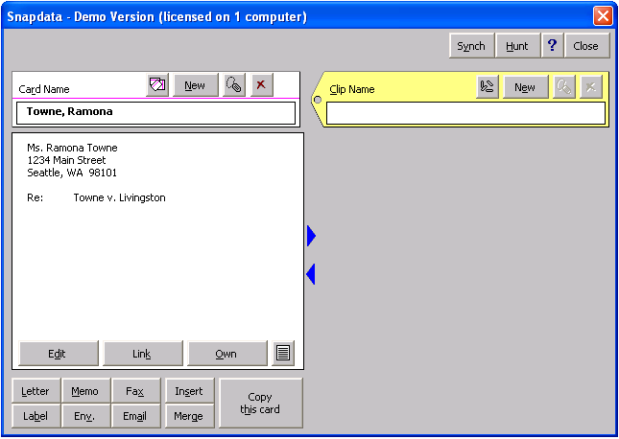Now that you have a card for Ms. Towne, use it to prepare the engagement letter. Assuming the Snapdata screen is still visible (if not, click Snap, Snapdata to get back to it), click Letter to display the Snapletter screen.

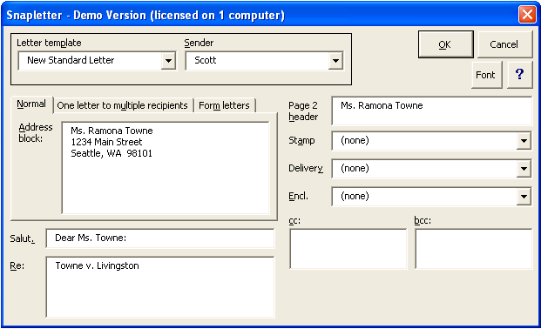Your Snapletter screen may look different than this one. But note that the address block, salutation, re line, and second-page header have been filled in with information from the Towne card. In addition, you may see several other boxes that allow you to further customize the letter, such as sender, stamp, delivery method, enclosures, cc recipients, and bcc recipients. Once everything is to your liking, click OK. The letter is generated, and all that remains is for you to type the body of the letter.

EXERCISE : Snapsave the engagement letter
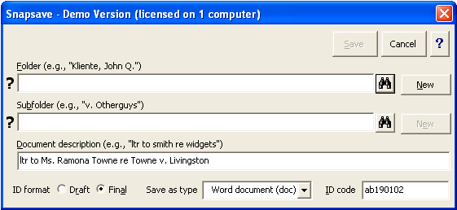With the engagement letter from the last exercise on your screen, click Snap / Save to display the Snapsave screen. Note that Snapdone has already filled in the document description and assigned a unique document ID code to the letter.
Since this is a brand new case, before saving the document you will have to create a Folder and Subfolder where the letter (and other documents in this case) will be saved.

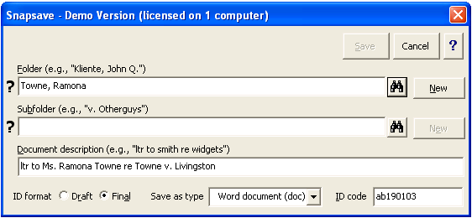Create a Folder
To create a Folder for the new client, type Towne, Ramona in the Folder box and click New. Depending on how Snapdone is configured in your office, you may also be asked to provide an “alias” for the folder. Aliases (usually client numbers) are used in some offices so that a more detailed ID code can be stamped on the printed document.
NOTE: This workbook assumes that Folders and Subfolders in your office correspond to clients and matters (Folder = client; Subfolder = matter). But your office may use a different organization scheme. Some offices even use “Cabinets,” which appear above the Folder box. If you are unfamiliar with your office’s organization scheme, consult with your administrator or contact Snapdone.

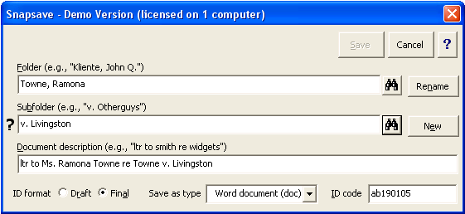Create a Subfolder
You also need to create a Subfolder for the Livingston matter. Type v. Livingston in the Subfolder box and click New. Again, depending on how Snapdone is configured in your office, you may be asked to provide an alias for the Subfolder (usually a matter number).

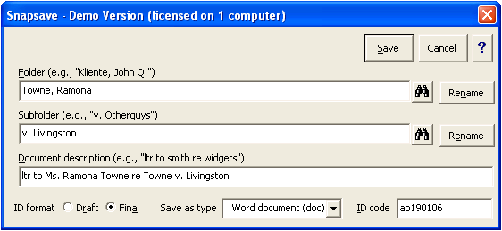Save the letter
Click Save, and the letter is stamped with the appropriate ID code and saved to the proper location.
Print the letter (you will use it in the next exercise), then close it from your screen.

EXERCISE : Revise the engagement letter
You have some revisions for the engagement letter. You will use the Snapopen command to find the letter, then Snapsave it again after making revisions.

Snapopen the letter
Click Snap / Open to display the Snapopen screen. Again, don’t be alarmed if your screen looks different than the one shown here. There are many ways to locate documents with the Snapopen screen. This exercise demonstrates two methods.

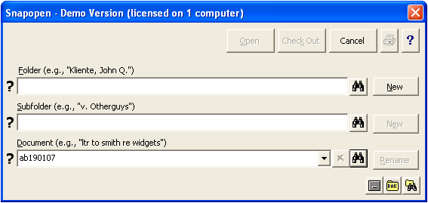Locating a document –
with the ID code
In Exercise 3 you printed the engagement letter. Since the eight-character ID code is stamped at the bottom of the printed letter, you can locate the document immediately without specifying a Folder or Subfolder. First make sure the Folder and Subfolder boxes are empty – this indicates you are looking in all folders and all subfolders. Then type the eight-character document ID code in the Document box (your code will be different than the code pictured here), and click the binoculars icon (or just press Enter) to perform the search.
NOTE: In some offices, the ID code stamped at the bottom of printed documents may include Folder and Subfolder codes (usually client/matter numbers). If so, you can accelerate searches by typing these codes into the Folder and Subfolder boxes before typing the document ID code.
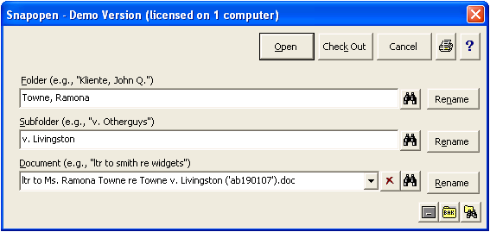The full name of the document appears, along with the appropriate Folder and Subfolder names. Click Open to open the letter.

Locating a document – without the document ID code
Now imagine you don’t have the printed engagement letter at hand. You can still locate the document, even without the ID code. Suppose you remember that Towne is the client name, but you forget the name of the matter. Click Snap / Open to see the Snapopen screen.
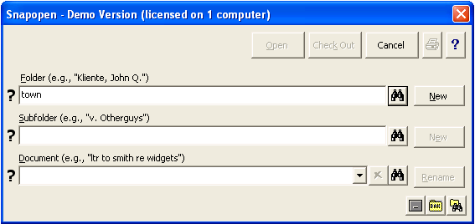First identify the Folder, since it is known. Type any part of the Folder name (for example, town or ramona) in the Folder box and click the binoculars icon (or just press Enter) to identify the correct Folder.
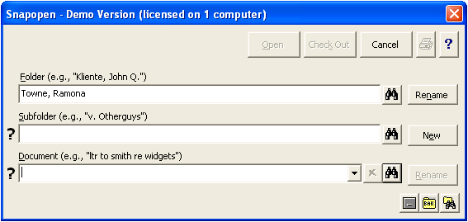Leave the Subfolder box empty (since the name of the matter is unknown), and click the binoculars icon beside the Document box (or just press Enter while your cursor is in the Document box). Snapdone searches within the designated Towne, Ramona Folder. Since there is only one document, it is automatically selected. If there were several documents, they would be listed, and you would choose the document from a list. Once the document is identified, click Open to open the letter.

Revise and save the letter
Make the (imaginary) revisions to the engagement letter, then click Snap / Save. When asked whether to replace the previous draft, click Yes. At the Snapsave screen, click Save, then leave the letter open on your screen for use in the next exercise.

EXERCISE : Create an envelope
There are three ways to create an envelope: (l) from scratch (click Snap / New / Envelope, and fill in the name and address), (2) from a Snapdata card (from the Snapdata screen, click Env), and (3) from a letter. Since the engagement letter is still on your screen from the previous exercise, we will use the third method.
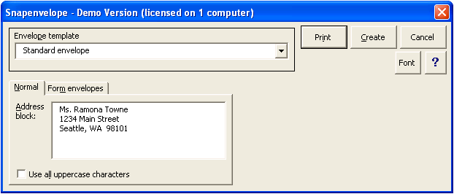With the engagement letter on your screen, click Snap / New / Envelope. Ms. Towne’s address appears in the Snapenvelope screen. Click Print to send the envelope directly to the printer.

EXERCISE : Make a fax cover sheet

Add a fax number to a card
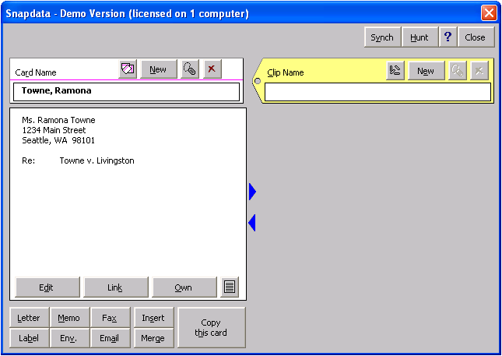Click Snap / Snapdata to display the Snapdata screen. If Ms. Towne’s card is not already displayed, you can quickly locate it by typing Towne or Ramona in the Card Name box and pressing Enter. Click Edit to open the card editing screen.
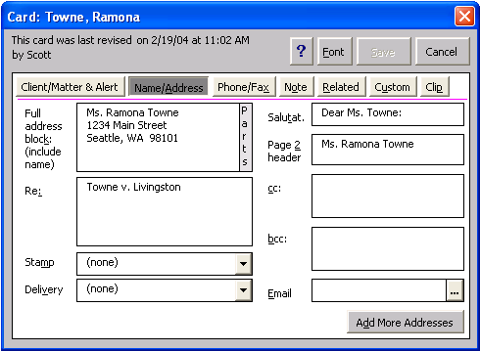Every Snapdata card has several sections. Click Phone/Fax to see the Phone/Fax section of the Towne card.

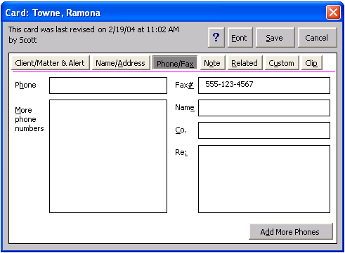Type Ms. Towne’s fax number in the Fax# box and click Save. The fax number is now saved on the card, and no one in your office will ever have to type it onto a fax cover again.

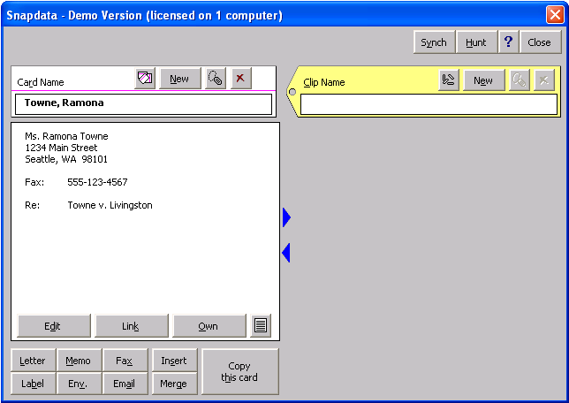Click Fax to make a fax cover to Ms. Towne.
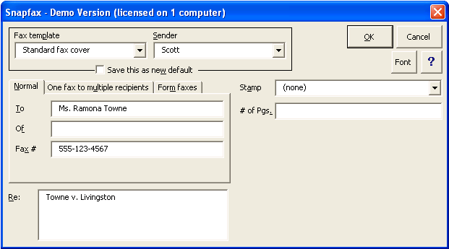Note that the Snapfax screen is filled in with Ms. Towne’s name, fax number, and a re line. Your screen may include other boxes too. Once everything is to your liking, click OK, and the fax cover will appear, ready for you to type a message before printing.

EXERCISE : Type a complaint

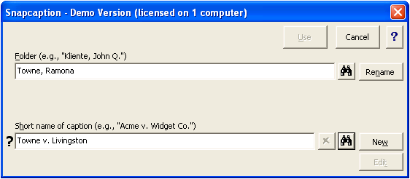Create a caption
Click Snap / Caption Bank to open the Snapcaption screen. If the Towne, Ramona Folder is not already selected, type Towne or Ramona in the Folder box and press Enter to select it.
Type a short name for the new caption (Towne v. Livingston) in the Short name of caption box and click New to create it.
NOTE: Depending on how Snapdone is configured in your office, there may also be a Subfolder box on this screen. It is used to further categorize your captions. For example, the Folder usually applies to a particular client, while the Subfolder applies to a particular matter for that client.
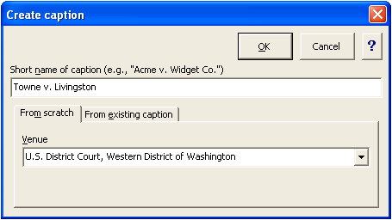The Create caption screen appears. Select a court in the Venue box and click OK.
Fill in the gray boxes on the caption, pressing Tab to move from one box to the next. After tabbing out of the last box, the caption is saved in the Caption Bank and a message appears, reminding you to click File / Close to finish the process.

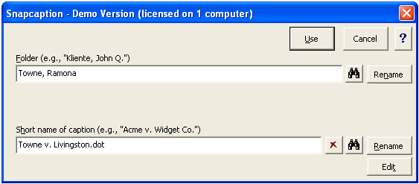Use a caption
Click Snap / Caption bank to open the Snapcaption screen. The caption you just created is preselected, so click Use to use it.
Type the title of the pleading in the gray box and press Tab. The title is copied into the footer, and you are ready to type the body of the pleading.

- PART TWO: CLIPS AND MERGES -
Casual Snapdone users may want to stop at this point. You can now create and use Snapdata cards to type letters, memos, faxes, envelopes and labels; Snapsave and Snapopen documents; and use the Caption Bank to create pleadings. More adventurous Snappers should proceed with this Part Two.

EXERCISE : Create a clip

Create some cards
First create cards for imaginary parties Bill Livingston (defendant), Betty Kugland (opposing counsel), and Friendly Insurance Company (defendant). Refer to Exercise 2 if you need help creating the cards.

What is a clip?
Clips are used to group cards together. You might have a Holiday List clip which contains people on your holiday card list. Or an Expert Witnesses clip to keep track of potential expert witnesses. In this exercise, you will create a clip for the Towne v. Livingston case which contains all the cards related to the case: Towne, Livingston, Kugland, and Friendly Insurance. You will then use the clip as a handy case reference and to easily generate form letters, mailing labels, faxes to multiple recipients, and more.

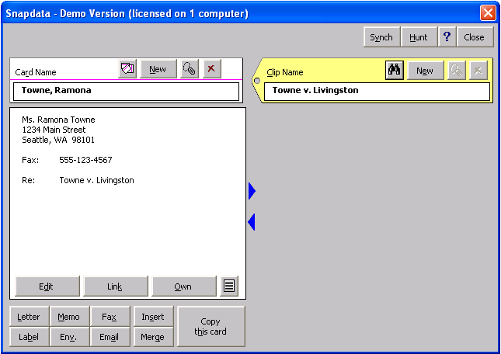Create the clip
Click Snap / Snapdata and notice the yellow tag on the right. This tag refers to Snapdata clips in the same way that the card on the left refers to Snapdata cards. To create a clip for this case, type Towne v. Livingston in the Clip Name box and click New. (The Towne card happens to be visible in this picture, but it is not necessary – clips and cards can be manipulated independently of each other.)

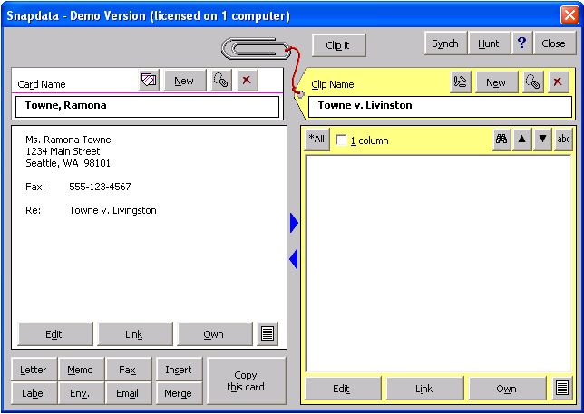Attach cards to the clip
The clip does not contain any cards yet. Since the Towne card happens to be visible, it makes a good starting point. Click Clip it to clip the Towne, Ramona card into the Towne v. Livingston clip.

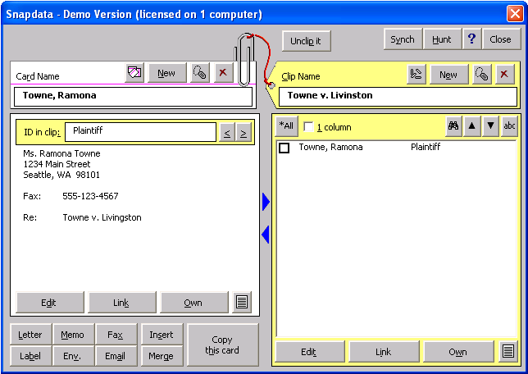Three visible cues make it clear that this card is now clipped into this clip. As indicated with arrows in the picture, the paperclip is clipped onto the card and Towne, Ramona now appears in the list on the right side of the screen. Also, a yellow ID in clip box has appeared at the top of the card. Use this box to indicate how this card is related to this clip. In this case, Ramona Towne is the plaintiff in the Towne v. Livingston litigation, so type Plaintiff in the box

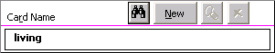You will clip three more cards into this clip. First locate the Livingston card by typing living in the Card Name box then clicking the binoculars icon (or press Enter instead of clicking the binoculars). If more than one card contains “living” in its name, they will appear in a list, and you can select the correct card on the list.
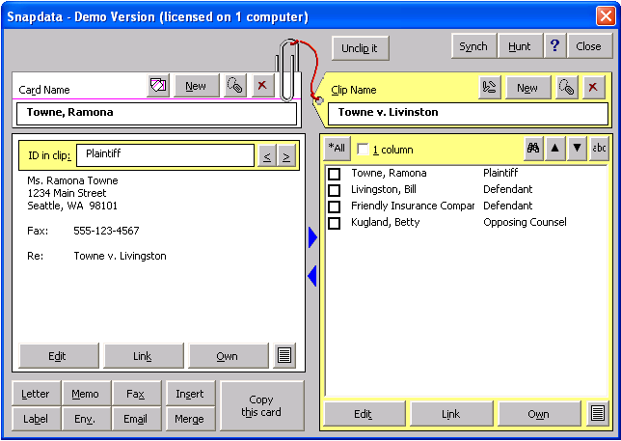Once you have located the Livingston card, click Clip it and type Defendant in the ID in clip box. Then locate and clip the two remaining cards: Kugland (opposing counsel) and Friendly Insurance (defendant).
When you finish, four cards will be contained in the Towne v. Livingston clip and listed on the right side of the screen.

EXERCISE : Exploring the Snapdata screen

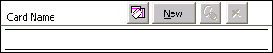Card and clip boxes
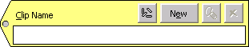Take a closer look at the Snapdata screen. The top half of the screen contains a Card Name box and a Clip Name box.
The Card Name box is used to create, select, rename and delete cards; the Clip Name box is used to create, select, rename and delete clips.
Create a card or clip by typing its name and clicking New.
Select a card or clip by typing part of its name and pressing Enter (or click the binoculars icon ).
Rename a card or clip by selecting it then clicking the dogtag icon ( ).
Delete a card or clip by selecting it then clicking the X icon ( ).

Clip it / Unclip it
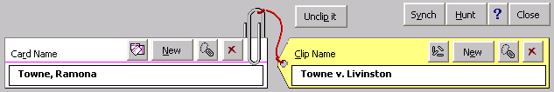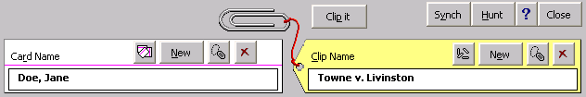When both a card and clip are selected, the Clip it or Unclip it button appears, depending on whether the selected card is clipped into the selected clip. Cards are added to and removed from clips with these two buttons.
Note that you can view any card at the same time you are viewing any clip – there is no requirement that the two be clipped together, or even related to each other.

EXERCISE : Insert addresses in a certificate of service
Create a certificate of service, using the caption you created in Exercise 7 (click Snap / Caption Bank, select the caption, and click Use).

Insert one address from a card
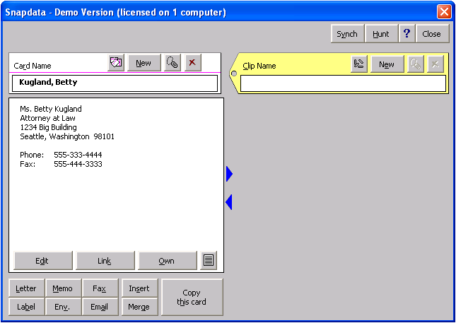Position the cursor at the location in the certificate of service where addresses of the various parties should appear, and switch to single-spacing if necessary.
Click Snap / Snapdata to display the Snapdata screen, select the Kugland card (type kug in the Card box and press Enter), and click Insert.

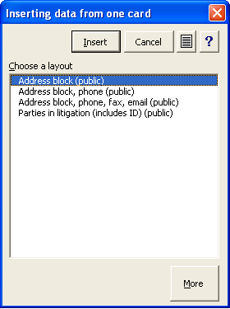The Inserting data screen lets you choose a layout for the inserted text. For this example, select a layout which includes the address block and click Insert.
You could use the same method to insert the addresses of Mr. Livingston and Friendly Insurance, but an even better method is shown in below.

Insert several addresses from a clip
Since the Towne v. Livingston clip contains all the relevant cards, you can use it to insert all the addresses at once. In this example, you will only insert two addresses, but you could use the same technique to insert any number of addresses.
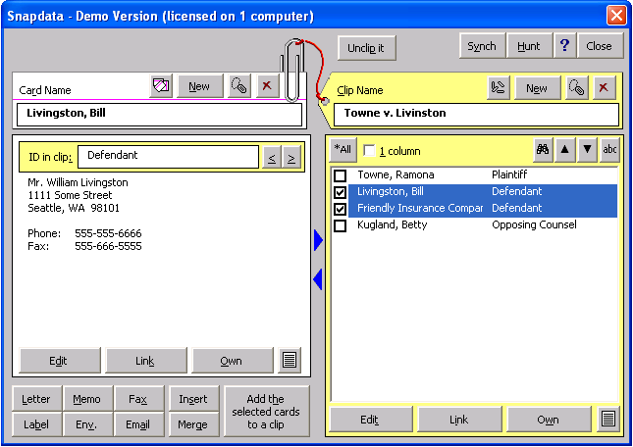In the certificate of service, position the cursor where the addresses of Livingston and Friendly Insurance belong, then click Snap / Snapdata. Select the Towne v. Livingston clip (type towne in the Clip box and press Enter), click the checkboxes to select both the Livingston card and the Friendly Insurance card, then click Insert.
In the “Inserting data” screen, choose a layout which includes the address block, then click Insert. Addresses from each of the two selected cards are inserted into the certificate of service.

EXERCISE : Add a re line to a clip
When you created a card for Ramona Towne in Exercise 2, you included the re line “Towne v. Livingston.” But Betty Kugland is the opposing counsel in several different cases, so you should not add a re line to her card. Instead, type a re line on the Towne v. Livingston clip. That way, whenever you use the Towne v. Livingston clip to write to anyone, the correct re line will be included.
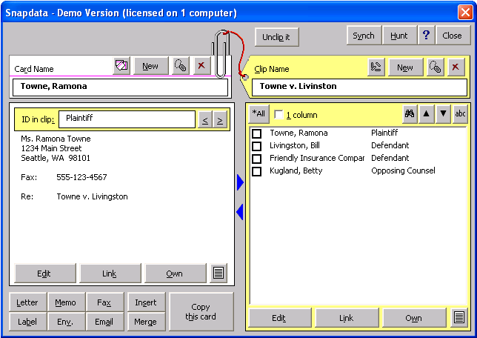Click Snap / Snapdata and select the Towne v. Livingston clip (type towne in the Clip box and press Enter). Click Edit at the bottom of the clip display (not Edit at the bottom of the card display) to open the Clip editing screen.

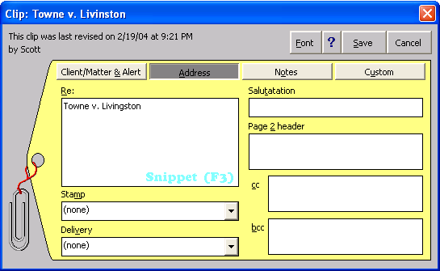Type Towne v. Livingston in the re box and click Save.

EXERCISE : Type a fax cover to multiple recipients
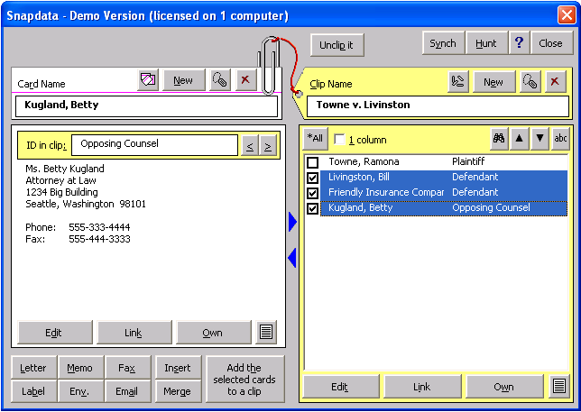You need to send a fax to the opposing parties and their counsel. You will create one fax cover which lists all three recipients.
Click Snap / Snapdata and select the Towne v. Livingston clip (type towne in the Clip Name box and press Enter). Click the checkboxes to select the desired cards (Kugland, Livingston, and Friendly Insurance), and click Fax.

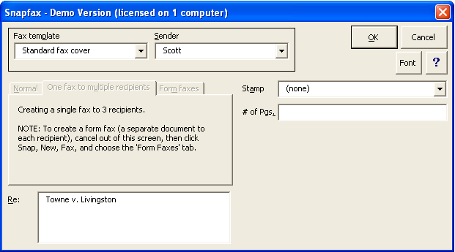Note that the default re line you added to the clip in Exercise 11 has been included. Make any desired changes in this screen, then click OK to create the fax cover.

EXERCISE : Create labels

Make a single label from a Snapdata card
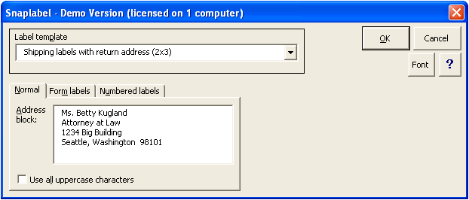You are sending a letter to Ms. Kugland with several enclosures, and you need to prepare a shipping label instead of an envelope. Click Snap / Snapdata, select the Kugland card (type kug in the Card box and press Enter), and click Label to display the Snaplabels screen.
Choose Shipping labels with return address (2x3) in the Label template box and click OK.
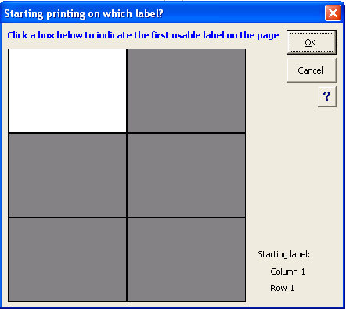A diagram appears, showing a page of labels. Click the label you want (skipping over any labels on the sheet which have already been used), and click OK. The completed label appears on your screen, ready to print.

Make several labels from a Snapdata clip
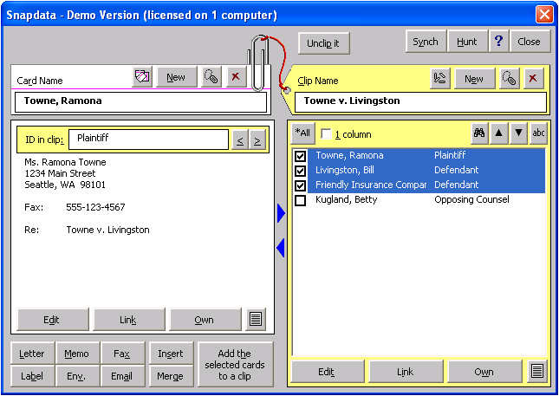The next day, you need multiple labels to send all the documents to Ms. Towne, Friendly Insurance, and Mr. Livingston. Click Snap / Snapdata and select the Towne v. Livingston clip (type towne in the Clip Name box and press Enter). Click the checkboxes to select the desired cards (Towne, Livingston, and Friendly Insurance), and click Label.
When the label diagram appears, click on a starting label (in case you have already used some of the labels on the page), and click OK. The labels appear, ready for printing.

EXERCISE : Wing it
Snapdone allows many approaches to any one task. If you are inclined to create an envelope from a letter on your screen, do so; if you would rather pull the address off a Snapdata card, so be it. You can select an item in a list and click the OK button, or you can double-click the item and be done with it. Pressing Enter works in many situations instead of clicking an icon. Try whatever seems right, and you will often find that Snapdone accommodates your own work style and rhythm.
A few additional sources of help are available as you explore the program. When curious about a particular button or icon, aim the mouse at it and a short, explanatory “Tool Tip” will appear. And of course, Snap / Help provides guidance too, including a few documents like this one.
Enjoy the program, and please let us know if you have an idea to make it work even better. User-inspired improvements lead to snappy upgrades.

