Snapnumbers
SnapTOC
© Inspired Computing, Inc., 1998-2001

Table of Contents
Snapnumbers 1
What Are Automatic Paragraph Numbers? 1
What Are Snapnumbers? 2
Inserting Snapnumbers 2
Changing the Numbering Scheme 3
Choosing a Predefined Numbering Scheme 3
Creating a Custom Numbering Scheme 3
Saving and Deleting Custom Numbering Schemes 5
Resetting Snapnumbers 6
SnapTOC 7
Marking Text for the Table of Contents 7
Generating the Table of Contents 8
Regenerating the Table of Contents 8
Removing Marks 8
Viewing TOC Marks 8

Snapnumbers

What Are Automatic Paragraph Numbers?
Background Information for New Users. If you are already familiar with automatic paragraph numbering, feel free to skip this section, and pick up with “What Are Snapnumbers?” on page 2.
Overview. Automatic paragraph numbers are codes placed into a document instead of typing actual characters. They are most commonly used to sequentially number paragraphs. The numbering codes generate whatever number is appropriate at that point in the document (even when the document is edited and paragraphs are rearranged). There are two major benefits to using automatic paragraph numbers: (1) they prevent many numbering errors (for example, two paragraph C’s, but no paragraph D); and (2) when documents are edited, the automatic numbers automatically renumber as appropriate. So, for example, in a document which contains 100 numbered paragraphs, if you insert a new Paragraph No. 1, all of the other paragraphs will automatically renumber themselves.
Levels. Most legal documents use more than one level of numbering. The document shown in Figure 2 (page 2) uses three levels: Level 1 is an uppercase Roman numeral followed by a period (I. II. III. …); Level 2 is an uppercase alpha character followed by a period (A. B. C. …); and Level 3 is an arabic numeral followed by a period (1. 2. 3. …). When typing a document which uses automatic paragraph numbers, instead of physically typing a number into the document, you choose what numbering level is needed, and the code is inserted, resulting in whatever number is appropriate at that point in the document.
Numbering Schemes. A numbering scheme determines the appearance of each level of numbering in a document. Here are a few sample numbering schemes:

Normal  Numbering Scheme | Legal  Numbering Scheme | Agreement  Numbering Scheme
Level 1: I. II. III. …  Level 2: A. B. C. …  Level 3: 1. 2. 3. …  Level 4: a. b. c. …  Level 5: (1) (2) (3) …  Level 6: (a) (b) (c) …  Level 7: (i) (ii) (iii) …  Level 8: (A) (B) (C) …  Level 9: (I) (II) (III) … | Level 1: 1. 2. 3. …  Level 2: 1.1 1.2 1.3 …  Level 3: 1.1.1 1.1.2 1.1.3 …  Level 4: 1.1.1.1 1.1.1.2 1.1.1.3 …  Level 5: 1.1.1.1.1 1.1.1.1.2 1.1.1.1.3 …  Level 6: 1.1.1.1.1.1 1.1.1.1.1.2 1.1.1.1.1.3 …  Level 7: 1.1.1.1.1.1.1 1.1.1.1.1.1.2 1.1.1.1.1.1.3 …  Level 8: 1.1.1.1.1.1.1.1 1.1.1.1.1.1.1.2 1.1.1.1.1.1.1.3 …  Level 9: 1.1.1.1.1.1.1.1.1 1.1.1.1.1.1.1.1.2 1.1.1.1.1.1.1.1.3 … | Level 1: Article I Article II Article III …  Level 2: Section 1.1 Section 1.2 Section 1.3 …  Level 3: 1.1.1 1.1.2 1.1.3 …  Level 4: a. b. c. …  Level 5: (1) (2) (3) …  Level 6: (a) (b) (c) …  Level 7: (i) (ii) (iii) …  Level 8: (A) (B) (C) …  Level 9: (I) (II) (III) …
Figure 1

Attached Levels. When more than one numeral or letter appears in an automatic paragraph number, it is because previous levels are “attached”. For example, in the Agreement Numbering Scheme shown in Figure 1 , the Level 2 number includes the attached Level 1 number: “Section 1.1”. As a more extreme example, in the Legal Numbering Scheme shown in Figure 1 , Level 9 includes eight attached previous levels, resulting in this automatic number: “1.1.1.1.1.1.1.1.1”.

What Are Snapnumbers?
Figure 2
I. Snapnumbers
A. Inserting Snapnumbers. Press Alt+1 through Alt+9 to insert a Snapnumber.
B. Changing Numbering Scheme. To switch to another numbering scheme, click Snap, Snapnumber Options.
II. SnapTOC
A. Marking Text.
1. Marking Manually. Press Alt+M to manually mark text.
2. Marking Automatically. To automatically mark text, click Snap, Mark Document for TOC.
B. Generating the Table of Contents. Click Snap, Generate TOC to generate the table of contents.
Snapnumbers provide a flexible, stable alternative to Word’s built-in paragraph numbering feature. They are not linked to styles, so they can be used anywhere in a document, regardless of formatting considerations. Simply type text normally – tabbing, indenting, and formatting as desired – then when you want to insert a Snapnumber press Alt+1 through Alt+9 to choose Level 1 through Level 9.
In the sample document shown in Figure 2 , Level 1 is uppercase Roman (I, II, III), Level 2 is uppercase alpha (A, B, C), and Level 3 is arabic (1, 2, 3). So you would press Alt+1 to type the “I.” and “II.”; press Alt+2 to type the “A.” and “B.”; and press Alt+3 to type the “1.” and “2.”

Inserting Snapnumbers
Faster method: Position the cursor where the Snapnumber should appear and press Alt+1 through Alt+9 to choose a level. This method is fast, but no preview is provided before a level is chosen.
Figure 3
Slower method with preview: Position the cursor where the Snapnumber should appear and click Snap, Snapnumber, Insert to display the Snapnumber screen Figure 3 . Press a number from 1 to 9 on the keyboard (or click a number on the screen) to choose a level. This method is slower, but allows you to preview the appearance of each level before making a selection.

Changing the Numbering Scheme

Choosing a Predefined Numbering Scheme
Several predefined numbering schemes are available (Normal, Legal, Interrogatories, etc.). To choose one, click Snap, Snapnumber, Setup to display the Snapnumber options screen:
4.1
Figure 4
4.2
Click Predefined 4.1 , choose a predefined numbering scheme 4.2 , and click OK.

Creating a Custom Numbering Scheme
If none of the predefined numbering schemes is right for a particular document, click Custom 5.1 to create a custom numbering scheme.
5.1
Figure 5
5.7
5.6
5.5
5.4
5.3
5.2
5.1 Custom: Click here to enable the customizing buttons.
5.2 Edit Level: Click one of the Edit Level # buttons to change the appearance of a particular level.
5.3 Number style box: This box appears after you click an Edit Level # button 5.2 . Use this box to choose a numbering style for the selected level (for example: I, II, III; A, B, C; 1, 2, 3).
5.4 Surrounding text box: Use this box to add text around the number (for example: 1., (1), Chapter 1, Section 1, Interrogatory No. 1).
5.5 Attach previous level(s) boxes: Use these boxes to attach numbers from previous levels to the selected level. For example, to create the document in Subfigure 5.5 , edit Level 2 and check the “Attach previous level(s)” box beside Level 1, as circled below:
Subfigure 5.5
Section 1.
1.1 This is the first paragraph.
1.2 This is the second paragraph.
Section 2.
2.1 This is the third paragraph.
2.2 This is the fourth paragraph.
5.6 Restart numbering after higher level: This box is usually selected. Deselect it only if you want numbering to continue sequentially for the level regardless of intervening higher-level numbers. For example, to create the document in Subfigure 5.6 , deselect Level 2’s “Restart numbering after higher level” checkbox as circled below:
Subfigure 5.6
I. HEADING ONE
1. This is the first paragraph.
2. This is the second paragraph.
II. HEADING TWO
3. This is the third paragraph.
4. This is the fourth paragraph.
5.7 Legal style: Select this box to make a level arabic style, even if it includes attached levels which are not arabic. For example, in Subfigure 5.7 , Level 1 is Roman in the heading (“I.”), but arabic in the paragraph (“1.1”). To create this document, select Level 2’s “Legal style (all arabic numbers)” checkbox as circled below.
Subfigure 5.7
I. HEADING ONE
1.1 This is the first paragraph.
1.2 This is the second paragraph.
II. HEADING TWO
2.1 This is the third paragraph.
2.2 This is the fourth paragraph.

Saving and Deleting Custom Numbering Schemes
Saving a Scheme. If you create a custom numbering scheme which will be used in other documents, you can save it so that it will appear on the list of predefined numbering schemes 4.2 . After creating the custom numbering scheme, click the Save button (circled in Figure 6 ).
Figure 6

Enter a name for the new scheme Figure 7 , and choose whether the scheme will be public or private. Public schemes are saved in a central location on a computer network, and everyone has access to them. Private schemes are saved in an area where only you have access to them. NOTE: Depending on how Snaplet is configured in your office, the public/private options may not appear on this screen. Some offices (particularly non-networked offices) use only private schemes; some offices use only public schemes. The Save as public and Save as private options appear only if your office uses both public and private schemes.
Figure 7
If you use the name of an existing scheme, you will be asked whether you want to replace the old scheme with the new scheme.
Deleting a Scheme. To delete one of the predefined numbering schemes, first select it then click the Delete button (circled in Figure 8 ). Note: You cannot delete the “Normal” scheme, but you can change it by saving a custom scheme and naming it “Normal”.
Figure 8

Resetting Snapnumbers
To reset numbering partway through a document, or to start numbering with a number other than 1, first select the Snapnumber to be changed, then click Snap, Snapnumber, Reset to display the Reset Snapnumber screen:
9.1
Figure 9
9.2
9.3
9.1 Reset Snapnumber: Select this option to change the number of the preselected Snapnumber.
9.2 Continue numbering: Select this option to revert to ordinary numbering for the preselected Snapnumber.
9.3 Starting number: Enter the desired starting number for the preselected Snapnumber here. Type an arabic number, even if the selected Snapnumber will be Roman or alpha.

SnapTOC
SnapTOC easily generates tables of contents, even when headings are embedded within numbered paragraphs. First you will mark text to be included in the table of contents, then you will generate the table of contents.

Marking Text for the Table of Contents
Marking Text Manually. You can manually mark text for the table of contents as you type. To manually mark an item, position the cursor at the end of the item and press Alt+M. In the sample document at right Figure 10 , asterisks indicate the points at which you would press Alt+M. NOTE: To see the marks as you work, toggle them on and off by clicking Snap, Table of Contents, Bookmarks (In)visible (see Figure 13 ).
Figure 10
I. Snapnumbers*
A. Inserting Snapnumbers.* Press Alt+1 through Alt+9 to insert a Snapnumber.
B. Changing Snapnumber Scheme.* To switch to another numbering scheme, choose Snap, Snapnumber Options.
II. SnapTOC*
A. Marking Text.*
1. Marking Manually.* Press Alt+M to manually mark text.
2. Marking Automatically.* To automatically mark text, choose Snap, Mark Document for TOC.
B. Generating the Table of Contents.* Choose Snap, Generate TOC to generate the table of contents.
Pressing Alt+M when you have a flashing cursor marks from the beginning of the paragraph to the cursor. This is the usual method for marking text. But for greater control – for example, to mark a few words in the middle of a paragraph – first select the desired text then press Alt+M.
NOTE: Word’s heading styles (Heading 1 through Heading 9) are automatically included in the table of contents, so you don’t need to mark any text which is formatted with a heading style.

Marking Text Automatically. Instead of marking each item for the table of contents manually, you can have SnapTOC mark a whole document at once. To automatically mark the document in Figure 10 (assuming you have not already marked it manually), choose Snap, Table of Contents, Mark Document to display the SnapTOC screen Figure 11 .
Figure 11
Three levels are to be included in this particular table of contents. At Level 1, the text to be marked for the table of contents is bold, so choose Bold text in the Level 1 box. At Level 2 the underlined text will be marked, so choose Underlined text in the Level 2 box. At Level 3 the italicized text will be marked, so choose Italicized text in the Level 3 box. These choices are shown in Figure 11 . Then click Mark Snapnumbered paragraphs to automatically mark all three levels throughout the document.
Using a Combination of Automatic and Manual Marking. Often you will use a combination of automatic and manual marking. After marking a document automatically, scroll through the document to verify the marks. If any need to be changed, mark them manually with Alt+M. Or remove the mark from a selected paragraph by clicking Snap, Table of Contents, Remove Marks.
Heading Styles Do Not Require Marking. Word’s built-in heading styles (Heading 1 through Heading 9) will always be included in the table of contents, even without marking. If heading styles are used in a document, you can ignore those levels when marking (although nothing will go wrong if you indicate that they should be marked).

Generating the Table of Contents
Once text has been marked, you are ready to generate the table of contents. Position the cursor where the table of contents should appear in your document, then choose Snap, Table of Contents, Generate.
Figure 12
To format the table of contents with half-inch tab increments (more widely spaced than Word’s default setting), select the Format TOC with half-inch tabs and indents checkbox. Then click Generate TOC at cursor’s location.

Regenerating the Table of Contents
After a document has been edited, you will need to regenerate the table of contents. With the cursor anywhere in the document, click Snap, Table of Contents, Generate TOC, Regenerate existing TOC.

Removing Marks
Occasionally you may need to remove TOC marks from all or a portion of a document. To remove all TOC marks in a document, choose Snap, Table of Contents, Mark Document, Remove all marks from document. To remove TOC marks from part of a document, first select the desired paragraphs then choose Snap, Table of Contents, Remove Marks.

Viewing TOC Marks
Table of contents markings are visible if you turn on the display of bookmarks, but their corresponding field codes can be distracting and confusing if you turn on the display of hidden text Figure 13 . You can toggle bookmarks on and off without turning on hidden text by choosing Snap, Table of Contents, Bookmarks (In)visible.
Figure 13
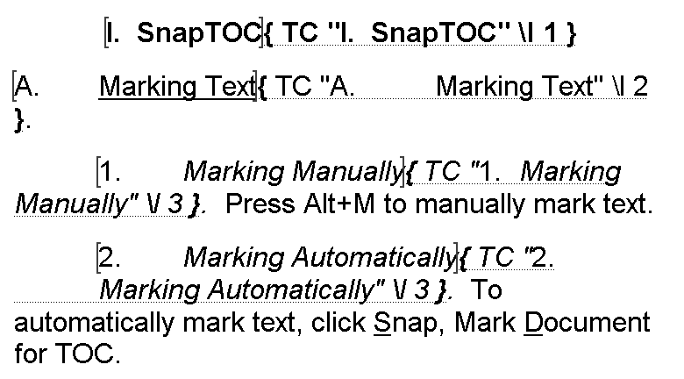
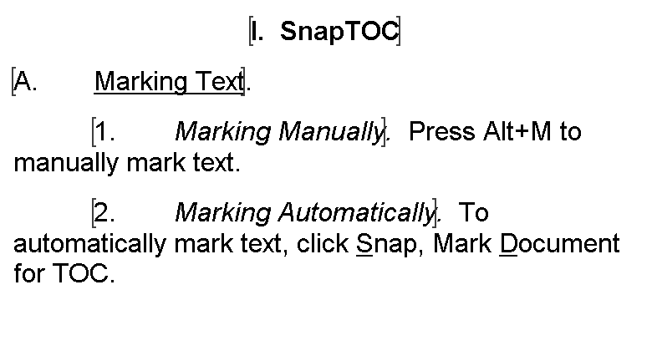
Bookmarks visible Bookmarks and hidden text visible
(recommended) (not recommended)

