When creating your own forms, you will often start with an existing document, replacing specific info (like the name Abigail Bentley) with general-use Fields (like {SignerName}). We’ll use the very short document below to practice. Remember, you’re the form author now; not the form user. You’re creating a form that will be saved as a template and used later to create finished documents.

My name is Abigail Bentley. I was born on April 17, 1960.

Signed:   
 ABIGAIL BENTLEY

➊ Click C:\Users\scott\AppData\Local\Microsoft\Windows\INetCache\Content.Word\table2.png Questionnaire, C:\Users\scott\AppData\Local\Microsoft\Windows\INetCache\Content.Word\plus.png Create to add an empty questionnaire on a separate page at the bottom of this document. Type labels in the left column, and questions in the middle column. When it’s time to add a row to make room for the second question, place the cursor in the last cell (the third column of the bottom row) and press Tab. When you’re done, the questionnaire should look like this:

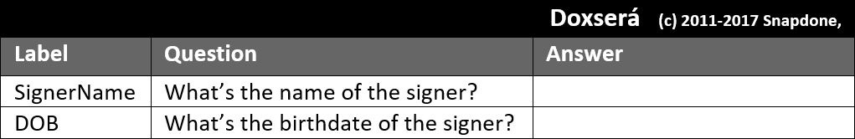

➋ Select the name Abigail Bentley where it first occurs in the form above and click C:\Users\scott\AppData\Local\Microsoft\Windows\INetCache\Content.Word\bunny.png Field. In the Field screen, select SignerName and click OK. Then select ABIGAIL BENTLEY in the signature block and click C:\Users\scott\AppData\Local\Microsoft\Windows\INetCache\Content.Word\bunny.png Field. In the Field screen, select SignerName, select UPPERCASE, and click OK.

➌ Select the date April 17, 1960 in the form above and click C:\Users\scott\AppData\Local\Microsoft\Windows\INetCache\Content.Word\bunny.png Field. In the Field screen, select DOB, select Date, and click OK.

➍ The form is complete and ready to be saved for future use. We recommend that you save forms in Word Template format (.dotx) to prevent users from accidentally overwriting forms when they are used.

After saving, double-click the saved template to try it out as a form user. If you saved the form as a template (.dotx) and you ever need to go back and revise it as a form author, right-click the form and choose Open.

You now know how to build basic questionnaires and add simple Fields to a form, including some options to control the appearance of those Fields (date format, upper/lowercase). In the next Practice you will create Conditions.