Snapdone User’s Manual
© 1997-2001 Inspired Computing, Inc.

Introduction
Choose the right manual. This detailed reference is designed to abruptly answer specific questions about Snapdone. For a friendlier introduction, refer to the Snapdone Workbook (Snap Help Workbook) or the Snapnumber/SnapTOC manual (Snap Help Snapnumber/TOC). Snapdone administrators should refer to the Snapdone Administration Manual (Snap Help Administration).
Quick answers in the One-Stop Index. A keystroke sequence is often all that is needed to answer a question. Look no further than the One-Stop Index (beginning on page 2), where keystrokes are listed for most entries.
Use hypertext (clickable text) for rapid online reference. When using this manual online (Snap Help Reference), click on page numbers or yellow reference boxes to move directly to that subject.

Table of Contents
I. Introduction 1
II. Table of Contents 1
III. One-Stop Index 2
IV. Help 18
V. Creating Documents 18
A. Letters 18
B. Memos 21
C. Fax Covers 21
D. Envelopes 21
E. Labels 22
F. Captions and Pleadings 23
G. Templates and Boilerplate Inserts 25
VI. Document Management 28
A. Folders and Subfolders 28
B. Snapsaving Documents 30
C. Opening Documents 32
D. Archived Documents 34
E. Tunnelvision 36
F. Filename Tools 36
VII. Snapdata 37
A. Snapdata – Limited vs. Unlimited 37
B. Snapdata – Top Section 37
C. Snapdata – Card and Clip Controls 39
D. Snapdata – Card 41
E. Snapdata – Clip 47
F. Snapdata – Bottom Section 48
VIII. Other Features 51
A. Snippets 51
B. Snapnumbers 53
C. SnapTOC 56
D. Shortcuts 57
E. SnapPaper – Print Trays and ID Stamps 58
F. SnapPreferences 59

One-Stop Index
Address book See Snapdata
Snap ۰ Snapdata
Address section in Snapdata p.43
Snap ۰ Snapdata ۰ select card or clip ۰ Addr
Alerts in Snapdata 18.9 p.42
Snap ۰ Snapdata ۰ select card or clip ۰ CM/Alert
Aliases
folder 8.6 p.29
subfolder 8.7 p.29
All caps on envelopes and labels 2.2 p.21
Snap ۰ New ۰ Envelope or Labels ۰ Use all uppercase characters
Alphabetical order See Sorting
Alt+1 through Alt+9 to insert Snapnumber p.53
Alt+J to jump to next field 34.8p p.65
Alt+M to mark text for table of contents p.56
Archived documents p.34
choosing whether to archive a document 10.7 p.31
Snap ۰ Save ۰ As usual or Don’t archive
searching for (finding) 13.7 p.35
Snap ۰ Open ۰ click file drawer icon (bottom right corner)
Attachments to email 25.10 p.51
Snap ۰ Snapdata ۰ select card(s) ۰ Email
Author fields p.27
Author/typist initials 34.4i p.60
Snap ۰ Setup ۰ Preferences ۰ Personal info ۰ Author/Typist initials when you are both author and typist
Automatic dates in letters, fax covers, memos 34.8m - 34.8o p.65
Snap ۰ Setup ۰ Preferences ۰ Miscellaneous ۰ Automatically update date before printing
Automatic paragraph numbers See Snapnumbers
Backup documents 12.14 p.34
Snap ۰ Open ۰ click BAK folder icon (bottom right corner)
Bates labels 3.1 p.22
Snap ۰ New ۰ Labels ۰ Numbered labels
Body text style p.57
Snap ۰ Body Text Style
Boilerplate p.27
Snap ۰ Insert Boilerplate
unprotecting fields 34.8e p.64
Snap ۰ Setup ۰ Preferences ۰ Unprotect templates and boilerplate
Bold text in Snapdone screens 1.7 p.20
surround text with ^carats^
Boxes, gray See Fields
Capital letters on envelopes and labels 2.2 p.21
Snap ۰ New ۰ Envelope or Labels ۰ Use all uppercase characters
Captions p.23
Snap ۰ Caption Bank
creating 4.7 p.24
Snap ۰ Caption Bank ۰ select folder and subfolder ۰ enter short name of caption ۰ New
deleting 4.9 p.25
Snap ۰ Caption Bank ۰ select caption ۰ Delete
editing 4.10 p.25
Snap ۰ Caption Bank ۰ select caption ۰ Edit ۰ revise caption ۰ File ۰ Close ۰ Yes
listing in a document 12.12g p.34
Snap ۰ Caption Bank ۰ search for captions ۰ click page icon (top right corner)
renaming 4.8 p.25
Snap ۰ Caption Bank ۰ select caption ۰ Rename
searching for (finding) 4.6 p.24
using to create pleadings 4.1 p.24
Snap ۰ Caption Bank ۰ select caption ۰ Use
Cards See Snapdata, cards
Categories for templates and boilerplate 5.1 p.26
Changing See Editing
Characters, special See Special characters and symbols
Checking out documents 12.7 p.33
Snap ۰ Open ۰ Check Out
Chronological order See Sorting
Client names and numbers, searching for (finding) 1.14 p.20; 18.3 p.42
Client-Matter/Alert section in Snapdata p.41
Snap ۰ Snapdata ۰ select card or clip ۰ CM/Alert
Clipping cards into clips
one at a time 16.7 p.39
Snap ۰ Snapdata ۰ select card and clip ۰ Clip it
several at once 25.12 p.51
Snap ۰ Snapdata ۰ select cards ۰ Add selected cards to a clip
Clips See Snapdata, clips
Clips section on Snapdata card p.47
Snap ۰ Snapdata ۰ select card ۰ Clip
Code, document ID 10.8 p.31
Snap ۰ Save ۰ Document ID code
Codes and special characters See Special characters and symbols
Configuration p.59
Snap ۰ Setup ۰ Preferences
Contact list See Snapdata
Snap ۰ Snapdata
Copying
cards 25.6 p.51
Snap ۰ Snapdata ۰ select card ۰ Copy this card
documents 11.2a p.31
Snap ۰ Open ۰ select document ۰ Open ۰ Snap ۰ Save ۰ No ۰ Generate a new, unrelated ID code for this document
filename and path to clipboard p.36
Snap ۰ Filename ۰ Remember Filename
Courts (venues) 4.7b p.24
Creating
captions 4.7 p.24
Snap ۰ Caption Bank ۰ select folder and subfolder ۰ enter short name of caption ۰ New
cards 16.13 p.40
Snap ۰ Snapdata ۰ enter name of card in Select card here box ۰ New
clips 16.15 p.40
Snap ۰ Snapdata ۰ enter name of clip in Select clip here box ۰ New
documents p.18
envelopes
one from scratch or from a letter p.21
Snap ۰ New ۰ Envelope
one with a Snapdata card 25.8 p.51
Snap ۰ Snapdata ۰ select card ۰ Env
several with Snapdata (merging) 25.11 p.51
Snap ۰ New ۰ Envelope ۰ Form envelopes ۰ Create ۰ Snap ۰ Snapdata ۰ select card(s) ۰ Merge
fax covers p.21; 25.4 p.49
Snap ۰ New ۰ Fax Cover
or Snap ۰ Snapdata ۰ select card(s) ۰ Fax
folders 8.6 p.29
Snap ۰ Open or Save ۰ enter name of folder ۰ New
form letters 1.5 p.19
Snap ۰ New ۰ Letter ۰ Form letters
labels
one from scratch or from a letter p.22
Snap ۰ New ۰ Labels
one with a Snapdata card 25.9 p.51
Snap ۰ Snapdata ۰ select card ۰ Label
several with Snapdata (merging) 25.11 p.51
Snap ۰ New ۰ Labels ۰ Form labels ۰ Create ۰ Snap ۰ Snapdata ۰ select card(s) ۰ Merge
layouts to insert Snapdata information 25.5g p.50
Snap ۰ Snapdata ۰ select card(s) ۰ Insert ۰ More ۰ New layout
letters p.18; 25.2 p.49
Snap ۰ New ۰ Letter
or Snap ۰ Snapdata ۰ select card(s) ۰ Letter
lists See Listing in a document
memos p.21; 25.3 p.49
Snap ۰ New ۰ Memo
or Snap ۰ Snapdata ۰ select card(s) ۰ Memo
multiple addresses, faxes, notes, or custom fields on a Snapdata card 19.2 p.43
pleadings 4.1 p.24
Snap ۰ Caption Bank ۰ select caption ۰ Use
Snapnumber schemes 28.3 p.53
Snap ۰ Snapnumber ۰ Scheme ۰ edit levels ۰ Save
Snapnumbers p.53
Alt+1 through Alt+9
or Snap ۰ Snapnumber ۰ Insert
Snippets 26.5 p.52
in any box which supports Snippets: F3 ۰ New Snippet
subfolders 8.7 p.29
Snap ۰ Open or Save ۰ select folder ۰ enter name of subfolder ۰ New
Custom fields p.46; 34.4f p.60
Snap ۰ Snapdata ۰ select card or clip ۰ Custom
Dash, spaces around 34.8d p.64
Snap ۰ Setup ۰ Preferences ۰ Miscellaneous ۰ Spaces around dash
Database of contact information See Snapdata
Snap ۰ Snapdata
Date, revision See Revision date and time
Dates, automatic in letters, fax covers, memos 34.8m - 34.8o p.65
Snap ۰ Setup ۰ Preferences ۰ Miscellaneous ۰ Automatically update date before printing
Decks (sets of cards and clips) 15.5 p.38; 34.8i p.65
Snap ۰ Snapdata ۰ Deck
Defaults
document view 34.6 p.62
Snap ۰ Setup ۰ Preferences ۰ View
draft or final ID format 34.5a p.61
Snap ۰ Setup ۰ Preferences ۰ Snapsaving ۰ Default document format
information included in document descriptions
fax covers 34.5m - 34.5o p.62
Snap ۰ Setup ۰ Preferences ۰ Snapsaving ۰ Information included in document descriptions: Faxes
letters 34.5b - 34.5d p.61
Snap ۰ Setup ۰ Preferences ۰ Snapsaving ۰ Information included in document descriptions: Letters
memos 34.5i - 34.5k p.62
Snap ۰ Setup ۰ Preferences ۰ Snapsaving ۰ Information included in document descriptions: Memos
pleadings 34.5l p.62
Snap ۰ Setup ۰ Preferences ۰ Snapsaving ۰ Information included in document descriptions: Pleadings
preferences p.59
Snap ۰ Setup ۰ Preferences
sender 1.2 p.19
target addresses, faxes, notes and custom fields on Snapdata cards 19.5 p.43
template for letters, memos, fax covers, envelopes, labels 1.2 p.19
Deleting
captions 4.9 p.25
Snap ۰ Caption Bank ۰ select caption ۰ Delete
cards 16.3 p.39
Snap ۰ Snapdata ۰ select card ۰ click red X icon (on small card)
clips 16.11 p.40
Snap ۰ Snapdata ۰ select clip ۰ click red X icon (on small clip)
documents 12.9 p.33
Snap ۰ Open ۰ select document ۰ Delete
folders footnote 1 p.28
layouts to insert Snapdata information 25.5i p.50
Snap ۰ Snapdata ۰ select card ۰ Insert ۰ select layout ۰ More ۰ Delete layout
multiple addresses, faxes, notes or custom fields from Snapdata cards 19.4 p.43
Snapnumber schemes 28.2 p.53
Snap ۰ Snapnumber ۰ Scheme ۰ Predefined ۰ select scheme ۰ Delete
SnapTOC marks from document
all marks 30.3 p.56
Snap ۰ Table of Contents ۰ Mark Document ۰ Remove all marks from document
selected marks p.57
select text ۰ Snap ۰ Table of Contents ۰ Remove Marks
Snippets 26.3 p.52
in any box which supports Snippets: F3 ۰ select Snippet ۰ Delete Snippet
subfolders footnote 1 p.28
Document production labels 3.1 p.22
Snap ۰ New ۰ Labels ۰ Numbered labels
Documents
archived p.34
Snap ۰ Open ۰ click file drawer icon (bottom right corner)
backups 12.14 p.34
Snap ۰ Open ۰ click bak folder icon (bottom right corner)
checking out 12.7 p.33
Snap ۰ Open ۰ Check Out
creating p.18
deleting 12.9 p.33
Snap ۰ Open ۰ select document ۰ Delete
description 10.2 p.30
Snap ۰ Save ۰ enter document description
filtering with Tunnelvision 12.1 p.32; p.36
Snap ۰ Open ۰ click tunnel icon (top left corner)
finding 12.12 p.33
ID stamp 10.8 p.31
Snap ۰ Save ۰ Document ID code
listing in a document 12.12g p.34
Snap ۰ Open ۰ search for documents ۰ click page icon (top right corner)
management p.28
moving 11.1 p.31
Snap ۰ Open ۰ select document ۰ Open ۰ Snap ۰ Save ۰ Yes ۰ select new folder and subfolder ۰ Save ۰ OK
naming 10.2 p.30
Snap ۰ Save ۰ enter document description
old 12.13 p.34
Snap ۰ Open ۰ click file drawer icon (bottom right corner)
opening See Snapopen
overwriting 11.1 p.31
Snap ۰ Save ۰ Yes ۰ Save
previewing 12.12h p.34
Snap ۰ Open ۰ search for documents ۰ click magnifying glass icon (top of screen) ۰ select document(s)
printing one without opening 12.5 p.33
Snap ۰ Open ۰ select document ۰ click printer icon (top right corner)
printing several at once without opening 12.12i p.34
Snap ۰ Open ۰ search for documents ۰ click folder with three documents icon (top of screen) ۰ select documents ۰ click printer icon (top right corner)
recently opened (last 10 Snapsaved) 12.11 p.33
renaming 11.1 p.31
Snap ۰ Open ۰ select document ۰ Open ۰ Snap ۰ Save ۰ Yes ۰ enter new document description ۰ Save ۰ OK
resaving 11.1 p.31
Snap ۰ Save ۰ Yes ۰ Save
saving p.30
Snap ۰ Save
searching for (finding) 12.12 p.33
sorting list (choosing order of list) 12.12b p.33
versions 11.2b p.32
Draft ID format 10.4 p.30
Snap ۰ Save ۰ Draft
Draft or final ID format, default 34.5a p.61
Snap ۰ Setup ۰ Preferences ۰ Snapsaving ۰ Default document format
Draft paper 34.7d p.63 & 34.7i p.64
Snap ۰ Setup ۰ Preferences ۰ Paper ۰ select printer ۰ select paper type ۰ Print drafts to
Editing
captions 4.10 p.25
Snap ۰ Caption Bank ۰ select caption ۰ Edit ۰ revise caption ۰ File ۰ Close ۰ Yes
documents See Snapopen
layouts to insert Snapdata information 25.5c p.49
Snap ۰ Snapdata ۰ select card ۰ Insert ۰ select layout ۰ More ۰ edit details of selected layout ۰ Save changes to layout
Snapnumber schemes 28.7 p.54
Snap ۰ Snapnumber ۰ Scheme ۰ edit levels ۰ Save
Snippets 26.9 p.52
in any box which supports Snippets: F3 ۰ select Snippet ۰ edit details of selected Snippet ۰ Save changes to Snippet
Ellipsis with spaces and periods 34.8l p.65
Snap ۰ Setup ۰ Preferences ۰ Miscellaneous ۰ Spaces and periods instead of ellipsis character
Email 25.10 p.51
Snap ۰ Snapdata ۰ select card(s) ۰ Email
Envelopes
creating one from scratch or from a letter p.21
Snap ۰ New ۰ Envelope
creating one with a Snapdata card 25.8 p.51
Snap ۰ Snapdata ۰ select card ۰ Env
creating several with Snapdata (merging) 25.11 p.51
Snap ۰ New ۰ Envelope ۰ Form envelopes ۰ Create ۰ Snap ۰ Snapdata ۰ select card(s) ۰ Merge
using all uppercase characters 2.2 p.21
Snap ۰ New ۰ Envelope ۰ Use all uppercase characters
Erasing See Deleting
Exhibit labels (numbered labels) 3.1 p.22
Snap ۰ New ۰ Labels ۰ Numbered labels
Fax covers p.21; 25.4 p.49
Snap ۰ New ۰ Fax Cover
or Snap ۰ Snapdata ۰ select card(s) ۰ Fax
automatic dates 34.8n p.65
Snap ۰ Setup ۰ Preferences ۰ Miscellaneous ۰ Automatically update date before printing Faxes
Fax/Phone section in Snapdata p.45
Snap ۰ Snapdata ۰ select card ۰ Fax/Ph
Fields
author p.27
custom p.46; 34.4f p.60
Snap ۰ Snapdata ۰ select card or clip ۰ Custom
in layouts to insert Snapdata information 25.5l p.50
Snap ۰ Snapdata ۰ select card ۰ Insert ۰ select layout ۰ More ۰ Fields
in templates and boilerplate p.27
jumping to next with Alt+J 34.8p p.65
repeating p.27
text boxes p.27
unprotecting in templates and boilerplate 34.8e p.64
Snap ۰ Setup ۰ Preferences ۰ Unprotect templates and boilerplate
Filename and path of document, copying to clipboard p.36
Snap ۰ Filename ۰ Remember Filename
Files See Documents
Files, synchronizing 34.11 p.65
Snap ۰ Setup ۰ Preferences ۰ File Synch
Final ID format 10.4 p.30
Snap ۰ Save ۰ Final
Final or draft ID format, default 34.5a p.61
Snap ۰ Setup ۰ Preferences ۰ Snapsaving ۰ Default document format
Finding See Searching
Folders p.28
aliases 8.6 p.29
creating 8.6 p.29
Snap ۰ Open or Save ۰ enter name of folder ۰ New
deleting footnote 1 p.28
listing in a document 8.4c p.29
Snap ۰ Open or Save ۰ search for folders ۰ click page icon (top right corner)
question mark beside folder box 8.1 p.28
renaming 8.8 p.30
Snap ۰ Open or Save ۰ select folder ۰ Rename
searching for (finding) 8.5 p.29
used by Snapdone 34.9 p.65
Snap ۰ Setup ۰ Preferences ۰ Folders
Foreign characters and symbols See Special characters and symbols
Form letters 1.5 p.19
Snap ۰ New ۰ Letter ۰ Form letters
Formatting codes in Snapdone screens 1.7 p.20
create underlined, bold or italic text by surrounding it with _underscores_ or ^carats^ or |vertical lines|
Forms (templates and boilerplate inserts) p.25
Global template for shared autotext, macros, styles, keyboards, toolbars 34.8g p.65
Snap ۰ Setup ۰ Preferences ۰ Miscellaneous ۰ Use Snapglobal.dot template for office-wide autotext, macros, styles, etc.
Help p.18
Snap ۰ Help
ID of cards in clips 16.5 p.39, 24.2 p.47
ID stamp on document 10.8 p.31, p.58
Snap ۰ Save ۰ Document ID code
draft or final format 10.4 p.30
Snap ۰ Save ۰ Draft or Final
printing extra p.37
Snap ۰ Filename ۰ Extra ID on This Page
Initials, author and typist 34.4i p.60
Snap ۰ Setup ۰ Preferences ۰ Personal info ۰ Author/Typist initials when you are both author and typist
Inserting
boilerplate into documents p.27
Snap ۰ Insert Boilerplate
information from Snapdata cards and clips 25.5 p.49
Snap ۰ Snapdata ۰ select card(s) ۰ Insert ۰ select layout ۰ Insert
Snapnumbers p.53
Alt+1 through Alt+9
or Snap ۰ Snapnumber ۰ Insert
Snippets p.51
in any box which supports Snippets: F3 ۰ select Snippet ۰ Insert
special characters and symbols See Special characters and symbols
Italics in Snapdone screens 1.7 p.20
surround text with |vertical lines|
Jumping to next field with Alt+J 34.8p p.65
Keyboard shortcuts p.57
body text style p.57
Snap ۰ Body Text Style
list of keyboard shortcuts p.18
Snap ۰ Help ۰ Keyboard Shortcuts
no spacing style p.57
Snap ۰ No Space Style
quote style p.57
Snap ۰ Quote Style
scrolling p.57
Ctrl+Alt+arrow keys
special characters and symbols in documents p.58
Ctrl+;
or Snap ۰ Symbols
special characters and symbols in Snapdone screens 1.7 p.20
zooming in and out p.57
Alt+→ and Alt+←
zoom toggle p.58
Alt+Z
Labels
creating one from scratch or from a letter p.22
Snap ۰ New ۰ Labels
creating one with a Snapdata card 25.9 p.51
Snap ۰ Snapdata ۰ select card ۰ Label
creating several with Snapdata (merging) 25.11 p.51
Snap ۰ New ۰ Labels ۰ Form labels ۰ Create ۰ Snap ۰ Snapdata ۰ select card(s) ۰ Merge
numbered 3.1 p.22
Snap ۰ New ۰ Labels ۰ Numbered labels
printing horizontally or vertically 3.8b p.23
using all uppercase characters 2.2 p.21
Snap ۰ New ۰ Labels ۰ Use all uppercase characters
Layouts to insert Snapdata information Subfig. 25.5 p.49
Snap ۰ Snapdata ۰ select card(s) ۰ Insert
creating 25.5g p.50
Snap ۰ Snapdata ۰ select card(s) ۰ Insert ۰ More ۰ New layout
deleting 25.5i p.50
Snap ۰ Snapdata ۰ select card(s) ۰ Insert ۰ select layout ۰ More ۰ Delete layout
editing 25.5c p.49
Snap ۰ Snapdata ۰ select card ۰ Insert ۰ select layout ۰ More ۰ edit details of selected layout ۰ Save changes to layout
fields 25.5l p.50
Snap ۰ Snapdata ۰ select card ۰ Insert ۰ select layout ۰ More ۰ Fields
listing in a document 25.5e p.50
Snap ۰ Snapdata ۰ select card ۰ Insert ۰ click page icon (top right corner)
renaming 25.5h p.50
Snap ۰ Snapdata ۰ select card(s) ۰ Insert ۰ select layout ۰ More ۰ Rename layout
Letters p.18; 25.2 p.49
Snap ۰ New ۰ Letter
or Snap ۰ Snapdata ۰ select card(s) ۰ Letter
automatic dates 34.8o p.65
Snap ۰ Setup ۰ Preferences ۰ Miscellaneous ۰ Automatically update date before printing Letters
closing in signature block 34.8f p.65
Snap ۰ Setup ۰ Preferences ۰ Miscellaneous ۰ Letter Closing
form letters 1.5 p.19
Snap ۰ New ۰ Letter ۰ Form letters
Listing in a document
archived documents 13.7g p.36
Snap ۰ Open ۰ click file drawer icon (bottom right corner) ۰ search for documents ۰ click page icon (top right corner)
captions 12.12g p.34
Snap ۰ Caption Bank ۰ search for captions ۰ click page icon (top right corner)
cards 16.12c p.40
Snap ۰ Snapdata ۰ search for cards ۰ click page icon (bottom right corner)
clips 8.4c p.29
Snap ۰ Snapdata ۰ search for clips ۰ click page icon (top right corner)
or Snap ۰ Snapdata ۰ select clip ۰ click page icon (left side of large clip)
documents 12.12g p.34
Snap ۰ Open ۰ search for documents ۰ click page icon (top right corner)
folders 8.4c p.29
Snap ۰ Open or Save ۰ search for folders ۰ click page icon (top right corner)
layouts to insert Snapdata information 25.5e p.50
Snap ۰ Snapdata ۰ select card ۰ Insert ۰ click page icon (top right corner)
Snippets 26.7 p.52
in any box which supports Snippets: F3 ۰ click page icon (top right corner)
subfolders 8.4c p.29
Snap ۰ Open or Save ۰ search for subfolders ۰ click page icon (top right corner)
Magnification See Zooming
Mail merge 1.5 p.19; 25.11 p.51
Manual, online p.18
Snap ۰ Help
Marking text for table of contents p.56
Alt+M
or Snap ۰ Table of Contents ۰ Mark Item
or Snap ۰ Table of Contents ۰ Mark Document
Matter names and numbers, searching for (finding) 1.12 p.20; 18.6 p.42
Memos p.21; 25.3 p.49
Snap ۰ New ۰ Memo
or Snap ۰ Snapdata ۰ select card(s) ۰ Memo
automatic dates 34.8m p.65
Snap ۰ Setup ۰ Preferences ۰ Miscellaneous ۰ Automatically update date before printing Memos
Merging 1.5 p.19; 25.11 p.51
Moving documents 11.1 p.31
Snap ۰ Open ۰ select document ۰ Open ۰ Snap ۰ Save ۰ Yes ۰ select new folder and subfolder ۰ Save ۰ OK
New See Creating
No spacing style p.57
Snap ۰ No Space Style
Notes section in Snapdata p.46
Snap ۰ Snapdata ۰ select card or clip ۰ Note
Numbered labels 3.1 p.22
Snap ۰ New ۰ Labels ۰ Numbered labels
Numbering, automatic paragraph See Snapnumbers
Old documents 12.13 p.34
Snap ۰ Open ۰ click file drawer icon (bottom right corner)
Opening documents See Snapopen
Options p.59
Snap ۰ Setup ۰ Preferences
Order See Sorting
Organization of documents (document management) p.28
Outlines See Snapnumbers
Overwriting old document 11.1 p.31
Snap ۰ Save ۰ Yes ۰ Save
Owners
of cards 17.2 p.41
Snap ۰ Snapdata ۰ select card ۰ click pencil icon (right side of screen)
of clips 24.7 p.48
Snap ۰ Snapdata ۰ select clip ۰ click pencil icon (left side of screen)
Paper See SnapPaper control
Snap ۰ Setup ۰ Preferences ۰ Paper
Paragraph numbers, automatic See Snapnumbers
Paths used by Snapdone 34.9 p.65
Snap ۰ Setup ۰ Preferences ۰ Folders
Personal information 34.4 p.60
Snap ۰ Setup ۰ Preferences ۰ Personal info
Phone/Fax section in Snapdata p.45
Snap ۰ Snapdata ۰ select card ۰ Fax/Ph
Pleadings See Captions
Preferences p.59
Snap ۰ Setup ۰ Preferences
Previewing documents 12.12h p.34
Snap ۰ Open ۰ search for documents ۰ click magnifying glass icon (top of screen) ۰ select document(s)
Printer trays See SnapPaper control
Snap ۰ Setup ۰ Preferences ۰ Paper
Printing
Documents without opening, one at a time 12.5 p.33
Snap ۰ Open ۰ select document ۰ click printer icon (top right corner)
Documents without opening, several at once 12.12i p.34
Snap ۰ Open ۰ search for documents ۰ click folder with three documents icon (top of screen) ۰ select documents ۰ click printer icon (top right corner)
extra ID stamp p.37
Snap ۰ Filename ۰ Extra ID on This Page
lists See Listing in a document
Profile 34.1 p.59
Snap ۰ Setup ۰ Preferences ۰ Profile
Question marks beside folder, subfolder, and document boxes 8.1 p.28
Quote style p.57
Snap ۰ Quote Style
Rearranging See Sorting
Reference manual, online p.18
Snap ۰ Help ۰ Reference
Remembering filename and path of document p.36
Snap ۰ Filename ۰ Remember Filename
Removing See Deleting
Renaming
captions 4.8 p.25
Snap ۰ Caption Bank ۰ select caption ۰ Rename
cards 16.2 p.39
Snap ۰ Snapdata ۰ select card ۰ Rename
clips 16.10 p.40
Snap ۰ Snapdata ۰ select clip ۰ Rename
documents 11.1 p.31
Snap ۰ Open ۰ select document ۰ Open ۰ Snap ۰ Save ۰ Yes ۰ enter new document description ۰ Save ۰ OK
folders 8.8 p.30
Snap ۰ Open or Save ۰ select folder ۰ Rename
layouts to insert Snapdata information 25.5h p.50
Snap ۰ Snapdata ۰ select card(s) ۰ Insert ۰ select layout ۰ More ۰ Rename layout
multiple addresses, faxes, notes and custom fields on Snapdata cards 19.3 p.43
Snippets 26.4 p.52
in any box which supports Snippets: F3 ۰ select Snippet ۰ Rename Snippet
subfolders 8.9 p.30
Snap ۰ Open or Save ۰ select subfolder ۰ Rename
Replacing documents 11.1 p.31
Snap ۰ Save ۰ Yes ۰ Save
Resetting Snapnumbers p.55
select Snapnumber ۰ Snap ۰ Snapnumber ۰ Reset
Revising See Editing
Revision date and time
of cards 17.3 p.41
of clips 24.5 p.48
of documents 12.12d (third column) p.34
Saving documents p.30
Snap ۰ Save
Schemes for Snapnumbers p.53
Snap ۰ Snapnumber ۰ Scheme
Scrolling, keyboard shortcuts p.57
Ctrl+Alt+arrow keys
Searching (finding)
for archived documents 13.7 p.35
for boilerplate 5.5 p.26
for captions 4.6 p.24
for cards 16.12 p.40
for categories 5.4 p.26
for client names and numbers 1.14 p.20; 18.3 p.42
for clips 16.14 p.40
for documents 12.12 p.33
for folders 8.5 p.29
for matter names and numbers 1.12 p.20; 18.6 p.42
for subfolders 8.4 p.29
for templates 5.5 p.26
Selecting See Searching
Shortcuts See Keyboard shortcuts
Snapboilerplate See Boilerplate
Snap ۰ Insert Boilerplate
Snapcaption See Captions
Snap ۰ Caption Bank
Snapdata p.37
Snap ۰ Snapdata
alerts 18.9 p.42
Snap ۰ Snapdata ۰ select card or clip ۰ CM/Alert ۰ type alert in red box
cards p.41
copying 25.6 p.51
Snap ۰ Snapdata ۰ select card ۰ Copy this card
creating 16.13 p.40
Snap ۰ Snapdata ۰ enter name of card in Select card here box ۰ New
deleting 16.3 p.39
Snap ۰ Snapdata ۰ select card ۰ click red X icon (on small card)
multiple addresses, faxes, notes, and custom fields on one card 19.1 p.43
deleting 19.4 p.43
renaming 19.3 p.43
target (default) 19.5 p.43
owners 17.2 p.41
Snap ۰ Snapdata ۰ select card ۰ click pencil icon (right side of screen)
parts of address block 19.7 p.44
Snap ۰ Snapdata ۰ select card ۰ Addr ۰ click PARTS label (right side of address box)
renaming 16.2 p.39
Snap ۰ Snapdata ۰ select card ۰ Rename
revision date and time 17.3 p.41
searching for (finding) 16.12 p.40
sections 17.1 p.41
clipping cards into clips, one at a time 16.7 p.39
Snap ۰ Snapdata ۰ select card and clip ۰ Clip it
clipping cards into clips, several at once 25.12 p.51
Snap ۰ Snapdata ۰ select cards ۰ Add selected cards to a clip
clips p.47
alphabetizing cards 24.9 p.48
Snap ۰ Snapdata ۰ select clip ۰ az
cards contained in a clip 24.1 p.47
creating 16.15 p.40
Snap ۰ Snapdata ۰ enter name of clip in Select clip here box ۰ New
deleting 16.11 p.40
Snap ۰ Snapdata ۰ select clip ۰ click red X icon (on small clip)
order of cards 24.6 & 24.11 p.48
Snap ۰ Snapdata ۰ select clip ۰ select card in clip ۰ click blue arrows (on clip)
owners 24.7 p.48
Snap ۰ Snapdata ۰ select clip ۰ click pencil icon (left side of screen)
recalling last 34.8k p.65
Snap ۰ Setup ۰ Preferences ۰ Miscellaneous ۰ Recall last clip
renaming 16.10 p.40
Snap ۰ Snapdata ۰ select clip ۰ Rename
revision date and time 24.5 p.48
searching for (finding) 16.14 p.40
sections 24.4 p.47
creating documents with cards and clips Fig. 25 p.49
decks 15.5 p.38; 34.8i p.65
Snap ۰ Snapdata ۰ Deck
emails, creating with cards and clips 25.10 p.51
Snap ۰ Snapdata ۰ select card(s) ۰ Email
envelopes
creating one with a Snapdata card 25.8 p.51
Snap ۰ Snapdata ۰ select card ۰ Env
creating several with Snapdata (merging) 25.11 p.51
Snap ۰ New ۰ Envelope ۰ Form envelopes ۰ Create ۰ Snap ۰ Snapdata ۰ select card(s) ۰ Merge
fax covers, creating with cards and clips 25.4 p.49
Snap ۰ Snapdata ۰ select card(s) ۰ Fax
ID of cards in clips 16.5 p.39, 24.2 p.47
inserting data into documents 25.5 p.49
Snap ۰ Snapdata ۰ select card(s) ۰ Insert ۰ select layout ۰ Insert
labels
creating one with a Snapdata card 25.9 p.51
Snap ۰ Snapdata ۰ select card ۰ Label
creating several with Snapdata (merging) 25.11 p.51
Snap ۰ New ۰ Labels ۰ Form labels ۰ Create ۰ Snap ۰ Snapdata ۰ select card(s) ۰ Merge
layouts to insert Snapdata information See Layouts
letters, creating with cards and clips 25.2 p.49
Snap ۰ Snapdata ۰ select card(s) ۰ Letter
limited mode p.37
Snap ۰ Snapdata ۰ Ltd
memos, creating with cards and clips 25.3 p.49
Snap ۰ Snapdata ۰ select card(s) ۰ Memo
merging information from cards and clips into forms 1.5 p.19; 25.11 p.51
starting box 34.8c p.64
Snap ۰ Setup ۰ Preferences ۰ Miscellaneous ۰ Snapdata Starting box
tips, toggling 15.10 p.38
Snap ۰ Snapdata ۰ click yellow box icon (top right corner)
unclipping cards and clips 16.4 p.39
Snap ۰ Snapdata ۰ select card ۰ select clip ۰ Unclip it
unlimited mode p.37
Snap ۰ Snapdata ۰ Snapdata Unlimited
view of card and/or clip 15.1 p.38
Snap ۰ Snapdata ۰ View
Snapdone profile 34.1 p.59
Snap ۰ Setup ۰ Preferences ۰ Profile
Snapdone user information 34.4 p.60
Snap ۰ Setup ۰ Preferences ۰ Personal info
Snapenvelope See Envelopes
Snapfax See Fax covers
Snaplabel See Labels
Snapletter See Letters
Snapmemo See Memos
Snapnumbers p.53
Alt+1 through Alt+9 to insert Snapnumber p.53
attach previous level 28.9 p.54
Snap ۰ Snapnumber ۰ Scheme ۰ Edit Level # ۰ Attach previous level(s) (checkboxes on right side of screen)
continue numbering 29.2 p.55
select Snapnumber ۰ Snap ۰ Snapnumber ۰ Reset ۰ Continue numbering from previous Snapnumber
creating schemes 28.3 p.53
Snap ۰ Snapnumber ۰ Scheme ۰ edit levels ۰ Save
custom schemes 28.4 p.54
Snap ۰ Snapnumber ۰ Scheme ۰ Custom
deleting schemes 28.2 p.53
Snap ۰ Snapnumber ۰ Scheme ۰ Predefined ۰ select scheme ۰ Delete
editing schemes 28.7 p.54
Snap ۰ Snapnumber ۰ Scheme ۰ edit levels ۰ Save
inserting p.53
Alt+1 through Alt+9
or Snap ۰ Snapnumber ۰ Insert
legal style 28.12 p.54
Snap ۰ Snapnumber ۰ Scheme ۰ Edit Level # ۰ Legal style
predefined schemes 28.1 p.53
Snap ۰ Snapnumber ۰ Scheme ۰ Predefined
resetting p.55
select Snapnumber ۰ Snap ۰ Snapnumber ۰ Reset
restart after higher level 28.11 p.54
Snap ۰ Snapnumber ۰ Scheme ۰ Edit Level # ۰ Restart after higher level
schemes p.53
Snap ۰ Snapnumber ۰ Scheme
starting number 29.4 p.55
select Snapnumber ۰ Snap ۰ Snapnumber ۰ Reset
style of Snapnumber 28.6 p.54
Snap ۰ Snapnumber ۰ Scheme ۰ Edit Level #
uppercase in heading styles 28.13 p.54
Snap ۰ Snapnumber ۰ Scheme ۰ Edit Level # ۰ All caps in heading style
Snapopen p.32
Snap ۰ Open
filtering documents with Tunnelvision 12.1 p.32; p.36
Snap ۰ Open ۰ click tunnel icon (top left corner)
opening several documents at once 12.12e p.34
Snap ۰ Open ۰ search for documents ۰ click folder with three documents icon (top of screen) ۰ select documents ۰ Open
starting box 34.8a p.64
Snap ۰ Setup ۰ Preferences ۰ Miscellaneous ۰ Snapopen Starting box
SnapPaper p.58; 34.7 p.63
Snap ۰ Paper Type
SnapPreferences p.59
Snap ۰ Setup ۰ Preferences
Snapsave p.30
Snap ۰ Save
Snapsymbols p.58
Ctrl+;
or Snap ۰ Symbols
ellipsis with spaces and periods 34.8l p.65
Snap ۰ Setup ۰ Preferences ۰ Miscellaneous ۰ Spaces and periods instead of ellipsis character
spaces around dash 34.8d p.64
Snap ۰ Setup ۰ Preferences ۰ Miscellaneous ۰ Spaces around dash
Snaptemplate See Templates
Snap ۰ New ۰ Template
SnapTOC p.56
formatting with half-inch tabs 31.1 p.57
Snap ۰ Table of Contents ۰ Generate ۰ Format TOC with half-inch tabs and indents
generating table of contents p.57
Snap ۰ Table of Contents ۰ Generate
marking Snapnumbered paragraphs automatically Fig. 30 , p.56
Snap ۰ Table of Contents ۰ Mark Document
marking text manually p.56
Alt+M
or Snap ۰ Table of Contents ۰ Mark Item
removing all marks from document 30.3 p.56
Snap ۰ Table of Contents ۰ Mark Document ۰ Remove all marks from document
removing selected marks from document p.57
select text ۰ Snap ۰ Table of Contents ۰ Remove Marks
viewing marks p.57
Snap ۰ Table of Contents ۰ Bookmarks (In)visible
Snippets p.51
creating 26.5 p.52
in any box which supports Snippets: F3 ۰ New Snippet
deleting 26.3 p.52
in any box which supports Snippets: F3 ۰ select Snippet ۰ Delete Snippet
editing 26.9 p.52
in any box which supports Snippets: F3 ۰ select Snippet ۰ edit details of selected Snippet ۰ Save changes to Snippet
inserting in a Snapdone screen p.51
in any box which supports Snippets: F3 ۰ select Snippet ۰ Insert
listing in a document 26.7 p.52
in any box which supports Snippets: F3 ۰ click page icon (top right corner)
renaming 26.4 p.52
in any box which supports Snippets: F3 ۰ select Snippet ۰ Rename Snippet
Sorting
cards in a clip 24.6 & 24.9 & 24.11 p.48
Snap ۰ Snapdata ۰ select clip ۰ az
document list 12.12b p.33
Special characters and symbols
in documents p.58
Ctrl+;
or Snap ۰ Symbols
in Snapdone screens 1.7 p.20
Stamp, document ID 10.8 p.31
Snap ۰ Save ۰ Document ID code
Styles, keyboard shortcuts p.57
Subfolders p.28
aliases 8.7 p.29
creating 8.7 p.29
Snap ۰ Open or Save ۰ select folder ۰ enter name of subfolder ۰ New
deleting fn1 p.28
listing in a document 8.4c p.29
Snap ۰ Open or Save ۰ search for subfolders ۰ click page icon (top right corner)
question mark beside subfolder box 8.1 p.28
renaming 8.9 p.30
Snap ۰ Open or Save ۰ select subfolder ۰ Rename
searching for (finding) 8.4 p.29
Support p.18
Symbols and special characters See Special characters and symbols
Synchronizing files 34.11 p.65
Snap ۰ Setup ۰ Preferences ۰ File Synch
Table of contents See SnapTOC
Target addresses, faxes, notes and custom fields on Snapdata cards 19.5 p.43
Templates p.26
Snap ۰ New ۰ Template
global for shared autotext, macros, styles, keyboards, toolbars 34.8g p.65
Snap ۰ Setup ۰ Preferences ۰ Miscellaneous ۰ Use Snapglobal.dot template for office-wide autotext, macros, styles, etc.
unprotecting fields 34.8e p.64
Snap ۰ Setup ۰ Preferences ۰ Unprotect templates and boilerplate
Text boxes See Fields
Tips, toggling in Snapdata screen 15.10 p.38
Snap ۰ Snapdata ۰ click yellow box icon (top right corner)
Tunnelvision p.36
ask for text when Snapsaving 34.5f p.61
Snap ۰ Setup ۰ Preferences ۰ Snapsaving ۰ Ask for text every time
default text when Snapsaving 34.5h p.61
Snap ۰ Setup ۰ Preferences ۰ Snapsaving ۰ Always use this text
filtering documents when Snapopening 12.1 p.32
Snap ۰ Open ۰ click tunnel icon (top left corner)
Typist/author initials 34.4i p.60
Snap ۰ Setup ۰ Preferences ۰ Personal info ۰ Author/Typist initials when you are both author and typist
Unclipping cards and clips 16.4 p.39
Snap ۰ Snapdata ۰ select card ۰ select clip ۰ Unclip it
Underlining in Snapdone screens 1.7 p.20
surround text with _underscores_
Unprotecting fields in templates and boilerplate 34.8e p.64
Snap ۰ Setup ۰ Preferences ۰ Unprotect templates and boilerplate
Uppercase characters on envelopes and labels 2.2 p.21
Snap ۰ New ۰ Envelope or Labels ۰ Use all uppercase characters
User information 34.4 p.60
Snap ۰ Setup ۰ Preferences ۰ Personal info
User profile 34.1 p.59
Snap ۰ Setup ۰ Preferences ۰ Profile
Venues 4.7b p.24
Versions of documents 11.2b p.32
View
default document 34.6 p.62
Snap ۰ Setup ۰ Preferences ۰ View
keyboard shortcuts p.58
of Snapdata card and/or clip 15.1 p.38
Snap ۰ Snapdata ۰ View
previewing documents 12.12h p.34
Snap ۰ Open ۰ search for documents ۰ click magnifying glass icon (top of screen) ۰ select document(s)
SnapTOC marks p.57
Snap ۰ Table of Contents ۰ Bookmarks (In)visible
Workbook, online p.18
Snap ۰ Help
Zoom toggle p.58
Alt+Z
Zooming in and out p.57
Alt+→ and Alt+←

Help
Snapdone includes several online references:
Snap Help Administration: covers administration of Snapdone, creating and managing forms, and Snapdata deck management.
Snap Help Keyboard Shortcuts: a categorized listing of Word’s built-in shortcuts and those added by Snapdone.
Snap Help Snapnumber/TOC: a good introduction to Snapdone’s alternative paragraph numbering feature (Snapnumbers) and alternative table of contents feature (SnapTOC).
Snap Help User’s Manual: displays this detailed reference manual.
Snap Help Workbook: a good introduction to Snapdone which teaches the basics in 14 exercises.
You may also call Snapdone at 206­567­5327 or send email to help@snapdone.com.

Creating Documents

Letters
To create a letter with a Snapdata card, see 25.2 . Otherwise, 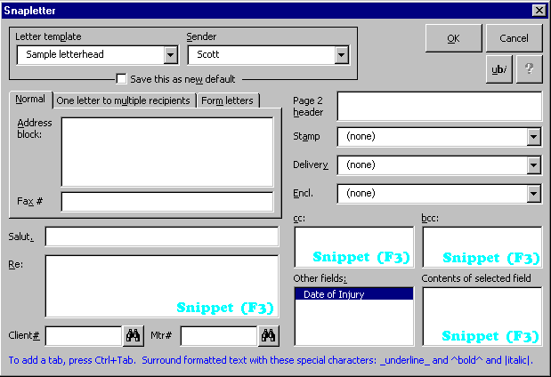click Snap New Letter to display the Snapletter screen. This screen varies from office to office, so many of the items pictured here may not appear on your screen.
1.1

1.17
1.7
1.6
1.26
1.19
1.20
1.21
1.22
1.23
1.24
1.25
1.18
1.2
1.15
1.14
1.13
1.10
1.12
1.11
1.9
1.8
1.5
1.16
1.4
1.3
Figure 1
1.1 Letter template: If multiple letterheads are available in your office, select one here.
1.2 Save this as new default: This checkbox appears when a different Letter template is chosen in box 1.1 or a different Sender in box 1.3 . Check this checkbox 1.2 to make the currently selected letterhead and sender your default choices.
1.3 Sender: Some letterhead templates in your office may include information about the sender, such as an email address or phone number. If personalization is included on the letterhead selected in box 1.1 , choose a Sender in box 1.3 . The information for each individual is set in their SnapPreferences screen Fig. 34 .
1.4 One letter to multiple recipients: Choose this tab to see instructions on creating a single letter to multiple addressees. See 16.12b and 24.1 for instructions on using several cards to create a single letter.
1.5 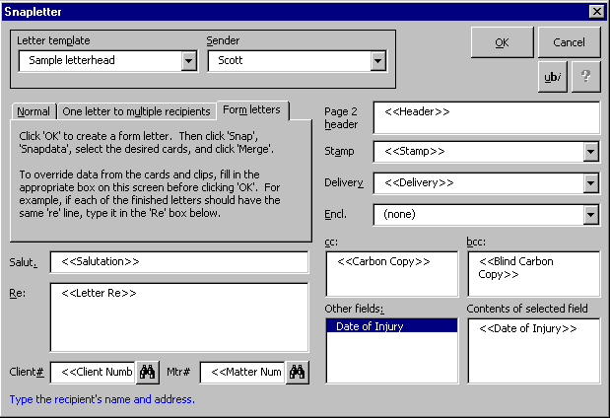Form letters: Choose this tab to create a form letter (a single form which is used to generate separate letters to several addressees). Choosing the Form letters tab fills all the boxes on the screen with field codes like <<Salutation>> and <<Letter Re>>.
1.5c
1.5b
1.5a
Subfigure 1.5
When the form is merged with Snapdata cards, the field codes are replaced with information from the cards. To override data from the cards, fill in the matching box on this screen before clicking OK.
For example, in a typical scenario the salutation should be different on each generated letter, so that Nancy’s letter says Dear Nancy and Jim’s letter says Dear Jim. So leave the Dear Ms. Broderick: field as it appears in box 1.5a . But the re line should be the same on each generated letter, so that Nancy’s letter and Jim’s letter both say Re: Something Important. So delete the Snapdone program code from box 1.5b and type Something Important there instead.
Click OK 1.5c to create the form letter. Type the body of the letter and save it if desired. Then click Snap Snapdata, select the desired cards in 16.6 , 16.12b or 24.1 , and click Merge 25.11 to generate the individual letters.
1.6 OK: Click OK to create the letter.
1.7 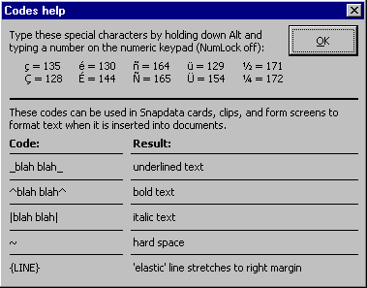ubi: This button displays the Codes help screen Subfig. 1.7 , which explains how to add foreign characters or formatting (underlined, bold or italic text) in the Snapletter screen.
Subfigure 1.7
1.8 Address block: Type the addressee’s name and address, just as they will appear in the letter.
1.9 Fax #: This box may appear if you choose delivery via facsimile in box 1.20 . Type the addressee’s fax number here.
1.10 Salut.: Type the salutation, including punctuation (for example, Dear Mary:).
1.11 Re: Type the subject matter or leave blank to omit the re line. To add hard returns and tabs, press Shift+Enter and Ctrl+Tab, respectively. To create underlined, bold or italic text, surround the text with underscores, carats, or vertical lines: _this is underlined_ ^this is bold^ and |this is italic|. (The vertical line character is Shift+Backslash on your keyboard.)
1.12 Matter search: To search for a matter number, type any part of the matter name in box 1.13 and click here.
1.13 Mtr#: Type the relevant matter number. If button 1.12 is visible, you can search for a matter number by typing any part of the matter name here and pressing Enter.
1.14 Client search: To search for a client number, type any part of the client name in box 1.15 and click here.
1.15 Client#: Type the relevant client number. If button 1.14 is visible, you can search for a client number by typing any part of the client name here and pressing Enter.
1.16 Message area: Watch this area for tips as the cursor moves about the screen.
1.17 Help: Click here to open this manual on your screen.
1.18 Page 2 header: Type the name(s) which will appear in the second-page header. Press Shift+Enter to add a hard return. Do not type the date or page number here; they are automatically generated by Snapdone.
1.19 Stamp: Choose a stamp (Confidential, Personal, Attorney-Client Privileged, etc.).
1.20 Delivery: Choose a delivery method (Hand Delivered, Via Facsimile, Certified Mail, etc.).
1.21 Encl: Choose an enclosure line (Enclosure, Enclosures, etc.).
1.22 bcc: Type the names of anyone who will receive “blind carbon copies” of the letter.
1.23 cc: Type the names of anyone who will receive “carbon copies” of the letter.
1.24 Contents of selected field: If the letterhead selected in box 1.1 contains custom fields, they are listed in box 1.25 . To examine or change the contents of a custom field, select it in box 1.25 and make any necessary changes in box 1.24 .
1.25 Other fields: If the letterhead selected in box 1.1 contains custom fields, they are listed here. To examine or change the contents of a custom field, select it in this box and make any necessary changes in box 1.24 .
1.26 Snippet (F3): See Snippets, p. 51.

Memos
To create a memo with a Snapdata card,, see 25.3 . Otherwise, click Snap New Memo to display the Snapmemo screen. The above discussion of the Snapletter screen Fig. 1 also applies to the Snapmemo screen.

Fax Covers
To create a fax cover with a Snapdata card, see 25.4 . Otherwise, click Snap New Fax Cover to display the Snapfax screen. The above discussion of the Snapletter screen Fig. 1 also applies to the Snapfax screen.

Envelopes
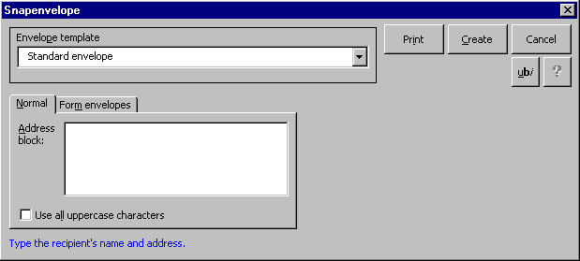To create an envelope with a Snapdata card, see 25.8 . To create a batch of envelopes using Snapdata cards, see the discusson of form letters above 1.5 . Otherwise, click Snap New Envelope to display the Snapenvelope screen. The above discussion of the Snapletter screen Fig. 1 also applies to the Snapenvelope screen, with these additions:
2.1
2.2
2.3
2.4
Figure 2
2.1 Address block: If a letter document is open when you click Snap New Envelope, this box is prefilled with the recipient’s address. If text is selected in a document when you click Snap New Envelope, this box is prefilled with the selected text (useful for choosing a particular address in a letter to multiple recipients).
2.2 Use all uppercase characters: Check this checkbox to print envelope addresses in uppercase characters.
2.3 Create: After filling in the address, click Create to see the finished envelope on your screen. Then use Word’s print command to print the envelope from your screen (useful for printing several identical envelopes).
2.4 Print: After filling in the address, click Print to send the envelope directly to the printer.

Labels
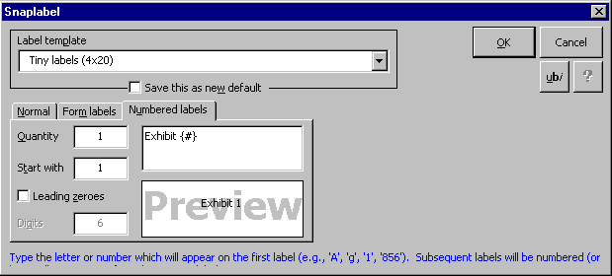To create a label with a Snapdata card, see 25.9 . To create a batch of envelopes using Snapdata cards, see the discusson of form letters above 1.5 . Otherwise, click Snap New Labels to display the Snaplabel screen. Much of this screen is identical to the Snapenvelope screen Fig. 1 , with these additions:
3.1
3.6
3.7
3.5
3.4
3.3
3.8
Figure 3
3.2

3.1 Numbered labels: Choose this tab to create sequentially numbered or lettered labels (exhibit labels, document production labels, etc.).

3.2 Quantity: Type the total quantity of labels to be printed (for example, 4 sheets of 30 labels each equals a total of 120).

3.3 Start with: Type the number or letter which should appear on the first label. If you are creating numbered labels with leading zeroes, do not type the zeroes here.

3.4 Leading zeroes: Check this checkbox to include leading zeroes before the label number (#000025 instead of #25). You must enter a number (not a letter) in box 3.3 before checking this checkbox.

3.5 Digits: If Leading zeroes 3.4 is checked, enter the number of digits here (for example, #000025 has 6 digits).

3.6 Label text: Type any text which surrounds the sequential number or letter. The pound symbol in curly braces {#} is a placeholder to mark where the sequential number or letter will appear, and cannot be deleted. For example, to create labels which say Exhibit A for Plaintiff, Exhibit B for Plaintiff, etc., type Exhibit {#} for Plaintiff in box 3.6 .

3.7 Preview: This box shows a preview of the label text. Label dimensions, font, and justification are not indicated in this preview; it merely indicates the text which will appear on each label.

3.8 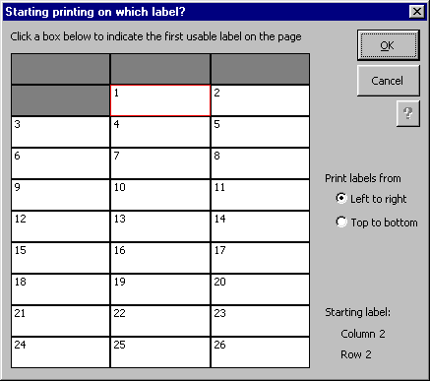OK: After filling in the Snaplabel screen, click OK to display the Start printing on which label? screen.
3.8d
3.8c
3.8b
3.8a
Subfigure 3.8
3.8a Label grid: The number of rows and columns in this grid changes, depending on which label format has been chosen. Click one of the boxes in this grid to choose the first label on which text should appear. When printing numbered labels 3.1 , numbers appear on this grid (but leading zeroes and other text are ignored).
3.8b Print labels from: Choose Left to right or Top to bottom to change the arrangement of labels on the page.
3.8c OK: Click OK to create the labels in a Word document, ready to print.
3.8d Help: Click here to open this manual on your screen.

Captions and Pleadings
Click Snap New Pleading or Snap Caption bank to display the Snapcaption screen.
4.1
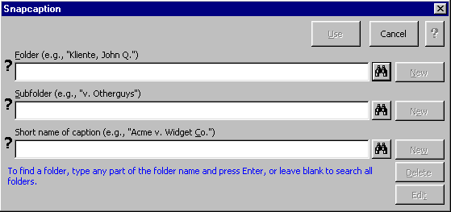
4.2
4.5
4.10
4.9
4.8
4.7
4.6
4.4
4.3
Figure 4
Note: depending on how Snapdone is configured in your office, some of the boxes and buttons in this picture may be missing.
4.1 Use: Click Use to create a pleading with the caption selected in box 4.3 .
4.2 Folder and subfolder: Use this area (described in Fig. 8 ) to choose a folder and subfolder for the caption.
4.3 Short name of caption: Use this box to select or create a caption.
To select a caption: Type any part of the caption name in this box and press Enter or click the Find caption icon 4.6 . The search is restricted to the folder and/or subfolder specified in the Folder and Subfolder boxes 4.2 . In other words, leave the Folder and Subfolder boxes blank for a broad search, or specify a folder or subfolder for a restricted search.
To create a caption: First choose a Folder and Subfolder 4.2 , then type a short name for the new caption in box 4.3 and click New 4.7 .
4.4 Message area: Watch this area for tips as the cursor moves about the screen.
4.5 Help: Click here to open this manual on your screen.
4.6 Find caption icon: Click here to list all captions or search for a particular caption. As an alternative to clicking, press Enter while the cursor is in box 4.3 . The scope of the search depends on whether a folder or subfolder has been specified (see 4.3 above).
List all captions by leaving box 4.3 blank or search for a particular caption by typing part of the caption’s name in box 4.3 .
If more than one caption is found, it is listed in the Choose a caption screen, which is similar to the Choose a document screen Subfig. 12.12 .
4.7 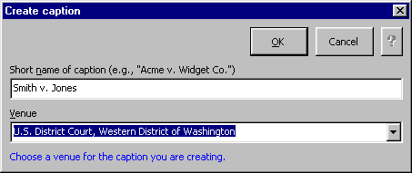New caption: The New button appears when you type a caption name in box 4.3 . To create a caption, first specify a folder and subfolder 4.2 , then type a short name for the new caption in box 4.3 and click New 4.7 to display the Create caption screen.
4.7c
4.7d
4.7b
4.7a
Subfigure 4.7
4.7a Short name of caption: If necessary, change the new caption’s name here.
4.7b Venue: Click the small down arrow (or press Alt+Down while the curser is in this box) to choose a venue.
4.7c Help: Click here to open this manual on your screen.
4.7d 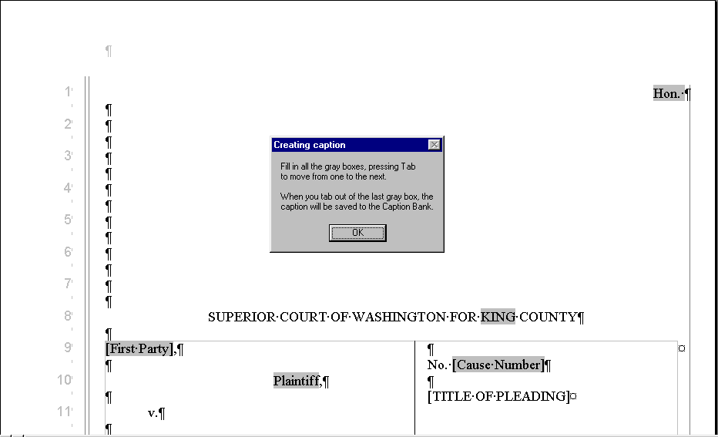OK: Click OK to begin filling in the caption.
Subfigure 4.7d
Fill in gray boxes: Depending on the venue, you will see a number of gray boxes (“fields”). Fill in each field, pressing Tab to move from one to the next (Shift+Tab to move backward). After tabbing out of the last box, the caption is saved into the Caption Bank and you are prompted to close the file.
NOTE: If you need to edit the caption somewhere outside the gray boxes, first finish filling in the gray boxes and saving the caption, then go back to the Caption Bank and choose to edit the same caption (Snap Caption Bank Edit 4.10 ). When editing the caption, you will be allowed to make changes which were not possible when you were creating the caption, since you will no longer be restricted to the gray boxes.
4.8 Rename caption button: To rename a caption, select it in box 4.3 then click Rename.
4.9 Delete: To delete a caption from the Caption Bank, select it in box 4.3 then click Delete.
4.10 Edit: To edit a caption, select it in box 4.3 then click Edit. Make revisions to the caption, then close and save the file (File, Close, Yes).

Templates and Boilerplate Inserts
Templates and boilerplate inserts are form documents particular to your office. The difference between templates and boilerplate inserts can be confusing. Generally, templates are complete form documents, and boilerplate inserts are pieces of documents which are inserted into an existing document on your screen.

Template Examples  (complete form documents) |  | Boilerplate Examples  (pieces of documents to be inserted)
• Lease  • Will  • Messenger form |  | • Interrogatories (inserted into document which already contains caption)  • Notary block (inserted into document which already contains contract)  • Engagement letter (inserted into document which already contains letterhead and addressee)

Templates
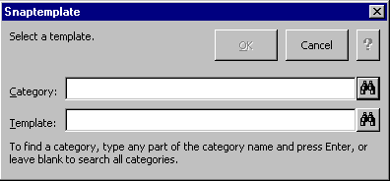Click Snap New Template to display the Snaptemplate screen:
5.1
5.3
5.5
5.4
5.2
Figure 5
5.1 Category: Use this box to select a template category. Categories in your office might include Real estate, Corporate, Estate management, Litigation, Dissolution, etc. Type any part of the category name and press Enter or click the Find category icon 5.4 . If you are not certain what category contains the desired template, leave this box blank.
5.2 Template: Use this box to select a template. Type any part of the template name and press Enter or click the Find template icon 5.5 . If a category is specified in box 5.1 , the search is restricted to that category. If the Category box 5.1 is blank, the search spans all categories.
5.3 Help: Click here to open this manual on your screen.
5.4 Find category icon: To list all categories, leave box 5.1 blank and click here. To search for a particular category, type any part of the category’s name in box 5.1 and click here.
5.5 Find template icon: To list all templates, leave box 5.2 blank and click here. To search for a particular template, type any part of the template’s name in box 5.2 and click here. (If box 5.1 is blank, all matching templates will be listed; if a category is specified in box 5.1 , the search is restricted to that category.)
If more than one template is found, the Choose a template screen is displayed. It is similar to the Choose a document screen Subfig. 12.12 .

Boilerplate
First position the cursor in the document at the point where the boilerplate text is to be inserted, then click Snap Insert Boilerplate to display the Snapboilerplate screen, which is similar to the Snaptemplate screen Fig. 5 .

Fields in Templates and Boilerplates
Templates and boilerplate may include three types of fields:
Text box fields appear as gray boxes in the document. Type text in the box and press Tab to move to the next box. When you tab out of the last box, all of the boxes are converted to regular text, and document protection is turned off so that you are no longer restricted to the text boxes.
Repeating fields allow you to enter text once and have it appear at several locations in the document. When you use a template or boilerplate which contains repeating fields, the Fill in fields on this form screen appears Fig. 6 .
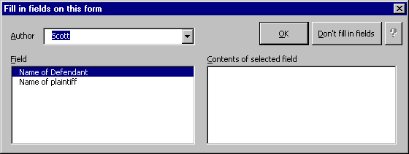Author fields provide information about the author of a document, such as an email address or bar association number. When you use a template or boilerplate which contains author fields, the Fill in fields on this form screen appears.
6.1
6.3
6.5
6.4
6.2
Figure 6
6.1 Author: If this box appears, the template or boilerplate contains author fields. Choose an author here, and the author fields will be filled in with the appropriate information, gathered from that author’s SnapPreferences screen Fig. 34 .
6.2 Field: If this box appears, the template or boilerplate contains repeating fields. Select a field here and fill in the contents of that field in box 6.5 . Do this for each field before clicking OK.
6.3 Help: Click here to open this manual on your screen.
6.4 Don’t fill in fields: Click this button to skip filling in fields and proceed directly to the document with field codes intact.
6.5 Contents of selected field: Select a field in box 6.2 and type the appropriate contents in this box 6.5 . Do this for each listed field before clicking OK.

Document Management

Folders and Subfolders
Documents and captions are organized in folders and subfolders. Each office has its own organization scheme, but for purposes of this explanation consider the most common arrangement: folder = client; subfolder = matter. In such an office, a letter relating to the Smith v. Jones case would be stored in the v. Jones subfolder, which is located in the Smith, John Q. folder:
Folder (client): Smith, John Q.
Subfolder (matter): v. Jones
Document: ltr to John Smith re discovery motion
Three S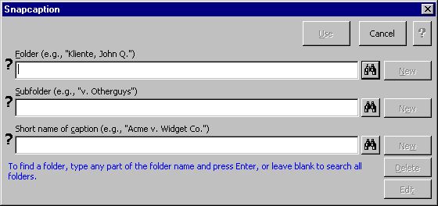na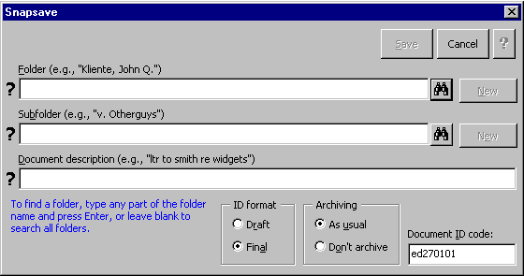pdon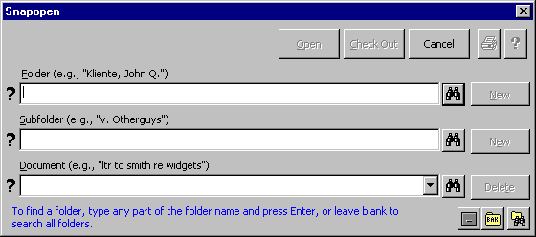e screens manipulate folders and subfolders: Snapopen (Snap Open), Snapsave (Snap Save), and Snapcaption (Snap Caption Bank).
Figure 7

The folder and subfolder controls common to these three screens are described here.
8.1
8.8
8.9
8.7
8.6
8.4
8.5
8.3
8.2
Figure 8
8.1 Question marks: The question marks indicate that a folder or subfolder has not yet been selected in box 8.2 or 8.3 .
8.2 Folder: Use this box to select or create a folder.
To select a folder, type any part of the folder name in this box 8.2 and press Enter or click the Find folder icon 8.5 .
To create a folder, type the name of the new folder in this box 8.2 and click New 8.6 .
8.3 Subfolder: Use this box to select or create a subfolder.
To select a subfolder, type any part of the subfolder name in this box 8.3 and press Enter or click the Find subfolder icon 8.4 . If a folder is specified in box 8.2 , the search is restricted to that folder. If box 8.2 is blank, the search spans all folders.
To create a subfolder, first select the appropriate folder in box 8.2 then type the name of the new subfolder in box 8.3 and click New 8.7 .
8.4 Find subfolder icon: Click this icon to list all subfolders or search for a particular subfolder. As an alternative to clicking this icon, press Enter while the cursor is in box 8.3 .
To list all subfolders, leave boxes 8.2 and 8.3 blank and click this icon 8.4 . To list all subfolders within a particular folder, select a folder in box 8.2 , leave box 8.3 blank, and click this icon 8.4 .
To search for a particular subfolder, type any part of the subfolder’s name in box 8.3 and click this icon 8.4 .
If more than one subfolder is found, the Choose a subfolder screen is displayed.
8.4b
8.4a
8.4c
Subfigure 8.4
8.4a Narrow it down: Use this button to shorten the list by searching for items which contain a certain word or phrase.
8.4b Subfolder list: Select the desired subfolder with the mouse (double-click a subfolder name) or keyboard (use arrow keys or type the first letter in a subfolder name to select a subfolder, then press Enter).
8.4c Save this list in a document icon: Click here to create a document containing the list of subfolders.
8.5 Find folder icon: Click this icon to list all folders or search for a particular folder. As an alternative to clicking this icon, press Enter while the cursor is in box 8.2 .
To list all folders leave box 8.2 blank and click this icon 8.5 . To search for a particular folder type any part of the folder’s name in box 8.2 and click this icon 8.5 . If more than one folder is found, the Choose a folder screen is displayed – it is similar to the Choose a subfolder screen Subfig. 8.4 .
8.6 New folder: To create a folder, type the new folder’s name in box 8.2 and click New 8.6 . Depending on how Snapdone is configured in your office, you may also be asked for an “alias” – a short name which prints as part of the document ID stamp. In offices where the folder corresponds to a particular client, the alias is usually the client number.
8.7 New subfolder: To create a subfolder first select a folder in box 8.2 , then type the new subfolder’s name in box 8.3 and click New 8.7 . Depending on how Snapdone is configured in your office, you may also be asked for an “alias” – a short name which prints as part of the document ID stamp. In offices where the subfolder corresponds to a particular matter, the alias is usually the matter number.
8.8 Rename folder: To rename a folder, select it in box 8.2 then click Rename 8.8 .
8.9 Rename subfolder: To rename a subfolder, select it in box 8.3 then click Rename 8.9 .

Snapsaving Documents

Saving for the First Time
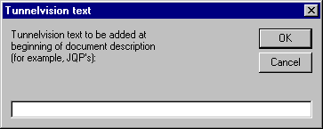After creating a document, click Snap Save. If your office uses Tunnelvision, the Tunnelvision text screen may appear. (For an explanation of Tunnelvision, see Tunnelvision, page 36.)
9.1
Figure 9
If this screen appears, enter the Tunnelvision text and click OK 9.1 to proceed to the 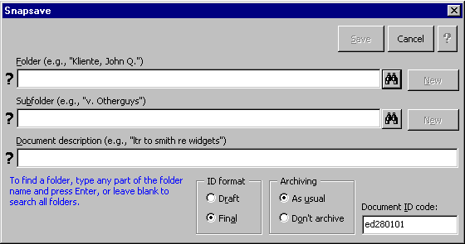Snapsave screen.
10.1
10.6
10.5
10.8
10.7
10.4
10.3
10.2
Figure 10
10.1 Folder and subfolder: Use this area (described in Fig. 8 ) to choose a folder and subfolder for the document.
10.2 Document description: Enter a description of the document here. In many cases, the description will already be filled in; you may change it if desired.
10.3 Message area: Watch this area for tips as the cursor moves about the screen.
10.4 ID format: Click Draft or Final to choose the ID stamp which prints on the document. The format of ID stamps varies from one office to another, but the draft ID stamp generally contains more details (typist, revision date and time, etc.) than the final ID stamp. If you are using Snapdone paper control 34.7a , this choice also affects which printer tray will be used when the document is printed. The default ID format can be set in the SnapPreferences screen 34.5a .
10.5 Save: After filling in the Folder, Subfolder, and Document description boxes, click Save to save the document.
10.6 Help: Click here to open this manual on your screen.
10.7 Archiving: Archiving should be As usual for most documents – the document will be archived after it has not been edited for a duration chosen by your administrator. If you want a particular document to remain on the active system indefinitely (a pleading index or office form, for example), choose Don’t archive – the document will not be archived unless it is later Snapsaved with As usual archiving.
10.8 Document ID code: This is an eight-character ID code automatically assigned by Snapdone. Each document is assigned its own unique code. You will generally not change the code in this box.

Resaving documents
With a document which has already been Snapsaved on your screen, click Snap Save to display the Overwriting old document screen and click Yes to overwrite the old document or No to create a new version or new copy of the document.
11.1
Figure 11
11.2
11.1 Yes: Click Yes to replace the old saved version of the document with the new revised version which is on your screen. When the Snapsave screen appears Fig. 10 , you may move the document to another location by changing the folder and/or subfolder 10.1 , or rename the document by changing the document description 10.2 .
11.2 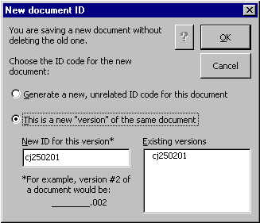No: Click No to display the New document ID screen:
11.2a
Subfigure 11.2
11.2d
11.2e
11.2c
11.2b
11.2a Generate a new, unrelated ID code: Select this option and click OK if the new document should be saved as a separate, unrelated document with its own unique ID code. This is one way to copy a document.
11.2b This is a new “version” of the same document: Select this option if the new document is a new version of the old document. The same eight-character base ID code will be retained for this version, so that both it and the preceding version(s) share the same code. NOTE: Word includes a built-in feature which allows multiple versions of a document to be saved together in a single file (File, Versions); Snapdone, however, saves multiple versions as separate files.
11.2c New ID for this version: Specify the version currently being saved. For example, if the original document was ab209903, the second version might be named ab209903.002, or a redlined version might be named ab209903.red.
11.2d Help: Click here to open this manual on your screen.
11.2e Existing versions: This window lists any other versions of the current document which have already been saved.

Opening Documents With Snapopen
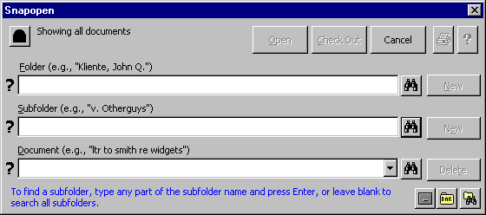To open a document which has been Snapsaved, click Snap Open to display the Snapopen screen:
12.1
12.5
12.7
12.11
12.12
12.2
12.13
12.9
12.14
12.10
12.4
12.3
12.8
12.6
Figure 12
12.1 Tunnelvision icon: This icon appears in the Snapopen screen if Tunnelvision is turned on in your SnapPreferences screen 34.8h . If you use Tunnelvision text when Snapsaving documents 34.5e , this feature can be used to restrict Snapopen so that it only sees documents which you authored. When an eye appears in the black tunnel icon , it indicates that Tunnelvision is on. When the tunnel icon is black , it indicates that Tunnelvision is off. To turn Tunnelvision on or off, click this icon 12.1 to display the Tunnelvision screen Subfig. 12.1 .
Subfigure 12.1
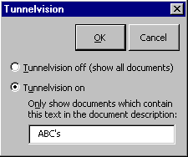 In the Tunnelvision screen, you can choose to turn Tunnelvision off (see all documents) or on (see only documents which contain the specified text somewhere within their document description).
12.2 Folder and subfolder: Use this area (described in Fig. 8 ) to look for documents in a particular folder or subfolder.
12.3 Document: Use this box to find and select a document.
To list all documents, leave this box blank and press Enter or click the Find document icon 12.12 . If a folder or subfolder has been specified in the Folder and Subfolder boxes 12.2 , only the documents in that folder or subfolder are listed.
To select a particular document, type the document’s ID code or any part of the document name in the Document box 12.3 and press Enter or click the Find document icon 12.12 . If a folder or subfolder has been specified in the Folder and Subfolder boxes, the search is restricted to that folder or subfolder.
If multiple documents are found, they are shown in the Choose a document screen Subfig. 12.12 .
12.4 Message area: Watch this area for tips as the cursor moves about the screen.
12.5 Print: After selecting a document in box 12.3 , click here to send it directly to the printer without opening it on your screen.
12.6 Help: Click here to open this manual on your screen.
12.7 Check Out: Documents can be checked out of the Snapdone system and copied to a floppy disk or other location for use outside the office. Select the document in box 12.3 , click Check Out, and choose where the checked-out document should be stored.
While the document is checked out, a read-only copy remains on the system with your name added to the document description so others will know who has the original document.
When you are ready to check the document back into the system (even if you have revised it), open it on your Word screen and click Snap Save. The checked-out document will be returned to its original location, and the read-only document which stood in its place will be removed.
12.8 Open: After selecting a document in box 12.3 , click here to open it on your screen.
12.9 Delete: To delete a document, select it in box 12.3 and click Delete.
12.10 List icon: Click here to list the selected folder, subfolder or document(s) in Word’s standard file open screen.
12.11 Recent documents list: Click this down arrow (or press Alt+Down while the cursor is in box 12.3 ) to list the last ten documents which were Snapsaved (not necessarily the last ten documents which were opened).
12.12 Find Document icon: Click this icon to list all documents or search for a particular document. As an alternative to clicking this icon, press Enter while the cursor is in the Document box 12.3 . If multiple documents are found, they are shown in the Choose a document screen.
12.12e
12.12f
12.12i
12.12h
12.12c
12.12b
12.12d
12.12a
12.12g
Subfigure 12.12
12.12a Narrow it down: Use this button to shorten the list by searching for items which contain a certain word or phrase.
12.12b Sort order: Choose how the list is sorted.
12.12c One column: If several columns are shown in box 12.12d , long document descriptions may be truncated. Check this checkbox to remove the extra columns and see more of the document descriptions.
12.12d Document list: Select the desired document with the mouse (double-click a document name) or keyboard (use arrow keys or type the first letter in a document name to select a document, then press Enter).
12.12e Select multiple documents icon: This icon toggles multiple document selection on and off. Click it once to turn on multiple document selection, then click on several documents in box 12.12d to select them all. When multiple documents are selected, the OK button 12.12f changes to an Open button – click it to open all selected documents. Or click the print icon 12.12i to print all selected documents.
12.12f OK: After selecting a document in box 12.12d , click here to return to the Snapopen screen Fig. 12 . If multiple document selection is turned on with icon 12.12e , this OK button 12.12f changes to an Open button – click it to open all documents selected in box 12.12d .
12.12g Save this list in a document icon: Click here to create a document containing the list of documents.
12.12h Preview icon: Click here to display a preview of the document selected in box 12.12d . Once the preview window is open, browse other documents by clicking on them in box 12.12d .
12.12i Print icon: Click here to print the document selected in box 12.12d . If multiple document selection is turned on with icon 12.12e , clicking the print icon prints all documents selected in box 12.12d .
12.13 Archives/Old documents icon: Depending on how Snapdone is configured in your office, click this icon to either list old, pre-Snapdone documents or find archived documents Fig. 13 .
12.14 Show backups icon: Every time a document is Snapopened (Snap Open), a copy is stored in a special Snapdone backup folder. Click this icon to list the last nine backups.

Archived Documents
The administrator of your system may periodically move old documents from the active system to long-term storage called archives. If you are unable to find a document on the active system, it may be because the document has been archived.
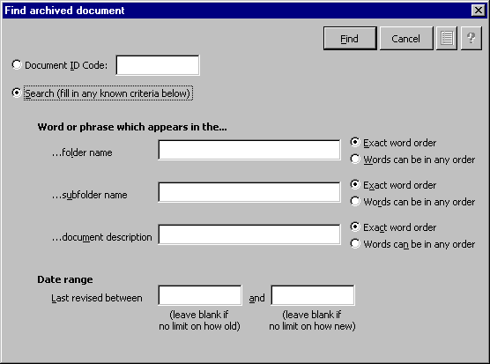To find an archived document, click Snap Open to display the Snapopen screen, then click the Find archived document icon 12.13 . (If the Find archived document screen does not appear, it is because your administrator has not turned on this feature – probably because no documents have been archived.)
13.1
13.6
13.10
13.9
13.8
13.7
13.5
13.4
13.3
13.2
Figure 13
13.1 Document ID code: If you know the eight-character document ID code, choose Document ID Code, enter the code in the box, and click Find 13.7 .
13.2 Search: If you do not know the eight-character document ID code, choose Search and fill in any known criteria in the bottom part of the screen.
13.3 Folder name: Type a word or words which appear in the folder name.
13.4 Subfolder name: Type a word or words which appear in the subfolder name.
13.5 Document description: Type a word or words which appear in the document description.
13.6 Help: Click here to open this manual on your screen.
13.7 Find: Once you have filled in the ID code ( 13.1 ) or other criteria ( 13.2 - 13.5 , 13.8 - 13.10 ), click Find to list any matching archived documents.
13.7b
13.7a
13.7g
Subfigure 13.7
13.7f
13.7e
13.7h
13.7d
13.7c
13.7a Folder: Check this checkbox to display the folder in which each found document was stored prior to being archived.
13.7b Subfolder: Check this checkbox to display the subfolder in which each found document was stored prior to being archived.
13.7c Edit date: Check this checkbox to display the date on which each found document was last saved.
13.7d List of found documents: Select a document here, then look at 13.7e to see where the document is archived.
13.7e Location of archived document: Select a document in 13.7d , then look here to see where the document is archived. Depending on how archived documents are stored in your office, you may find the archived document on a floppy disk, tape drive, or a special area on your network. Whichever is the case, the name of the archive set will guide you to the correct batch of archived documents.
13.7f Help: Click here to open this manual on your screen.
13.7g Save this list in a document icon: Click here to create a document containing the list of archived documents.
13.7h Find: Click here to change the search criteria and try another search.
13.8 Exact word order: Select this option to find only documents which contain words in the exact order you have typed them. For example, searching for john smith would not find Johnny Smith or John Q. Smith, but would find John Smithsonian and Upjohn Smith.
13.9 Words can be in any order: Select this option to find documents which contain the words you have typed in any order. For example, searching for john smith would find Johnny Smith, John Q. Smith, and John Smithsonian.
13.10 Last revised between: To restrict the search to documents which were last saved during a certain date range, fill in one or both of these boxes. For example, to find only documents which were last revised during January 1998, use Last revised between 1/1/98 and 1/31/98. To find only documents which were last revised before 1998, use Last revised between (blank) and 12/31/97. To find only documents which were last revised more recently than 1999, use Last revised between 1/1/2000 and (blank).

Tunnelvision
Tunnelvision is used in the Snapopen screen Fig. 12 to filter documents. For example, author John Q. Smith may only want to look at documents which he authored. He can use Tunnelvision with Snapsave to make sure all documents he creates are tagged with jqs’s in the document description, and use Tunnelvision with Snapopen so that only the tagged documents are shown.
Before Tunnelvision can be used, it must be enabled by the Snapdone administrator. Then you must turn on Tunnelvision text when Snapsaving 34.5e . And finally, you must turn on Tunnelvision when Snapopening 34.8h .
If you type your own documents, configure Snapsave so that it includes the Tunnelvision tag automatically 34.5g . But if you type documents for several different authors, you will need to enter Tunnelvision text manually 34.5f .

Filename Tools

Remember Filename
Some third-party programs require you to enter the path and filename of a document – redlining programs, cite-checking programs, etc. Click Snap Filename Remember Filename to copy the filename of the current document to the clipboard, then switch to the program which requires a filename, position the cursor in the appropriate filename box, and press Ctrl-V to paste the filename into the box.

Print Extra ID Code
If Snapdone is configured to print ID codes only on the first or last page of a document, there may be situations when extra ID codes are desired. For example, if a document includes several exhibits, you may want the ID code to print on each of the exhibit pages.
To create an extra ID code, position the cursor near the end of the desired page and click Snap Filename Extra ID on This Page. When the document is Snapsaved (Snap Save), an extra ID code will be inserted on the page.

Snapdata

Snapdata – Limited vs. Unlimited
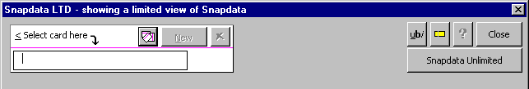Click Snap Snapdata to display the Snapdata screen. This screen has two modes: limited and unlimited. Limited mode is for casual users who do not use clips. Unlimited mode is for more advanced users who manage their Snapdata with clips. You can switch between the two modes at any time.
14.1
Figure 14
14.2
14.1 Snapdata Unlimited: Click here to switch to unlimited mode.
14.2 Ltd: Click here to switch to limited mode.
Snapdata screens shown in this manual use unlimited mode. If you are using limited mode you will see fewer Snapdata controls on your screen.

Snapdata – Top Section
Click Snap Snapdata to display the Snapdata screen. The top section of the screen contains several buttons that control the way Snapdata cards and clips are displayed.
15.1
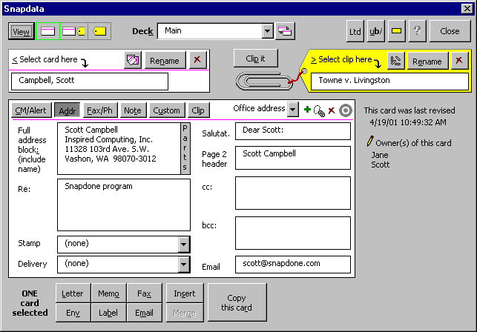
15.6
15.5
15.10
15.9
15.8
15.4
15.3
15.2
Figure 15
15.7

15.1 View: The View buttons appears when both a card and clip have been selected ( 16.6 and 16.8 ). Click View to cycle through the three views shown below.
15.2 View card icon: Click here to view all details of the selected card without details of the selected clip.
Subfigure 15.2

15.3 View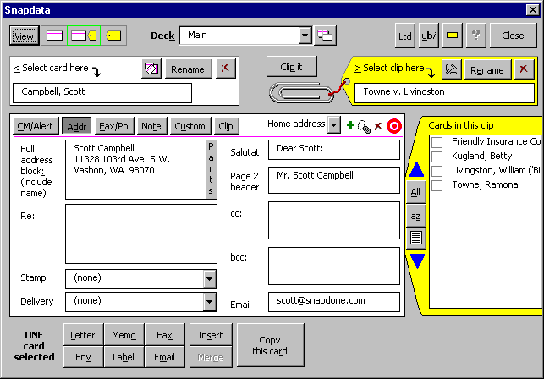 card and clip icon: Click here to view some details of the selected card and the selected clip simultaneously.
Subfigure 15.3

15.4 View clip icon: 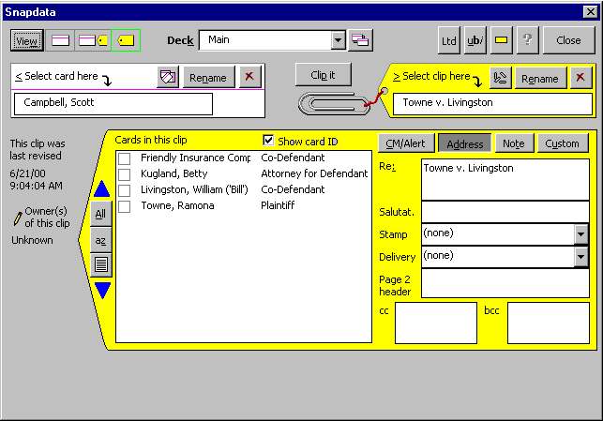Click here to view all details of the selected clip without details of the selected card.
Subfigure 15.4

15.5 Deck: This box appears if decks are turned on in your SnapPreferences screen 34.8i . Choose a deck here to work with a particular set of cards and clips.
15.6 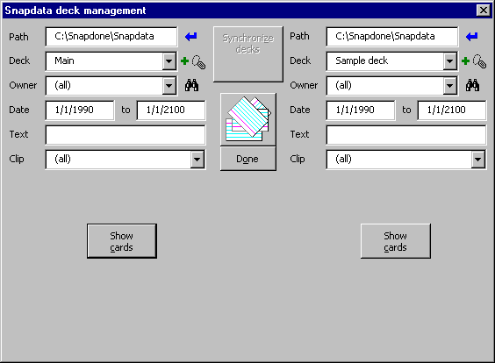Manage decks icon: Click here to display the Snapdata deck management screen. (If a “permission not granted” message appears, your administrator has not granted you permission to manage decks.) For more information on managing Snapdata decks, see the Snapdone Administration Manual, Snap, Help, Administration.
Subfigure 15.6

15.7 Help: Click here to open this manual on your screen..
15.8 Ltd: Click here to switch to a limited view of Snapdata Fig. 14 .
15.9 ubi: Click this icon to display a help screen Subfig. 1.7 explaining how to add foreign characters or formatting (underlined, bold or italic text) in the Snapdata screen.
15.10 Toggle tips icon: As the mouse arrow moves over the Snapdata screen, small yellow messages, or “tooltips” appear. These tooltips can be toggled on and off with the Toggle tips icon 15.10 .

Snapdata – Card and Clip Controls
Click Snap Snapdata to display the Snapdata screen. The card and clip controls near the top of the screen are used to create, select, and manage Snapdata cards and clips. This part of the screen changes depending on whether a card and/or clip is selected and depending on the relationship between the selected card and clip. Three variations are shown here:
16.1

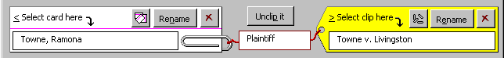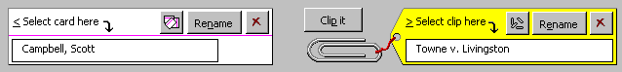
16.5
16.14
16.15
16.12
16.13
16.7
16.11
16.10
16.8
16.9
16.4
16.3
16.2
16.6
Figure 16
16.1 List all cards icon: This icon appears when box 16.6 is empty or a card has been selected. Click this icon 16.1 to list all existing cards in the search results screen Subfig. 16.12 .
16.2 Rename: To rename a card, select it in box 16.6 and click Rename.
16.3 Delete card icon: To delete a card, select it in box 16.6 and click this icon.
16.4 Unclip it: This button appears when a card is selected in box 16.6 , a clip is selected in box 16.8 , and the card is a member of the clip. Click Unclip it to remove the card from the clip (this does not delete the card).
16.5 ID of card in clip: This box appears when a card is selected in box 16.6 , a clip is selected in box 16.8 , and the card is a member of the clip. Use this box to identify a card’s relationship to a clip. For example, in a clip related to a particular matter named Smith v. Jones, you might identify the Joe Smith card as Plaintiff and the Jane Jones card as Defendant. These card IDs also appear in each clip’s list of cards 24.2 .
16.6 Select card here: Use this box to select or create a card. To select a card, type part of the card name here and press Enter. To create a card, type the new card’s name here and click New 16.13 .
16.7 Clip it: This button appears when a card is selected in box 16.6 , a clip is selected in box 16.8 , and the card is not a member of the clip. Click Clip it to add the card as a member of the clip.
16.8 Select clip here: Use this box to select or create a clip. To select a clip, type part of the clip name here and press Enter. To create a clip, type the new clip’s name here and click New 16.15 .
16.9 List all clips icon: This icon appears when box 16.8 is empty or a clip has been selected. Click this icon to list all existing clips in the Choose a clip screen (similar to the Choose a subfolder screen Subfig. 8.4 ).
16.10 Rename: To rename a clip, select it in box 16.8 and click Rename.
16.11 Delete clip icon: To delete a clip, select it in box 16.8 and click this icon.
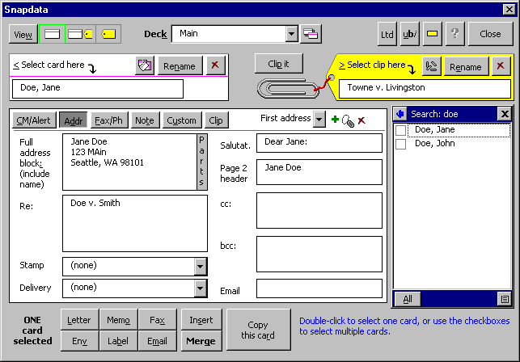 16.12 Find cards icon: To find a card, type any part of the card’s name in box 16.6 then click this icon (or press Enter). If more than one matching card is found, they are listed in the card search results screen:
Subfigure 16.12
16.12d
16.12c
16.12b
16.12a

16.12a Expand window icon: If the card names are very long, click this icon to widen the search results screen. Click the icon again to shrink it back to normal size.
16.12b Card list: This list includes all the cards which were found with 16.1 or 16.12 . Clicking on a card name in this list selects the card in box 16.6 . You may check multiple checkboxes in this list to include several cards when using the buttons at the bottom of the Snapdata screen Fig. 25 .
16.12c Save list in document icon: Click this icon to save the list of cards in a document. You will be asked whether you want to include all cards or only selected cards. You can also choose to list only card names or to list all information on the cards.
16.12d All: Click All to check or uncheck all of the checkboxes in 16.12b .
16.13 New: To create a new card, type the card’s name in box 16.6 and click New.
16.14 Find clips icon: To find a clip, type any part of the clip’s name in box 16.8 and click this icon (or press Enter). If more than one matching clip is found, they are listed in the Choose a clip screen. It is similar to the Choose a subfolder screen, Subfig. 8.4 .
16.15 New: To create a new clip, type the clip’s name in box 16.8 and click New.

Snapdata – Card
Click Snap Snapdata to display the Snapdata screen. 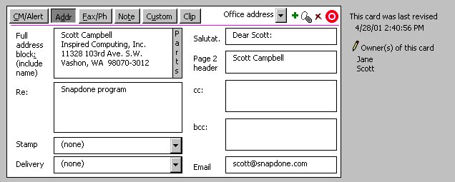When a card is selected in box 16.6 , the middle of the screen shows a detailed view of the selected card (click 15.2 if necessary to show the full card view).
17.1
Figure 17
17.3
17.2
17.1 Section buttons: Every Snapdata card is divided into six sections. To move among the sections, click one of the gray buttons along the top of the card: CM/Alert, Addr, Fax/Ph, Note, Custom, and Clip. Each section is described in detail below Figs. 18-23 .
17.2 Edit owners icon: By default, the “owner” of a Snapdata card is the person who created it. Owners have no special control over their cards; they are simply listed as a reference so that everyone knows who is responsible for each card. Depending on what privileges have been granted by your administrator, you may alter the list of owners to some degree.
With minimal privileges, you may click the Edit owners icon 17.2 to add or remove yourself to or from the list of owners on a particular card.
With higher privileges, clicking the Edit owners icon 17.2 allows you to add or remove anyone to or from the list of owners on a particular card.
17.3 Revision date and time: This shows when the card was last revised (but not necessarily when the card was last used).

Client-Matter/Alert Section
18.1
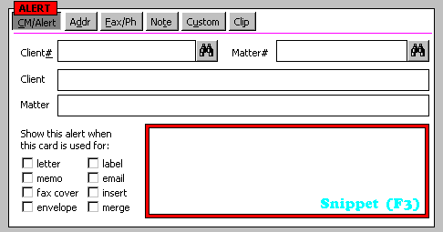To see the Client-Matter/Alert section of a card, click Snap Snapdata select a card CM/Alert.
18.10
18.4
18.7
18.6
18.5
18.9
18.8
18.3
18.2
Figure 18
18.1 Alert signal: This signal appears whenever there is text in the alert message box 18.9 . The alert signal is visible whenever the card is viewed, no matter which section of the card is being displayed, so users are alerted that there is an important message on this card.
18.2 Client#: If this card relates to a particular client, you may enter the client number here.
18.3 Find client icon: Depending on how Snapdone is configured in your office, this button may not be visible. If it is visible, you may type part of a client’s name in box 18.2 and click the Find client icon (or press Enter) to search for the client among existing folders or subfolders. If the search is successful, the client number is entered in box 18.2 and the client name is entered in box 18.7 .
18.4 Show this alert checkboxes: Even though the alert signal 18.1 is displayed whenever a message is typed in box 18.9 , you may want to invoke a more intrusive warning for a particularly important alert. Each of these checkboxes causes the warning message to appear when this card is used to generate a particular type of document.
For example, if the letter checkbox is checked, then whenever this card is used to create a letter, the person creating the letter will see a warning screen which displays the alert message in box 18.9 , and an OK button must be clicked before proceeding with creation of the letter.
18.5 Matter#: Depending on how Snapdone is configured in your office, this box may not be visible. If this card relates to a particular matter, you may enter the matter number here.
18.6 Find matter icon: Depending on how Snapdone is configured in your office, this button may not be visible. If it is visible, you may type part of a matter name in box 18.5 and click the Find matter icon (or press Enter) to search for the matter among existing folders or subfolders. If the search is successful, the matter number is entered in box 18.5 and the matter name is entered in box 18.8 .
18.7 Client: If this card relates to a particular client, you may enter the client name here.
18.8 Matter: If this card relates to a particular matter, you may enter the matter name here.
18.9 Alert message: Use this box to enter an important message which should be seen by everyone who uses this card. Entering a message here causes the alert signal 18.1 to be displayed whenever this card is viewed. You can make the alert message even more intrusive by checking one or more of the Show this alert checkboxes 18.4 .
18.10 Snippet (F3): See Snippets, p. 51.

Address Section
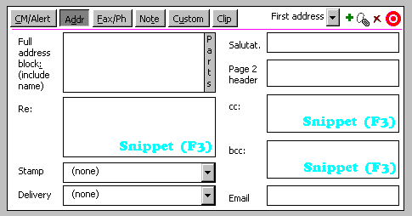To see the Address section of a card, click Snap Snapdata select a card Addr.
19.1

19.16
Figure 19
19.15
19.14
19.13
19.12
19.11
19.5
19.4
19.3
19.2
19.10
19.9
19.8
19.7
19.6
19.1 Address selection: Each card can hold multiple addresses – for example, a home address and office address. Click the small down arrow to select an address.
19.2 New address icon (to create multiple addresses on one card): To add a new address to this card, click this icon. For example, if there is already an office address on this card, click here to add a home address. When the home address is created, information from the office address is copied to reduce retyping – be sure to make any necessary changes. Once both addresses exist on the card, use 19.1 to switch between them.
19.3 Rename address icon: To change the address name which appears in 19.1 , click this nametag icon and enter a new name.
19.4 Delete address icon: If this card contains more than one address, you can delete one by selecting it in 19.1 then clicking this icon.
19.5 Target address icon: When a card contains multiple addresses, one of them is considered the “target” or default address. The target address is the one which appears first when a card is viewed. The target icon 19.5 is red when the target address is selected in 19.1 and gray when any other address is selected. To make another address the target address, select the desired address in 19.1 and click the gray target icon 19.5 to turn it red.
19.6 Full address block: Type the full address block here, including the addressee’s name, the way it would appear on an envelope.
19.7 Parts: When a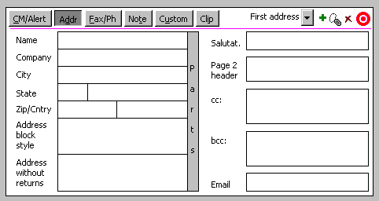n address is entered in box 19.6 , it is broken into several parts for use in forms which include Snapdata merge codes. Click the gray Parts label 19.7 to show the individual parts and change them if necessary.
19.7j
19.7i
19.7h
19.7g
19.7f
19.7e
19.7d
19.7c
19.7b
19.7a
Subfigure 19.7

19.7a Name: This text is often used on memos and also appears on fax covers if box 20.5 is empty.
19.7b Company: This is sometimes used on memos and may also appear on fax covers if box 20.6 is empty.
19.7c City.
19.7d State abbreviation: The two-letter state abbreviation is used here.
19.7e Zip.
19.7f Address block style: The address here is broken onto multiple lines with hard returns.
19.7g Address without returns: The address here is formatted for use within a line of text, with commas instead of hard returns.
19.7h Parts: Click the gray Parts label to exit the Parts display.
19.7i State: The full name of the state is spelled out here.
19.7j Country.
19.8 Re: If the same re line is used almost every time a letter is created with this card, enter it here. When a re line is entered here, it is also copied to 20.7 in the Fax/Phone section. If fax covers need a different re line, change the re line in 20.7 accordingly.
19.9 Stamp: If the same stamp is used almost every time a letter is created with this card, select it here.
19.10 Delivery: If the same delivery line is used almost every time a letter is created with this card, select it here.
19.11 Salutat.: The salutation is automatically generated when you fill in the address block and move the cursor out of box 19.6 , but you may change it if necessary. The form of the automatic salutation is determined by the form of the name in the address block: if John Smith is entered in the address, the generated salutation is Dear John; If Mr. John Smith is entered in the address, the generated salutation is Dear Mr. Smith.
19.12 Page 2 header: When this card is used to create a letter, this text (typically the name of the addressee) is inserted in the second-page header. This text is automatically generated when you fill in the address block and move the cursor out of box 19.6 , but you may change it if necessary.
19.13 cc: If the same cc’s are used almost every time a letter is created with this card, enter them here.
19.14 bcc: If the same bcc’s are used almost every time a letter is created with this card, enter them here.
19.15 Email: If the Email button 25.10 is visible in your Snapdata screen, it can be used to send an email to the address in this box 19.15 .
19.16 Snippet (F3): See Snippets, p. 51.

Fax/Phone Section
20.1
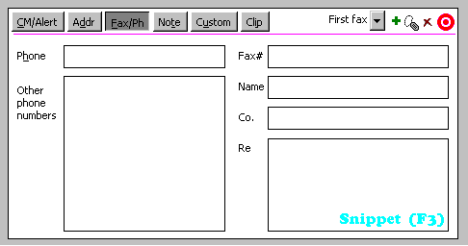To see the Fax/Phone section of a card, click Snap Snapdata select a card Fax/Ph.
20.8
Figure 20
20.7
20.6
20.5
20.4
20.3
20.2

20.1 Phone: This is the primary phone number, commonly used as the voice number on fax covers. Type only the phone number here, without any explanatory words.
20.2 Other phone numbers: These numbers are not used on forms; they are here for reference only. You may format and annotate them as you desire.
20.3 Multiple fax controls: These controls are similar to the corresponding controls in the Address section of the card, 19.1 through 19.5 .
20.4 Fax#: This is the primary fax number, for use on fax cover sheets. Type only the fax number here, without any explanatory words.
20.5 Name: If this box is left blank, the name in box 19.7a is used on fax covers created with this card. But if you want the name which appears on fax covers to be different (perhaps less formal) than the name used on other documents, enter a name here for use exclusively on fax covers.
20.6 Co.: If this box is left blank, the company name in box 19.7b is used on fax covers created with this card. But if you want the company name which appears on fax covers to be different than the company name used on other documents, enter a company name here for use exclusively on fax covers.
20.7 Re: The re line in box 19.8 is automatically copied here, but you may change it if the re line for fax covers is different than the re line for letters.
20.8 Snippet (F3): See Snippets, p. 51.

Notes Section
21.1
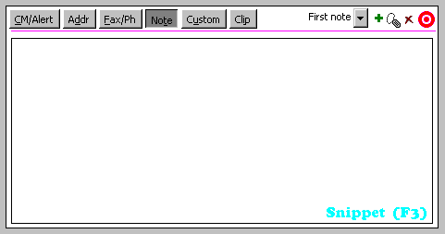To see the Notes section of a card, click Snap Snapdata select a card Note.
Figure 21
21.3
21.2

21.1 Note: You may enter any notes in this box.
21.2 Multiple note controls: These controls are similar to the corresponding controls in the Address section of the card, 19.1 through 19.5 .
21.3 Snippet (F3): See Snippets, p. 51.

Custom Fields Section
22.1
To see the Custom field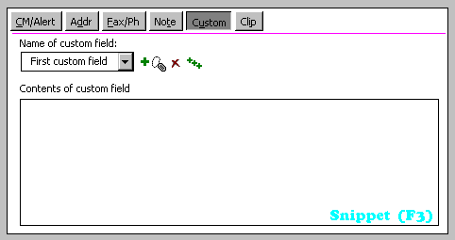s section of a card, click Snap Snapdata select a card Custom.
22.2
Figure 22
22.4
22.3
22.1 Multiple custom field controls: These controls are similar to the corresponding controls in the Address section of the card, 19.1 through 19.5 .
22.2 Contents of custom field: First choose a custom field in the Name of custom field box, then view or modify its contents in this box.
22.3 Add default custom fields: Your administrator may have preassigned several default custom fields which should appear on Snapdata cards. If so, click this icon to add the default fields to this card.
22.4 Snippet (F3): See Snippets, p. 51.

Clips Section
To see the 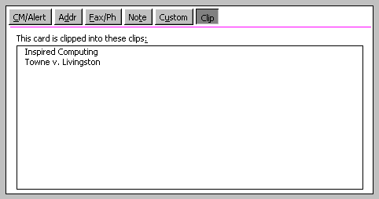Clips section of a card, click Snap Snapdata select a card Clip.
23.1
Figure 23

23.1 List of clips: These are the clips to which this card is attached. Click the name of a clip to select it in box 16.8 .

Snapdata – Clip
Click Sn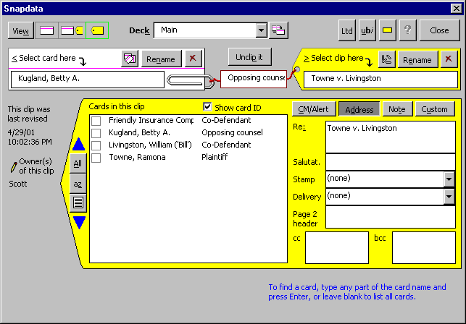ap Sn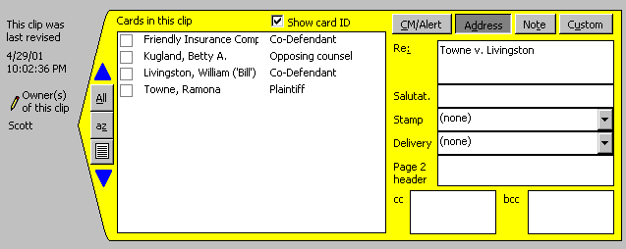apdata to display the Snapdata screen. When a clip is selected in box 16.8 , the middle of the screen shows a detailed view of the selected clip (click 15.4 if necessary to show the full clip view).
24.1

24.4
24.3
24.2
24.11
24.10
24.9
24.7
24.8
24.6
24.5
Figure 24
24.1 Cards in this clip: This list shows the cards which are included in this clip. Clicking on a card name in this list selects the card in box 16.6 . Check multiple checkboxes in this list to include several cards when using the buttons at the bottom of the Snapdata screen Fig. 25 .
24.2 Card IDs: This column shows the ID for each card in this clip. IDs can be added or changed by clicking on the desired card in 24.1 and entering the ID in box 16.5 .
24.3 Show card ID: Occasionally the card names in the left column 24.1 may be so long that they are truncated in the display. Unchecking this checkbox 24.3 turns off the right column 24.2 so that more room is available to display card names.
24.4 Clip sections: Every Snapdata clip is divided into four sections, each of which is similar to the corresponding section on a Snapdata card (CM/Alert Fig. 18 , Address Fig. 19 , Note Fig. 21 , and Custom Fig. 22 ). When a clip is used to create a document (by selecting one or more cards in 24.1 ), information in the clip sections (if it exists) overrides information in the card sections.
For example, suppose there is a John Smith card which contains the re line Smith Estate and a Smith v. Jones clip which contains the re line Smith Corp. v. Jones, et al. If a letter is created (by clicking 25.2 ), the re line will be different depending on whether the card was selected in 16.6 (uses the re line from the card) or the card’s checkbox was checked in 24.1 (uses the re line from the clip).
This can be useful, particularly with client-matter names, client-matter numbers, and re lines. Suppose there is an opposing counsel Jane Doe who opposes you in two different cases: Bob v. Betty and Kate v. Ken. In addition to being an opposing counsel, Jane also happens to be on your softball team. Sometimes you write to Jane personally re Softball Practice Schedule; sometimes you write to her re Bob v. Betty; and sometimes you write to her re Kate v. Ken. Type Softball Practice Schedule in the re box on Jane’s card 19.8 , Bob v. Betty in the re box on a Bob v. Betty clip, and Kate v. Ken in the re box on a Kate v. Ken clip. Now when it’s time to create a letter to Jane with the Letter button 25.2 , you can choose the appropriate re line by (a) selecting Jane’s card in 16.6 ; (b) selecting the Bob v. Betty clip in 16.8 and checking Jane’s checkbox in 24.1 ; or (c) selecting the Kate v. Ken clip in 16.8 and checking Jane’s checkbox in 24.1 .
24.5 Revision date and time: This shows when the clip was last revised (but not necessarily when the clip was last used).
24.6 Move card up icon: You can change the order of cards listed in a clip. To move a card up the list, select it in 24.1 and click the blue up arrow 24.6 .
24.7 Edit owners icon: This icon controls owners of a clip in the same way 17.2 controls owners of a card.
24.8 All: Click All to check or uncheck all of the checkboxes in 24.1 .
24.9 az: Click az to alphabetize the cards listed in 24.1 .
24.10 Save list in document icon: Click this icon to save the list of cards in a document. You will be asked whether you want to include all cards or only selected cards. You can also choose to list only card names or to list all clip information.
24.11 Move card down icon: You can change the order of cards listed in a clip. To move a card down the list, select it in 24.1 and click the blue down arrow 24.11 .

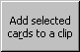Snapdata – Bottom Section
Click Snap Snapdata to display the Snapdata screen. The bottom section of the screen contains several buttons that use Snapdata cards to create documents and fill in forms.
25.1
25.12
25.11
25.7
25.6
25.5
25.10
25.9
25.8
25.4
25.3
25.2
Figure 25

25.1 Card selection indicator: This reminder indicates whether multiple cards are selected. If you intend to create a document using only one card, make sure only one card is selected – it is possible to select more than one card with the checkboxes in 16.12b or 24.1 .
25.2 Letter: Select a card or cards, then click Letter to create a letter. If the letter is to a single recipient, select the card in 16.6 . If the letter is to multiple recipients, check the desired checkboxes in 16.12b or 24.1 (this creates a single letter addressed to all recipients; if you instead want to send an identical letter to each recipient, see 25.11 ).
25.3 Memo: Select a card or cards, then click Memo to create a memorandum. If the memorandum is to a single recipient, select the card in 16.6 . If the memorandum is to multiple recipients, check the desired checkboxes in 16.12b or 24.1 (this creates a single memorandum addressed to all recipients; if you instead want to send an identical memorandum to each recipient, see 25.11 ).
25.4 Fax: Select a card or cards, then click Fax to create a fax cover. If the fax cover is to a single recipient, select the card in 16.6 . If the fax cover is to multiple recipients, check the desired checkboxes in 16.12b or 24.1 (this creates a single fax cover addressed to all recipients; if you instead want to send an identical fax cover to each recipient, see 25.11 ).
25.5 Insert: Click Insert to insert data from one or more Snapdata cards into the current document. First position the cursor at the desired location in the document then click Snap Snapdata, select the card(s), and click Insert to display the Inserting data screen and, if you want to display all the options in this screen, click More.
25.5a
25.5n
25.5l
25.5m
25.5k
25.5j
25.5i
25.5g
25.5h
25.5e
25.5d
25.5c
25.5b
Subfigure 25.5
25.5f

25.5a Choose a layout: Each “layout” in this box is a particular arrangement of data from a Snapdata card. For example, one layout may contain only the name and address, while another layout includes the name, address, phone number, fax number, and email address. Click on a layout to select it, then click Insert 25.5d to insert data from the selected card(s) in the current document at the cursor’s location. Layouts marked (public) appear on everyone’s screen; layouts marked (private) only appear on your screen.
25.5b Save changes to layout: After making changes to a layout in box 25.5c , click here to save those changes (or click Insert 25.5d to use the changed layout without saving it).
25.5c Details of selected layout: This box shows the contents of the layout selected in box

25.5a . Modify the selected layout by editing it in this box 25.5c then clicking Save changes to layout 25.5b (or click Insert 25.5d to use the changed layout without saving it).
25.5d Insert: After selecting a layout in box

25.5a , click Insert to insert data from the selected card(s) into the current document at the cursor’s location.
25.5e Save list in document icon: Click here to create a document listing all available layouts.
25.5f Help: Click here to open this manual on your screen.
25.5g New layout: Click here to create a new layout. If you have been granted the privilege to do so, you will have the option to make the new layout public (appears on everyone’s layout screen) or private (only appears on your layout screen).
25.5h Rename layout: To rename a layout, select it in box

25.5a and click Rename layout.
25.5i Delete layout: To delete a layout, select it in box

25.5a and click Delete layout.
25.5j Use two columns: When multiple cards are selected, this checkbox determines whether the inserted data is formatted in one or two columns. Use box 25.5m to determine how many cards need to be selected before two columns are used.
25.5k Add blank line between multiple items: When multiple cards are selected, this checkbox determines whether an extra hard return is inserted between each set of inserted data.
25.5l Fields: This box lists the Snapdata fields which can be used in a layout. Each field corresponds to a piece of information on a Snapdata card – for example, the <<Name and Address>> field refers to information found in box 19.6 . To include a field in a layout, first select the desired layout in box

25.5a , then position the cursor at the desired location in box 25.5c , then select the desired field in box 25.5l and click Paste 25.5n to paste the field into the layout.
25.5m Number of items: When 25.5j is checked, the number in this box 25.5m determines how many cards must be selected before the inserted data is formatted in two columns. For example, if the number in this box is 3 and two addresses are inserted in a document, they are stacked one above the other; if the number is 2 and two addresses are inserted in a document, they are inserted side by side.
25.5n Paste: To include a field in a layout, first select the desired layout in box

25.5a , then position the cursor at the desired location in box 25.5c , then select the desired field in box 25.5l and click Paste 25.5n to paste the field into the layout.
25.6 Copy this card: This button appears when one card is selected. To create a card which is very similar to an existing card – perhaps the spouse of someone for whom a card has already been created – select the existing card in box 16.6 and click Copy this card. The new card contains all the information from the old card, so be sure to scan it carefully and change anything which does not apply to the new card.
25.7 Message area: Watch this area for tips as the cursor moves about the screen.
25.8 Env: Select a card, then click Env to create an envelope. To create several envelopes to different people, see 25.11 .
25.9 Label: Select a card, then click Label to create a label. To create several address labels to different people, see 25.11 .
25.10 Email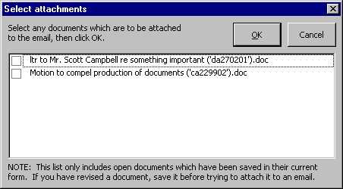: This button appears if your administrator has turned on Snapdata emailing. Select a card or cards, then click Email to create an email. If any saved documents are open, the Select attachments screen appears Subfig. 25.10 . Check the checkbox for any documents which are to be included as attachments to the email, then click OK.
Subfigure 25.10

25.11 Merge: This button is enabled and highlighted if the current document on your screen is a form document containing Snapdone merge codes. Click Merge to merge the card(s) selected in 16.6 , 16.12b or 24.1 with the form document on your screen.
For example, to generate form letters: (1) create the form by clicking Snap New Letter Form letters OK; (2) type the body of the letter and save if desired; (3) merge Snapdata cards into the form letter by clicking Snap Snapdata, selecting cards in 16.6 , 16.12b or 24.1 , and clicking Merge.
A batch of envelopes or mailing labels can be generated in the same way: (1) create the form by clicking Snap New Envelope (or Labels), Form envelopes (or Form labels), OK; (2) merge Snapdata cards into the form envelope or label by clicking Snap Snapdata, selecting cards in 16.6 , 16.12b or 24.1 , and clicking Merge.
25.12 Add selected cards to a clip: This button appears if more than one card is selected in 16.12b or 24.1 . Instead of clipping cards into a clip one at a time with the Clip it button 16.7 , use this button 25.12 to clip several cards at the same time.

Other Features

Snippets
Snapdone’s Snippet feature allows you to save frequently used bits of text when filling in Snapdone form screens, Snapdata cards or Snapdata clips. For example, if you regularly send carbon copies of correspondence to a particular trio of attorneys, you could save that trio as a Snippet which is available whenever your cursor is in one of Snapdone’s cc boxes.
When the cursor is in a box which supports the use of Snippets, a light blue Snippet (F3) signal appears Fig. 1 , Figs. 18-22 . When this signal is visible, press F3 to display the Snippets screen.
26.1
26.9
Figure 26
26.5
26.3
26.4
26.8
26.7
26.6
26.2

26.1 Save changes to Snippet: After making changes to a Snippet, click here to save those changes (or click 26.8 to use the changed Snippet without saving changes).
26.2 Choose a Snippet: Click on a Snippet to select it. Snippets marked (public) appear on everyone’s screen; Snippets marked (private) only appear on your screen.
26.3 Delete Snippet: To delete a Snippet, select it in box 26.2 and click Delete Snippet.
26.4 Rename Snippet: To rename a Snippet, select it in box 26.2 and click Rename Snippet.
26.5 New Snippet: Click here to create a new Snippet. If you have been granted the necessary privileges, you will have the option to make it public (appears on everyone’s Snippet menu) or private (only appears on your Snippet menu).
26.6 Help: Click here to open this manual on your screen.
26.7 Save list in document icon: Click here to create a document listing all Snippets.
26.8 Insert: After selecting a Snippet in box 26.2 , click Insert to insert it in the screen which preceded the Snippets screen.
26.9 Contents of selected Snippet: This box shows the contents of the Snippet selected in box 26.2 . Modify the selected Snippet by editing it in this window then clicking Save changes to Snippet

26.1 (or click 26.8 to use the changed Snippet without saving changes).

Snapnumbers
In addition to this reference, Snapnumbers are introduced, explained and demonstrated in the Snapnumbers/SnapTOC manual (Snap Help Snapnumber/TOC).

Inserting Snapnumbers
Figure 27
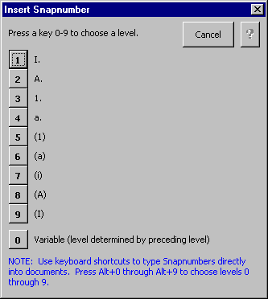Faster method (keyboard shortcut): Position the cursor where the number should appear and press Alt+1 through Alt+9 to choose a Snapnumber level. This method is fast, but no preview is provided before a level is chosen.
Slower method: Position the cursor where the number should appear and click Snap Snapnumber Insert to display the Insert Snapnumber screen Fig. 27 .
Press a number key 1 to 9 to choose the level of the Snapnumber or click one of the numbered buttons. This method is slower, but allows you to see the format of each level before making your selection.

Snapnumber Schemes
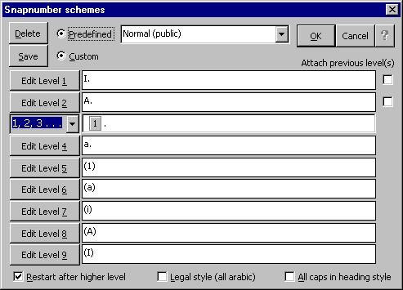Click Snap Snapnumber Scheme to display the Snapnumber schemes screen.
28.1
28.8
28.4
28.13
28.11
28.2
28.3
28.12
28.10
28.9
28.7
28.6
28.5
Figure 28
28.1 Predefined: Numbering schemes can be saved for future use. To use a previously saved scheme, choose Predefined, select the scheme in box 28.5 , and click OK.
28.2 Delete: To delete a previously saved Snapnumber scheme, choose Predefined 28.1 , select the scheme in box 28.5 , and click Delete.
28.3 Save: To save a custom Snapnumber scheme for future use, choose Custom 28.4 and click Save. If you have been granted privileges to do so, you will be asked to choose whether the scheme is public (appears on everyone’s scheme screen) or private (only appears on your scheme screen).
28.4 Custom: Choose Custom to modify individual elements of the current document’s Snapnumber scheme. This enables the customizing controls 28.6 through 28.13 .
28.5 List of predefined schemes: This box appears when Predefined 28.1 is chosen. Choose a scheme here and click OK to apply it to the current document. Schemes marked (public) appear on everyone’s menu; schemes marked (private) appear only on your menu.
28.6 Number style box: This box appears when an Edit Level # button (for example, 28.7 ) is clicked. Use this box 28.6 to choose a numbering style for the selected level.
28.7 Edit Level 1-9: These nine buttons are enabled when Custom 28.4 is chosen. Click one of the Edit Level buttons to change the appearance of that level.
28.8 Help: Click here to open this manual on your screen.
28.9 Attach previous level(s) boxes: Click an Edit Level # button (for example, 28.7 ) to make these checkboxes appear. Check these checkboxes to attach numbers from previous levels to the level which is currently being edited.
28.10 Surrounding text box: Click an Edit Level # button (for example, 28.7 ) to make this box appear. Use this box to add text around the number selected in box 28.6 (for example: 1., (1), Section 1, Interrogatory No. 1).
28.11 Restart after higher level: Click an Edit Level # button (for example, 28.7 ) to make this checkbox appear. Uncheck this checkbox only if you want numbering to continue sequentially for the selected level regardless of intervening higher-level Snapnumbers.
28.12 Legal style (all Arabic): Click an Edit Level # button (for example, 28.7 ) to make this checkbox appear. A checkmark in this checkbox forces all numbers in the selected level to be Arabic, even if they include attached levels 28.9 which are not Arabic.
28.13 All caps in heading style: Click an Edit Level # button (for example, 28.7 ) to make this checkbox appear. If the selected level uses a textual numbering style (for example, One, Two, Three…), then a checkmark in this checkbox 28.13 forces the Snapnumber to appear in uppercase letters when Word’s heading styles are used (Heading 1 through Heading 9).

Resetting Snapnumbers
To reset numbering partway through a document, or to start numbering with a number other than 1, first select the Snapn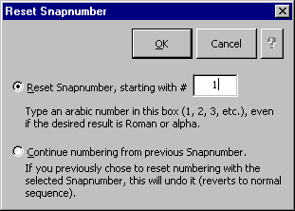umber to be changed, then click Snap Snapnumber Reset to display the Reset Snapnumber screen:
29.1
29.3
Figure 29
29.2
29.4
29.1 Reset Snapnumber: This option changes the selected Snapnumber to the value in box 29.4 .
29.2 Continue numbering: This option makes the selected Snapnumber revert to ordinary sequential numbering.
29.3 Help: Click here to open this manual on your screen.
29.4 Starting number: To specify a value for the selected Snapnumber, choose Reset Snapnumber 29.1 and enter the desired number here. Type an Arabic number, even if the selected Snapnumber is roman or alpha.

Troubleshooting Snapnumbers

Sharing Snapnumbered Documents
If you are sharing a Snapnumbered document with someone who does not use Snapnumbers, you may want to convert all of the Snapnumbers to regular text: select all text with Ctrl+A then press Shift+Ctrl+F9 (this will also convert other selected fields to regular text).

Numbers All Become “1”
When editing a long document, it is possible for Word to lose track of sequential numbering. Force Word to recalculate numbers by clicking Snap Snapnumber Scheme OK.

Part of Snapnumber Missing When Printed
This happens in documents where some or all of the text was imported from a WordPerfect document. During the conversion process, “condensed” formatting is sometimes inappropriately applied. To fix it, select all text with Ctrl+A then click Format Font Character Spacing and choose Normal in the Spacing box.

SnapTOC
In addition to this reference, Snapdone’s table of contents feature is introduced, explained and demonstrated in the Snapnumbers/SnapTOC manual (Snap Help Snapnumber/TOC).

Marking Text
Marking Text Manually. To manually mark an item for inclusion in the table of contents, position the cursor at the end of the item and press Alt+M (or click Snap Table of Contents Mark Item). This marks text from the beginning of the paragraph to the location of the cursor. To mark text which is not at the beginning of the paragraph, first select the text then press Alt+M.
NOTE: Word’s heading styles (Heading 1 through Heading 9) are automatically included in the table of contents, so there is no need to mark text which is formatted with a heading style.
Marking Text Automatically. If a document is Snapnumbered, SnapTOC can mark 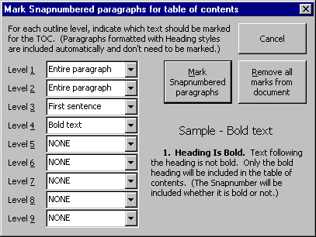it automatically. Click Snap Table of Contents Mark Document to display the Mark Snapnumbered paragraphs screen.
30.1
30.4
30.3
30.2
Figure 30
30.1 Level selections: Use these boxes to choose how much of each paragraph gets marked for inclusion in the table of contents. For example, in Figure 30 only the first sentence of each paragraph numbered with a Level 3 Snapnumber will be included in the table of contents.
30.2 Mark Snapnumbered paragraphs: After making selections in 30.1 , click here to automatically mark all Snapnumbered paragraphs in the document.
30.3 Remove all marks from document: Click here to remove all SnapTOC markings from the document.
30.4 Sample: This area displays a sample to illustrate choices made in 30.1 .

Generating
Once text has been marked, position the cursor where the table of contents should appear in your document and click Snap Table of Contents Generate.
31.1
Figure 31

31.1 To format the table of contents with half-inch tabs (more widely spaced than Word’s default setting), check the Format TOC with half-inch tabs and indents checkbox. Then click Generate TOC at cursor’s location.

Regenerating
To regenerate the table of contents, click Snap Table of Contents Generate TOC Regenerate existing TOC.

Removing Marks
To remove all TOC marks in a document, click Snap Table of Contents Mark Document Remove all marks from document. To remove TOC marks from part of a document, first select the desired paragraphs then click Snap Table of Contents Remove Marks.

Viewing TOC Marks
Toggle the display of SnapTOC bookmarks by clicking Snap Table of Contents Bookmarks (In)visible.

Shortcuts

Styles
Snapdone allows quick access to three frequently used styles: Body text (Snap Body Text Style), No Spacing (Snap No Space Style), and Quote (Snap Quote Style). Word includes keyboard shortcuts for the first three heading styles (Ctrl+Alt+1 through Ctrl+Alt+3), and Snapdone adds keystrokes for the remaining six heading styles (Ctrl+Alt+4 through Ctrl+Alt+9). Also remember Word’s shortcut for Normal style (Ctrl+Shift+N).

View
Scrolling. Snapdone allows you to scroll through a document directly from the keyboard. Hold down Ctrl+Alt while using the arrow keys to scroll up, down, left and right.
Zoom In / Zoom Out. Snapdone allows you to zoom in and zoom out (change your view percentage) directly from the keyboard. Press Alt+→ to zoom in or Alt+← to zoom out.
Zoom Toggle. In page layout view, press Alt+Z to toggle between full page and page width views. In normal layout view, Alt+Z toggles between 100 percent and “best fit.”

Snapsymbols
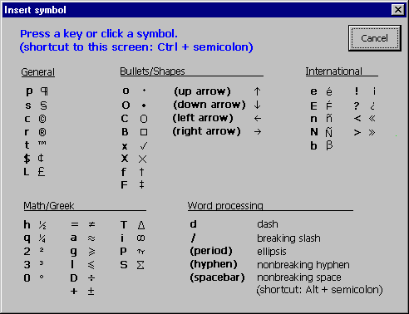Press Ctrl+semicolon (or click Snap Symbols) to display the Insert symbol screen Fig. 32 . Press a key or click the screen to insert the desired symbol. Note that upper/lowercase is important. For example, lowercase p = ¶, but uppercase Shift+P = π.
Figure 32

SnapPaper – Print Trays and ID Stamps
Each document is assigned a SnapPaper type which controls (1) the placement and appearance of the document ID stamp on the printed document and (2) the paper tray which is used to print the document (if you have turned on Snapdone’s paper tray control in the SnapPreferences screen 34.7a ).
For example, letters may print from the upper printer tray with the ID stamp in the bottom right corner, while pleadings may print from the lower printer tray with the ID stamp in the bottom left corner.
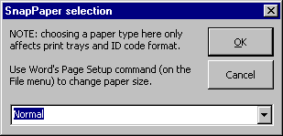To view or change a document’s SnapPaper assignment, click Snap Paper Type to display the SnapPaper selection screen Fig. 33 . Note that choosing a SnapPaper does not affect paper size, margins, orientation, or other formatting on Word’s Page Setup screen (File, Page Setup) – only the ID stamp and printer tray are affected.
Figure 33

SnapPreferences
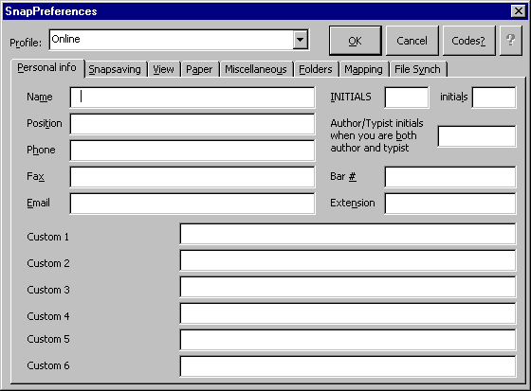Click Snap Setup Preferences to display the SnapPreferences screen.
34.1
34.9
34.8
34.7
34.2
34.6
34.5
34.4
34.3
Figure 34
34.10
34.11
34.1 Profile: This box appears if you have more than one Snapdone profile. For example, if you work on a notebook computer, you may have an Online profile (when connected to the network at the office), an Offline profile (when not connected), and a Remote profile (when dialing into the network from home). Snapdone automatically selects a profile when Word starts, but can be changed by choosing a profile here and clicking OK.
34.2 Codes?: Click here to display a help screen showing how to add foreign characters in the SnapPreferences screen Subfig. 1.7 .
34.3 Help: Click here to open this manual on your screen.
34.4 The Personal info tab contains information which is inserted in various Snapdone forms when you are selected as a sender in box 1.3 or author in box 6.1 . The boxes on this tab correspond to Snapdata merge codes which are used in Snapdone forms, templates and boilerplate.
34.4k
34.4j
34.4i
34.4a
34.4h
34.4g
34.4f
34.4e
34.4d
34.4c
34.4b
Subfigure 34.4
34.4a Name: Snapdata merge code: <<PD:Constants:PersonalName>>.
34.4b Position: Snapdata merge code: <<PD:Constants:PersonalPosition>>.
34.4c Phone: Snapdata merge code: <<PD:Constants:PersonalPhone>>.
34.4d Fax: Snapdata merge code: <<PD:Constants:PersonalFax>>.
34.4e Email: Snapdata merge code: <<PD:Constants:PersonalEmail>>.
34.4f Custom fields: Your office may have up to six custom fields. Snapdata merge code: <<PD:Constants:PersonalCustom1>> through <<PD:Constants:PersonalCustom6>>.
34.4g INITIALS: Uppercase. Snapdata merge code: <<PD:Constants:PersonalInitialsUC>>.
34.4h initials: Lowercase. Snapdata merge code: <<PD:Constants:PersonalInitialsLC>>.
34.4i Author/Typist initials: Use this box to specify the initials which should appear in documents which call for author/typist initials when you are both the author and typist. Leave this box empty if you do not want any author/typist initials to appear in such a document.
34.4j Bar #: Snapdata merge code: <<PD:Constants:BarNum>>.
34.4k Extension: Snapdata merge code: <<PD:Constants:PersonalExtension>>.
34.5 The 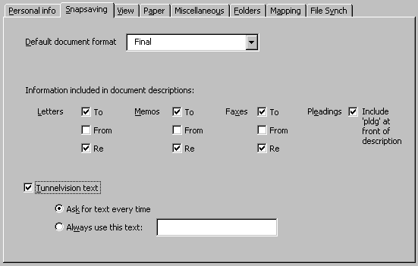Snapsaving tab controls the Snapsaving process (Snap Save).
34.5a
34.5l
34.5k
34.5j
34.5i
34.5h
34.5g
34.5f
Subfigure 34.5
34.5o
34.5n
34.5m
34.5e
34.5d
34.5c
34.5b
34.5a Default document format: The first time a document is Snapsaved (Snap Save), this box determines whether Draft or Final is the default choice 10.4 .
34.5b Information included – Letters – To: If this checkbox is checked, the recipient’s name is included in document descriptions generated for letters (ltr to John Smith).
34.5c Information included – Letters – From: If this checkbox is checked, the sender’s name is included in document descriptions generated for letters (ltr from Jane Doe).
34.5d Information included – Letters – Re: If this checkbox is checked, the first 40 characters of the re line are included in document descriptions generated for letters (ltr re widgets).
34.5e Tunnelvision text: If this checkbox is checked, document descriptions are prefaced with Tunnelvision text (typically the author’s initials: jqp’s ltr to tom smith). See Tunnelvision, p. 36.
34.5f Ask for text every time: If Tunnelvision text is turned on with checkbox 34.5e , choose Ask for text every time if you type documents for more than one author. When you initially Snapsave a document, you will be required to enter the appropriate Tunnelvision text (for example, jqp’s) in the Tunnelvision text screen Fig. 9 .
34.5g Always use this text: If Tunnelvision text is turned on with checkbox 34.5e , choose Always use this text if a single author is responsible for all the documents you type. When you initially Snapsave a document, the text in box 34.5h (for example, jqp’s) will be added to the document description.
34.5h Text for Tunnelvision: If Tunnelvision text is turned on with checkbox 34.5e and Always use this text 34.5g is selected, then the text in this box 34.5h (for example, jqp’s) will be added to the document description when you initially Snapsave a document.
34.5i Information included – Memos – Re: If this checkbox is checked, the first 40 characters of the re line are included in document descriptions generated for memos (memo re widgets).
34.5j Information included – Memos – From: If this checkbox is checked, the sender’s name is included in document descriptions generated for memos (memo from Jane Doe).
34.5k Information included – Memos – To: If this checkbox is checked, the recipient’s name is included in document descriptions generated for memos (memo to John Smith).
34.5l Include ‘pldg’: If this checkbox is checked, the word pldg is included at the front of document descriptions generated for pleadings (pldg first set of interrogatories).
34.5m Information included – Faxes – To: If this checkbox is checked, the recipient’s name is included in document descriptions generated for fax covers (fax to John Smith).
34.5n Information included – Faxes – From: If this checkbox is checked, the sender’s name is included in document descriptions generated for fax covers (fax from Jane Doe).
34.5o Information included – Faxes – Re: If this checkbox is checked, the first 40 characters of the re line are included in document descriptions generated for fax covers (fax re widgets).

34.6 Vie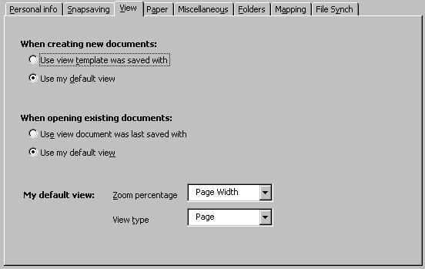w: When a document is created with Snap New or opened with Snap Open, these settings determine the initial view.
Subfigure 34.6
34.6f
34.6e
34.6d
34.6c
34.6b
34.6a
34.6a Creating documents - Use view template was saved with: Choose this option to view new documents with the same view used when the template was created.
34.6b Creating documents - Use my default view: Choose this option to view new documents with your default view ( 34.6e and 34.6f ).
34.6c Opening documents – Use view document was last saved with: Choose this option to view documents you open with the same view used when the document was last saved.
34.6d Opening documents – Use my default view: Choose this option to view documents you open with your default view ( 34.6e and 34.6f ).
34.6e Default view – Zoom percentage: Choose how large documents appear in your usual view.
34.6f Default view – View type: Choose page layout view or normal view as your usual view.
34.7 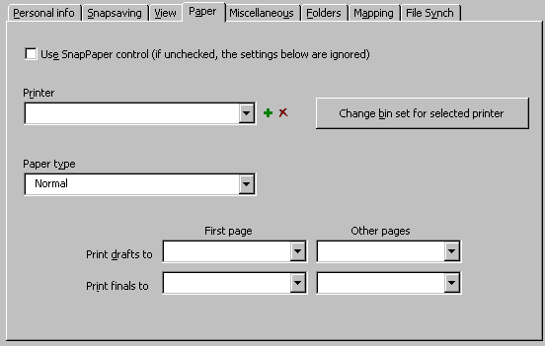Paper: Use this tab to control which printer tray is used for different types of documents.
34.7j
34.7h
34.7f
34.7e
34.7i
34.7g
Subfigure 34.7
34.7d
34.7c
34.7b
34.7a
34.7a Use SnapPaper control: If this checkbox is checked, the choices made on this tab override choices made on Word’s File Page Setup Paper Source tab. If unchecked, the choices made on this tab are ignored.
34.7b Printer: Use this box to choose the printer for which you are making paper tray choices.
34.7c Paper type: After selecting a printer in box 34.7b , use this box to choose the paper type for which you are making paper tray choices.
34.7d Print drafts to – First page: After selecting a printer in box 34.7b and a paper type in box 34.7c , use this box to choose a paper tray for the first page of draft documents. (A document is considered a draft document if Draft was selected in box 10.4 when the document was last Snapsaved.)
34.7e Print finals to – First page: After selecting a printer in box 34.7b and a paper type in box 34.7c , use this box to choose a paper tray for the first page of final documents. (A document is considered a final document if Final was selected in box 10.4 when the document was last Snapsaved.)
34.7f Delete printer icon: To remove a printer from box 34.7b , select it in box 34.7b and click this icon. This does not remove the printer from your computer – only from Snapdone’s list of printers.
34.7g Change bin set: The list of paper trays which appears in 34.7d , 34.7e , 34.7i and 34.7j should match the trays which are available for that printer in Word’s File Page Setup Paper Source screen. If they don’t match, click this button 34.7g to choose a different set of trays for the printer selected in box 34.7b .
34.7h Add printer icon: To add a printer to box 34.7b , first select the printer in Word’s print screen (File Print), then click Snap Setup Preferences Paper, and click this icon.
34.7i Print drafts to – Other pages: After selecting a printer in box 34.7b and a paper type in box 34.7c , use this box to choose a paper tray for second and later pages of draft documents. (A document is considered a draft document if Draft was selected in box 10.4 when the document was last Snapsaved.)
34.7j Print finals to – Other pages: After selecting a printer in box 34.7b and a paper type in box 34.7c , use this box to choose a paper tray for second and later pages of final documents. (A document is considered a final document if Final was selected in box 10.4 when the document was last Snapsaved.)

34.8 Mis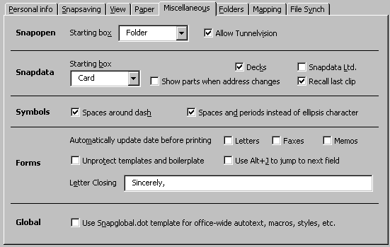cellaneous: Several miscellaneous options are found on the Miscellaneous tab.
34.8g
34.8f
34.8e
34.8p
34.8o
34.8n
34.8d
34.8l
34.8c
34.8i
34.8b
34.8a
34.8m
34.8k
34.8j
34.8h
Subfigure 34.8
34.8a Snapopen – Starting box: When the Snapopen screen appears Fig. 12 , this box determines whether the cursor starts in the Folder, Subfolder or Document box.
34.8b Snapdata – Show parts when address changes: If this checkbox is checked, whenever you change the contents of the Full address block 19.6 on a Snapdata card, the Parts label 19.7 turns pink to alert you that changes may also need to be made in the various Parts boxes Subfig. 19.7 . While the Parts flag is pink, tabbing out of the Full address block automatically displays the Parts boxes.
34.8c Snapdata – Starting box: When the Snapdata screen appears Fig. 16 , this box determines whether the cursor starts in box 16.6 or box 16.8 .
34.8d Symbols – Spaces around dash: When a dash is inserted from the Snapsymbol screen Fig. 32 , this checkbox determines whether it is preceded and followed by a space character.
34.8e Forms – Unprotect templates and boilerplate: If this checkbox is unchecked, when a Snapdone template or boilerplate which contains text box fields is used (Snap New Template or Snap Insert Boilerplate), the document is automatically protected for form fields so that it is easy to tab from one field to the next. After tabbing out of the last field, the document is automatically unprotected and all fields are converted to plain text.
If this checkbox is checked, the automatic protection and unprotection does not occur. This has the advantage that you are not immediately restricted to the text boxes, but the disadvantage that it is not so easy to move from one field to the next (but see 34.8p to make it easier).
34.8f Forms – Letter Closing: If your office’s letter template provides for it, this box determines the closing (for example, Sincerely,) in letters which are created with you as the sender 1.3 .
34.8g Global: Your administrator may have created autotext, macros, styles, keyboard assignments, or toolbars in a global template named Snapglobal.dot. If this checkbox 34.8g is checked, a copy of that file is automatically updated and loaded every time you start Word.
34.8h Snapopen – Allow Tunnelvision: This checkbox determines whether the Tunnelvision icon 12.1 appear in your Snapopen screen.
34.8i Snapdata – Decks: This checkbox determines whether the deck controls 15.5 and 15.6 appear in your Snapdata screen.
34.8j Snapdata Ltd: This checkbox determines whether the Snapdata screen appears in limited or unlimited mode Fig. 14 . This selection can also be made on the Snapdata screen itself.
34.8k Snapdata – Recall last clip: This checkbox determines whether, when you open the Snapdata screen, the last clip viewed is automatically selected in box 16.8 .
34.8l Symbols – Spaces and periods instead of ellipsis character: When an ellipsis is inserted from the Snapsymbol screen Fig. 32 , this checkbox determines whether it consists of Word’s default ellipsis character or three periods separated by nonbreaking space characters.
34.8m Forms – Automatic Date - Memos: If this checkbox is checked, memos you create contain an automatic date code instead of a hard date, so the date is updated each time the document is opened.
34.8n Forms – Automatic Date - Faxes: If this checkbox is checked, fax covers you create contain an automatic date code instead of a hard date, so the date is updated each time the document is opened.
34.8o Forms – Automatic Date - Letters: If this checkbox is checked, letters you create contain an automatic date code instead of a hard date, so the date is updated each time the document is opened.
34.8p Forms – Use Alt+J to jump to next field: This option is usually used in conjunction with 34.8e . It allows you to jump from one form field to the next by pressing Alt+J, whether the document is protected or not.

34.9 Folders: This tab shows where various Snapdone files are stored on your system.
34.10 Mapping: This tab defines mapped drives if sharenames are used on tab 34.9 .
34.11 File Synch: This tab controls synchronization of files which occurs when Word starts.

To avoid massive accidental deletions, Snapdone includes no command to delete an entire folder or subfolder. If you create a folder or subfolder with the wrong name, rename it with 8.8 or 8.9 . If you really do need to delete an entire folder or subfolder, use Windows Explorer or some other file manager.

