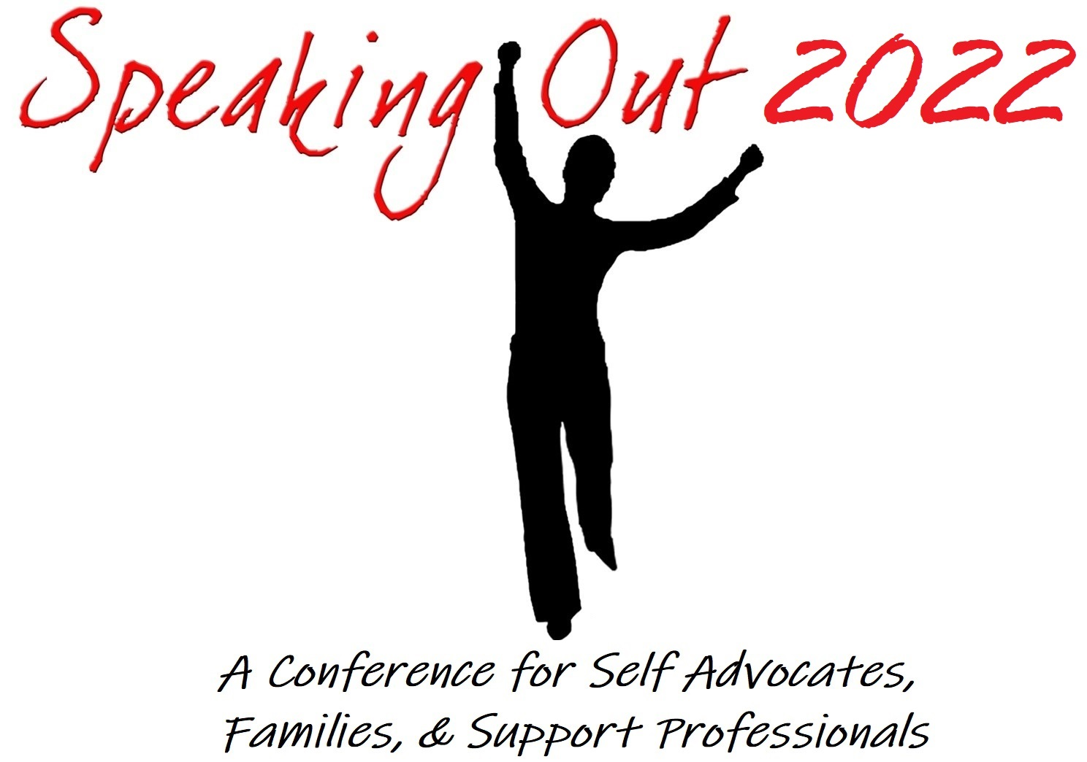

Speaking Out
T-shirts for sale $12 each.

Speaking Out
Hats for Sale
$15 each

This 2-night, 2 Day conference will be held at the UNIFOR Family Education Centre in beautiful Port Elgin. October 14,15 & 16th 2022

Please note UNIFOR Vaccinations policy
As you can imagine, safety for our Centre staff and guests coming to the Centre to participate in conferences/meetings is our upmost priority. To minimize the spread of Covid-19 and to ensure we can operate safely, we will require that all guests attending classes at the Centre be fully vaccinated. Please email confirmation of vaccinations to confcentre@unifor.org prior to check in. Masks are also required to be worn inside the building. (We will keep you updated as this could possibly change by the time your event takes place.)
Registration Fees

Have your Registration and payment in by Friday September 2, 2022 for your name to be entered to win your registration fee...…reimbursed funds will be presented at the conference

Regular Registration with Payment due by Friday September 16, 2022
Registration Fees apply to all who attend except presenters who will be emailed a separate registration form once presentation acceptance has been confirmed.

Full conference begins Friday October 14 - Registration at 4pm, dinner at 6 and evening social at 8pm in Nick’s lounge.
Full conference sessions begin Saturday morning.

Full Registration with Double occupancy $500.00
Full Registration Single Room $675.00

Friday night only -supper and evening social $40.00

Saturday only - conference session includes lunch $130.00

Saturday evening only - supper and evening social $40.00

Sunday morning - conference session and lunch $ 90.00

Who is the Speaking Out conference for?

- People with developmental disabilities and Self- Advocates
- Families
- Support professionals.

Who better to learn from than your peers, colleagues & people with lived experiences?
The Speaking Out conference is a great place to network and learn from each other.

What is included in your registration?

FULL REGISTRATION
- Friday and Saturday night accommodations
- All meals starting with Friday night dinner and ending with Sunday lunch.
- Unlimited coffee, tea and juice at break stations throughout the centre.
- Conference sessions on Saturday and Sunday.
- Free Parking
- Friday and Saturday evening socials.
- Displays and networking opportunities

FRIDAY EVENING ONLY
- Dinner
- Friday night social
- Coffee, tea and juice at break out stations.

SATURDAY ONLY
- Saturday conference sessions
- Lunch
- Displays and networking opportunities
- Coffee, tea and juice at break out station.

SPEAKER REGISTRATION
- Speakers will receive a separate registration form with a discounted rate if their application to present is approved.
- The discount rate applies to up to 3 presenters per presentation
- If presenter is presenting more than one session topic at the conference the discount is not offered multiple times.

Please fill out ALL sections of the registration form page 6 &7.
A separate registration form for each person attending is required.

Mail completed registration form (pages 6 & 7) and full payment to the address below.

PAYMENT INSTRUCTIONS: Cash or cheques accepted.
Cheques are to be made payable to Speaking Out

Mailed to:
SPEAKING OUT
c/o The New Vision Advocates
190 Adelaide St. St
London, On
N5Z 3L1

Cancellation Policy: If you cancel your registration, please contact us in writing or email vicky.pearson@cll.on.ca

Cancellations received by Friday September 30, 2022 are refundable less a $50.00 registration processing fee per person.

Cancellations will not be accepted after Friday September 30, 2022
ALL cancellations after this date are non-refundable.

Please note, if you do not cancel and do not attend, you are still responsible for full payment.

Participants will be required to follow all COVID-19 Guidelines as directed by the UNIFOR Centre and the local Health Unit

Directions to the Centre

GPS address for the UNIFOR Family Education Centre:
115 Shipley Ave
Port Elgin, Ontario
N0H 2C0

The Unifor (CAW) Family Education Centre, located along the shores of Lake Huron in south western Ontario at Port Elgin:
Off Highway #21, just south of Port Elgin, Ontario turn west towards the lake on CAW Road #25 (there is a set of traffic lights at this intersection). Continue on CAW Road #25, down a hill, toward the lake. At the bottom of the hill turn right on Shipley Avenue. The first right on Shipley Avenue is the main entrance to the Centre.

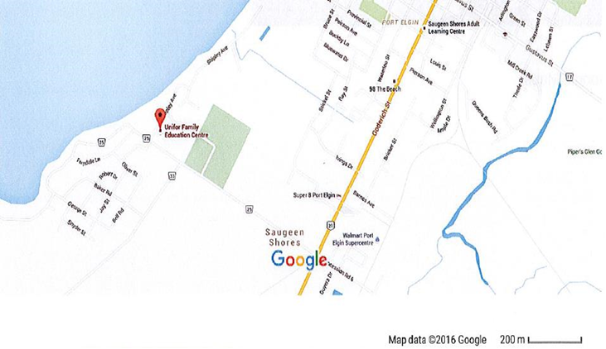

SPEAKING OUT 2022
REGISTRATION FORM

The Speaking Out 2022 Conference is being held at the beautiful Unifor (CAW) Family Education Centre October 14 -16, 2022 in Port Elgin, Ontario.
For more information check out the conference website at: www.speakingoutconference.com
- Please read cancellation policy Page 4
- Sign photo consent on page 7.
Payment of Conference Fees
Payment is to be made by cheque. Cheques should be made out to “Speaking Out”. Registration will be confirmed once payment is received. Payment is due with registration.
Send payment to: Speaking Out, c/o New Vision Advocates, 190 Adelaide Street South, London, ON N5Z 3L1.

Conference Registration:

Name:_____ _____________________________
Organization: ____ __________________
Address: ________________________________
Phone:__________________________ email address: _______________________________
Emergency Contact:

Name:____________________ Phone#: _______________Relationship___________________

Registration Details: *Applies to Non-presenters only. * Payment due with registration.
Full Conference: (includes 2 nights’ accommodations, meals, conference registration and social events Friday and Saturday evenings.) [ ]Single room $675.00 [ ]Double Room $ 500.00

Day Conference: (includes lunch, one day conference fee)
[ ] Saturday, Oct. 15 $130.00 [ ] Sunday, Oct 16 $ 90.00

Friday night only: (includes supper and entertainment on Friday)
[ ] Friday, Oct. 14 $40.00
Saturday night only: (includes supper and entertainment on Saturday)
[ ] Saturday Oct. 15 $40.00

Dietary needs & Allergies: _______________________________.

_____________________________________________________________

If possible, I would like to share a room with: ________________________________________From________________________________.

I require an adjoining room with____________________________________________________.

Please indicate any accessibility needs: ___________________________________________
(6 wheelchair accessible rooms available) _______________________________________________________________
_________________________________________________________________________________________________
_________________________________________________________________________________________________
_________________________________________________________________________________________________.

Display Tables will be available for persons or groups interested in sharing information with others about your group, success story and to network. Please check the box if you would like to set up a display table: [ ]

Photo Consent: I or my designate/guardian hereby authorize the Speaking Out Conference Committee to print/publish (in any medium or form, including, but not limited to print, electronic, etc.) my photographs/videos including my image or likeness. All photographs will be used for promotional and/or educational material for the conference.

Signature ___________________________________ Date: ___________________

