**The Rational Meditation Guidebook**

Welcome to the Rational Meditation Guidebook. In these pages I will lay out the specifics of the SF/EF method of meditation I have created. This process lays out a rational, framework-driven basis for a person to undertake a mediation practice. A more thorough breakdown of the philosophy behind and the implications of these ideas that can help create a better life can be found in my course The Self Shift Sessions.

The steps laid out in brief for future consultation are:

**Surrender:**

* Practicalities
* Seek only truth
* Be patient
* Be open to pleasure
* Life is not a trapeze act

**Filter**

* Identify thoughts

**Experience**

* Experience externals without labels
* Experience feelings on the body and OF the body

**Feel**

* Look inwards and experience the experiencer

To understand this type of meditation we first need to understand a concept I call the Duality of Experience. Put very simply this concept states that we experience reality in two ways simultaneously – we experience the realm of reality in the present moment in tandem with the realm of thought. A simple way of envisioning this would be to imagine looking at reality through a screen. While doing something simple like washing dishes, we can be both occupied on the level of reality doing the task, while also thinking about something not related to what we are working on. The level of thought could be seen as a secondary application running on the screen – the size it takes up depends on how much attention we give it. You could be 1% focused on the task at hand, and 99% focused on your thoughts of a new romantic partner, or a big challenge you are facing. But slip and cut your finger on a knife and all of a sudden you are back to 0% thought and 100% reality. The practice of SF/EF meditation is to consciously drive down the amount of time spent in thought and increase the amount of time spent in reality, by dedicating a certain period of time to the practice of recognising what is true. **(See fig. 1.)**

**Figure 1 – The Duality of Experience**

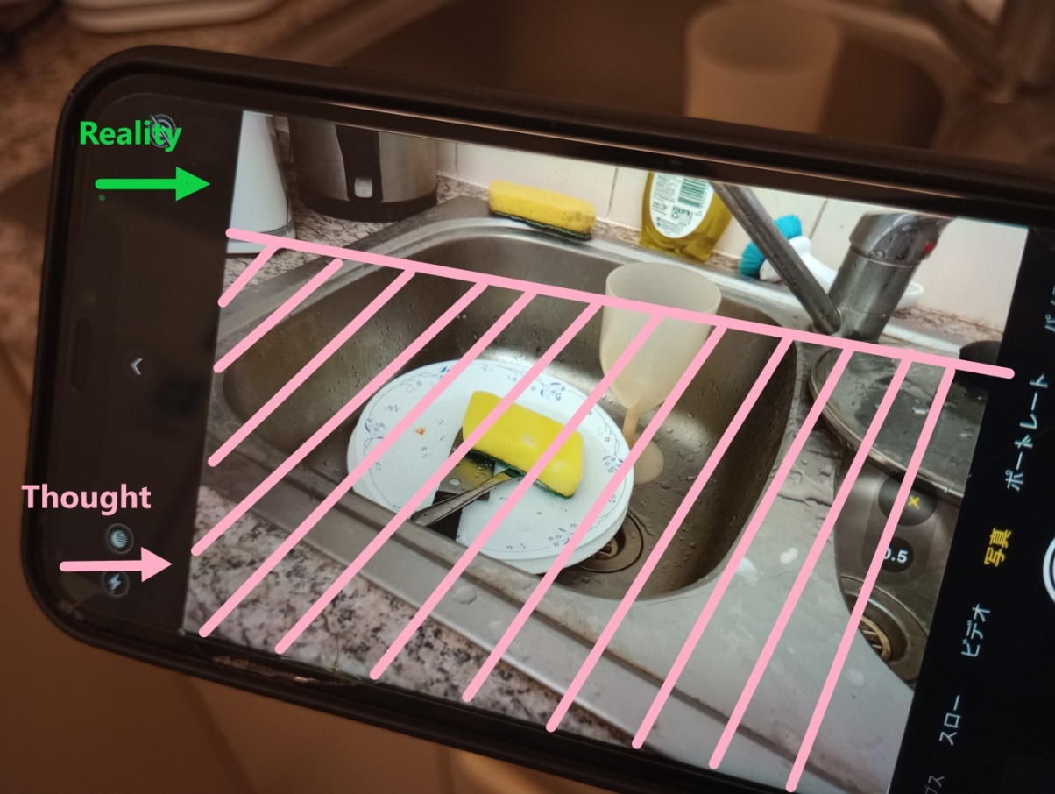

Another way of thinking about this is that sometimes we direct our thoughts, what I call Selected Thoughts, and sometimes thoughts seem to arise unbidden – Unselected Thoughts see **(Fig 2A)**. By using this method of meditation we create only one Selected Thought – ‘Seek Truth,’ which relegates all Unselected Thoughts behind a barrier of attention created by the rule we have created for this mediation. **(2B)**.

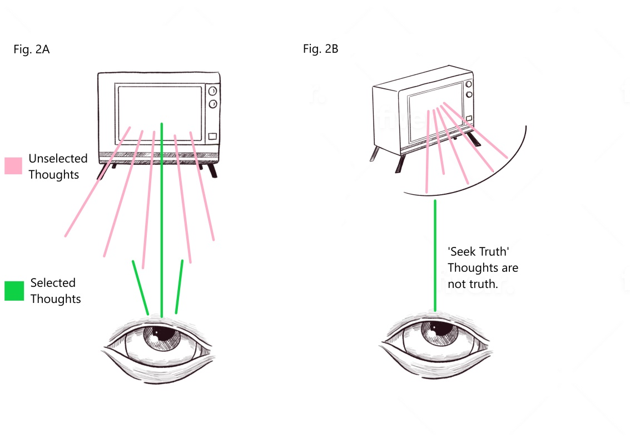

A key problem for many starting meditation is that they try to force what isn’t into what is. An illustration of this can be seen in **Figure 3**, the person (originating from the word persona meaning a mask, or an actor in a play), comprised of an EYE - the observer and sometimes commander of thoughts, the TV – where thoughts are viewed, sometimes originate and are often inhabited by the EYE, and feelings (communicated by the body, the SPONGE). The problem for many is that we try to force all three of these elements into one element, the enlightened self, when the true path to this state is to put space between these elements, to let go of what isn’t to fall into what is. **Figure 3.**

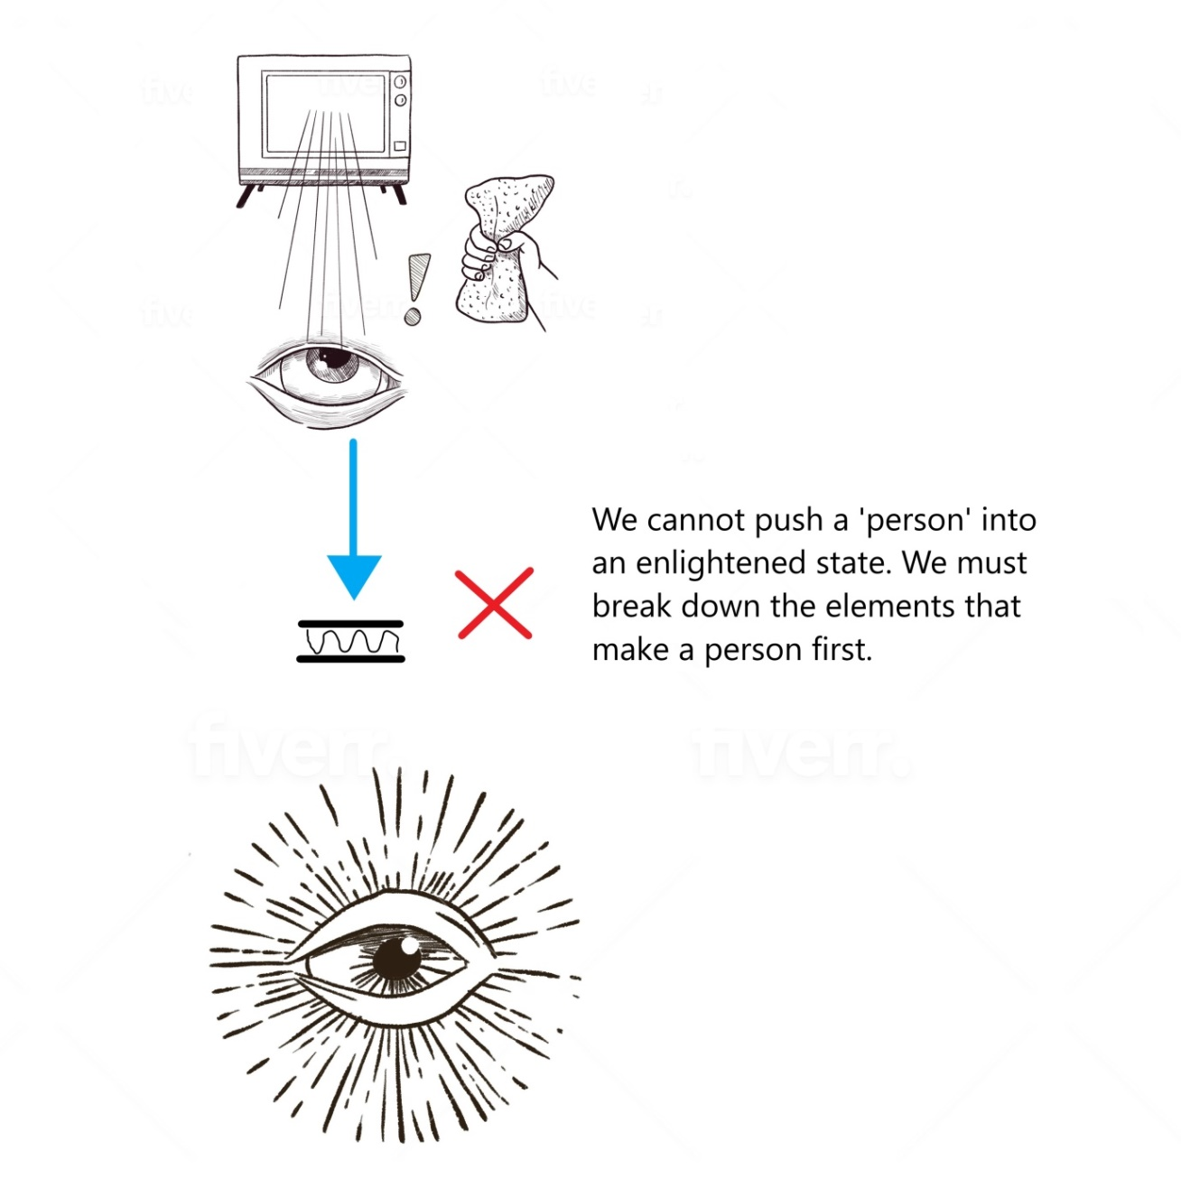

In order to do this we must understand that proximity is belief; we want to create space between the elements to fall into the enlightened state (see **Figure 4**.)

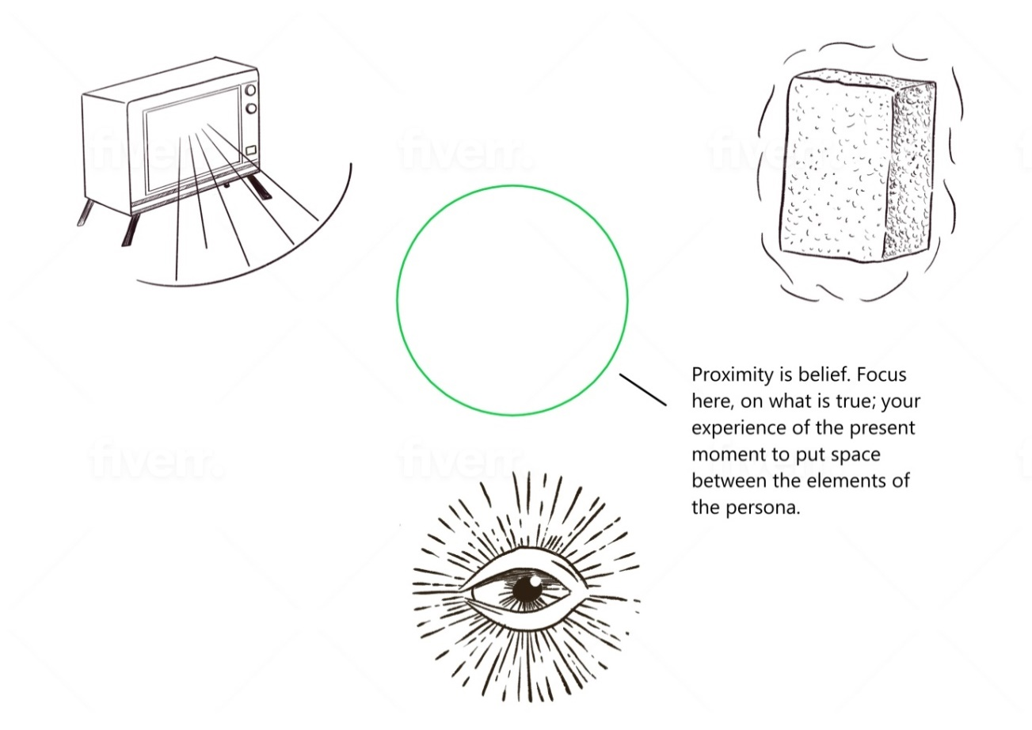

The steps to proceed are as follows:

**Step 1: Surrender**

In the first step surrender, we lay the groundwork for the meditation practice. You shouldn’t need to come back to these rules too much while engaging in the practice of meditation, but it is important to go into the practice with these guidelines in mind.

**1A. Practicalities**

**Time:** Firstly it is important to set an intention for the practice that for a set period of time we will seek only truth. It is important to dedicate yourself to a set period of time where your only purpose is to meditate, to seek truth. In its regular state the mind wants to wander through time, from ten years ago to five months from now. It is important to put a framework in place when you settle down to meditate, book a period of *now* – set a timer for 10, 15, 25 minutes when your thoughts will be confined to the present, step out of the infinite timeline of thoughts in time. Like jogging, the more time you put in the more results you will see sooner, but keep it as a *fun new challenge*, if it start to become a chore or too frustrating, take a break and try again tomorrow.

While I recommend meditating in the morning to give yourself a solid base from which to take on the day ahead, I do not recommend meditating very first thing in the morning. Later we discuss the ego being like a puppy. If you were training a puppy would you try to teach it first thing in the morning when it is opening up to all the stimuli available to it? Jumping and licking and wagging its tail? No, it is better to allow the ego to settle a little first, find some familiar grooves of thought, allow it to calm a little before trying to train it.

**Positioning:** There is no special way to sit or breathe in this style of meditation, just get comfortable in a seated or laying down position. I recommend closing your eyes because our eyes are such a dominant sense – it takes a fraction of a second to see something and label it, and part of this work is removing the labels from things. Closing your eyes and making your hearing and physical sensations more primary senses inserts a circuit breaker in the process, it gives you more leeway to experience things without immediately adding a label of meaning to them.

Later in the process we connect to the body so I recommend placing both hands over your heart, the reason being that the hands are tactile and have a strong connection to the mind, so placing them on the heart can help you get a sense of the minor tensions and changes that are occurring in your body, and notice when they relax as you move through the process.

**1B. Seek only truth.**

Many people experience frustration when they attempt to meditate, so the first step is to let go of expectations. Many people go into meditation with a goal to attain a certain state, which is a thought, which puts a value judgement on everything that does not align with that goal.

There is no force to this practice – you are not trying to make yourself into something else, you are trying to focus only on what is absolutely true – your experience of the present moment, letting all else fall away. Meditation is not a procedure of forcible transformation, it is instead a letting go of all that you are not. Relax and surrender.

**1C. Patience is a Virtue**

Meditation is a practice, just like any other. Take jogging for example – no one would put on their jogging shoes and expect to set a world record on their first run around the block. But for some reason when we meditate we expect to be more than proficient or even masterful in our first session. We can be disappointed when enlightenment doesn’t fall in our lap on the first go. Meditation is a practice – just as a jogger is not disappointed after a run that they didn’t put their feet in the exact same footsteps as the previous day, take each meditation experience as it comes.

Even if you spend most of your time meditating aware of your thoughts – that is a good thing – at least you are aware of your thinking now – this is growth. I teach people not to resent or resist the ego – think of it as a rambunctious puppy you have never trained. Entering into this practice is gradually over time going to train your mind to be more still, more focused on the now. First and foremost the attempt is the win.

**1D. Be open to pleasure**

Now I said earlier that there is no goal, that is true. But it is equally true that meditation can lead to states of great pleasure, this is why people do it. Think of it very simply like this: you have the capacity in you to at any time experience great pleasure; chemically that state is available to you. You could be having the worst day possible when suddenly you get wonderful news, or meet an amazing new person and go on an impromptu date with them. In the space of a second your day can change from miserable to happy and pleasurable.

So know that you have the mental chemical capacity to experience great happiness at any moment given the right circumstances and be open to the fact that you are taking part in an activity that has been known to lead to great pleasure, peace and joy. Don’t seek pleasure, but be open to it, in your mind, heart and body.

**1E. Life is not a trapeze act**

Thoughts and feelings take effort to maintain. It takes effort to be a person, it takes zero effort to *be.* We can spend most of our day trying to think the right thoughts and not the wrong ones, to have good feelings and not bad. It’s as though there’s an invisible audience watching us and we’re performing a trick to be the ‘right kind of person’ on a trapeze wire, not going too far off track on either side. For this step let go of all that. Realise that life isn’t a trapeze act, and in fact under the tightrope is a safety net of the greatest peace you could ever envision. There is no tightrope, there is no audience, there is only you and the peace and beauty of your experience of the present moment. We have this idea that happiness comes from the external, from doing or achieving something. Try getting used to the idea that the ultimate happiness can be derived from doing nothing, from *being* nothing. Initially your mind will try to call you back up onto the tightrope, because that feels natural, these ideas of relaxation feel unnatural. Forget about that. You will make better decisions after this practice, because you did it.

**Step 2: Filter**

This is the step you will spend the most time in when starting out with this practice. Basically we want to decrease the amount of time we spend in thought and increase the amount of time we spend in experience and awareness. If you look at **figure 1**, the aim of this whole practice is very simple – decrease the percentage of time in thought and increase the percentage of time in reality.

So how to filter? Early in the course we ask a simple question – is the thought of an apple as true as the experience of an apple in your hand? The answer is no, the experience is most true, and the follow up question is are there any thoughts that are more true than our current experience? Again the answer is no, what is experienced in the here and now is always most true. No thought you ever have will be more true than your experience of the present moment, and as our goal for this meditation period of time is to seek truth, all we should seek is what we are experiencing now.

**2A Identify Thoughts**

So when it comes to filtering, all we are doing is identifying thoughts, and labelling them as less true than reality. By doing this we place thoughts behind a barrier of awareness, as seen with the television in **figure 2B**. We do not entertain or try to counter the thoughts; we just recognise them as thoughts. Our purpose now is to experience what is most true, and reality in the present moment is most true. So quickly, as if on instinct we just identify thoughts as thoughts and label the as something to not be considered given the parameters of the task at hand. We put them behind the barrier.

We have one selected thought throughout this practice – to seek truth, and knowing that thought is not absolute truth all Unselected Thoughts are subjugated to this one selected thought. **(Figure 3).**

**2B Thought *can* not exist**

One other thing to consider is that when it comes to ratios of experience the greatest amount thought can ever achieve is 99% thought and 1% reality – reality will always exist in the background. But the opposite is not true. You have surely had moments in the past where you experienced no thought and only reality – when captivated by a sunset or some other moment of beauty in life. In these moments the ratio of experience was 100% reality and 0% thought. So deducting from this we can say that thought is a choice – if we can experience completely thought will disappear – reality has primacy over thought. This can be a good tool to use as you become more experienced with these techniques, to realise that there is an ‘*OFF*’ switch to thought. It doesn’t need to exist, it is only our entertaining of it that allows it to perpetuate.

**Step 3: Experience**

**3A Experience Externals**

From this we pivot directly from filtering into experiencing – I notice a thought, I know it is less true than the experience of the present moment, the thought is confined behind the barrier of awareness. I now immediately seek out something to experience instead of the thought – a sound, my breath, whatever is true in my current experience.

A key point here is to experience inputs from reality without labels. This subject is a large part of a module in the course, but in a basic sense think of it like this – have you ever gone on holiday and things seemed more vivid or real? Maybe it was the sound of the surf outside your holiday home or street sounds in a new country. The reason these inputs are more compelling is because you haven’t yet assigned a firm meaning to them, because they are novel to your experience you aren’t taking them for granted yet.

The only litmus test here is truth – what is true in your current experience. If I were to meditate and hear my children laughing and think ‘that’s so beautiful’ – that’s giving that experience more value than some other noise – that’s a label, that’s meaning, that’s thought. The only value is how true is the experience.

When you experience as part of this practice, experience everything as though you were just born and it is your first time experiencing this thing. The sound of birds, the sensation of your breath, the sound of a motorbike passing outside. The difference between this style of meditation and many other forms is there are no ‘distractions’, there is nothing to focus on other than what is true, which is everything you experience in the present moment. Anything true can be a portal to peace.

**3B Experience Sensations on the Body, and OF the Body**

When you have been filtering and experiencing for some time and your thoughts have lessened in intensity it can be a good time to move your focus to your body – the sensations ON it – what your feel on your skin – the breeze, your clothes, cushions behind or below you.

From this point move to experience the inner state of your body – your breath, your heartbeat, any warmth or comfort you are feeling internally. Be willing to sink into these feelings and enjoy them as part of your current experience. As you do this you may become aware of tension in your body, particularly in your torso, where you might get heavy in the stomach at a certain daily input, or the chest where your body may tighten when under stress. By purely observing these sensations you will accept them (attention becomes acceptance) and the feelings will fade from your body in a physical way. Through repeated practice this will allow you to get an idea of what the fundamental base state of your body is in its natural relaxed state. This will in turn allow you to recognise when new feelings and sensations arise in your body, allowing you to know when you are feeling a feeling and address it quickly, rather than allowing it to turn into a storm of feelings in your body and corresponding negative thoughts in your mind.

**Step 4: Feel**

**4A Turn Inward**

In this step we turn out attention inward rather than outward. It is good to attempt this towards the end of the meditation, although when you are practiced you may be able to jump rapidly through all steps straight into this step in a minute or so. When your thought/experience ratio has reduced to around 30% thought and 70% experience or greater is a good time to try switching your attention inwards. By turning inward I mean look at the thing that is experiencing everything that is happening. This is the enlightened state separated from the persona. Feel if there is any separation from the thing that is experiencing and those things being experienced. You should find that there is a seamless cloth, an unbroken connection between what is being experienced and the experiencer. The logical conclusion from this is that all is one. And if you’re also true as part of the experience and thought in the form of judgement exists in a separate realm, in this moment you are invaluable. Be grateful to yourself as part of reality for this feeling.

This is a wondrous feeling to experience, and conversely if a thought tries to enter when in this state you should be able to feel that it is something separate to what is experiencing, something alien to this state, this being. But test this for yourself – in this meditative state does a thought feel part of the whole or separate to it? Having experienced this you should, from your own direct experience be able to clearly answer the following question: Are you a thought experiencing reality, or reality, experiencing a thought?

There is no bottom to the depth of this experience, you can go deeper and deeper within – every slight thing you experience; every sound, every sensation on your skin can be filled with such beauty and pleasure. Now remember this isn’t the goal to chase, this is just a possibility. It’s not guaranteed each time you meditate, but with enough practice it can become so easy to fall into when you don’t chase it. From this state such beauty is possible. We find our base state as part of reality in reality is peace and joy and love. These things are our birthright, and as part of reality we can be grateful and love ourselves even more for this gift.

**Conclusion**

This is my SF/EF method for meditation. The basic practicalities to take away from this are as follows:

**Surrender:**

* Set a timer for a duration of your choosing
* Be comfortable, hands on heart
* Be open to pleasure
* Be patient, there are no wrong steps
* Step off the trapeze of life and persona

**Filter**

* Identify thoughts, upon recognition pivot directly into experience

**Experience**

* Experience externals without labels
* Later experience feelings on the body and OF the body

**Feel**

* Turn inwards – experience the experiencer of reality
* Experience the truth and connectedness of all experiences, including the true self – the experiencer of experiences

Remember, the path of the meditator, of the truth-based self is one of regular practice. Do not expect the same result every time you meditate – sometimes your mind will be more busy, something will be going on in your life and your thoughts will have more of a hold. Like the jogger not placing their feet in the same steps each time they run, the point is not to have exact, replicable experiences each time, it is to strap on the metaphorical shoes, to go out and be the meditator by virtue of your action, as often as possible. It is natural that the mind will run away with your attention at times. Another analogy to consider is to think of the ego, the source of Unselected Thoughts as being like a fish no the line – if you try to reel a fish in when it is fresh it will often escape. Instead the experienced fisherman will allow the line to play, so that the fish tires itself out. When you recognise the ego running away just come back to the letters SF/EF – Surrender, Filter/Experience, Feel. In the early days in particular a large amount of the practice will be calling back to the Filter/Experience part of the combination, as you put thoughts back behind the barrier of awareness by refocusing on your experience in the moment. The Feel portion may come later, when thoughts have reduced to around 30% and Experience is up around 70% can be a good time to make the leap inwards.

I hope this guidebook helps you and if you have any questions or are interested in my Self Shift Sessions course, which uses this information as a fulcrum to leverage incredible change, peace and acceptance throughout life in general please don’t hesitate to reach out.