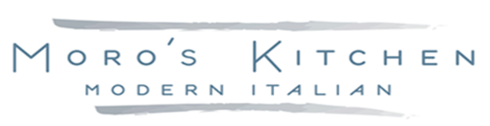

*Desserts*

Apple Crisp $6  
Key Lime Pie $6  
Chocolate Croissant Bread Pudding $8  
Tiramisu $6

Affogato *(espresso over gelato)* $6  
Cannoli $3.50

House Made Sorbetto $6  
*Wild Berry, Mango* House Made Gelato $6   
*Stracciatella, Pistachio,*

*Salted Caramel, Chocolate*

*Coffee Drinks*

Drip Coffee (regular)*decaf out of stock* $3

Espresso $2.75

Latte $3.75

Cappuccino $3.25

Americano $2.75

Macchiato $3.75

Hot Tea $2 *(Earl Grey, Green Tea, Chamomile, Lemon Ginger, English Breakfast)*

ESPRESSO MARTINI $9

*Coffee Drinks*

Drip Coffee (regular)*decaf out of stock* $3

Espresso $2.75

Latte $3.75

Cappuccino $3.25

Americano $2.75

Macchiato $3.75

Hot Tea $2 *(Earl Grey, Green Tea, Chamomile, Lemon Ginger, English Breakfast)*

ESPRESSO MARTINI $9

*Desserts*

Apple Crisp $6  
Key Lime Pie $6  
Chocolate Croissant Bread Pudding $8  
Tiramisu $6

Affogato *(espresso over gelato)* $6  
Cannoli $3.50

House Made Sorbetto $6  
*Wild Berry, Mango* House Made Gelato $6   
*Stracciatella, Pistachio,*

*Salted Caramel, Chocolate*