**Please edit your abstract in the field below and submit it in Microsoft Word format to:** [**Zihua.zhu@pnnl.gov**](mailto:Zihua.zhu@pnnl.gov)**.**

|  |  |  |  |
| --- | --- | --- | --- |
| Student level: | undergraduate | graduate | Note: |

Title: Abstract title

First Author1, Second Author2, and Third Author3

Corresponding Author: [email@address.com](mailto:email@address.com)

1. Affiliation of the first author, including Department/Institution, City and Country.

2. Affiliation of the second author, including Department/Institution, City and Country.

3. Affiliation of the third author, including Department/Institution, City and Country.

Welcome to PNWAVS 2020 Symposium. Your abstract should be no more than one page in length, including all figures, tables, and references. The abstract should be written in English with Times New Roman, font size 12. Please do not alter the margins, text sizes, or other formatting used in this template. Abstracts that do not meet the template guidelines may be modified to fit the template.

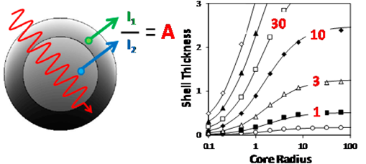 **(a)**

**Figure 1 (a)** Please provide a caption for your figure. **(b)** Figures may be submitted in color.

References:

[1] F. Author, S. Author and T. Author, Article title, Journal Name volume(year), 1-10.

[2] F. Author, et al., Book Title, fourth ed., Publisher, Place of Publication, year.

[3] F. Author, *et al*., Chapter title in: F. Editor, *et al*., Book Title, Publisher, Location, year, pp. 1-10.

[4] Please include any acknowledgements as the final entry in the reference list.