CONTACT INFORMATION
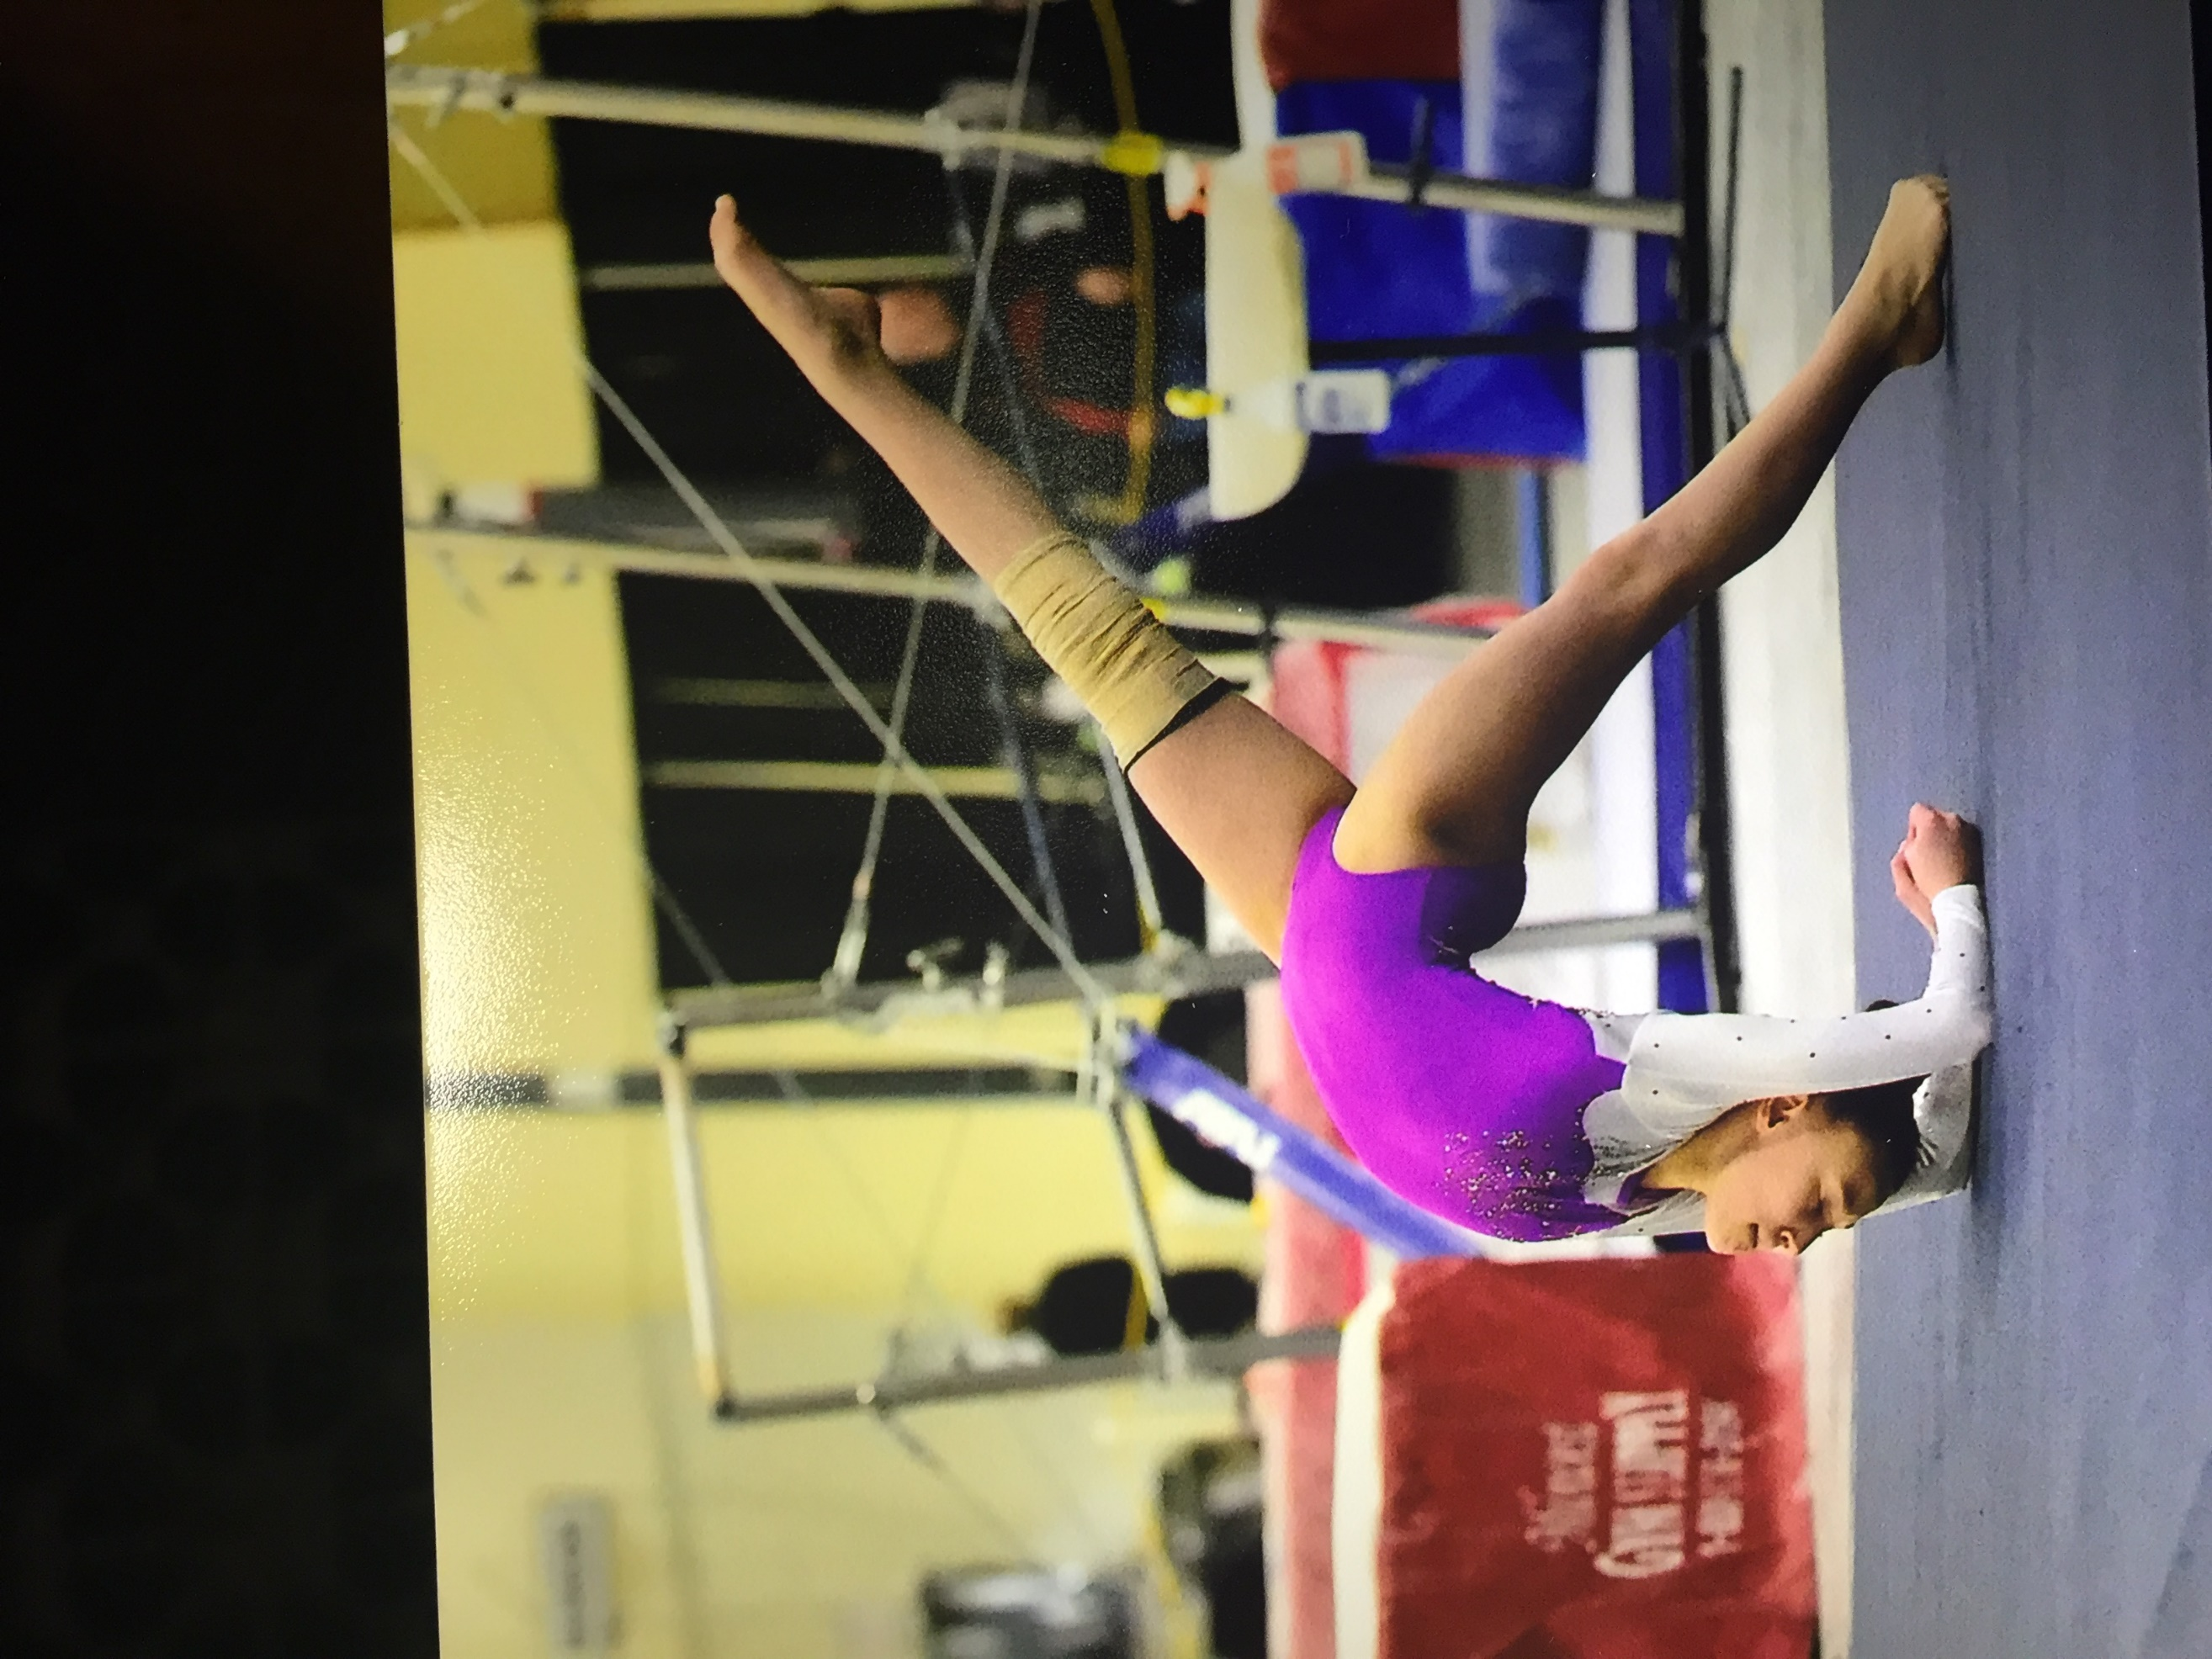

Cheyenne PRatola
Current Grade: 11
Graduation Date: 2021
Date of Birth: 08/07/2003
Current Level: 10 https://www.youtube.com/user/bjbase1

academic information
Prairie Ridge High School 6000 Dvorak Drive Crystal Lake, IL 60014 Phone: 815-479-0404 Current GPA: 3.80 Intended Areas of Study: Major: Art/Animation or Zoology – undecided Minor: Dance or Performing Arts

Coach Contact Information
Legacy Elite Gymnastics 881 Shoreline Drive Aurora, IL 60188 Phone: 630-851-5437 Coach Jiani Email: jianiwu@aol.com Coach Anna Email: gymbe4@gmail.com Coach Jiani Cell Phone: 630-404-6086 Coach Anna Cell Phone: 630-404-8374 Coaches: Jiani Wu, Yuejiu Li, Anna Li
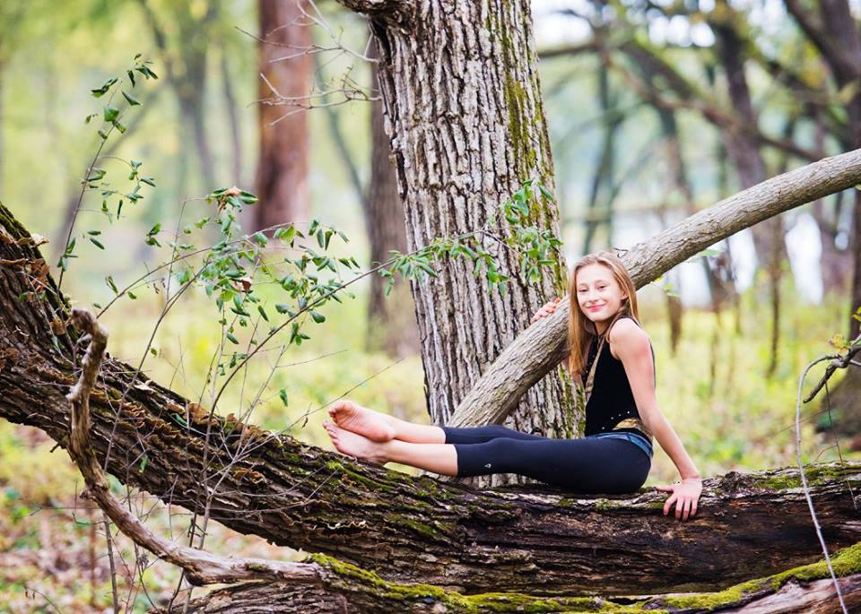
Parents Names: Ben and Wendy Pratola Parents Phones: M/847-757-9802 Parents Address: 6119 Coachlight Rd Parents Phones: D/847-372-5050 City/State/Zip: Crystal Lake, IL 60012 Parents Email: wpratola@att.net Gymnast Phone: 815-284-2673 Gymnast Email: cpratola@att.net
SKILLS

vault
Yurchenko Layout, Yurchenko Full (working)

Bars
Clear Hip to HS, bail to HS, front giant, toe hand, toe up, straddled Jaeger, blind full, double back tuck dismount, double layout dismount

Beam
Split ½, straddle jump, switch leap, switch side leap, switch 1/2, wolf jump, full turn leg 90 degrees, front aerial, side aerial, back tuck, onodi, back handspring back tuck, back handspring back layout step out, side aerial back handspring, back 11/2 or 2 twist dismount, side gainer dismount.

floor
Full turn with leg at 180 degrees. Full turn in squat. Double turn leg at 90 degrees, double or triple turn on toe, fouettes, Split, Straddle, Ring, and Switch leaps, front and back tucks, pikes, and layouts, front twist front pike, back 1½ twist front pike, double back tuck.
SCORES/AWARDS

Level 9 2015-2016 age 12:
Highest Scores: Vault 9.300, Bars 9.450, Beam 9.450, Floor 9.475 AA 36.850 IL State: Vault 9.00 , Bars 9.350, Beam 9.225, Floor 9.250, AA 36.825 - 3rdAA Regionals: Vault 9.300, Bars 9.300, Beam 8.600 (fall), Floor 9.475, AA 36.675 - 8thAA Level 9 Eastern Championships: First Alternate
2016-2017 AGE 13 – injury no compete year

Level 10 2017-2018 age 14:
Highest Scores: Vault 9.275, Bars 9.1, Beam 9.375 Floor 9.2, AA 36.65 State: Vault 9.275, Bars 8.8, Beam 9.0, Floor 8.5 (Fall), AA 35.575 - 6th beam, 7th Bars Regionals: Vault 9.00, Bars 9.025, Beam 8.700 (fall) Floor 9.00, AA 35.725

Level 10 2018-2019 age 15:
Highest Scores: Vault 9.025, Bars 9.400, Beam 9.200 Floor 9.300, AA 36.675 State: Vault 8.975, Bars 9.3, Beam 7.75 (Fall), Floor 9.075, AA 35.1 - 2nd Bars Regionals: Vault 8.925, Bars 9.4, Beam 9.05, Floor 9.3, AA 36.675 - 7th bars
EXTRA CURRICULARS
12 years combined dance training in Classical Ballet (Vagonova), Jazz, Contemporary, Lyrical, Hip Hop and Tap. 1 year Aerial Silks. 5 Years competition on award winning competitive dance team. 2 years Nutcracker cast– various roles. 9 years school talent show cast – Solo vocal and dance. School Choir - 4 years. Community Service including: Diaper Drives, Toys for Tots, GOTR, Letters to Soldiers, Canned food drive, and visiting senior memory care centers and performing in dance and tumbling shows for seniors.

