

cENTER FOR qUALITY aNALYSTICAL dATA

Adding Value Since 1999



Adding Value Since 1999

**CQAD**

February 16, 2023

CQAD

Eric Curtis, Mathew Kinzer, and Jack Sutton

**INVESTMENT RESEARCH REPORT**

Adding Value Since 1999

**Recommendation:**

**/** **STRONG SELL /**

**NASDAQ:** KHC

**Current Market Price:** $35.82

**Downside Potential:**



How Long Will Investors Pay a Premium?

**Important Market and Valuation Metrics**

**Market Cap:** 43.935B

**ROE:** 7.1%

**Dividend Yield:** 4.2%

**Dividend Payout:** 56.5%

**Diluted EPS:** $2.83

**Earnings Retention:** 43.5%

**Sustainable Growth:** 3.1%

**PEG:** 4.4

**Price to Book:** 1

**EBIT:** $4,881

**Adjusted EBITDA:** $6,336

**Equity Value:** $ 46,709

**Enterprise Value:** $ 65,739

**Financial Leverage:** 1.9

**Kraft Heinz Company**

Contents

**Company Update** 2

**Company Overview** 2

**PROPERTIES** 2

**ESG** 3

**Management – Recent Litigation Settlement, Slightly Aggressive Accounting Practices, Team Forward Looking** 3

**Top Line – Extremely Consistent Revenues, Burdening COGS Caused by Inflation** 4

**Growth Cycle of Kraft – A Mature Company, On Its Way to Decline** 4

**Investment Thesis** 4

**Kraft – A Consumer Defensive Stock Who Presents Zero Growth. How Long Will Investors Pay a Premium?** 4

**Liquidity, Capital Structure, Solvency, and Financial Flexibility** 5

**LIQUIDITY** 5

**CAPITAL STRUCTURE, SOLVENCY, & FLEXIBILITY** 6

**Adjustments Made to Income Statement to Arrive at Recurring NICO** 8

**ADJUSTMENTS TO TOP LINE: REVENUES AND COGS** 8

**ADJUSTMENTS TO SG&A** 8

**GOODWILL AND INTANGIBLE IMPAIRMENT** 8

**INTEREST EXPENSE** 8

**OTHER EXPENSES** 9

**TAX PROVISIONS** 9

**Financial Information and Valuation** 9

**Projected Income Statement – Based on Fundamental Analysis** 9

**Risk and Disclaimers** 10

**Additional Figures and Tables** 11

**Table 1: Adjustments Made to Arrive at Recurring NICO** 11

**Table 2: Mike DeProspero Cash Flow Profile** 12

**Figure 1: Price to Earnings and Stock Price Non-Indexed** 12

**Table 3: DuPont and DeGeorge Disaggregation** 13

**Figure 2: 87 Page ESG Summary** 13

**Table 4: Capital Structure, Solvency & Flexibility Analysis** 14

# **Company Update**

## **Company Overview**

Kraft is a consumer cyclical/defensive stock that can typically perform well even during harsh economic conditions. Because of this, investors looking to balance their portfolio with investment vehicles less than 1 beta could do well in holding this security, however there is significant risk of downside. Because Kraft consistently trades at a book value close to one, investors for the past 5 years have signaled zero growth premiums. Going forward with current fundamental trends, Kraft can afford to operate on the same path for approximately 2 more years before their stock price could see a correction to the downside. Kraft is a solid company that pays a decent annual dividend, but they’re just too expensive for the value they add and offer zero growth opportunity. See our investment thesis below “How Long Will Investors Pay a Premium”.

Kraft operates in a consumer-centric focused industry that operates in the heavily regulated food industry. Brand name and assets are the primary generators of value added and book value. Brand names are heavily touted as products sold to others as intellectual property. The market is to be considered heavily competitive.

Kraft has a proven and strong track record for the quality of their financial statements, controls, and procedures for the past 6 years.

### **PROPERTIES**

KHC is co headquartered in Pittsburgh, Pennsylvania, and Chicago, Illinois. The co headquarters is leased and houses executive offices, U.S. business units, and functions such as administrative, financial, legal, and human resources. Additional owned and leased offices were only mentioned as being maintained in various operating regions. Product manufacturing takes place in a global network of manufacturing and processing facilities. All facilities are in good condition. Co manufacturing arrangements with third parties are only made when advantageous. In 2022:

1. Transferred ownership of a facility in Ontario, Oregon, under a long-term third-party manufacturing agreement.
2. Divested assets and operations of business-to-business powdered cheese business, including a facility in Albany, Minnesota.
3. Acquired a manufacturing facility in the international segment.

As of December 31, 2022:

|  |  |  |
| --- | --- | --- |
| Total Facilities: 78 | North America | International |
| Owned: 72 | Owned: 32 | Owned: 40 |
| Leased: 6 | Leased: 3 | Leased: 3 |

### **ESG**

Our take on business is that the goal of any operation is to make money for the owners, now and into the future, by adding value to products and services. Since KHC did not sell any carbon credits or identify in their financial statements anything directly related to ESG, we chose to omit our assessment of ESG due to the lack of its qualitative nature.

A simplified version of their 87-page ESG report can be found below in Additional Figures and Tables, Figure 2.

## **Management – Recent Litigation Settlement, Slightly Aggressive Accounting Practices, Team Forward Looking**

In 2021, current and former officers, directors, and 3G entities were named in a lawsuit and later resulted in the company reaching a settlement. The allegations were: breaches of fiduciary duties, unjust enrichment. The company does not foresee any future related claims. Settlement paid in 2022.

1. Class Action: Union Asset Management Holding AG, Northern District of Illinois
   1. Allegations:
      1. False or misleading statements and omissions in public releases, earnings calls, documents, and SEC filings.
      2. 3G Entities conducted insider trading and used confidential company information.
   2. Settlement
      1. Q4 2022, the company recorded a net expense of $210 million, considering estimated insurance recoveries and contributions from other defendants.
      2. Reflected in balance sheet on December 31, 2022
      3. Liability difference should not have a major financial impact.
      4. Settlement awaits approval.
2. Stockholder Derivative Action, initially for the Western District of Pennsylvania and now Northern District of Illinois. Settlement under development and plaintiffs have not mentioned a specific amount.
   1. Allegation
      1. Breach of fiduciary duties, unjust enrichment.
      2. Federal claims based on alleged false or misleading statements on SEC filing.
      3. Claims of cost cutting measures that supposedly harmed the company.

Management’s accounting practices seem to be somewhat aggressive as many adjustments were required to arrive at recurring NICO, however poor economic conditions in recent times explain most of this behavior. Management did well on their early extinguishment of debt that could have materially affected the income statement in a high inflationary environment, paired with a large portion of their debt being floating rate.

## **Top Line – Extremely Consistent Revenues, Burdening COGS Caused by Inflation**

Kraft has a proven track record of generating $26 billion in revenue every single year in the past 6 years while maintaining an average annual dividend yield of 4.2%. However, in recent years inflation has taken a toll on KHC’s COGS and should be expected to slowly revert to its mean of $17.119 billion, currently $18.363 billion.

## **Growth Cycle of Kraft – A Mature Company, On Its Way to Decline**

Since Kraft is paying dividends, purchasing treasury stock, and is no longer trying to advertise, develop, or grow organically or externally. We can conclude they are in the late maturity stage of their life cycle. The company has begun to make small acquisitions and divestitures to prove they are headed for decline sooner than later, but not yet. The company also has a Capex ratio of 1.3 and has been near 1 for the last five years, which supports our conclusion that they are in the maturity stage.

# **Investment Thesis**

## **Kraft – A Consumer Defensive Stock Who Presents Zero Growth. How Long Will Investors Pay a Premium?**

If Kraft does not find internal/external growth, the stock may reach a correction point if investors become less confident and less willing to pay a premium for the stock. Historically, price to earnings has been growing at a 4-year CAGR of 8.83% since 2018 even though the stock has since declined and traded sideways since March of 2019.

In 2017, KHC had a price to earnings of 18.5 before the stock began it’s 73% plunge from a peak of $93.03 to $25.52 August 2019. Going long on KHC poses significant risk to investors as the street punishes lack of growth. The stock price below has been indexed (base year 2017 = 1 for a more meaningful comparison of stock price and price to: earnings, EBIT, and EBITDA.



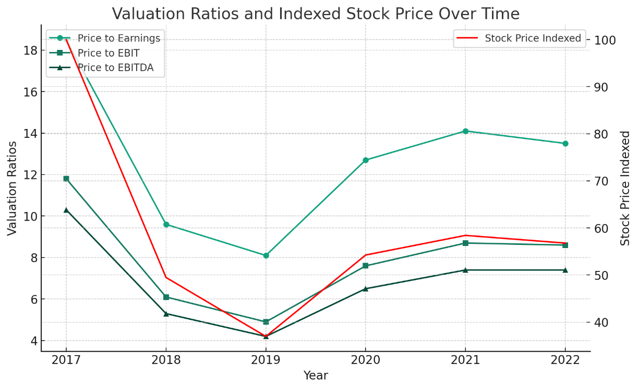

Our overall assessment of KHC is in line with the Street who has priced the stock's declining CAGR at -10.7% vs. our recurring NICO per share of -4.8%.

KHC is widely among investors considered a consumer defensive stock that consistently performs, regardless of economic conditions. During times of poor economic growth, KHC would represent a haven for investors looking to weather conditions such as a recession. Although expectations would be lower, steady revenues would still exist with an annual dividend of about 4.2%.

## **Liquidity, Capital Structure, Solvency, and Financial Flexibility**

### **LIQUIDITY**

Liquidity is not achieved via balance sheet line items, but their efficient operation and cash conversion cycles. Management stance on capital structure has also placed increasing focus on reducing debt since 2020. Kraft also utilizes an accounts receivable securitization and factoring program to provide liquidity.

Operating cycle turnovers have remained relatively even less receivables turnover which has seen a sharp decline since 2017 and settling in 2019. This was mostly due to the Kraft Heinz merger that started in 2015 where they would have seen a change in their credit policy. Note 14 of the 2018 10k also notes that an increased use of accounts receivable securitization and factoring programs has been utilized and policy renewed every year with the United States. Note 16 of the 2020 10k also states that the factoring programs in the United States were unwound and resulted in no related amounts on the balance sheet. An SPE is utilized for this purpose to isolate the company from financial risk. The SPEs only job is to handle receivables. This would also explain the jump from 2018 to 2019 in operating cycles.

KHC noticeably receives money on its sales before they pay suppliers although the trend is downward. Harder economic times partially explain the slowdown in operating cycles as well as the overall increase in purchases, cash for inventory, and operating cash disbursements while cash received from customers is down. Further information would need to be known about the SPEs, which are not in the 10k, as this poses some risk for investors. In theory, KHC can hide losses on accounts receivable when sold at a discount under the shield of the SPE.

### **CAPITAL STRUCTURE, SOLVENCY, & FLEXIBILITY**

Overall trend in capital structure has been decreasing over time and can be explained by the buyback of stock as it decreases the book value of the company, a weakening economy, and the overall stance the company has taken by paying off debt, decreasing liabilities, and deleveraging. Operating liabilities have remained even and confirms the payment of debt and treasury stock to be the primary decrease in capital structure. This also explains the drop in debt to EBITDA, COVID caused management to adopt a more risk adverse strategy.

2021 proved to be a more difficult year in terms of interest expense which reduced pretax income to cover interest expenses and explains the significant decrease in 2021. The increase was primarily driven by a 917 million loss on extinguishment of debt. The fixed charge coverage ratio followed suit.

2018’s impairment of goodwill and impairment of intangible assets was the primary cause of the decrease in equity. 8.6 billion related to SG&A across 5 brands. The impairment loss to goodwill was due to “Restatement of Previously Issued Consolidated Financial Statements”.

KHC has access to an additional $686 million market value in treasury shares. We did not adjust the balance sheet to show this information and kept treasury stock as contra equity. Even though stock prices have remained even year over year since 2020, the market value of treasury stock has climbed significantly. This is good.

## **Adjustments Made to Income Statement to Arrive at Recurring NICO**

Adjustments were made to the income statement to reflect core operations and were stripped of all nonrecurring items. This is to examine sustainable organic growth. See Table 1 in Additional Figures and Tables for a summarized graphic of changes.

### **ADJUSTMENTS TO TOP LINE: REVENUES AND COGS**

Top line adjustments were made to better reflect operations. Within revenues: unfavorable impacts of acquisitions, divestitures, and foreign currency were added back into revenues due to management’s discussion in Item 7 on unfavorable impacts to revenue. Percentage points were given for their estimated effect on revenues and applied. Sales/acquisitions represent a one-time purchase or sale and therefore should be removed. Furthermore, a 53rd week of sales was removed in 2022 to reflect a 52-week standard year.

Within COGS: peak inflation costs and the 53rd week of COGS are the remaining top line adjustments. Although high inflation marks a new trend, 2022 experienced the peak of inflation and therefore does not reflect the going concern of KHC. A modest 15 basis point adjustment in COGS was made to reflect this change in 2022. It should be noted that the increase in costs in recent years still represents a trend due to inflation. We expect the increase seen in COGS for 2022 to slowly revert to the geometric mean of 17,119 as inflation cools down over the next five years holding all else constant.

### **ADJUSTMENTS TO SG&A**

Within SG&A: restructuring charges and the litigation settlement were all costs associated with SG&A. Both items were identified by reading item 7. In 2022, some of KHC’s executives allegedly provided materially false or misleading information to shareholders. Some of the executives were let go while others remained at the firm. Both line items represent a one-time charge.

### **GOODWILL AND INTANGIBLE IMPAIRMENT**

KHC oftenexperiences impairment of assets and significantly so in 2018. However, these represent noncash items and are added back in on the statement of cash flows. This is also the significance of using operating cash flow earned.

### **INTEREST EXPENSE**

In 2021, KHC experienced an early extinguishment of debt related to the payment of early tender premiums associated with the 2021 Tender Offer. This represents an abnormal occurrence.

### **OTHER EXPENSES**

Within other expenses: impairment of fixed assets, IPO related merger costs, ineffective hedging not related to operations, unrealized adjustments on derivatives, and other expenses. In KHC’s case, other income/expense represents a normal stream of income. Due to its consistency, we took the harmonic mean of other expenses/income over total revenue ratio and normalized a harmonic mean of 1.2371% of total revenues. Any value outside the mean was removed to smooth data.

Impairment of fixed assets was identified by management in the notes to financial statements and are grouped within other expenses/income. This is another noncash item. Ineffective hedging was not related to operations and had no further detail within the 10k. KHC is a food and beverage company, not a hedge fund.

### **TAX PROVISIONS**

Tax provisions tend to have a rate that reverts to the mean. Currently, corporations in the United States are exposed on average to a 25% tax. Taxes were adjusted to reflect this and removed any tax benefits or deferred taxes to represent a flat 25% tax.

# **Financial Information and Valuation**

## **Projected Income Statement – Based on Fundamental Analysis**

Projected values assume a geometric average of the past 6 years of performance and assumed consistent. This paints a picture for management if they were not to change their current course of action.



# **Risks and Disclaimers**

### **RISKS ASSOCIATED WITH KRAFT**

Currently, KHCs largest and biggest threat is inflation. Rising food costs can cause significant change in consumer buying behavior and as well negatively affect their top line. It is the number one because of their increase in costs and floating debt was secured early. Other risks that were identified as notable were listed below, otherwise, KHC can be assumed to have normal risks assumed within the normal course of business.

Berkshire Hathaway can exert influence over KHC and significant influence over matters requiring stockholder approval.

Assets are tested annually at a minimum for impairment and proctor additional testing if market capitalization declines, competitive losses, cost increases, significant disposals, or operational disruptions. Referring to our adjustments to recurring NICO, KHC is at significant risk of noncash item losses.

KHCs primary source of income is from the United States but faces exposure to foreign exchange risk and may affect net income. Kraft has done a good job in the past with hedging.

Regulatory risks within the consumer foods industry are highly restrictive and regulated. Any changes to federal law, regulation, or even downgrade in credit rating could greatly impact the going concern.

### **DISCLAIMER**

This research report expresses our research opinions, which we have based upon interpretation of certain facts and observations, all of which are based upon publicly available information, and all of which are set out in this research report. Any investment involves substantial risks, including complete loss of capital. There can be no assurance that any statement, information, projection, estimation, or assumption referred to directly or indirectly in this report will be realized or accurate. Any forecasts, estimates, and examples are for illustrative purposes only and should not be taken as limitations of the minimum or maximum possible loss, gain, or outcome. Any information contained in this report may include forward-looking statements, expectations, pro forma analyses, estimates, and projections. You should assume these types of statements, expectations, pro forma analyses, estimates, and projections may turn out to be incorrect for reasons beyond our control. This is not investment or accounting advice, nor should it be construed as such. Use of our Research is at your own risk. You should do your own research and due diligence, with assistance from professional financial, legal and tax experts, before making any investment decision with respect to the securities covered herein. All figures are assumed to be in US dollars, unless specified otherwise.

To the best of our ability and belief, as of the date hereof, all information contained herein is accurate and reliable and does not omit to state material facts necessary to make the statements herein not misleading, and all information has been obtained from public sources we believe to be accurate and reliable, and who are not insiders or connected persons of the stock covered herein or who may otherwise owe any fiduciary duty or duty of confidentiality to the issuer. This report’s estimated fundamental value only represents a best effort estimate of the potential fundamental valuation of KHC.

# **Additional Figures and Tables**

## **Table 1: Adjustments Made to Arrive at Recurring NICO**



## **Table 2: Mike DeProspero Cash Flow Profile**



## **Figure 1: Price to Earnings and Stock Price Non-Indexed**

## **Table 3: DuPont and DeGeorge Disaggregation**

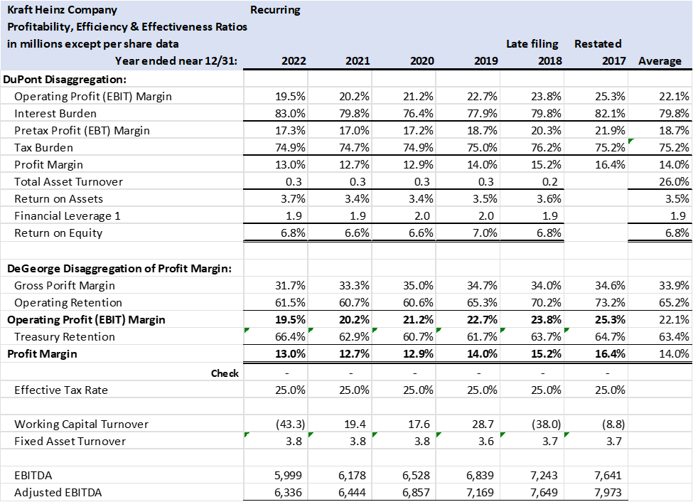

## **Figure 2: 87 Page ESG Summary**

## **Table 4: Capital Structure, Solvency & Flexibility Analysis**

