Friends of Oaks Park

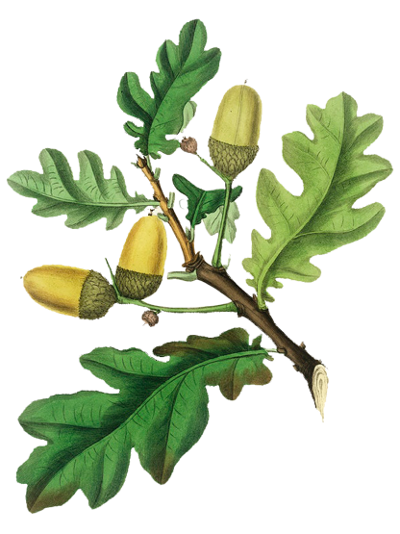

Membership Form

- Join the Friends
- Get involved
- Support the Park

October 2021

Please join us if you would like to support this historic park and grounds.

I would like to join the Friends of the Oaks Park.
Membership Type: Life Membership (£25 per household)
Annual Membership (£5 per household)

It would be very helpful to us if you would pay by standing order, using the form opposite for your bank, otherwise please enclose a cheque with your application, payable to Friends of Oaks Park.

Surname:  (Please print) | First Name:
Address & Postcode: |  | Phone No:
 |  | Date:
Email address:

If you have any particular interests (e.g. exercise, wildlife), or ideas for the park, please tell us here:

In line with GDPR legislation, we will only hold and use any personal data in connection with your membership. It will never be shared with third parties.

Please detach and return this page to:

Tina Bates, Treasurer, Friends of Oaks Park,
95 Chipstead Way, Woodmansterne, Surrey SM7 3JJ

Standing Order Instructions
(Please send this part to your bank or complete via your online banking)
Surname:  (Please print) | First Name(s):
To the Manager [Bank]:

Sort Code: | Account Number:
Recipient:  The Friends of Oaks Park  TSB Bank Plc, Wallington | Payee Sort Code: 30-99-04  Payee Account: 00709735

Please pay The Friends of Oaks Park from the account detailed in this instruction:
One single payment of £25
or
Annual payments of £5 , commencing on [date]:

Reference (Please quote your surname when making payments):

