Colorado Gun Dog Association Membership Application

THE PURPOSE OF THE COLORADO GUN DOG ASSOCIATION IS TO OFFER OPPORTUNITIES FOR
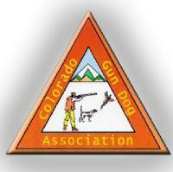
EVERYONE TO ENJOY THEIR DOG(S) IN FRIENDLY COMPETITION OR JUST PLAIN FUN
MEMBER INFORMATION

DATE:
NAME (PRINT):
PHONE #: ____________________________________
CELL: ________________________________________
E-MAIL:______________________________________
ADDRESS (CITY, STATE, ZIP): ___________________________________________________________________________
NAME & BREED OF DOGS:
1._______________________________________________________
2._______________________________________________________
3._______________________________________________________
Membership term is for 1 calendar year renewing in January of each year. Membership is per family and consists of member their spouse and any children under the age of 18 living in the same house. When voting in club functions only 1 vote per membership or family is permitted. Your photograph may be taken while participating in club events for use in promoting the CGDA.
Membership Terms
Membership cost: $125.00 per year
RETURN COMPLETED APPLICATION AND SIGNED INDEMNITY FORM AND DUES TO:
Colorado Gun Dog Association,
c/o Jason Baldwin
7568 S. Duquesne Way. Aurora, Co. 80016

