**Feeding – We feed Purina Pro Plan Large Breed Puppy**

**Could your best buddy benefit from a slow feeder?**

Walk into any pet store and you see a variety of brightly colored plastic feeders designed to slow the speedy eater. There are different designs, from plastic nobbles to whirly maze-like patterns, so the dog has to push food with their paw or tongue to get access and stop a chow hound in their tracks.

To the uninitiated, slow feeders may seem like a fad, another way of manufacturers getting money out of beleaguered pet parents. But ***slow feeders are anything but a gimmick*** and are beneficial to your dog's health for a number of reasons.

For example, ***pet parents of deep-chested breeds, which are at increased risk of bloat, are recommended to switch to slow feeder or puzzle feeders to reduce the amount of air the dog wolfs down. In respect of reducing a risk factor for bloat, slow feeders have the potential to be life-saving.***

But slow feeders have other benefits, such as reducing flatulence in greedy dogs! If you'd like to clear the air and bone up on slow feeders, let's look at the pros and cons.

**Better for the Body**

Does your DOG inhale food? Is the bowl empty before you've straightened up from putting it on the floor?

Eager eaters like these often ingest air (aerophagia) as well as food. The best-case scenario is the air travels along the gut and is released as flatulence. This isn't too much of a health problem (for the dog) but can make a nose peg for the owner seem a good idea.

On the other paw, ***air in the stomach can cause it to swell up and bloat. If that dog then runs around or plays, they are at greater risk of the stomach flipping over to cause a GDV (gastric dilatation and volvulus). The life-threatening condition requires emergency surgery, and even then lives are lost.*** Which makes anything that makes eating safer seem a good idea.

A slow feeder does what it says on the label: Slows up the ingestion of food so the dog swallows less air.

**Mind Over Matter**

Unlike the dog that plants their face in a bowl of food and chows down, slow feeders require some thought as to how to get at the food. A dog figuring out how to get those biscuits out of the puzzle feeder gets valuable mental stimulation. Problem-solving in order to eat also mimics natural behaviors, where in the wild a dog has to work to get a meal.

Thinking problems through is extremely beneficial to the dog. It reduces boredom, which in turn alleviates frustration, and reduces problem behaviors such as excessive barking or chewing. An interesting sign of the importance of this mental stimulation is that dogs are a lot less likely to overeat when fed this way, as if their brain better recognizes this is a meal rather than a treat or snack.

**Doggy Drawbacks**

There are some drawbacks, albeit minor ones.

Some dogs are slow on the uptake and struggle to master a complex feeder. If this happens, take things in easy stages. For example, if a feeder has flaps the dog has to lift up, but they can't work out what to do, then start with the flaps open. Get the dog used to the idea of eating from the small trays, then close one flap and show him how to open it.

Choose your feeder carefully. Some are more robust than others, so match the sturdiness of the feeder to the size and enthusiasm of your dog. A large dog with a powerful appetite may damage a delicate feeder beyond repair!

One consideration is the cost of a slow feeder, with some of them being quite pricey. However, it's easy enough to improvise with muffin tins or plastic bottles, and have the satisfaction of making your own.

**To Slow Feed or Not to Slow Feed**

Both the mental stimulation and positive health benefits of slow feeders make them a winner for all but the fussiest of eaters (But for these guys swallowing air isn't a problem anyway). Just be sure to work with your dog to get them used to this new way of eating. However, if your dog is a truly fussy eater and not food-motivated, just be sure they don't starve -- an old-fashioned bowl wins out for these guys.

**FortiFlora Supplements for Dog Digestion**

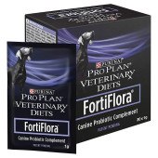

* We suggest this pro-biotic for the first few days home as they settle in they may have upset tummies. You can put ½ of the packet in their food once a day for the first few days. Having a box of these on hand should your pup or adult dog need it is very helpful!

**Purina Pro Plan Veterinary Supplements FortiFlora Promotes Intestinal Health and Balance in Puppies & Adult Dogs**

Stress from travel and changes in diet or routine may trigger gastrointestinal upset and diarrhea in puppies and adult dogs. The good news is that dog breeders and owners can proactively counter these effects by feeding Purina Pro Plan Veterinary Supplements FortiFlora Canine Probiotic Supplement.

Introduced in 2006, FortiFlora was developed by a team of Purina nutritionists, researchers and veterinarians. Backed by years of research, the research team confirmed that *Enterococcus faecium*SF68®, the probiotic bacteria contained in FortiFlora, promotes intestinal health and balance in growing puppies and adult dogs. FortiFlora is the No. 1 probiotic brand recommended by veterinarians.1

Purina veterinarian Jason Gagne, DVM, DACVIM (Nutrition), a board-certified veterinary nutritionist®, explains, “Diarrhea is a common physical response to stress or anxiety. In dogs with diarrhea, the normal balance of bacteria in the intestine is upset. Probiotics help provide an alternative way to nutritionally promote and maintain a balanced intestinal microflora.”

In a clinical study conducted at Colorado State University, Michael R. Lappin, DVM, PhD, DACVIM, the Kenneth W. Smith Professor in Small Animal Clinical Veterinary Medicine, showed that treating shelter dogs with diarrhea using a combination of metro­nidazole, a medication used to treat diarrhea and other intestinal problems, and *E. faecium* SF68 led to faster improvement than administering metro­nida­zole alone.

“*Enterococcus faecium* SF68 is one of the most widely studied probiotic strains,” Dr. Lappin says. “As a result of our work, I advocate on behalf of FortiFlora whenever I can because I believe it can help animals with stress-related gastrointestinal disease.”

1 Kantar Veterinary Tracker, 2021.

**Purina Pro Plan Veterinary Supplements FortiFlora Helps Manage Gastrointestinal Upset**

Purina Pro Plan Veterinary Supplements FortiFlora Canine Probiotic Supplement contains a safe and effective strain of beneficial bacteria proven to promote normal intestinal microflora. FortiFlora may be helpful in managing puppies and dogs experiencing:

* Diet change or consumption of inappropriate foods
* Soft stools in puppies
* Loose stool
* Stress due to travel
* Antibiotic treatment

**Purina Pro Plan Veterinary Supplements FortiFlora: An Easy-to-Feed Nutritional Supplement**

Purina Pro Plan Veterinary Supplements FortiFlora Canine Probiotic Supplement is an easy-to-feed nutritional supplement for the dietary management of puppies and adult dogs with soft or loose stools and for promoting a strong immune system. Available online at proplanvetdirect.com and at pet specialty retailers and from your veterinarian, FortiFlora comes in a box containing 30 sachet packets that can be sprinkled on a dog’s food or in bottles with 45- and 90-count chewable tablets. FortiFlora should be fed under the supervision or direction of your veterinarian. For more information about FortiFlora, please call 800-222-VETS (8387).

**FISH OIL Supplements – Omega 3**

**(Recommended to Add 6-Month-Old)**

[Fish oil](https://prf.hn/click/camref:1100l9KzB/adref:ea-fish-oil/destination:https%3A%2F%2Fwww.chewy.com%2Fs%3Fquery%3Dfish%2Boil%26rh%3Dc%253A288%252Cc%253A372%252Cc%253A374%252CProductForm%253ALiquid%252CProductForm%253ASoftgel%252CProductForm%253ACapsule%252CProductForm%253AGel%26sort%3Drating) is one of the best supplements to add to your dog’s diet. Fish oil supports your canine companion’s heart health, promotes a silky coat, reduces itchy and flaky skin, and can help relieve allergies and [joint pain](https://www.akc.org/expert-advice/health/glucosamine-for-dogs-to-treat-arthritis-joint-pain/). It can even help strengthen their immune system and could help them fight [canine cancer](https://www.akc.org/expert-advice/health/how-to-help-your-dog-avoid-cancer/).

That’s because fish oil contains [omega-3 fatty acids](https://prf.hn/click/camref:1100l9KzB/adref:ea-fish-oil/destination:https%3A%2F%2Fwww.chewy.com%2Fs%3Fquery%3Domega%2B3%26rh%3Dc%253A288), an essential “good” type of fat that helps your dog’s body and brain. Like humans, ***dogs can’t produce omega-3 fatty acids on their own and must get them from their diet.*** If you’re considering including fish oil as a part of your dog’s nutritional routine, here’s what you need to know.

What Are Fatty Acids Found in Fish Oil?

There are four types of dietary fats: trans fats, saturated fats, monounsaturated fats, and polyunsaturated fats. Omega fatty acids, found in polyunsaturated fats, create important hormones that regulate blood flow and inflammation. However, they aren’t found naturally in the body. Omega-3 is found primarily in cold-water fish, shellfish, plant and nut oils, and flaxseed. But, your dog needs omega-3 in their diet for several reasons.

Omega-3 also helps balance out omega-6 fatty acids, commonly found in processed foods and most grains. Since many [dog food](https://www.akc.org/expert-advice/nutrition/best-dog-food-choosing-whats-right-for-your-dog/) manufacturers use meat from corn-fed animals or refined oil (which are high in omega-6), dogs often have an overabundance of omega-6 fatty acids in their diet. Your dog ends up with too much omega-6 and not nearly enough omega-3 fatty acids. And although we need omega-6 fatty acids, our modern diet often has too many. The body needs both in balance, and the same is true for dogs.

**Why Should I Give My Dog Fish Oil?**

Fish oil is a good way to give your four-legged companion the omega-3 fatty acids they need. Depending on their general health and diet, fish oil supplements may become part of a long-term plan. Or, they may just provide a temporary nutritional boost to your dog’s diet.

Another benefit of fish oil is that it helps dogs across the span of their lifetimes. [DHA, a component in omega-3 fatty acid](https://prf.hn/click/camref:1100l9KzB/adref:ea-fish-oil/destination:https%3A%2F%2Fwww.chewy.com%2Fs%3Frh%3Dc%253A288%252Cc%253A372%252Cc%253A374%26query%3Ddha), **aids in the proper brain and eye development of puppies.** **DHA may also improve cognitive function in older dogs dealing with**[**canine cognitive dysfunction**](https://www.akc.org/expert-advice/health/do-dogs-get-alzheimers/)**. Research has shown that omega-3 fatty acids can help to treat**[**canine arthritis**](https://www.akc.org/expert-advice/health/dealing-with-canine-arthritis/)**and chronic kidney disease.**

As with anything affecting your dog’s health, talk to your [veterinarian](https://www.akc.org/expert-advice/vets-corner/) about supplementing your dog’s diet with fish oils before proceeding.

Dasuquin® with MSM

Available in a [Chewable Tablet](https://www.dasuquin.com/product/dasuquin-chewable-tablets-w-msm) or tasty [Soft Chew](https://www.dasuquin.com/product/dasuquin-soft-chews-w-msm).

**(Recommended to Add 1 Year Old)**

**How does Dasuquin® work?**

Dasuquin® goes beyond standard Glucosamine supplements. It contains a patented combination of Avocado/Soybean Unsaponifiables, Green Tea Extract, Glucosamine Hydrochloride, and Chondroitin Sulfate.  
  
ASU works synergistically with Glucosamine and Chondroitin Sulfate to help support your pet’s joints. In fact, research has shown that the combination of Glucosamine, Chondroitin Sulfate, and ASU works better than Glucosamine and Chondroitin Sulfate alone!

Helps support cartilage matrix production

Helps inhibit cartilage breakdown

Helps support joint comfort

**Why Dasuquin®?**

Supporting the health of pets is priority #1 at Nutramax Laboratories Veterinary Sciences, Inc., the makers of Dasuquin®. We are committed to providing quality products that are backed by science and held to the highest standard. This is why Dasuquin® is the #1 Joint Health Brand recommended by veterinarians.*  
  
We source high-quality ingredients and manufacture in state-of-the-art facilities to ensure that our high standards are met through every step of the manufacturing process.

**Which Dasuquin® is right for my pet?**

* Glucosamine Hydrochloride (FCHG49®)
* Sodium Chondroitin Sulfate (TRH122®)
* Avocado/Soybean Unsaponifiables(ASU) Powder (NMX1000®)
* Boswellia Serrata Extract
* Green Tea Extract
* Methylsulfonylmethane (MSM)
* Curcuma LongaExtract (Turmeric) (NMXCC95®)
* Alpha-Lipoic Acid (ALA)
* Manganese (as manganese ascorbate)
* Omega-3 Fatty Acids (Soft Chew Only)
* Eggshell Membrane (ESM) (NMXEM70™)

**BONES/TREATS**

YES

Raw bone marrow meaty bones – can be found at your local butcher in the meat section. Most larger stores also carry these in their frozen meat section as well.

Buffalo Horns – stuffed or un-stuffed – Can order off of Chewy.com

Freeze dried liver or other types of meats

Jerky – not the humankind with all of the seasonings, just plain ol’ jerky.

NO

Baked bones – these will splinter and cause damage to mouth and gut – lacerations to their intestines.

Antlers – too strong, can crack a tooth.

Rawhide – soaked in formaldehyde which is a cancer-causing carcinogen. Can also cause bowel obstructions.

**TOYS/PUZZLES**

* We suggest KONG toys as they hold up to their strong mouth
  + Fill a Kong with cheese and peanut butter mixed with their kibble
    - Freeze it, then give it to them for the day if you have to leave to keep them busy
* Snuffle mats
  + Put their kibble or other dry treats in them and let their brains work!

**BEDS**

* **KURANDA** [Silver Aluminum Chew Proof Dog Bed | Kuranda Dog Beds®](https://kuranda.com/dog-beds/aluminum-dog-bed)
  + We prefer the aluminum because it is harder to destroy when they are in T-Rex mode 😊
* They very often do NOT like fluffy bedding, they like the floor, but they LOVE THESE BEDS!

**TRAINING TOOLS**

* **Books**
  + **Meet Your Dog – by Kim Brophey (Chapter 10 is our dog category)**
  + **When Pigs FLY! Training Success With Impossible Dogs – by Jane Killion**
* Potty Bells
* Clicker
* Treat bag
  + Have high value treat when asking for something new from your pup to reward them generously!
* Training sessions don’t need to be longer than 5 minutes when they are young. Their ability to focus is limited.
  + You can increase incrementally. Each dog is different, be PATIENT!!!!
  + **YOU or your CHILDREN are NOT THE TOY!!!**
    - Have plenty of puppy approved items handy to stuff in the puppy’s mouth when they get home.
  + If the puppy picks something up like a shoe or sock, **have something in your hand that they CAN have before you take it away.** Replace the item with something they can have so it is a positive.
    - As you take the shoe away, say NO, in a low deep voice.
    - As you put the puppy approved item in their face say YES in a high pitch good voice.

**Grooming List**

**Slicker Brush** - Main GO TO Brush – Chris Christensen Big G

Everyday brush to keep them clean and fluffy 😊

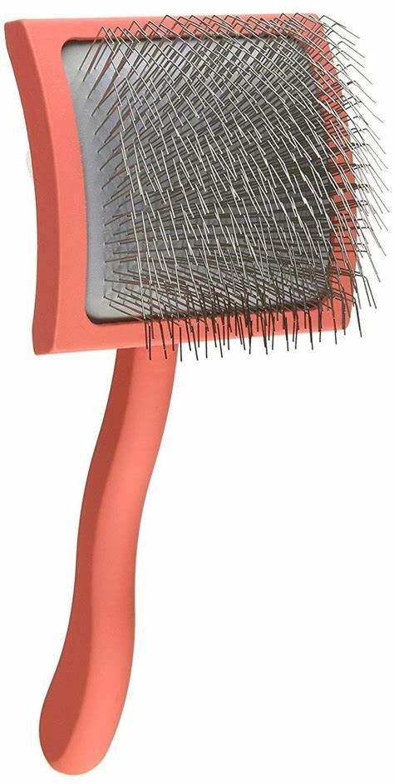

**Rake – De-matting**

When these dogs shed, this will be your best friend! We don’t use unless they are blowing their coat.

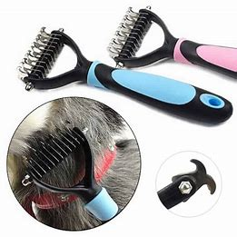

**Straight Long Prong Comb**

These dogs have thick hair, this long comb helps you get to the under coat to keep their skin healthy!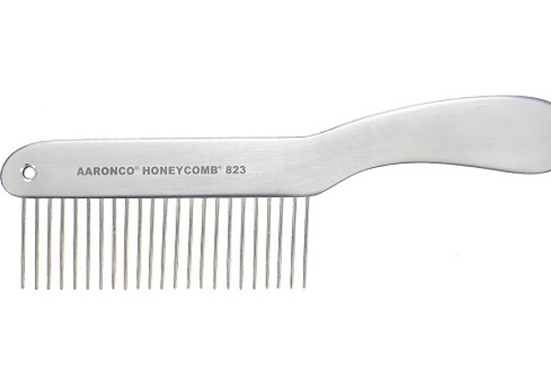

***Rolled Leather Collar***

This helps avoid matting in the neck and behind the ears as much.

](https://www.istockphoto.com/photo/beautiful-reddish-havanese-dog-after-bath-lying-in-blue-towel-gm528961478-93161711)

In addition to his friendly disposition, your dog’s long, silky coat is one of his most wonderful traits. But it can also be one of his most challenging. Long coats have a tendency to develop mats and tangles, and getting them out can be very tricky for you and an unpleasant experience for your dog. Long-haired dogs that like to get wet are especially likely to develop these coat problems. Don’t stress, you just need a game plan and the right tools before you start dog grooming.  Continue reading for Cowboy Magic’s 8 Steps to Untangle Matted Dog Hair!

Dog Grooming Tips

Removing mats and tangles can be difficult, especially if you have a dog who doesn’t like to stand still. Plus, sensitive dogs won’t appreciate you pulling on their coats, and may be unwilling to tolerate the procedure. Consider using treats to help your dog associate grooming sessions with something pleasant.

The best approach is prevention. Brush your dog daily to keep his coat clean and to prevent mats from developing. Tangles are typically easy to avoid with regular grooming. Fine-coated dogs and dogs with long, thick undercoats will quickly mat if they are not brushed regularly. If your dog loves the outdoors, then he will likely pick up burrs, sticks and leaves that can cause his coat to mat more quickly.

If you find your long-coated dog has developed mats and tangles, start working on them now before the situation gets completely out of hand.

8 Steps to Untangle Matted Dog Hair

**1.** **Assemble your tools.** In order to conquer mats and tangles, you need the right equipment. A dematting tool, a mat splitting tool and a slicker brush are your best friends when taking on mats and tangles. You can find these tools at a pet supply store, or online.

**2.** **Have good products on hand.** To make the dematting and detangling process easier on both you and your dog, arm yourself with the best products for the job. **Cowboy Magic®**[Detangler & Shine](https://cowboymagic.com/cowboy-magic-detangler/) helps loosen the hair caught up in mats and tangles. Since you’ll need to bathe your dog after you remove mats and tangles, have **Cowboy Magic®** [Rosewater Shampoo](https://cowboymagic.com/cowboy-magic-rosewater-shampoo/) and [Rosewater Conditioner](https://cowboymagic.com/cowboy-magic-rosewater-conditioner-2/) nearby.

[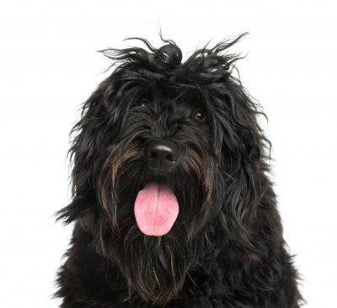](https://www.istockphoto.com/photo/close-up-of-a-portuguese-water-dog-gm1068781416-285891612?clarity=false)

**3. Find the mats and tangles.** Brush your dog with the slicker brush to locate mats and tangles. Mats often form under the ears, below the neck, under the belly and along the back legs.

[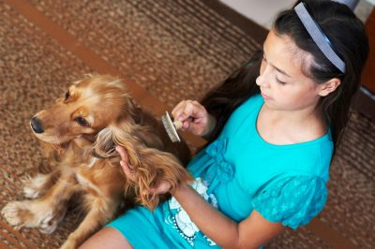](https://www.istockphoto.com/photo/the-girl-is-combing-dog-gm161792039-23056754?clarity=false)

**4.** **Apply detangler.** Start the detangling and dematting process by applying [Detangler & Shine](https://cowboymagic.com/cowboy-magic-detangler/) to areas of the coat that are matted or tangled. Rub the product into the coat so it penetrates the problem area.

**5.** **Use your fingers.** Work the mat or tangle out with your fingers by pulling and easing the hair apart a little at a time. This is painstaking work, but your efforts will pay off if you keep at it. If you can’t break through the mat after working on it for a considerable amount of time, use the mat splitting tool to cut through the mat. Be sure to cut in the direction the hair grows.

[](https://www.istockphoto.com/photo/studio-shot-of-an-adorable-english-cocker-spaniel-gm1188946933-336464083?clarity=false)

6. **Use your brush.** When you have removed as much of the tangle or mat as you can, use the slicker brush to finish the job. For tangles, gently brush a few hairs at a time to separate them from the rest of the tangle. For mats, brush in the direction the hair grows, adding more [Detangler & Shine™](https://cowboymagic.com/cowboy-magic-detangler/) if necessary to loosen the hairs.

[](https://www.istockphoto.com/photo/head-shot-of-golden-labradoodle-with-open-mouth-looking-straight-at-camera-isolated-gm931470570-255319448)

7. **Bathe your dog.** Once you have removed as many of the mats and tangles you can, give your dog a bath. Be sure all the mats and tangles are gone before you wet your dog, as water will make a tangle worse and a mat tighter and harder to get out. Use [Rosewater Shampoo](https://cowboymagic.com/cowboy-magic-rosewater-shampoo/) to get your dog clean, and follow with [Rosewater Conditioner](https://cowboymagic.com/products/cowboy-magic-rosewater-conditioner/) to help ensure mats and tangles don’t develop as you are drying your dog.

8. **Prevent problems.** To help prevent mats and tangles from coming back, apply [Detangler & Shine](https://cowboymagic.com/cowboy-magic-detangler/)to your dog’s coat after he’s completely dry. If your dog likes to swim, put the [Detangler & Shine](https://cowboymagic.com/cowboy-magic-detangler/) on him just before he goes into the water to help prevent mats and tangles from forming.

If your dog’s coat has been neglected and he has a particularly bad case of matting or tangling as a result, he may need to go to a professional groomer for clip or a shave. Or, if you have a good pair of clippers and know how to use them, you can do it yourself. If your dog has developed a skin irritation or sores as a result of having matter tangled in his coat, he may need to visit your veterinarian.

Clipping the coat to a very short length will enable you to start over and help prevent mats and tangles from forming in the first place.

With the right dog grooming tools, products and procedures at your fingertips, you can keep mats and tangles at bay, even if your dog is prone to them. Your dog will be happier for the extra effort, and so will you.

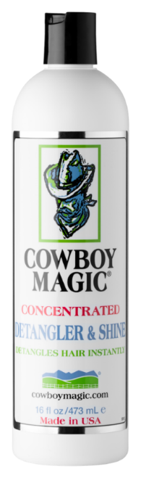 **COWBOY MAGIC – is our go to when brushing to help if they end up getting mats!**

**Puppies Make Children Better**

Many of you have asked about children and the benefits that puppies and dogs have on their lives. Here are some answers based on research findings. Pass them on to parents and to those who love children...   
  
Finding # 1. Children who lived with a pup during their first year of life had better immune systems than those who did not.  
  
Finding # 2. Playing and petting a puppy decreases cortisol and increases Oxytocin, a body chemical that promotes happiness, calms the mind and increases mood.  
  
Finding # 4. Allowing a 3-year-old to put the food and water bowl down helps them develop self-esteem.  
  
Finding # 5. Teachers who studied children and pet ownership reported that dogs and puppies are an invaluable aid to developing a child’s empathy and self-esteem for others.  
  
Finding # 6. Autism. One in 45 children in the US are diagnosed with autism (ASD), which is nearly 2% of the entire population of children ages 2-17. Dog and puppies were found to offer the following benefits:

* Provided them a sense of security
* Decreased meltdowns
* Decreased anxiety and acts of aggression
* Increased a willingness to try new things
* Increased the ability to face fearful situations
* Increased social interactions and shifted the focus away from the child’s disability
* Encouraged verbal communication

Article from BreedingBetterDogs.com