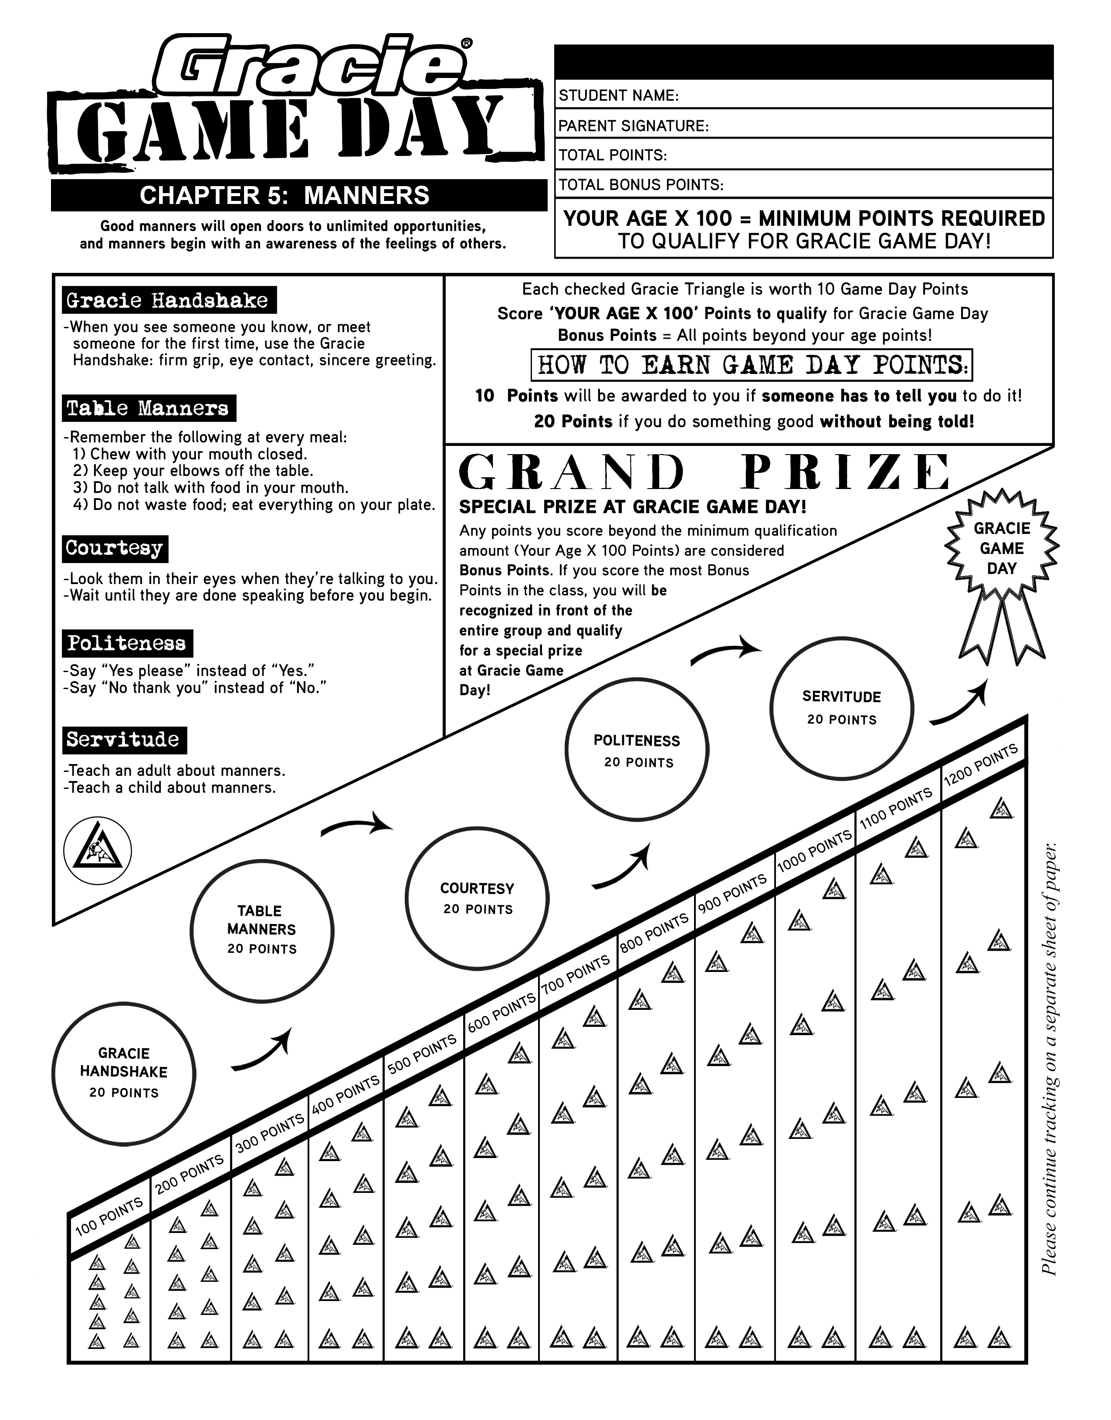

**Saturday, Month, Day, Time-Timepm**