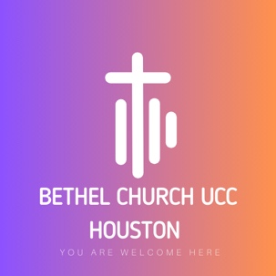

Raymond Bradford Community Garden

Volunteer Waiver of Liability Form

RELEASE AND WAIVER: I attest that I am physically fit to participate in all of the
activities associated with the maintenance and upkeep of the Raymond Bradford Community Garden
as a volunteer. I hereby for myself, my heirs, executor(s) and administrator(s), waive and release any
and all rights and claims for damages I may have against Bethel Church UCC, its employees,
representatives, successors and assigns and any individual associated with Bethel Church UCC,
and will hold them harmless for any and all injuries suffered in connection with my volunteer activities
at the Raymond Bradford Community Garden or any property owned by Bethel Church UCC.

PHOTOGRAPHIC RELEASE: Further, I hereby grant full permission to any and all of the
foregoing to use my likeness in all media including photographs, recordings, or any other record
made in connection with my activities at the Raymond Bradford Community Garden.

PLEASE NOTE: If a volunteer is under 18 years of age, then a parent or guardian must also
sign this waiver.

Under no circumstances will any volunteer be allowed in the Raymond Bradford Community Garden
without first signing this Volunteer Waiver of Liability Form.

_________________________ ______________________
Print Your Name and today’s Date

_______________________________________________
Signature

_______________________________________________
Date of Birth (month/day/year)
_________________________ ______________________
Signature of Parent/Guardian Relationship to Volunteer
If volunteer is under 18 years of age

