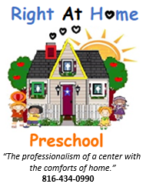

Instructions on how to redeem the $50 referral gift card.
- Print off this coupon.
- Fill out the information including your name, the name of the family who you are referring and your email address with phone number.
- Give the coupon the the parent(s) of the children who are wanting to enroll their children in our preschool.
- That parent has to turn the coupon into the preschool with their enrollment forms.
- You will be contacted to let you know we have the coupon with your information on it.
- We will contact you again after the chidren of the referred family has attended for 40 days. (about 2 months)
- We will send gift card to you as our appreciation.
Thank you for your interest in helping us reach out to care and teach children with the professional and quality preschool childcare.

For more information, contact us today.
24 Hour Direct Line 816-434-0990
RightAtHomePreschool.com/tuition-quote
Facebook or Instagram: Rightathomepreschool
Rightathomepreschool@hotmail.com

