Qualifications
Astrology Practitioner: Chart and transit specialist since 1991. Intuitive guidance, life transitions, relationship, career counseling,
holistic nutritionist & body-centered wisdom. Angel, Herbal, Elemental Tarot & more.

Astrology Instructor & Writer: Private & group classes. Eight entertaining three-hour evenings with Kathryn’s Simply Astrology textbook. Discover your & others birth chart symbols.

NEW - Somatic Oracular Sessions: You are the Oracle & I am the Guide. Journey inside with a trusted intuitive to find your own answers.

Education
Astrology: Studied with 7 astrologers and completed 20+ additional seminars: Relationship & Human Potential (1990s - 2021)

Oracles of Sophia: Embodied Goddess Mystery School Training (2024 - 2026)

Registered Holistic Nutritionist: Canadian School of Natural Nutrition, Halifax, NS (2010)

Herbology: Medical Herbal Training, Halifax, NS (2009)

Psychology Counseling: University of Victoria; Group Process, Counseling & Conflict Resolution (2002-03)

Bachelor of Arts: Concordia University, Montreal, QC; Communications
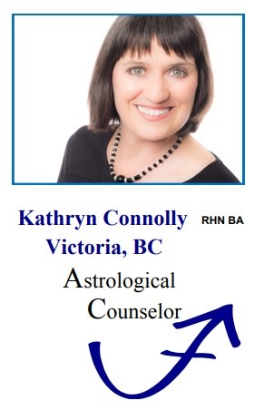
Testimonials

“Thanks to Kathryn, a core issue I’d dealt with for years has been resolved. She combines astrological knowledge with a finely tuned intuition and a warm human touch.”
Bruce, Author/Teacher

“I’d call Kathryn an astrologer, counselor, intuitive and caring friend all rolled into one.”
Teri, Design Consultant

“I highly recommend Kathryn for those with the desire and courage to explore the unlit corners of your psyche. She was really on the mark!”
Carole, Counselor

“Kathryn has a gift for leading people through the depths and into the light with, great gentleness and respect.”
Shirley, Chinese Medicine Practitioner

“Kathryn has been instrumental in both my husband’s and my life. Working with her, we have gained clarity about our real needs ~ a vital step towards fulfilling our right livelihood.
Madeleine, Adult Educator, & Brad, Musician

“Thank you for the amazing class you instructed! Astrology has helped me mature just by simply accepting myself and not trying to mold myself into someone different.”
Roberta, Graphic Design

kathrynmconnolly17@gmail.com
www.oracularastrology.ca
604-240-8544
Chart Interpretation Since 1991

* Individuals & Couples
* Transits & Tarot
* Life Transitions
* Oracular Divination
* Relationship Clarity

In Person & Distance

About Kathryn

Called a ‘Reader of the Psyche’, Kathryn interprets your birth chart, as accurate as an
X-ray. Combining astrology, tarot, transits, intuition, divination, nutrition and counseling – while building trust and rapport – she brings 35 years experience to the table.

Gain Clarity
Why is my love life so rocky?
How can my partner and I communicate better?
What are my child’s special talents?
What types of work would best suit me?
What’s going on? My life is in shambles!
Why do I get every flu bug going around?
Why am I so afraid of failure?
Is the timing right for this new venture?
What’s coming up for me over the next year?

Benefits
Lifelong Challenges: What you are here to learn and tools to assist you.
True Talents: Where you excel and enrich others.
Relationships: Understanding your role in how things unfold.
Planning Ahead: What’s influencing you now and in future.
Timing
Transits: Know when to proceed confidently for success and when to face obstacles with a plan in place. Visit Testimonials and watch for Monthly Transit Updates at www.oracularastrology.ca.

Simply Astrology
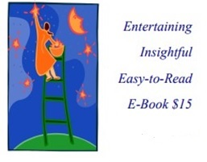
Illuminating the Stargazer’s Art
Kathryn Connolly

“I am enjoying your book so much! It’s really given me a deeper and clearer understanding of astrology and it’s so reader friendly. Good job!
Deb, Entrepreneur

“Seldom have I seen a book that says so much, so well, with so few words! Its fun approach draws me back again and again for a quick fix of inspiration.”
Beth, Multi-Media Artist
Services

Recorded Life Check-In $400 ~ 2 hrs.
Charts, Tarot, Transits, & MP3 File
Necessary for 1st Appointment

Oracular & Somatic Sessions $200 ~ 1 hr.
Dynamic Collaborative Sessions
Intuitive and Body Centered

Return Visits: Transits ~ $200 hr.
How the Next Chapter Unfolds
Updating Future Trends

Follow-Up Life Coaching ~ $200 hr.
Explore Prior Session Themes
Breath & Body Wisdom

Relationship Consults ~ $275 hr.
Discover Differing Love Styles
Synastry & Composite Charts

Proactive Parenting ~ $175 hr.
Direct Your Child’s Innate Talents
Clarify Your Supporting Role

Discover Astrology $375 ~ 8 Classes
Fun, Fascinating Classes with Text
Interpret Your & Other Charts

Milestone Celebration Evenings ~ $$125 pp
Small Group Special On-Site Gatherings
Charts, Transits, Tarot & Fun

“Following your true path is
essential to a fulfilling life.
Astrology is the map & timing.”

