In Memoriam
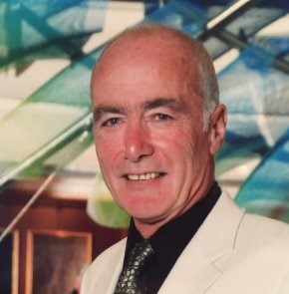
John J. Barrett 68 years February 10, 1948 – December 18, 2016

John will be sadly missed in the North Shore Soccer community as a soccer organizer, a soccer fan and as a referee.
John was Co Chair of the Northshore Sportsman League for many years, a life long Celtic supporter and a respected referee. Whilst we as player’s did not agree with all John’s decisions he was always a firm and fair referee.
John also had a long career as a registered nurse with the West End Community Mental Health Team.
Our condolences go out to the John’s family.
As players we will always remember the words
“Come here Son ” in his Scottish accent.
Donations to Coast Mental Health are appreciated. http://www.coastmentalhealth.com/donate/gifts-of-securities/

