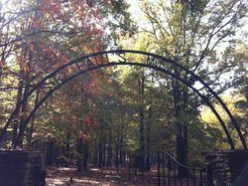

KHPS St. Paul’s African American Cemetery Cleanup

When: Saturday, May 18, 2019

What Time: The event begins at 9:00 a.m. and finishes up at noon. After the event, a picnic is scheduled for all individuals who are interested in attending. The picnic will finish up at 2:00 p.m.
What is the St. Paul’s Cemetery Clean Up?
The clean up involves numerous volunteers that come together bringing their rakes, leaf blowers, brooms, plastic bags, buckets, and any other clean up materials they can think of and get together to clean up natural debris and trash. Anyone is welcome to come assist with the cleanup and take a tour of the cemetery. We are in need of many helpers. If you want more information about our May 18 event, send an email to hgaugler@msn.com.

Are there other opportunities to help preserve the cemetery?
In the summer of 2018, the KHPS introduced a new community outreach program to encourage members of the community to adopt a month and take responsibility for cleaning up hard debris and trash for that month. We continue to need volunteers to adopt a month. If you are interested in this program, contact Chris Gaugler at hgaugler@msn.com. A fact sheet is also posted to our website.

