**Creative Curriculum**

**Monthly**

**Themes**



|  |  |
| --- | --- |
| **January** | |
| **Theme:** | Winter & Arctic Animals |
| **Goals:** | To introduce children to the concept of changing seasons through a variety of activities in each learning center, as well as, teacher directed activities.   To introduce children to the season of winter through a variety of activities in each learning center, as well as teacher-directed activities.   To introduce children to a variety of arctic animals through activities in each learning center as well as teacher-directed activities.   To discuss the differences between animals that hibernate versus animals that do not. |
| **Holidays:** | New Year’s Day Martin Luther King, Jr. Day |
| **Letters:** | M, N, O |
| **Number:** | 6 |
| **Color:** | White |
| **Shape:** | Oval |
| **Bible Verse:** | “He gives snow like wool.” Psalm 147:10 |
|  |  |



|  |  |
| --- | --- |
| **February** | |
| **Theme:** | I'm Special |
| **Goals:** | To introduce children to the concept of individuality in people and they are each special.   To introduce the children to emotions…letting them know it is “okay” to feel all emotions.   To introduce child to the concept of friendship. |
| **Holidays:** | Valentine's Day Dental Health Month Groundhog's Day |
| **Letters:** | P,Q,R |
| **Number:** | 7 |
| **Color:** | Purple |
| **Shape:** | Heart |
| **Bible Verse:** | “Love is patient, Love is kind.” 1 Corinthians 13:4 |



|  |  |
| --- | --- |
| **March** | |
| **Theme:** | Our World |
| **Goals:** | To introduce children to the concept of taking care of our world.   To introduce children to the importance and effects of recycling.   To introduce children to the importance of replenishing the earth’s resources (planting trees, etc.)   To introduce gardening by starting seedlings for garden playground |
| **Holidays:** | St. Patrick's Day 1st Day of Spring |
| **Letters:** | S,T,U |
| **Number:** | 8 |
| **Color:** | Green |
| **Shape:** | Diamond |
| **Bible Verse:** | “God created the heaven and the Earth.” Genesis 1:1 |



|  |  |
| --- | --- |
| **April** | |
| **Theme:** | Transportation & Safety |
| **Goals:** | To introduce children to a variety of types of transportation.   To introduce children to safety…ex. crossing the street, helmets biking or skating, construction warnings, etc.   To introduce children to traffic and safety signs and their meanings. |
| **Holidays:** | Passover Easter |
| **Letters:** | V,W |
| **Number:** | 9 |
| **Color:** | Yellow |
| **Shape:** | Star |
| **Holidays:** |  |
| **Bible Verse:** | “Keep me safe my God.” Psalm 16:1 |

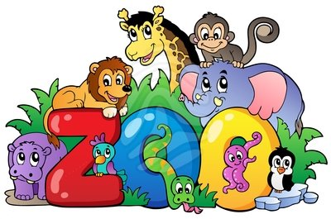

|  |  |
| --- | --- |
| **May** | |
| **Theme:** | | Zoo Animals |
| **Goals:** | | To introduce children to a variety of different zoo animals.   To introduce children to the concept of extinct and endangered wildlife.   To discuss protecting and respecting wildlife and its importance.   To discuss dinosaurs. |
| **Holidays:** | | Teacher Appreciation Week Mother's Day Memorial Day |
| **Letters:** | | X,Y,X |
| **Number:** | | 10 |
| **Color:** | | Blue |
| **Shape:** | | Octagon |
| **Bible Verse:** | | "But ask the animals, and they will teach you.” [Job 12:7-10](http://www.biblica.com/en-us/bible/online-bible/niv/job/12/) |

C:\Users\Owner\AppData\Local\Microsoft\Windows\Temporary Internet Files\Low\Content.IE5\TGEDNC0K\MC900335120[1].WMF

|  |  |
| --- | --- |
| **June** | |
| **Theme:** | Sea Life & Water Safety |
| **Goals:** | To introduce children to the ocean and a variety of types of sea life.   To introduce the importance of caring for our waters and streams.   To discuss water safety to the children. |
| **Holidays:** | Father's Day |
| **Letters:** | Review |
| **Number:** | Review |
| **Color:** | Review |
| **Shape:** | Review |
| **Bible Verse:** | “His love is mightier than the waves of the sea.” Psalm 93:4 |

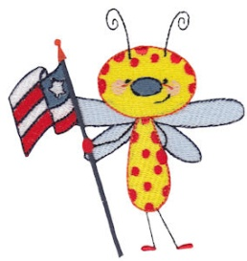

|  |  |
| --- | --- |
| **July** | |
| **Theme:** | Bugs & The Great Outdoors |
| **Goals:** | To introduce children to a variety of insects and bugs.   To discuss a variety of activities that can be done outdoors.   To include outdoor games and activities. |
| **Holidays:** | Independence Day |
| **Letters:** | Review |
| **Number:** | Review |
| **Color:** | Review |
| **Shape:** | Review |
| **Bible Verse:** | “Go to the ant, O sluggard; consider her ways, and be wise.” |

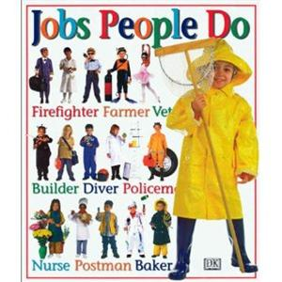

|  |  |
| --- | --- |
| **August** | |
| **Theme:** | Jobs People Do |
| **Goals:** | To introduce the children to a variety of jobs through each learning center and teacher-directed activities.   Invite parents to share jobs with class.   Represent jobs in a non-biased manner. |
| **Holidays:** | Graduation for rising Kindergartners |
| **Letters:** | Review |
| **Number:** | Review |
| **Color:** | Review |
| **Shape:** | Review |
| **Bible Verse:** | ‘Be strong, be brave, and be fearless.” Joshua 1:9 |

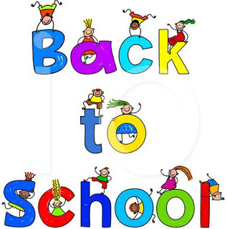 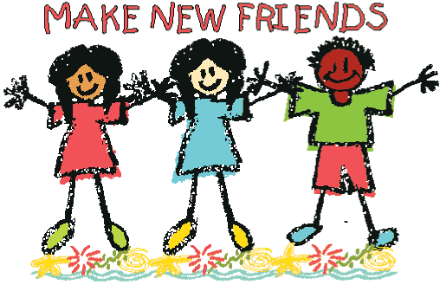

|  |  |
| --- | --- |
| **September** | |
| **Theme:** | Back to School & Making Friends |
| **Goals:** | To help children through the transitions of moving to new classrooms for the fall.   To include a variety of socialization and transition activities.   To help children feel secure in their new classroom environments. |
| **Holidays:** | Labor Day |
| **Letters:** | A,B,C |
| **Number:** | 1 & 2 |
| **Color:** | Orange |
| **Shape:** | Circle |
| **Bible Verse:** | “A good friend is a blessing from God.” 1 Samuel 18:3 |

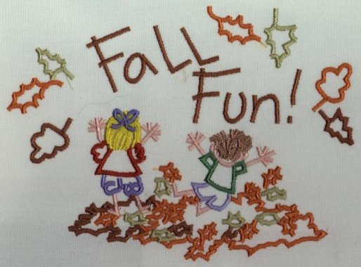

|  |  |
| --- | --- |
| **October** | |
| **Theme:** | Fall Fun & People Around the World |
| **Goals:** | To introduce children to the season of fall.   To discuss the seasons and the changes associated.   To introduce children to a variety of cultures and traditions in a positive, un-biased way. |
| **Holidays:** | Halloween |
| **Letters:** | D,E,F |
| **Number:** | 3 |
| **Color:** | Black |
| **Shape:** | Circle |
| **Bible Verse:** | “I am with you always.” “Matthew 28:20 |

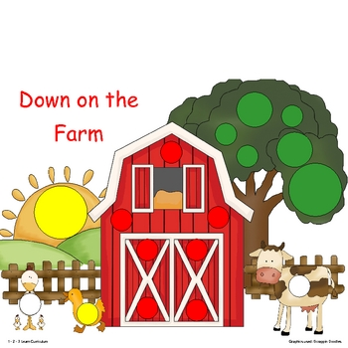

|  |  |
| --- | --- |
| **November** | |
| **Theme:** | Down on the Farm |
| **Goals:** | To introduce the children to farm animals and farm life.   To discuss where food actually comes from (not the grocery store).   To discuss the season and that this is the time of year for harvesting.   To include the history and celebrate Thanksgiving, avoiding stereotypes sometimes associated with Native American cultures. |
| **Holidays:** | Thanksgiving |
| **Letters:** | G,H,I |
| **Number:** | 4 |
| **Color:** | Brown |
| **Shape:** | Square |
| **Bible Verse:** | “God will meet all your needs” Philippians 4:19 |



|  |  |
| --- | --- |
| **December** | |
| **Theme:** | Happy Holidays |
| **Goals:** | To introduce children to a variety of holidays around the world in an  un-biased manner.  Be inclusive of holidays that are celebrated within each classroom and invite families to share with the class.   Emphasize the importance of traditions… such as, a time for giving, sharing, and family. |
| **Holidays:** | Hanukkah Christmas Kwanza |
| **Letters:** | J,K,L |
| **Number:** | 5 |
| **Color:** | Red |
| **Shape:** | Rectangle |
| **Bible Verse:** | “A Savior has been born to you.” Luke 211 |
|  |  |
|  |  |