08 21 2025

**A. The Spirit of Anti-Christ (Was here before man was created).**

What is the spirit of the anti-Christ?

The phrase spirit of the antichrist is found in [1 John 4:2–3](https://www.bibleref.com/1-John/4/1-John-4-2.html): “This is how you can recognize the Spirit of God: Every spirit that acknowledges that Jesus Christ has come in the flesh is from God, but every spirit that does not acknowledge Jesus is not from God. This is the spirit of the antichrist, which you have heard is coming and even now is already in the world.”

It’s vital to understand the context of John’s statements. A predominant worldview when he wrote this letter suggested that diverse spirits were at work in the world. Many [false teachings](https://www.gotquestions.org/false-teachers.html), mystery religions, spiritual experiences, and variations of Christianity were emerging at the time. The spiritual atmosphere was not unlike the one present in our world today. People entertained countless views regarding the truth.

John presented a definitive solution for wading through this variety of beliefs and teachings. He instructed his readers to pay attention and test the spirits: “Dear friends, do not believe every spirit, but test the spirits to see whether they are from God, because many false prophets have gone out into the world” ([1 John 4:1](https://www.bibleref.com/1-John/4/1-John-4-1.html)).

But how do we test the spirits? How can we discern which teachers are imparting truth? How do we recognize the spirit of the antichrist?

These “spirits” John spoke of were not merely disembodied, supernatural beings. John taught that a prophet or teacher was the actual mouthpiece for a spirit. Spiritual doctrines are promulgated through human spokespersons. Teachers of truth are filled with the Spirit of God and thus are agents who speak for God. Teachers of falsehood are spreading the “doctrines of demons” ([1 Timothy 4:1](https://www.bibleref.com/1-Timothy/4/1-Timothy-4-1.html)).

So, the first test relates to theology or doctrine: “Every spirit that acknowledges that Jesus Christ has come in the flesh is from God” ([1 John 4:2](https://www.bibleref.com/1-John/4/1-John-4-2.html)). We can ask, does the content of the person’s teaching acknowledge that Jesus Christ—fully God and fully human—has come in the flesh? If the answer is yes, then we know the Spirit of God inspires that person. If not, his entire teaching ought to be rejected. This particular test was especially apropos in John’s day, as the heresy of [Gnosticism](https://www.gotquestions.org/Christian-gnosticism.html) was becoming prevalent; Gnosticism taught that Jesus only appeared to have a human body but was not actually a flesh-and-blood person.

Next, John says, “But every spirit that does not acknowledge Jesus is not from God. This is the spirit of the antichrist” ([1 John 4:3](https://www.bibleref.com/1-John/4/1-John-4-3.html)). Anyone who does not acknowledge Jesus Christ as the Bible presents Him is inspired by the spirit of the antichrist.

The word antichrist means “against Christ.” People who say that Jesus is not from God are controlled by the spirit of the antichrist. Satan opposes Christ, and he desires to deceive people into a false view of who Jesus is. The spirit of the antichrist teaches against Christ. To twist the truth about Jesus Christ is to pervert the gospel. Satan works to spread lies about Christ and keep people in the dark: “Many deceivers, who do not acknowledge Jesus Christ as coming in the flesh, have gone out into the world. Any such person is the deceiver and the antichrist” ([2 John 1:7](https://www.bibleref.com/2-John/1/2-John-1-7.html)).

The spirit of the antichrist is the birds that eat the seeds along the path in Jesus’ parable ([Mark 4:4](https://www.bibleref.com/Mark/4/Mark-4-4.html), [15](https://www.bibleref.com/Mark/4/Mark-4-15.html)). It is “the god of this age” who blinds the minds of unbelievers, keeping them from seeing “the light of the gospel that displays the glory of Christ” ([2 Corinthians 4:4](https://www.bibleref.com/2-Corinthians/4/2-Corinthians-4-4.html)). It is “the father of lies” ([John 8:44](https://www.bibleref.com/John/8/John-8-44.html)). The spirit of the antichrist is “the great dragon . . . who leads the whole world astray” ([Revelation 12:9](https://www.bibleref.com/Revelation/12/Revelation-12-9.html)).

The Bible teaches that the world will eventually produce a world ruler, called “the beast” in Revelation, who will wield great power and demand worship of himself. He will have “a mouth to utter proud words and blasphemies” ([Revelation 13:5](https://www.bibleref.com/Revelation/13/Revelation-13-5.html)) and is empowered by Satan ([Revelation 13:2](https://www.bibleref.com/Revelation/13/Revelation-13-2.html)). He is called “the man of lawlessness . . . the man doomed to destruction” in [2 Thessalonians 2:3](https://www.bibleref.com/2-Thessalonians/2/2-Thessalonians-2-3.html). This final [Antichrist](https://www.gotquestions.org/what-is-the-antichrist.html) will be the culmination of the evil workings of Satan throughout the centuries. The Antichrist of the end times will embody all the deception and perversion of truth that the spirit of the Antichrist has always promoted. Today, “the secret power of lawlessness is already at work” ([2 Thessalonians 2:7](https://www.bibleref.com/2-Thessalonians/2/2-Thessalonians-2-7.html)). The same spirit that will empower the Antichrist of the last days is currently operating in the world to bring confusion and deception to the issue of Jesus Christ’s person and work. “This is the spirit of the antichrist, which you have heard is coming and even now is already in the world” ([1 John 4:3](https://www.bibleref.com/1-John/4/1-John-4-3.html)).

Even given the pervasive influence of the spirit of the antichrist, there is no need to fear. As John reminds us, the Spirit of truth indwells all believers and provides protection from the spirit of the antichrist: “You, dear children, are from God and have overcome them, because the one who is in you is greater than the one who is in the world” ([1 John 4:4](https://www.bibleref.com/1-John/4/1-John-4-4.html)).

We have some practical ways to distinguish the false spirit of the antichrist from the true Spirit of God: “[False prophets] are from the world and therefore speak from the viewpoint of the world, and the world listens to them. We are from God, and whoever knows God listens to us; but whoever is not from God does not listen to us. This is how we recognize the Spirit of truth and the spirit of falsehood” ([1 John 4:5–6](https://www.bibleref.com/1-John/4/1-John-4-5.html)). Those who are influenced by the spirit of the antichrist are of the world. They have the same values as the world; therefore, the world listens to them. Those who acknowledge Christ have His Spirit of truth, and they embrace the apostles’ message. The [gospel](https://www.gotquestions.org/what-is-the-gospel.html) the apostles preached is never popular in the world, but it is that very gospel that holds the power to save, through God’s Spirit of truth ([Romans 1:16](https://www.bibleref.com/Romans/1/Romans-1-16.html)).

The believer’s job is to test the spirits carefully ([1 John 4:1](https://www.bibleref.com/1-John/4/1-John-4-1.html)). We must be “wise as serpents and innocent as doves” ([Matthew 10:16, ESV](https://www.bibleref.com/Matthew/10/Matthew-10-16.html)). We should not automatically embrace the message of any preacher or teacher simply because of his or her reputation or credentials; rather, we must listen cautiously to their Christology. What they say about Jesus is of utmost importance.

**B.**  **The Anti-Christ (Will come 3 ½ years before the Tribulation) will end the sixth day of creation.**

# **Who is the Antichrist? 10 Things to Know from the Bible**

“The Antichrist” and “The Man of Lawlessness” are two names for the same person who will be everything that is the very opposite of our Lord Jesus Christ, hence Antichrist.

“The Antichrist” and “The Man of Lawlessness” are two names for the same person who will be everything that is the very opposite of our Lord Jesus Christ, hence Antichrist.

## **Antichrist Meaning**

It may come to a surprise that the word “Antichrist” is only found in the Bible in 1 and 2 John and occurs both in singular and plural forms.

In [2 Thessalonians 2](https://www.biblestudytools.com/2-thessalonians/2.html), Paul refers to this person as the Man of Lawlessness. He puts himself in place of God’s law. That’s why he’s the Man of Lawlessness. And he’s a figure who the Bible repeatedly points to arising in the end times. There have been many, clearly, who are anti-Christ in one way or another, but here is the person who will be the distillation of opposition to our Lord and Savior Jesus Christ. He represents all that is hostile to God.

## **The Antichrist in the Bible**

The Bible speaks about the Antichrist in the context of the last days, a time when evil will be fully unleashed on the earth. These days will be marked by a fierce and terrifying battle between God and His enemy, as described in [2 Thessalonians 2:3-4](http://www.christianity.com/bible/search/?ver=niv&q=2+thessalonians+2%3a3-4), which says, “Don’t let anyone deceive you in any way, for that day will not come until the rebellion occurs and the man of lawlessness is revealed, the man doomed to destruction.”

In [1 John 2:18](http://www.christianity.com/bible/search/?ver=niv&q=1+john+2:18), we are reminded that, “Dear children, this is the last hour; and as you have heard that the Antichrist is coming, even now many antichrists have come. This is how we know it is the last hour.” While the final Antichrist is a future figure, John also warns about a spirit of opposition to Christ that has been present throughout history, encouraging us to stay alert and grounded in our faith.

The good news is that Scripture consistently affirms God’s ultimate victory over evil. In [Revelation 17:14](http://www.christianity.com/bible/search/?ver=niv&q=revelation+17:14), we read, “They will wage war against the Lamb, but the Lamb will triumph over them because he is Lord of lords and King of kings—and with him will be his called, chosen, and faithful followers.” And in [Romans 16:20](http://www.christianity.com/bible/search/?ver=niv&q=romans+16:20), Paul reassures believers, saying, “The God of peace will soon crush Satan under your feet.” These promises remind us that no matter how dark or overwhelming the battle may seem, God is in control, and His triumph is certain.

While it may be terrifying to think about a coming Antichrist but it's important to remember that for those of us who trust in Christ, there is great hope and assurance. As [Colossians 1:13](http://www.christianity.com/bible/search/?ver=niv&q=colossians+1:13) reminds us, “For He has rescued us from the dominion of darkness and brought us into the kingdom of the Son He loves.”

## **Can We Know Who the Antichrist is?**

While we don't know who the Antichrist is or will be, Scripture provides a few explanations of his characteristics and actions. In 2 Thessalonians, Paul describes him in this way: “He will oppose and will exalt himself over everything that is called God or is worshiped, so that he sets himself up in God’s temple, proclaiming himself to be God.” ([2 Thessalonians 2:4](http://www.christianity.com/bible/search/?ver=niv&q=2+thessalonians+2:4))

*The Bible provides several descriptions and traits that define the profile of the Antichrist. Let's delve into these characteristics to understand what the Scriptures reveal about this figure:*

## **1. The Antichrist opposes all religions and exalts himself over everything called god.**

Paul doesn’t say simply that the Antichrist opposes God. He says the Antichrist takes his stand against every so-called god. What that means is he’s going to take his stand against all [religion](https://web.archive.org/web/20230208233320/https://www.christianity.com/).

There’s increasingly a climate in our times in which many people of a secular mindset think that [religion](https://www.christianity.com/) is the primary problem in the world.

“What causes all the trouble?,” they say, “What causes all the wars in the world? It’s religion.”

It’s not difficult to imagine in our time someone who will come up and say, with regard to Islam, Christianity, Hinduism, and Judaism, “A plague on all your houses. What we’ve got to get rid of is religion.”

He exalts himself against every so-called god and puts himself in the place of all other religions. It’s not difficult for me to imagine there being a massive following of a person who proclaims himself in this way and for people to say, “We’re desperate to throw off the shackles of our repressive religions.” He exalts himself above everything that’s called god.

## **2. The Antichrist puts himself in place of God’s law and God himself.**

“He sets himself up in the temple of God” ([2 Thessalonians 2:4](http://www.christianity.com/bible/search/?ver=niv&q=2+thessalonians+2:4)). In the Old Testament, what’s the significance of the temple?

* If you go in to the most holy place of the temple, that’s where the 10 Commandments are – in the Ark of the Covenant. The Antichrist is putting himself in the place of God’s law.
* That’s also where the sacrifice was made; so he’s putting himself in the place of the sacrifice.
* That’s where the presence of God came down. The Antichrist is putting himself in the place of God."

This is the spirit of Antichrist: “I know the law; I’m above the law; I define what’s right and wrong, not God. I’m above the sacrifice. I’m putting myself in the place of God.”

## **3. The Antichrist is referred to as "the Beast"**

In the Book of Revelation, the Antichrist is referred to as "the Beast" ([Revelation 13](http://www.christianity.com/bible/search/?ver=niv&q=revelation+13)). This beast emerges from the sea, symbolizing chaos and evil, and is given power by the dragon, representing Satan. The Beast's reign is marked by blasphemy against God, persecution of the saints, and a relentless quest for global domination.

## **4. The Antichrist will be a boastful king**

The prophet Daniel provides a glimpse into the nature of the Antichrist, describing him as a boastful king ([Daniel 7](http://www.christianity.com/bible/search/?ver=niv&q=daniel+7)). This king speaks against the Most High, oppresses the holy people, and seeks to change set times and laws. Daniel's vision emphasizes the arrogance and audacity of the Antichrist, highlighting his efforts to undermine God's order and authority.

In [Daniel 7:8](http://www.christianity.com/bible/search/?ver=niv&q=daniel+7:8), the Antichrist is portrayed as a "little horn" with a mouth that speaks boastfully. This imagery signifies his initial insignificance but eventual rise to power. [Daniel 7:25](http://www.christianity.com/bible/search/?ver=niv&q=daniel+7:25) further elaborates on his actions, stating, "He will speak against the Most High and oppress his holy people and try to change the set times and the laws. The holy people will be delivered into his hands for a time, times, and half a time."

## **5. The Antichrist will perform miracles**

The Antichrist will be powerful and perform miracles. These miraculous acts are meant to authenticate his false claims and persuade many to follow him. A few of the miracles he will perform are described in Scripture:

* Calling Fire from Heaven ([Revelation 13:13](http://www.christianity.com/bible/search/?ver=niv&q=revelation+13:13)): This act imitates the miracle performed by the prophet Elijah in the Old Testament ([1 Kings 18:38](http://www.christianity.com/bible/search/?ver=niv&q=1+kings+18:38)). By replicating such a profound sign, the Antichrist seeks to present himself as a powerful prophet or divine figure.
* Healing the Wounded Beast ([Revelation 13:3](http://www.christianity.com/bible/search/?ver=niv&q=revelation+13:3), 12): The Beast receives a fatal wound but is miraculously healed, astounding the world and leading people to worship him. This counterfeit resurrection is designed to mimic Christ’s resurrection, aiming to deceive people into thinking the Antichrist possesses divine power.
* Performing Other Miraculous Signs ([2 Thessalonians 2:9](http://www.christianity.com/bible/search/?ver=niv&q=2+thessalonians+2:9)): Paul’s reference to “all sorts of displays of power through signs and wonders” suggests a variety of miracles, not specified in detail but intended to awe and deceive the masses.

These miraculous acts serve a strategic purpose in the Antichrist’s plan to usurp God’s authority and establish his own rule.

## **6. The Antichrist will persecute Christians**

The antichrist will fiercely persecute Christians, attempting to extinguish their faith and loyalty to God. This persecution will be marked by intense suffering, oppression, and a systematic effort to undermine and destroy the Christian faith.

Here are several key biblical references and examples that highlight this aspect of the Antichrist's reign:

[Daniel 7:21](http://www.christianity.com/bible/search/?ver=niv&q=daniel+7:21), 25: In his vision, Daniel sees the Antichrist waging war against the saints and overpowering them. "As I watched, this horn was waging war against the holy people and defeating them" ([Daniel 7:21](http://www.christianity.com/bible/search/?ver=niv&q=daniel+7:21)). Additionally, [Daniel 7:25](http://www.christianity.com/bible/search/?ver=niv&q=daniel+7:25) elaborates, "He will speak against the Most High and oppress his holy people and try to change the set times and the laws. The holy people will be delivered into his hands for a time, times, and half a time." These verses indicate that the Antichrist will actively oppress and persecute those who remain faithful to God, seeking to change established religious practices and laws.

[Revelation 13:7](http://www.christianity.com/bible/search/?ver=niv&q=revelation+13:7): The Apostle John’s vision in Revelation portrays the Beast, another term for the Antichrist, making war against the saints and prevailing over them. "It was given power to wage war against God's holy people and to conquer them. And it was given authority over every tribe, people, language and nation." This global authority and power will enable the Antichrist to systematically target and persecute Christians worldwide.

[Matthew 24:9](http://www.christianity.com/bible/search/?ver=niv&q=matthew+24:9): Jesus warned His disciples about the persecution that would come in the end times. "Then you will be handed over to be persecuted and put to death, and you will be hated by all nations because of me." This warning indicates that the Antichrist’s reign will be a time of great tribulation for believers, marked by widespread hatred and violent persecution.

## **7. The Antichrist opposes all religions and exalts himself**

Paul doesn’t say simply that the Antichrist opposes God. He says the Antichrist takes his stand against every so-called god. What that means is he’s going to take his stand against all religion.

There’s increasingly a climate in our times in which many people of a secular mindset think that religion is the primary problem in the world.

“What causes all the trouble?,” they say, “What causes all the wars in the world? It’s religion.”

It’s not difficult to imagine in our time someone who will come up and say, with regards to Islam, Christianity, Hinduism, and Judaism, “A plague on all your houses. What we’ve got to get rid of is religion.”

He exalts himself against every so-called god and puts himself in the place of all other religions. It’s not difficult for me to imagine there being a massive following of a person who proclaims himself in this way and for people to say, “We’re desperate to throw off the shackles of our repressive religions.” He exalts himself above everything that’s called god.

## **8. He will not work alone**

The Antichrist will not act alone in his destruction. Revelation tells us of three figures that will act together. The unholy trinity in the Bible consists of three key figures: Satan (the opposite of God), the Antichrist (the opposite of Jesus, the Son of God), and the false prophet (the opposite of the Holy Spirit)

Each plays a crucial role in the events described in Revelation, and together, they form a counterfeit version of the Holy Trinity. [Revelation 19:20](http://www.christianity.com/bible/search/?ver=niv&q=revelation+19:20) tells us: “Then the beast was captured, and with him the false prophet who worked signs in his presence, by which he deceived those who received the [mark of the beast](https://www.biblestudytools.com/dictionary/mark-of-the-beast/) and those who worshiped his image. These two were cast alive into the lake of fire burning with brimstone”.

## **9. The Antichrist will establish centralized worship and a new religion**

The Antichrist will implement a global religion centered around his own deification. This new system will likely involve mandatory participation, as suggested by the enforcement of the [mark of the Beast](https://www.christianity.com/wiki/end-times/what-is-the-mark-of-the-beast-in-the-bible.html) ([Revelation 13:16-17](http://www.christianity.com/bible/search/?ver=niv&q=revelation+13%3a16-17)). Those who refuse to comply will face severe penalties, including economic sanctions and death.

[Revelation 13](http://www.christianity.com/bible/search/?ver=niv&q=revelation+13) tells us about a central image of a beast that will be worshipped. The false prophet, who works alongside the Antichrist, will create an image of the Beast and compel people to worship it. "Because of the signs it was given power to perform on behalf of the first beast, it deceived the inhabitants of the earth. It ordered them to set up an image in honor of the beast who was wounded by the sword and yet lived. The second beast was given power to give breath to the image of the first beast, so that the image could speak and cause all who refused to worship the image to be killed." This image represents the focal point of the new religious system, requiring complete devotion and worship.

## **10. He will impact the global economy**

The Antichrist will implement a system where everyone must receive a mark on their right hand or forehead to engage in commerce. "It also forced all people, great and small, rich and poor, free and slave, to receive a mark on their right hands or on their foreheads, so that they could not buy or sell unless they had the mark, which is the name of the beast or the number of its name." This mark, often referred to as the "[mark of the Beast](https://www.biblestudytools.com/dictionary/mark-of-the-beast/)," will be a means of economic control, ensuring that only those who pledge allegiance to the Antichrist can participate in the marketplace. This system will control access to all economic transactions, from purchasing food to conducting business, making it impossible to survive without complying with the antichrist's demands.

[Revelation 18](http://www.christianity.com/bible/search/?ver=niv&q=revelation+18) describes the fall of "Babylon the Great," a symbolic representation of the Antichrist's global economic system. This chapter outlines the opulence and wealth accumulated under this system, benefiting those aligned with the Antichrist. "The merchants of the earth will weep and mourn over her because no one buys their cargoes anymore" ([Revelation 18:11](http://www.christianity.com/bible/search/?ver=niv&q=revelation+18:11)).

## **Preparing for the Antichrist**

When we piece together these biblical descriptions, a clear picture emerges of the Antichrist's actions and behaviors. He is a master of deception, using lies and false miracles to lead people astray. His blasphemy knows no bounds, as he openly defies God and demands worship for himself. This opposition to God is central to his identity, making him the ultimate adversary in the biblical narrative.

Understanding these characteristics helps us grasp why the Antichrist is such a significant and fearsome figure in Christian eschatology. His actions represent the pinnacle of human rebellion against God, embodying everything that is against Christ and His teachings.

John says in his letter that, even now, the spirit of Antichrist is at work. When we know what the Antichrist will look like – what the man of lawlessness will look like – that tells us what the spirit of this man is like when he finally comes.

* He puts himself above God’s law, thinking: “I’m the one who decides what’s right and wrong, not God.
* He puts himself above the sacrifice, thinking: “I’m a good person. I don’t need this.”

Putting oneself in the place of God goes back to the Garden of Eden. The spirit of Antichrist is already at work. And that’s the very center of the spiritual battle for us as we seek to be loyal to Christ and to serve him with all of our hearts today.

**C. The Tribulation Judgement of Christ for the Earth. The first 3 ½ Years of the Seventh Day of Creation.**

**7 SEALS, 7 TRUMPETS, 7 SIGNS, 7 BOWLS**

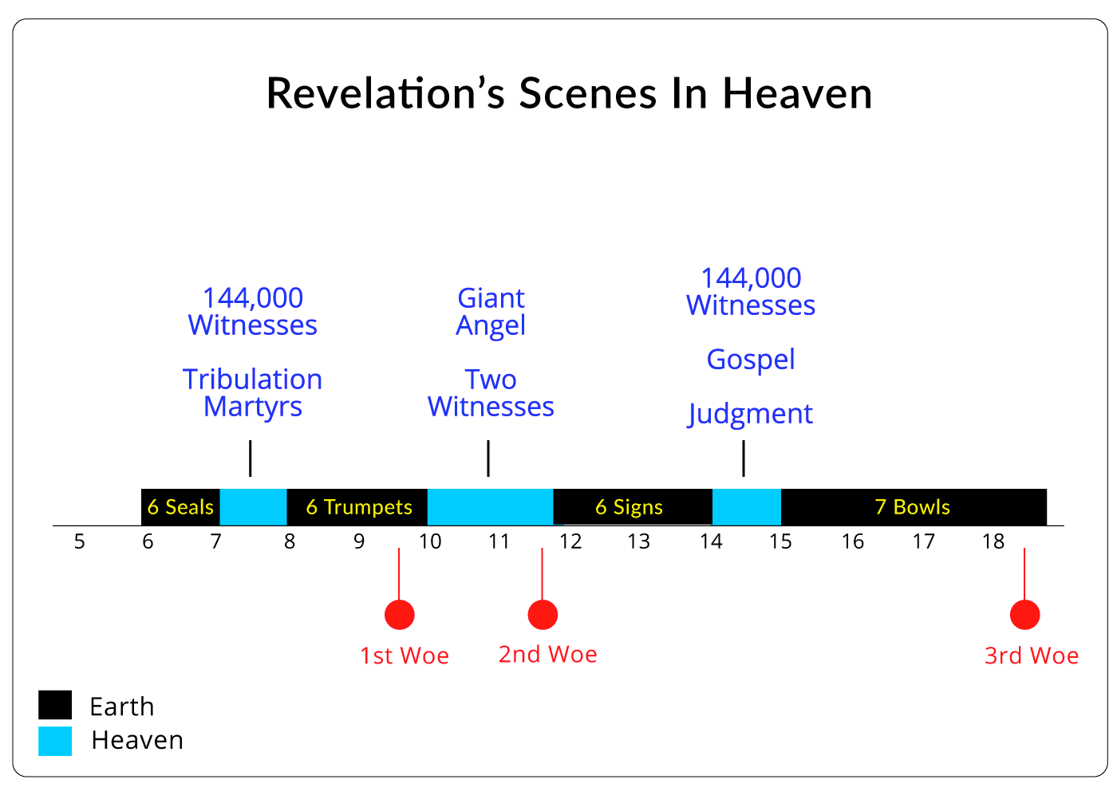

**The Seven Seals**

The Seven Seals are the first set of judgments. The seals provide an overview of the terrors that will occur in the Tribulation period. The description of the Tribulation period begins in chapter 6 and ends in chapter 19. The first six seals are described in Revelation 6:1-17. The first seal describes peace which corresponds to the first 3.5 years of the tribulation (Daniel 9:27; 1 Thessalonians 5:2-3). The remaining seals describe the general punishments that will occur during the last part of the tribulation. The seventh seal is mentioned in Revelation 8:1, but it telescopes into the seven trumpets.

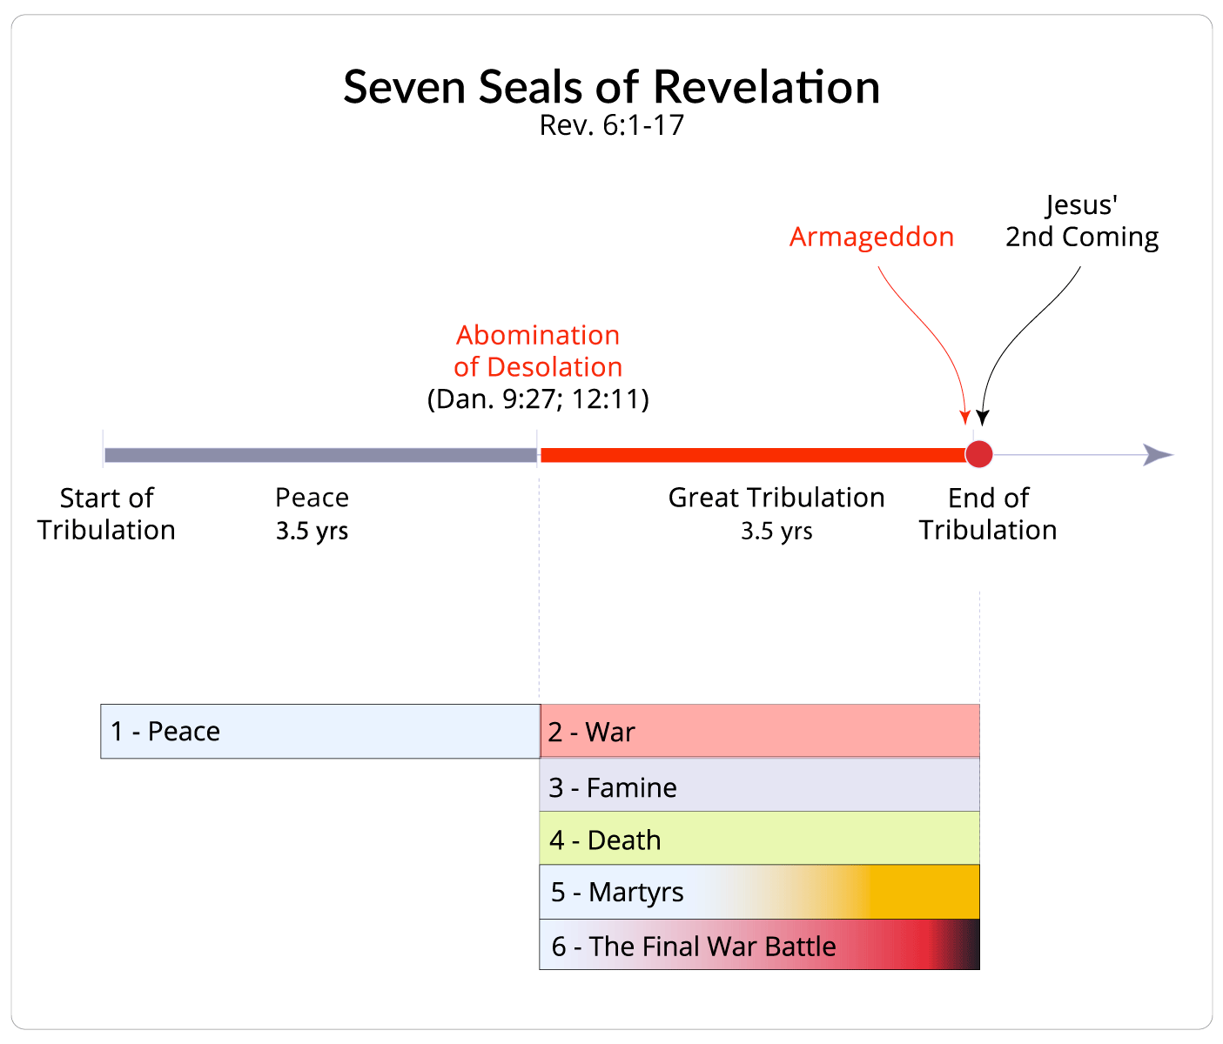

**First Scene in Heaven**

The first scene in the description of the tribulation period occurs in Revelation 7:1-17. In this scene we encounter the 144,000 witnesses (Revelation 7:4-8) and the tribulation martyrs (Revelation 7:9-17). This interlude focuses on the spread of the gospel during the Tribulation and the death of Tribulation saints.

**The Seven Trumpets**

The seventh seal telescopes into the Seven Trumpets. The first six trumpets occur in Revelation 8:1-9:21. The first four trumpets describe a series of specific judgments on the earth, and the last two trumpets describe the release of demonic forces upon the earth.

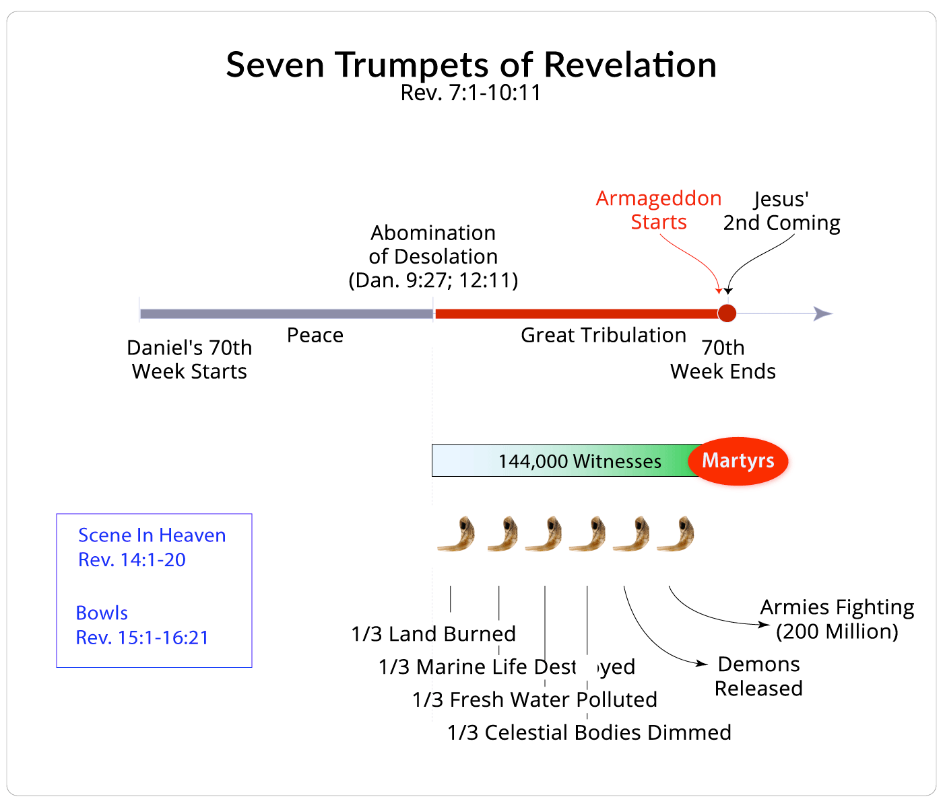

**The First Woe**

The first woe occurs in Revelation 8:13. The verse reads,

Then I looked, and I heard an eagle flying in midheaven, saying with a loud voice, “Woe, woe, woe to those who dwell on the earth, because of the remaining blasts of the trumpet of the three angels who are about to sound!” Revelation 8:13.

Revelation 9:12 tells us that the first woe is past. A review of Revelation 9:1-11 reveals that demonic forces were released from the bottomless pit (Luke 8:31; 1 Peter 3:19; 2 Peter 2:4; Jude 6) between Revelation 8:13 and Revelation 9:12. That is, the woe was about increased demonic activity upon the earth. The next “woe” is finished in Revelation 11:14. The final one occurs at the time of the battle of Armageddon.

**The Second Scene in Heaven**

The second scene in the description of the Tribulation occurs in Revelation 10:1-11:14. This scene includes a “strong angel,” which is a giant angel (Revelation 10:1-11). During this break in the description of the Tribulation period, two witnesses appear (Revelation 11:1-13). Their purpose is to serve as witnesses; however, we are not told what they will communicate.  This scene focuses on the spread of the gospel and the ministry of the two witnesses.

**The Second Woe**

The second woe is referenced in Revelation 11:14 and occurs at the end of the second scene. The verse reads,

The second woe is past; behold, the third woe is coming quickly. Revelation 11:14.

This second woe refers to the massive demonic activity described in Revelation 9:13-21.

**The Seven Signs**

The seventh trumpet occurs in Revelation 11:15 and telescopes into seven signs. It is commonly believed that the seven trumpets telescope into the seven bowls, but a close examination of Revelation reveals that a sequence of seven signs follows the trumpets. Beginning in Revelation 12:1, the first sign is given to us.

A great sign appeared in heaven:a woman clothed with the sun, and the moon under her feet, and on her head a crown of twelve stars; and she was with child; and she cried out, being in labor and in pain to give birth. Revelation 12:1-2.

The second sign is a dragon in Revelation 12:3.

Then another sign appeared in heaven: and behold, a great red dragon having seven heads and ten horns, and on his heads*were*seven diadems. Revelation 12:3.

The third sign is a male child in Revelation 12:5-6. The fourth sign is Michael the archangel (Revelation 12:7-17). The fifth sign is the antichrist (Revelation 13:1-10), and the sixth sign is the false prophet in Revelation 13:11-18).

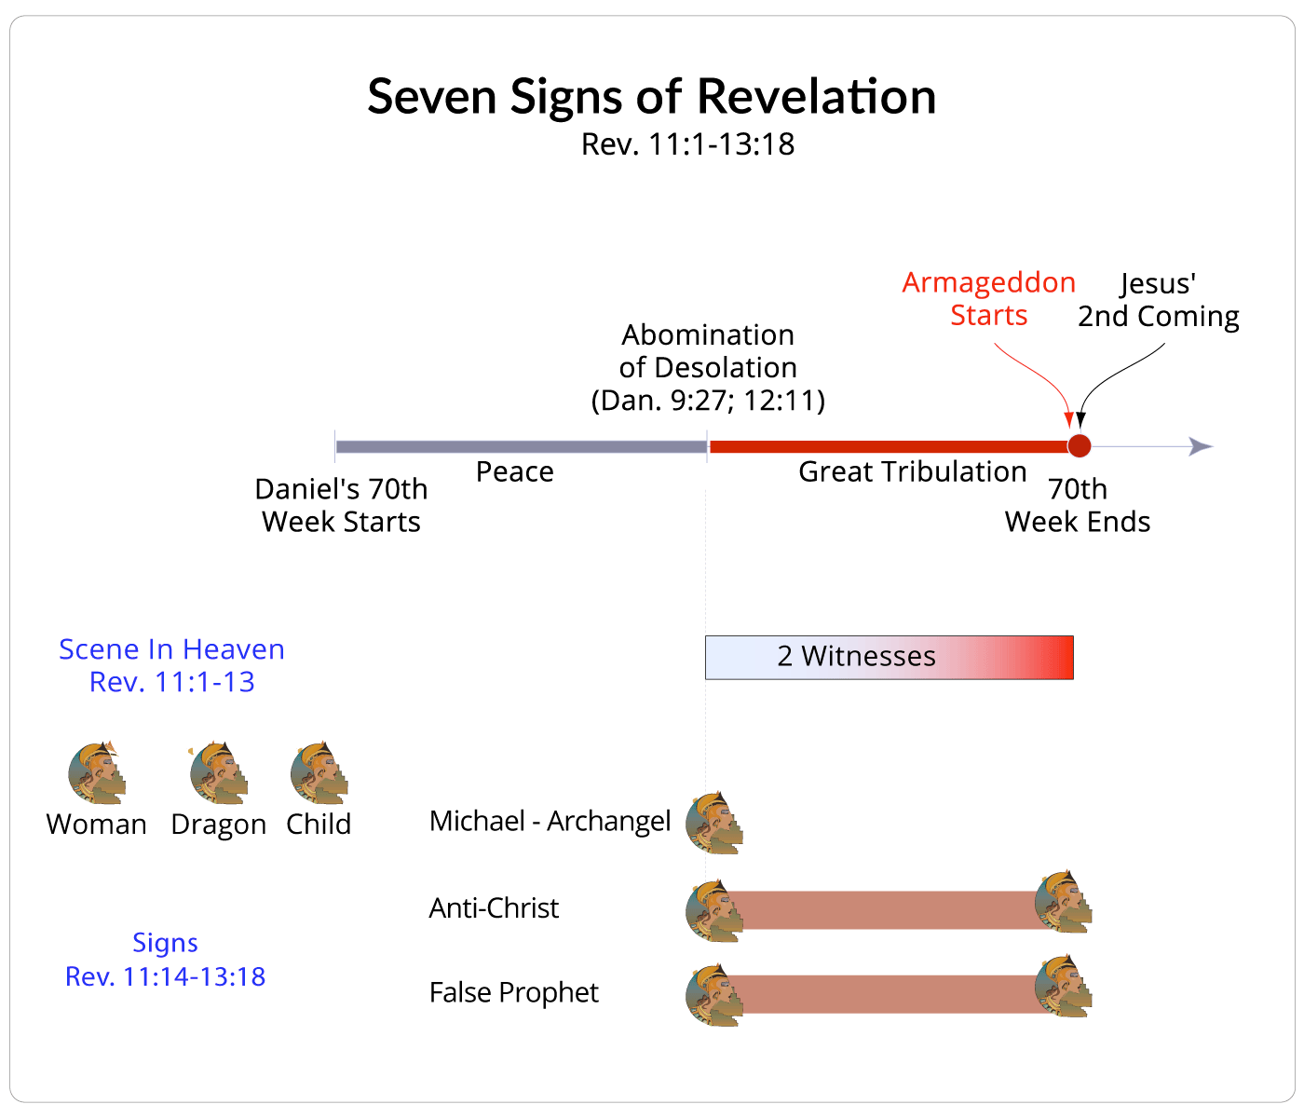

**The Third Scene in Heaven**

The third scene occurs in Revelation 14:1-20. This scene includes another glimpse of the 144,000 witnesses (Revelation 14:1-5), an angel presenting the gospel (Revelation 14:6-13), and looking ahead to the final judgment upon the nations of the world, which is called the battle of Armageddon (Revelation 14:14-20).

**The Seven Bowls**

The seventh sign telescopes into the seven bowls (Revelation 15:1, 7). The first six bowls occur in Revelation 15:1-19:21. They describe horrible plagues that occur on the planet, the universe, animals, and human life. The final bowl is the battle of Armageddon.

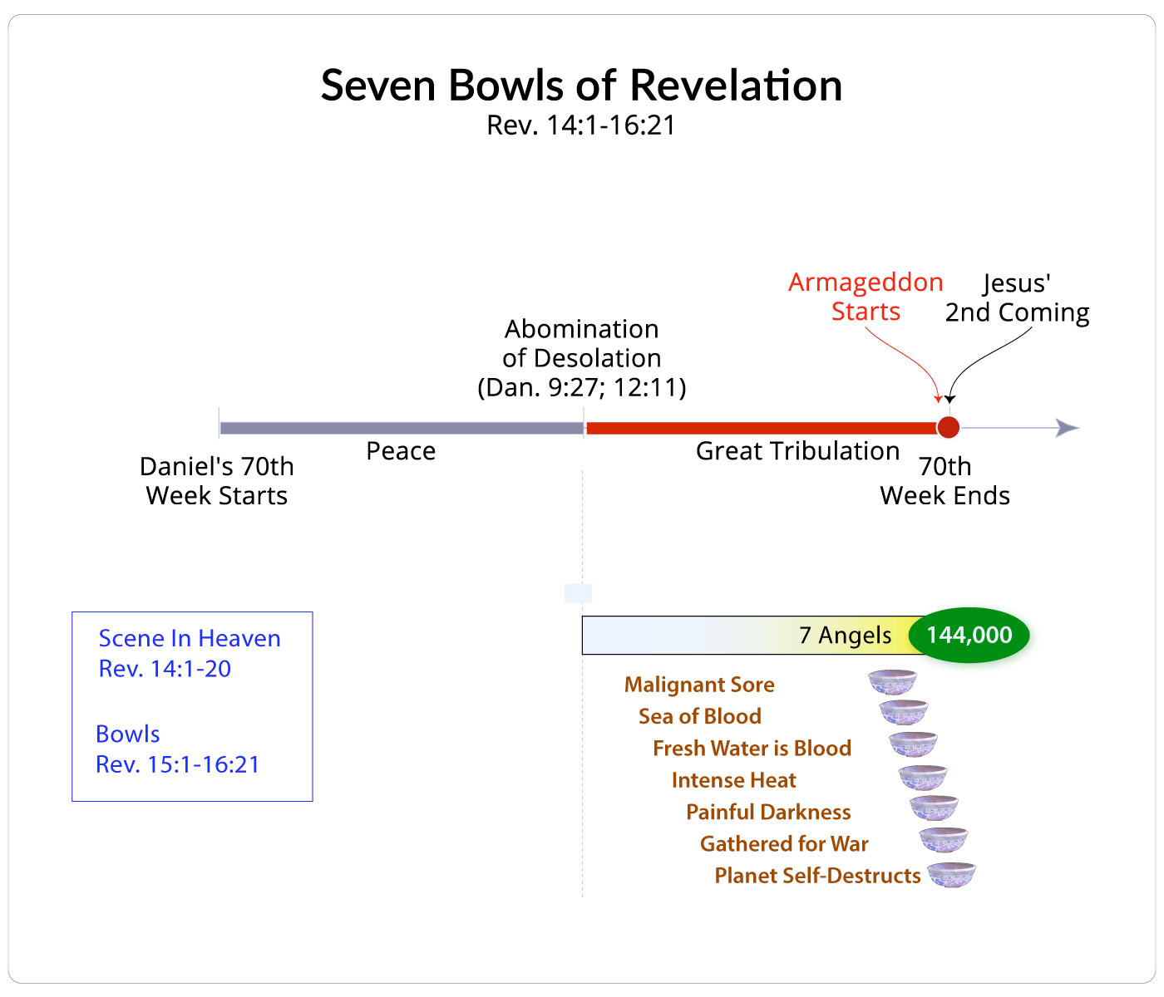

**The Third Woe**

The third woe is repeated three times in Revelation 18:10, 16 and 19. Revelation 18 describes the final aftermath that will occur on the earth which is the battle at Armageddon. Revelation 19 describes the second coming of Christ and a summary of the battle at Armageddon. The armies of the world will be defeated (Revelation 19:17-19), the antichrist and false prophet will be defeated (Revelation 19:20-21) and Satan and the demons will be put into the bottomless pit (Revelation 20:1-3). The seven bowls and the third woe conclude the description of the Tribulation period in the book of Revelation (Revelation 6:1-19:19).

**Conclusion:**

It is important to realize that throughout the tribulation period while God calls men and women to repent of their sins, the people will respond with anger against God rather than repentance (Revelation 9:20-21; 16:9-11).

The rest of mankind, who were not killed by these plagues, did not repent of the works of their hands, so as not to worship demons, and the idols of gold and of silver and of brass and of stone and of wood, which can neither see nor hear nor walk; and they did not repent of their murders nor of their sorceries nor of their immorality nor of their thefts. Revelation 9:20-21.

Men were scorched with fierce heat; and they blasphemed the name of God who has the power over these plagues, and they did not repent so as to give Him glory. Then the fifth angel poured out his bowl on the throne of the beast, and his kingdom became darkened; and they gnawed their tongues because of pain, and they blasphemed the God of heaven because of their pains and their sores; and they did not repent of their deeds. Revelation 16:9-11.

Yet, some individuals will understand that they are sinners who have rejected God and that God’s judgment is deserved. They will respond to God’s call to repent and believe in Christ (Revelation 7:4-8). Sadly, most believers will die during the tribulation as martyrs.

When the Lamb broke the fifth seal, I saw underneath the altar the souls of those who had been slain because of the word of God, and because of the testimony which they had maintained; and they cried out with a loud voice, saying, “How long, O Lord, holy and true, will You refrain from judging and avenging our blood on those who dwell on the earth?” And there was given to each of them a white robe; and they were told that they should rest for a little while longer, until the number of their fellow servants and their brethren who were to be killed even as they had been, would be completed also. Revelation 6:9-11. After these things I looked, and behold, a great multitude which no one could count, from every nation and all tribes and peoples and tongues, standing before the throne and before the Lamb, clothed in white robes, and palm branches were in their hands; and they cry out with a loud voice, saying, “Salvation to our God who sits on the throne, and to the Lamb.” Revelation 7:9-10.

**The Eighth Day:**

Eternity begins - The Father’s Kingdom comes to the Earth - The Supper - The Son of the Father gives His Father, His Kingdom. And the Earth will be put back into its place as it was in the beginning.