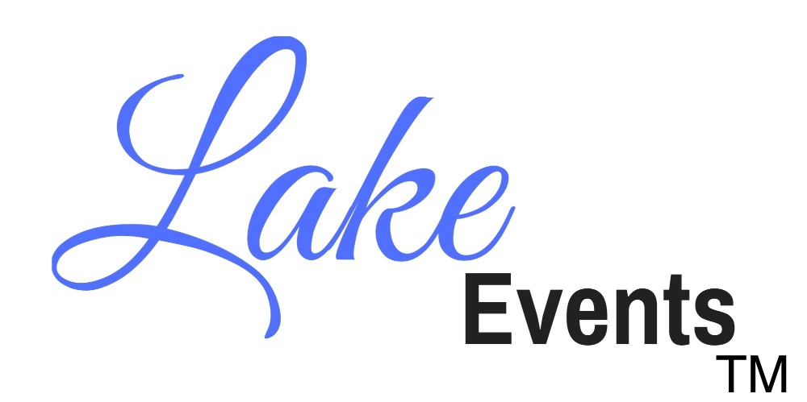
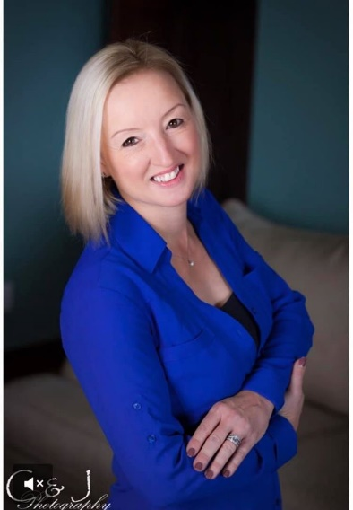
Lake Events, LLC is excited to announce an innovative digital advertising campaign that drives revenue and brand awareness.
As social media coordinator for your company we will develop original content and suggest creative ways to attract more customers, increase sales, and promote your brand. Together we will develop a marketing strategy tailored to meet your goals.
My name is Sherri Falkenberg, I am the Founder and CEO of Lake Events, LLC. As an experienced Event Coordinator and successful Campaign Manager I can offer proven social media content and strategies, digital ad buys, and outside marketing techniques with partners including digital billboards, advertising, networking, photography and print services.
lakeeventsgroup.com
216.704.9009
Digital Marketing Agency
Event Coordinator

