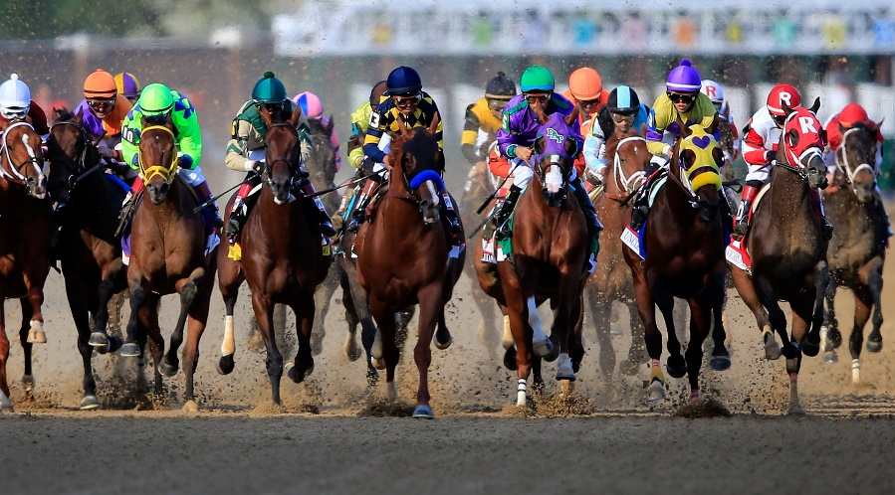

**Kentucky Derby Day Business to Business Expo**

Saturday, May 4, 2019 / 10 am – 3 pm

@ **SPIRE Institute**

5201 Spire Circle, Geneva, OH 44041

Business Name: _________________________

Your Name: ____________________________

Address: ___ ____________________________

Contact phone number(s): _______ _________

Website/Email address: ___ _ _____ __________

Type of Service or Product(s): _ ___ __________

$160 includes 8’ table and 2 chairs (multiple spaces may be purchased)

Please mail completed form and payment to: 

Sherri Falkenberg / www.lakeeventsgroup.com

15 E. Shore Blvd., Timberlake, OH 44095