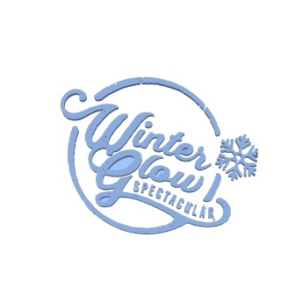
2nd Ever Winter Glow Spectacular Golf Tournament
Benefiting the 2023 Liberty Lake Winter Glow Spectacular
Date: June 10, 2023
Time: 6:30 Check In and 8:00 am Shotgun Start
Place: Liberty Lake Golf Course, Liberty Lake, WA
Format: 4 Person Scramble
Cost: $125.00 Per Golfer
Includes: Green Fees, Cart, and Lunch
Golfer #1 – Name_____________________HC or Avg Score_____
Golfer #2 – Name_____________________HC or Avg Score_____
Golfer #3 – Name_____________________HC or Avg Score_____
Golfer #4 – Name_____________________HC or Avg Score_____
Contact Person:
Name____________________________________
Address__________________________________
Phone #__________________________________
Send check & form to: Mark Saba, 1221 N Malvern Rd., Liberty Lake, WA. 99019 Email: mjsaba1221@gmail.com
Please make check payable to: Winter Glow Spectacular
Deadline to Register: May 27, 2023
Additional information please contact Mark Saba at 509-475-9261
“Hit em Straight and have a FUN TIME!”

