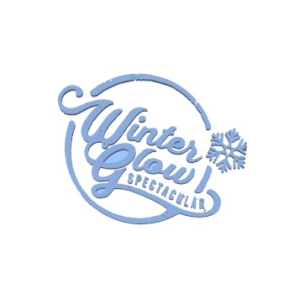 2nd Ever Winter Glow Golf Tournament
Hole & Door Prize Sponsor Sign Form
Date/Time: June 10, 2023 - 8:00 am Shotgun Start
Place: Liberty Lake Golf Course, Liberty Lake, WA
Format: 4 Person Scramble
Sponsor Cost:
$125.00 Hole & Door Prize Sponsor
$100.00 Hole Sponsor
$25.00 Door Prize or Gift Card
$125_____ $100____ $25____
Company Name________________________________________
Address_______________________________________________
Phone #_______________________________________________
Contact Person_________________________________________
Winter Glow is a 501(c) 3 Non Profit, Tax ID # 47-1386773. Send check & form to: Mark Saba, 1221 N Malvern Rd., Liberty Lake, WA 99019. Please make check payable to: Winter Glow Spectacular Additional information please contact Mark Saba at 509-475-9261

