Final Skit Presentations Sample

[Tuesday 2 skit 2015](https://www.youtube.com/watch?v=sKY4MYf-uNE)

[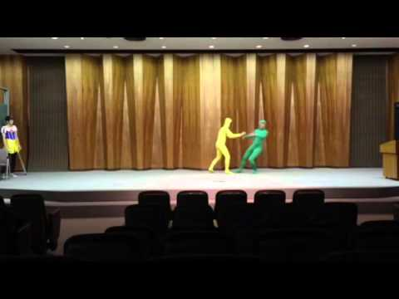](https://www.youtube.com/watch?v=sKY4MYf-uNE)