To: ––––––––––––––––
––––––––––––––––
––––––––––––––––
From: ––––––––––––––––
––––––––––––––––
––––––––––––––––

Safety Notice to the Federal Aviation Aeromedical Office and
Demand for an Investigation and Administrative Action for Airline and Pilot Union Aviation Law and Medical Standards Violations and Interference

Notice to Agent is Notice to Principal and Notice to Principal is Notice to Agent.

I, ___________________________, one of the People, of the 50 states, do give notice to you, appointed servants or personnel, representatives of a federal agency overseeing and regulating the airline industry that provides transportation to the People within America and beyond, in order to make clear the law created by the People, as forefathers of America, and Framers of the 50 State Constitutions and the Constitution of the United States, that you and your agents may provide due care and immediate remedy to the People;

I, declare that the United States government is required, by Constitution, to provide a Republican form of government to all 50 States (See the Constitutional Provision Below):

United States Constitution Article 4 Section 4:
Section 4. The United States shall guarantee to every State in the Union a Republican Form of Government and shall protect each of them against invasion; and on Application of the Legislature, or of the Executive (when the Legislature cannot be convened) against domestic Violence.

Texas Constitution Article 1 Section 2: Republican Form of Government
Section 2. All political power is inherent in the people, and all free governments are founded on their authority, and instituted for their benefit. The faith of the people of Texas stands pledged to the preservation of a republican form or government, and, subject to this limitation only, they have at all times the inalienable right to alter, reform or abolish their government is such manner as they may think expedient.

Please take further notice, that, as one of the People, I recognize that there are now Federal and State Partnerships that allow money to be given to businesses for following Covid Mandates and that the Federal programs also give administrative costs that benefit all parties administering the programs, thus leaving unclean hands and conflicts of interest that are not usually known by the common people.

Therefore, I wish to explain the fundamental principles regarding republics, that you may realize, understand, and act accordingly. You are not allowed to interfere with rights of the People by vote, or any other means, and any such attempts are considered a trespass (see authorities below):

Kentucky Constitution Bill of Rights: Text of Section 2:
Absolute and arbitrary power over the lives, liberty and property of freemen exists nowhere in a republic, not even in the largest majority.

Arizona Constitution Declaration of Rights: Text of Section 8: Right to Privacy:
No person shall be disturbed in his private affairs, or his home invaded, without authority of law.

Please take notice that the word Republic deals with affairs, matters, and things that are open to the public, and not things that are private, in which neither the States, Federal Government, nor corporations functioning under the corporation commission of the state, were given any authority.

Please take notice that Congress is constitutionally granted, by the People, the authority to legislate such laws as are required to address the People’s business. Public Law 85-726-Aug. 23, 1958, also known as the Federal Aviation Act of 1958, was legislated, giving authorities as detailed below:

“AN ACT
To continue the Civil Aeronautics Board as an agency of the United States, to create a Federal Aviation Agency, to provide for the regulation and promotion of civil aviation in such manner as to best foster its development and safety…
Be it enacted by the Senate and House of Representatives of the
United States of America in Congress assembled That this Act, divided
into titles and sections according to the following table of
contents, may be cited as the “Federal Aviation Act of 1958”.”

Please take notice that “SAFETY” is noted 47 times in the ACT and nowhere authority over airmen health was given to air carriers.

Please take notice under Declaration of Policy in the ACT: The Board

Sec. 102. “In the exercise and performance of its powers…the Board shall consider the following…in the public interest, and in accordance with the public convenience and necessity:’

Sec. 102 (b) “The regulation of air transportation…assure the highest degree of safety in…” and (e) “The promotion of safety in air commerce…”

Please take notice that under the ACT.

Sec. 301. “(a) … The Agency shall be headed by an Administrator…shall be responsible for the exercise of all powers and the discharge of all duties of the Agency…and the discharge of his responsibilities for under this Act, the Administrator shall not submit his decisions for approval of, not to be bound by the decisions or recommendations of, any committee, board, or other organization created by Executive order.”

Please take notice the FAA is required by law to investigate any reports of violations:
- I am now aware that you are charged with investigating violations of the law by American Airlines and the Allied Pilots Association, the representative of the pilots in the service of American Airlines, (FAA Disclosure AAE-EHL-20231208-990) which may extend to other airlines and pilot unions.
- You have been informed of the notice to the Office of Audit and Evaluations received by said office on December 4, 2023, and
- You have received the supplemental information of violations received by that office on January 11, 2024, and
- The Administrator has received multiple SAFETY POSTS directed at him by @CaptSaliba on the messaging service X, formerly known as Twitter, and
- It is your duty, if you choose not to investigate, to fully declare such non-action so the people can see and understand your reasoning for not commencing an investigation in accordance with Sec. 601 of the ACT.

Sec. 601. (a) “The Administrator is empowered, and it shall be his duty to promote safety of flight of civil aircraft in air commerce…” and (b) “In prescribing standards, rules and regulations… Administrator shall give full consideration to the duty resting upon air carriers to perform their services with the highest possible degree of safety in the public interest… The Administrator shall exercise and perform his powers and duties under this Act in such manner as will best tend to reduce or eliminate the possibility of, or recurrence of, accidents in transportation, but shall not deem himself required to give preference to either air transportation or other air commerce in the administration and enforcement of this title.”

Please take notice that in past communication, as evidenced below and shared by American Airlines’ Captain Saliba, you submitted to entities in contravention to Sec. 301 (a) of the Federal Aviation Act of 1958. You are reminded that such act is in violation of the law imposed upon you and the Federal Aviation Administration by the People in the Act.

Take notice that your inaction and failure to comply with Sec. 301 (a) in support of pilot authority vested in him by the Act, as indicated in your correspondence below, may have resulted in adverse conditions of employment for pilots at American Airlines and other air carriers.

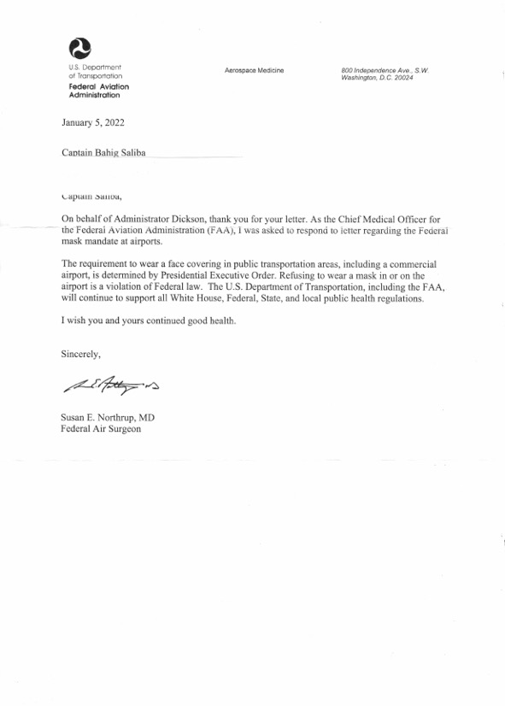Please take notice that under:
Sec. 303. “(a) The Administrator is empowered…for the exercise and performance of the powers and duties vested in and imposed upon him by law… (7) making investigations and conducting studies in matters pertaining to aeronautics…”

Sec. 306. “In exercising the authority granted in him, and discharging the duties imposed by, this Act, the Administrator shall give full consideration… to the public right of freedom of transit through the navigable airspace.”

It is evident that the FAA did not regulate masking of pilots who hold FAA medical certificates, or masking in general, or gave authority to the airlines to impose any medical treatment on airline pilots in their service under 49 U.S. Code §42112. If that is not correct and so I am informed, please provide information in support of such authority.
Also, if you have or are providing any exemptions from the requirements of any rule or regulation to American Airlines or any other airline or allowing the Allied Pilots Association or any other pilot union to interfere in public policy, by imposing any masking on pilots or any medical treatment, it is your duty to fully declare such exemptions so that the People may see and understand your reasoning and action under Sec. 307. (e)

Sec. 307. (e) “The Administrator from time to time may grant exemptions from the requirements of any rule or regulation prescribed under this title if he finds that such action would be in the public interest.”

Please understand the Other Powers and Duties of Administrator:

Sec. 313. (a) “The Administrator is empowered to perform such acts, to conduct such investigation, to issue and amend such orders, and to make and amend such general or special rules, regulations, and procedures, pursuant to and consistent with the provisions of this Act, as he shall deem necessary to carry out the provisions of, and to exercise and perform his powers and duties under, this Act.” and (c) “In the conduct of any public hearings or investigations authorized by this Act or by the Federal Airport Act, the Administrator shall have the same powers to take evidence, issue subpoenas, take depositions, and compel testimony as are vested in members of the Board…”

Please note that under the Air Carrier Economic Regulation. Certificate of Public Convenience and Necessity:

Sec. 401. (a) No Air carrier shall engage in any air transportation unless there is in force a certificate issued by the Board authorizing such air carrier to engage in such transportation.

If American Airlines or any other carrier did not receive authorization under Sec. 401 (a) to impose any medical treatment on the pilots who are providing transportation in accordance with 49 U.S. Code §42112, it is your duty to declare that and take administrative actions accordingly.

And Compliance with Labor Legislation:

(k) (5) “The term “pilot” … who is properly qualified to serve as and holds a currently effective airman certificate authorizing him to serve as, such pilot or copilot.” Necessarily means a pilot who holds a valid FAA medical certificate, not an air carrier specific medical certificate.

Please take notice that the Act imposes upon the Board the following:

Inquiry Into Air Carrier Management

SEC. 415. For the purpose of exercising and performing its powers
and duties under this Act, the Board is empowered to inquire into the
management of the business of any air carrier and, to the extent reasonably
necessary for any such inquiry, to obtain from such carrier,
and from any person controlling or controlled by, or under common
control with such air carrier, full and complete reports and other
information.

And upon the Administrator Sec. 601 (a) Under Title VI ––– SAFETY REGULATION OF CIVIL AERONAUTICS.

Please note that I am aware of the following and add that it is applicable to other airlines:

“Pilot FAA medical certification is a process that has served the aviation industry well over the decades. The air carrier is not a party to the process. Coercing pilots, under threat of termination, to accept a medical treatment and the acceptance of any drugs under these conditions, even when the drug is authorized by the FAA, violates informed consent, the foundation of pilot medical certification, thus invalidating the process.”

“The wall separating air carrier and Pilot FAA medical certification has been breached by American Airlines and many other airlines, which, through their practice of coercion, created a second-tier medical standard not approved or authorized by the agent of the People, the FAA.”

If the FAA authorized the creation of other medical standards it is your duty to inform me with supporting evidence so I may understand.

“American Airlines, and many other airlines, coerced pilot and under threat of termination, extorted a fit-for-duty declaration, an interest held by the agent of the People, the FAA and operated aircraft for profit.”

“American Airlines and other airlines’ practice of coercing pilots under threat of termination brings into question the validity of the medical certification of the airline pilots who currently occupy the flight decks of air carrier aircraft and is in direct violation of 14 CFR §91.11, interference with flight crewmember duties.”

For your understanding of the law see https://www.faa.gov/about/office_org/headquarters_offices/agc/practice_areas/regulations/interpretations/Data/interps/2011/Roberts-AJV-1_2011_Legal_Interpretation.pdf

“American Airlines and other carriers’ practice invalidates a pilot’s medical certification and as such they are in violation of 14 CFR 121.383 (a)(2)(i), requiring pilots serving in their capacity to have on their person a valid FAA medical certificate.”

“Under the above noted conditions, a fit-for-duty declaration, as required under 14 CFR Part 117, an interest held by the agency, becomes invalid in the absence of informed consent and the acceptance of any drug treatment imposed on airline pilots in the service of any airline.”

“Coercing pilots to accept a medical treatment under threat of termination as indicated by the message of Captain Chip Long, American Airlines’ former Senior VP of flight, (see documents provided by the Office of Audit and Evaluation) and securing a fit-for-duty declaration, an interest held by the agency, and operating aircraft for profit is extortion by definition.”

For the above reasons, it is the duty of the FAA Administrator and yours as imposed upon you to inform the public of the authorization and provide such details for the public to understand their actions regarding the appearance that the FAA has authorized the conduct of air carriers as detailed above and in the Report of Serious and Continued Violations at American Airlines, provided to the Office of Audit and Evaluation on December 4, 2023, now in your possession.

If the FAA, the agent of the People, did not give American Airlines and the Allied Pilots Association any authorization to interfere in public policy, then it is your duty to investigate and take administrative action to correct and provide remedy for the People.

Finally, notice that the People are aware of your actions or lack of action and are observing to determine if you are indeed complying with FAA requirements and the Act or if you may not be complying. Should you not comply with the FAA requirements, you will be in violation of the clear law and will be found guilty of maladministration and possibly malfeasance. The People do not desire action against any public official who is following the law.

We are observing the lack of action with alarm and pray that you will determine to actively follow the requirements of your appointment.

___________________________________________ ____________
Autograph Date

