**A Forgotten or Abandoned Village**

I have recently read somewhere that "every man should have his own village." Hm…it‘s interesting. For instance, I am a city dweller. My parents also were born and live in our town. And grandparents lived in Postavy. So it means that I have no village! Well, but if I think a bit? ... My family does not start from me and does not finish. My ancestors came from the countryside and therefore I have a village. Its name is Kaduky and it is situated near Postavy. My grandmother, great-grandparents and several generations of my ancestors were born and lived there.

The village is not big, only 14 yards. It isn’t located in a remarkable place: the forest and the lake are so far from Kaduky and there are no other sights. It seems to me that my distant ancestor travelled-travelled around the world, got tired, stopped at this place and began to live. Maybe the devil led him for a long time (because according to Slavonic people Kaduk is a devil, an evil spirit), my ancestor got tired of wandering and founded this village. Hm…everything can be!

The village was small but its life was amazing. Many young people lived in the cottages. The villagers sowed grain, grew cattle, worked and of course, played. It seems to me that everything was in such a way. I know quite a few episodes of my ancestor’s life. I haven’t got grandparents because they passed away many years ago and only my mother can tell me about their lives. For example, I know that young people gathered together at the "vecharyny" (parties) in my great-grandfather Mikhail’s cottage because he had the biggest house in the village. People danced in his inner porch as it occupied a good half of the house. My great-grandparents were the first people in the village who began to decorate a Christmas tree with tinsel, ornaments, lights and sweets at New Year. Rural kids came to my great-grandfather’s house in order to admire a Christmas tree because it was considered to be a novelty at that time.

The villagers were not rich but they lived in peace: they helped each other in any way they could.

The village was away from military actions when the Great Patriotic War broke out. The Germans came to the village from to time, went from house to house and collected food.

People started to work on the collective farm after the war. It was difficult to raise the destroyed economy. Salaries were not paid, people worked for their working days. And only at the end of the year the villagers got little grain. My grandmother recalled: "If we did not have our own land, we would die!"

Naturally, people wanted better life for their children and therefore the youth were the first who left the village: to study, to find a job in the city. There wasn’t any school in Kaduky and children had to go to the nearest village. Thus many families with children began to leave their native place. Gradually, the old became the only inhabitants of the village. Of course, they were rarely visited by the children and their grandchildren came to spend summer holidays there. At that time (in summer) the population of a small village doubled. But the aboriginal people became less and less. In the end this small place became an orphan. And the last dweller, aunt Valya, died several years ago. The whole village Kaduky died! Of course, there are houses in the village. They are used as a summer residence. People come there in summer and at the weekends. But it’s so quiet in this country: there is no smoke coming from the chimneys, no clucking hens and mooing cows. Silence is everywhere ... The village exists and at the same time it is dead. I cannot say that the village of my ancestors is forgotten or abandoned – it’s not true. It is visited… it is kept in mind… but ... if you do not live in the house… then it dies.

Брошенный дом, словно нищий бродяга,

Стоит у дороги «с пустою сумой»…

Старый, слепой и хромой бедолага —

Нет сил у него больше спорить с судьбой…

Кончилась сказка — деревня забыта,

Не вьёт больше аист на крыше гнезда…

Только крапива, как верная свита,

«Свой» дом охраняет… И этим горда…

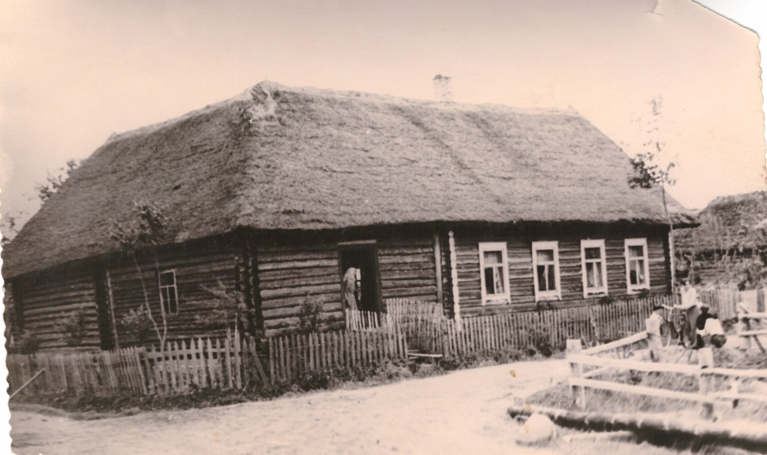

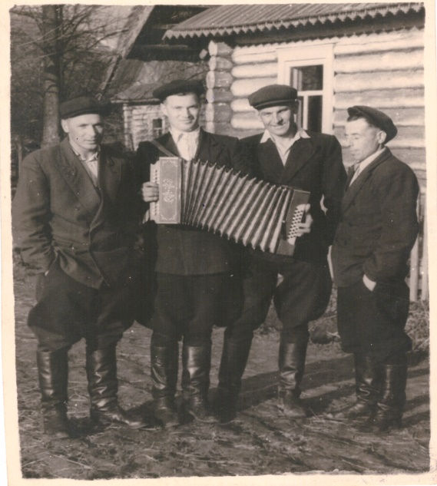 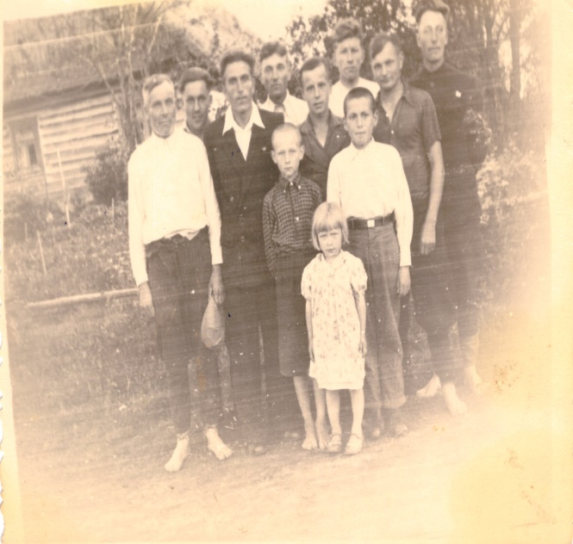

**A Winter Tale**

**A Snowflake-Traveler**

         Once upon a time a snowflake lived in a distant snow country. The whole days it frolicked and spent time in dances with its sisters. The snowflake had fun and a carefree time. When its friend, a wind, flew… it circled over the ground flying from tree to tree, from bush to bush. Then it returned to its home again. One day the snowflakes gathered together in a magical garden and began to tell different stories. And our snowflake heard the story that impressed it most of all. The oldest snowflake said: "This is the very story I heard from my grandmother and my grandmother from its grandmother. It was a long time ago. A snowflake lived in our kingdom which visited the land not in winter as it is required of each snowflake but in summer. And it came back home. Everyone was told about the journey. However, no one believed in it, everybody thought that the snowflake was crazy. Because we all know that there is no snow on the ground in summer." While its sisters and friends were chatting in the garden our snowflake wasn’t listening to them anymore. It was thinking of a brave traveler.

Days passed and there was fun in the whole snow kingdom: the snowflakes danced, frolicked and laughed. Only our Snowflake was sad and unhappy. It was tired of the routine and wanted something new and unseen.

The winter finished. All inhabitants were preparing for a long summer holiday. The snowflake went into the garden. It wanted to be alone. "Here is another winter has passed," – the snowflake thought with sadness. "The summer will pass.... and what is any summer like?" It thought again about a bold snowflake that visited the land many years ago, about its courage. "No, I do not have enough courage to do such a thing!" The snowflake was about to leave the garden when the wind flew, caught it and carried down to the ground. Our snowflake scared, it did not have time to understand, it just felt like coming down.

Some time later it noticed that nothing bad happened. The snowflake opened its eyes which it had closed while flying down. Our little snowflake saw a blue sky, lots of green trees and there was a huge colourful carpet full of different flowers that was so different from a winter white veil. The snowflake was excited by the picture of a sunny summer day. But then it began to melt in the sun. "Well, that's all" – the snowflake thought. "I'm going to die and no one will know that I have spent some minutes in summer. But still… I'm happy to see such beauty." Our baby continued to melt.

But its best friend, the wind, helped the snowflake again. The wind blew lightly and our brave snowflake landed in a cold stream and turned into a droplet. It looked around. There were a lot of drops, they frolicked in that cool water. They jumped from pebble to pebble and laughed. The snowflake-droplet also jumped with joy. It flew from one small stone to another and enjoyed the sun. "What fun, what beauty!" It was ready to scream to the world about its happiness. "Do not jump so high!" -it heard. The snowflake turned about. There was a small droplet next to it. "If you jump so high you can jump on a big stone and die. You should be careful "- a new friend said. The snowflake did not want to die because it had just realized her dream. So it tried to be more circumspect. But it did not last long. The snowflake-droplet began to frolic and jump with its new friends ... and found itself in the middle of a large stone.

A hot sunbeam slipped on it and turned it into a little noticeable cloud of steam. Our snowflake could die, if the wind didn’t help the snowflake. The wind picked up the cloud and carried it up quickly. The higher was a cloud, the colder it became around. It turned into a real snowflake. Our traveler opened its eyes. The wind landed in the garden. The snowflake thanked its friend. The wind had already done so much for our baby: showed the world, saved from death.

The snowflake went home. "Where have you been? What happened to you?" –the snowflake was asked. "I have been there where summer is. I have flown away for my dream and I'm happy!" –the snowflake said and went to bed.

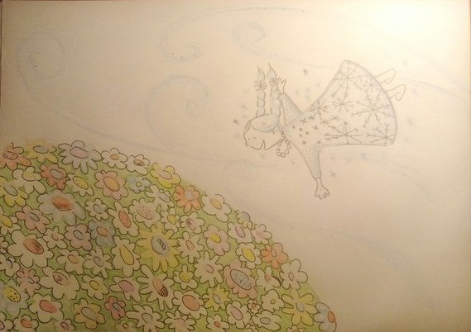

The picture was drawn by Ekaterina Podgayskaya