MEMBA INSTITUTE STUDENT CODE OF CONDUCT

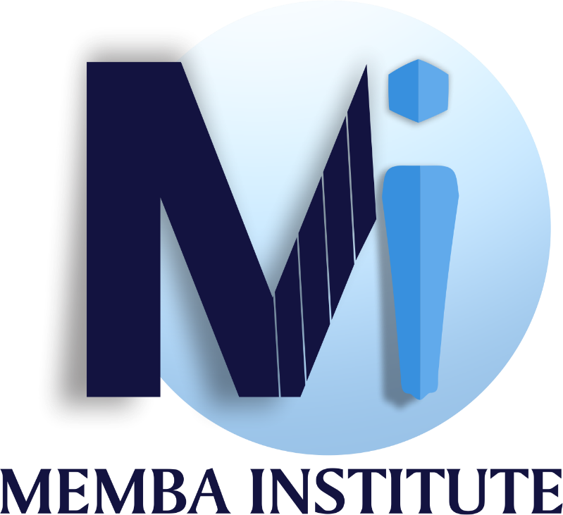

9165 Otis Ave
Suite 236-4
Indianapolis, IN 46216
Telephone Number: 317-922-2900
Email: MEMBA@membaconsult.com
Website: membaconsult.com

Chief Operating Officer
Danielle McVea

Office of Administration
Damon Covington

INTRODUCTION
MEMBA Healthcare Consulting Firm LLC, dba MEMBA Institute, is designed to educate, empower, and bring awareness to the growing financial challenges within the Healthcare Industry. Inappropriate (and/or) fraudulent medical billing and uninsured members aid in the rise of healthcare spending and insurance premiums.
Here at MEMBA our mission to be a Change Agent propels us to educate, empower, and bring awareness
- To help combat the growing medical billing concern MEMBA has partnered with American Academy of Professional Coders, to teach and provide medical coders with Coding Certifications that demonstrate a professional’s working knowledge to support the submission of cleaner claims, faster reimbursement, fewer denials, and better run practices and facilities.
- Our partnership with the National Healthcareer Association (NHA) affords us the opportunity to train and educate Medical Assistants, Administrative Assistants, and Pharmacy Technicians with an industry recognized Certification.
- To combat the growing post-pandemic labor challenges in the Culinary/Hospitality industry MEMBA has partnered with the National Restaurant Association (NRA) and Supper Cooking Academy to offer hands on industry experience and certifications.
- These partnerships help confidently foster change for our students.
The purpose of this document is to assist post-secondary students, teachers and school administrators with the conduct needed to achieve a safe and productive learning environment. This Code of Student Conduct addresses not only the role of the student and the school, but also addresses:
- Grounds for disciplinary action; and
- Procedures for taking disciplinary action
The individuals governed by this document are post-secondary students, 18 years of age and older who no longer participate in a secondary educational program.

Outlined below are Behaviors considered to be disruptive and in violation of the student code of conduct.
Disruptive Behaviors:
• Confrontation with another student
• Disruptive behavior
• Failure to comply with class and/or school rules
• Possession of items or materials that are inappropriate for an educational setting
• Cheating/misrepresentation
• Confrontation with a staff member
• Defiance of school personnel
• Distribution/sale of items/materials that are inappropriate for an educational setting
• Failure to comply with previously prescribed penalties
• Fighting
• Harassment/ Assault/Bullying
• Libel/slander
• Theft
• Vandalism
• Breaking/entering and burglary
• Disruption on campus/disorderly conduct
• Racial Discrimination
• Possession or use of alcohol and/or controlled substances
• Possession of weapons
• Trespassing
• Sexual Harassment
• Making a false report/threat against the school
• Hate crime

If any student, teacher, or school administrator is found in violation of any of the above disruptive behaviors; they’re subject to immediate suspension, pending investigation for program removal (student) or termination (employee).

Acknowledgment of Responsibility

By signing this document, you agree to the said terms listed within the document.

Student Signature
Date

Administrator Signature
Date

