SATYAKI BHATTACHARYA
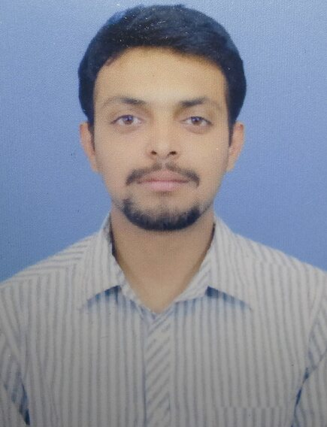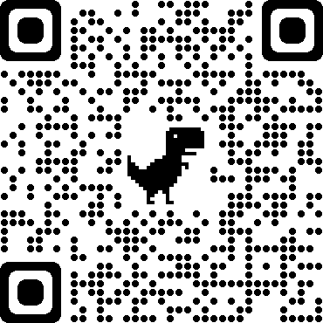
Phone: 8210564577 Email: satyakibhattacharya27@gmail.com
Website: https://myjourneytotheendcom.godaddysites.com
Father’s Name: Souvik Bhattacharya
Mother’s Name: Mousumi Bhattacharya
Date of Birth: 27/02/1995
Address: Road No 7 , Hill Area , Bariatu , Ranchi 834009
Career Objectives:
- To be a part of an enthusiastic work environment where I can enhance my knowledge and apply my technical skills to accomplish organizational goals and thus grow with and within the organisation always giving full stress on self actualisation.
Skills:
- Good Communication skills
- Quick Learner
- Good in Logical Reasoning
Academic Background:
Qualification | Passing Year | Institution | Marks In CGPA / Percentage
MCA | 2021 | ITM University , Gwalior | CGPA - 6.32
BSC (Computer Application) | 2017 | Ranchi College , Ranchi | 68.44 %
12th | 2014 | G & H High School , Ranchi | 56 %
10th | 2011 | G & H High School , Ranchi | CGPA - 5.6

Project Undertaken:
- CNC PRINTER : Computer Numerical Control Printer basically works with two stepper motors and a servo motor, wherein the pen plots the input given from the computer on the drawing board using microcontroller on an open-source physical computing platform Arduino.
- Software used : Inkscape (0.48.5) , Processing (3.0.2) , Arduino IDE.
- Hardware used : Arduino UNO , Motor Driver Shield , Stepper Motors , Servo Motor , CD drive case.
Certifications:
- Free Code Champ :- Responsive Web Design
View certification at https://freecodecamp.org/certification/satyaki_bhattacharya/responsive-web-design
- Solo Learn :- PHP Tutorial at https://www.sololearn.com/Certificate/1059-18188582/jpg/
- NIELIT :- Cyber Security and cloud computing at Certificate No. OLC1349
- Cognitive Class.ai :- Introduction to Data Science at https://courses.cognitiveclass.ai/certificates/4a710dbc6ae44647aef44a8202f6747d
- Udemy :- Full Stack Web Development at https://udemy-certificate.s3.amazonaws.com/image/UC-e55bda86-59d3-43c5-aacc-db3dba9351c8.jpg?v=1597324446000
Languages:
- Front End: HTML, CSS.
- Back End: PHP
- Scripting: Python, Javascript
- Database: MYSQL

