FOR IMMEDIATE RELEASE:

**Former SMU prof’s hunger strike into fourth week**

News provided by: <http://smallfrybigmission.ca>

HALIFAX, Nova Scotia, October 17, 2018 -- Shannon Nickerson is weak, ill, and experiencing heart palpitations... but still resolved after 24 days of a hunger strike calling for a policy review public inquiry.

Since September 23rd, former Saint Mary’s University Psychology professor Shannon Nickerson has been protesting from a van parked alternatively at Victoria Park and in front of SMU, trying to bring attention to the need for a public evaluation of the administrative systems overseeing human rights protection of Canadians.

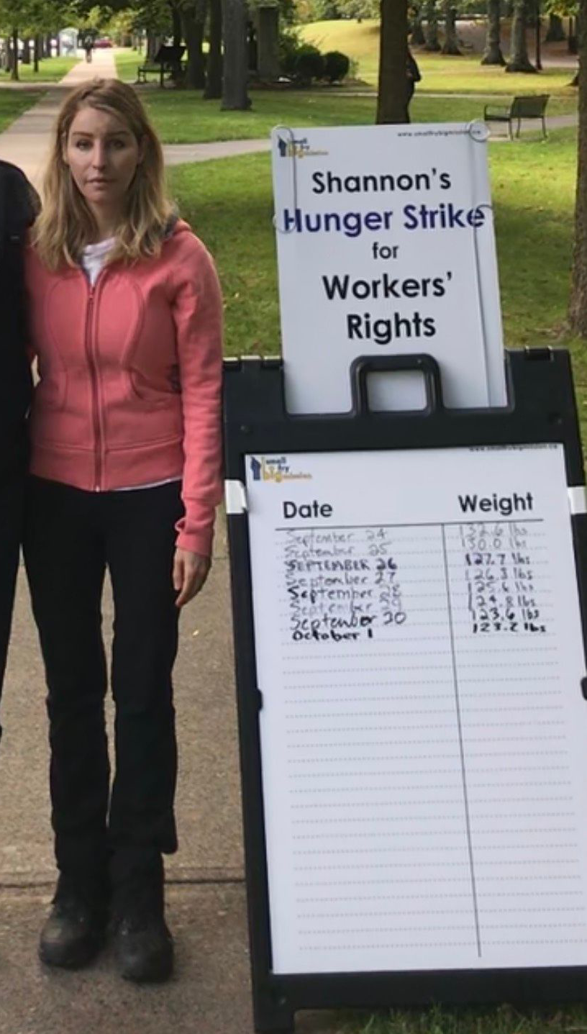

“This may seem like a drastic action... and it is” says Nickerson, referring to her decision to resort to a hunger strike. “I have tried all available channels to work within the system, and it’s come to a point where I couldn’t live with myself if I just sat back and let that system continue to abandon our most vulnerable workers.”

**Nickerson is calling for a ‘policy review’ public inquiry** into 1) the constitutionality of the current legislation that prevents unionized Canadian workers from accessing fair resolution to their human rights concerns, and; 2) the Nova Scotia human rights administrative systems - the NS Human Rights Commission and the NS Labour Board - whose statistics show only 0-1% of claims are ever granted.

Nickerson submitted personal requests for the public inquiry to each of the 51 members of the N.S. legislature on October 5th, but has not heard back from any of them.

From 2000 to 2011, Nickerson taught Psychology courses at SMU, with a flawless employment record and student evaluations. In 2009, within a week of undergoing the first of five brain-related surgeries, she was threatened with termination by a supervisor.

Nickerson is asking people to join her in asking for the public inquiry, by contacting:

**Office of the Secretary to the Governor General of Canada:  
Her Excellency the Right Honourable Julie Payette**  
1-800-465-6890 | info@gg.ca | https://www.gg.ca/

**Office of the Lieutenant Governor of Nova Scotia:  
His Honour the Honourable Arthur J. LeBlanc, ONS, QC**  
902-424-7001 | lgoffice@novascotia.ca | https://lt.gov.ns.ca/

**Their local MLA**: https://nslegislature.ca/members

For more information, please contact: 902-448-0570 | [info@smallfrybigmission.ca](mailto:info@smallfrybigmission.ca)

###